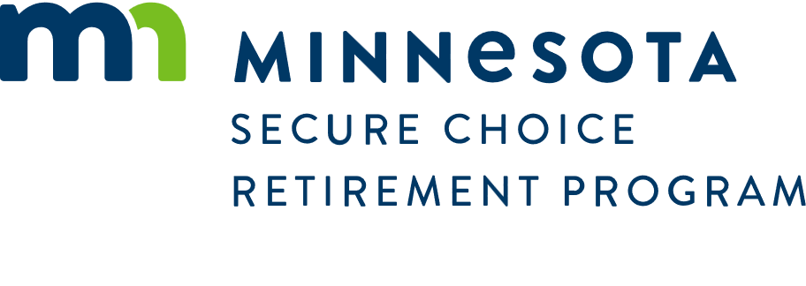

Memo
Date: April 1, 2025
To: MN Secure Choice Board of Directors
From: Dave Bergstrom, Interim Executive Director

RE: FY 2026 MN Secure Choice Retirement Program Budget
Staff is proposing the following budget for the fiscal year starting July 1, 2025, to June 30, 2026.

Budget Items
Position | Salary | Details
Permanent Executive Director | $216,00 | $173,000 plus an additional 25% for Social Security, Medicare, Retirement, and other benefits
Executive Assistant – full time | $90,000 | $72,000 plus an additional 25% for benefits
Communication Specialist – full time | $125,000 | $100,000 plus an additional 25% for benefits
State Program Administrator – full time | $125,000 | $100,000 plus an additional 25% for benefits
State Program Administrator – half time temporary position. | $36,000 | $48.00 an hour plus 7.65% for Social Security and Medicare (4 months)
Total | $592,000 | If positions are filled all fiscal year.
 | $525,000 | Assuming positions won’t all be filled on July 1, 2025.

Expenses | Amount
$20,500 - rent and office support: Annual office space rent  $7,500 - annual fee for office furniture rental, copying & printing services, building security, etc. | $28,000
General supplies –Letterhead, envelopes, pens, folders, etc. | $3,000
Postage | $10,000
Ongoing Information Services Cost - $200/month per employee. Includes computer, docking station rental, software and network support, and phone technology support. 5 employees x $200. | $12,000
Payroll and Accounting functions – This cost assumes that will be using the SmART(Small Agency program for administrative support) | $54,000
Other MNIT services – includes preparation of file to give to record keeper and other hardware or system requests. | $50,000
Statewide indirect costs (state agencies may be billed at the end of the year to make up for budget shortages in other agencies – such as MNIT, Department of Finance.) | $25,000
Travel Costs – conference attendance and mileage reimbursements for staff and Board. | $5,000
Training – for staff | $6,000
Georgetown Center for Retirement Initiatives Research Membership | $1,000
Consulting Services for Operational Consultant | $100,000
Website Hosting and development | $20,000
Total Expenses | $314,000
Grand Total | $839,000

The budget does not include any costs for record keeping services. This cost will be added when the contract with the Record Keeper is finalized.

Mn Secure Choice was appropriated $5,000,000 effective June 30. 2024, to offset the cost of administering the Program. The assets are invested in the Invested Treasure’s Cash (ITC) Pool. The ITC objectives are to preserve capital, meet liquidity needs, and provide competitive money market returns. As of March 31, the account balance was $5,016,748. To date, the interest has exceeded the cost of the FY 2025 Budget.

It is anticipated that the account will earn approximately $150,000 in Fiscal Year 2026.

