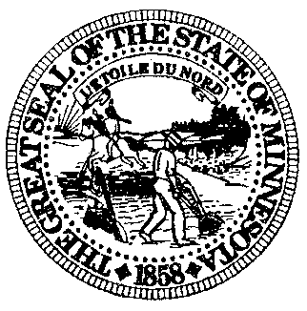

**TEL (651) 643-3060**

**FAX (651) 643-3072**

**www.post.state.mn.us**

**MINNESOTA BOARD OF**

**PEACE OFFICER STANDARDS AND TRAINING**

**1600 UNIVERSITY AVENUE, SUITE 200**

**SAINT PAUL, MINNESOTA 55104-3825**

**ALLEGED MISCONDUCT FOR CALENDAR YEAR 2024 – STATEWIDE**

Minn. Stat. 626.8457, subd. 3, requires Chief Law Enforcement Officers (CLEOs) to annually report summary data regarding the investigation and disposition of cases involving alleged unprofessional conduct by peace officers based on the department’s allegations of misconduct policy (Minn. R. 6700.2200).

|  |  |  |  |  |  |
| --- | --- | --- | --- | --- | --- |
|  |  | Disposition | | | |
|  | Number of  Investigations | Exonerated | Not Sustained | Sustained | Pending |
| Category |  |  |  |  |  |
| A. Use of Force | 130 | 36 | 12 | 15 | 67 |
| B. Pursuit / Emergency Vehicle Operation | 220 | 20 | 5 | 114 | 81 |
| C. Impartial Policing / Discriminatory Conduct | 29 | 11 | 4 | 1 | 13 |
| D. Other | 898 | 95 | 56 | 253 | 494 |
| **TOTALS** | **1277** | 162 | 77 | 383 | 655 |

Rev. 3/2025