

# Vendor’s Invoice - Governor's Advisory Council on Opioids, Substance Use, and Addiction

Updated April 2025

## Intro

* This invoice is to be used only by members of the Governor's Advisory Council on Opioids, Substance Use, and Addiction organized under the Minnesota Management and Budget (MMB) Office of Addiction and Recovery.
* Council members may use this form **within two weeks (14 days)** following a council meeting date to request compensation for mileage, parking, meals, lodging, per diem, and/or childcare expenses.
* A detailed list of allowable expenses in provided in the [Council Business Expense Reimbursement Policy](https://mn365.sharepoint.com/:b:/r/sites/MMB-GACOSUA/Working/2025%20Governor%27s%20Advisory%20Council%20Business%20Expense%20Reimbursement%20Policy%20and%20Instructions.pdf?csf=1&web=1&e=HcJfY6).

## Instructions

**Step 1:** SAVE this document to your computer BEFORE you begin filling it out. Do NOT fill it out within SharePoint.

**Step 2:** Enter your information in the light blue fields (boxes) in the Council member’s information, Compensation and Reimbursement and Vendor’s Certification and Signature sections.

**Step 3:** Save the document as a PDF and digitally sign.

**Step 4:** Email the complete, signed PDF and all accompanying documentation to [catherine.rohde@state.mn.us](mailto:catherine.rohde@state.mn.us).

If you prefer, you may mail your submission to**:** Minnesota Management and Budget Fiscal Services Unit, Attention: Accounts Payable 400 Centennial Office Building 658 Cedar Street, Saint Paul, MN 55155

## MMB Staff only

*This section is to be completed by MMB Fiscal Services Unit staff only.*

|  |  |
| --- | --- |
| **Date invoice received by MMB:** |  |

## Council member’s information

| **Item** | **Enter your information in this column** |
| --- | --- |
| **Name:** |  |
| **Street:** |  |
| **City:** |  |
| **State:** |  |
| **Zip Code:** |  |
| **Phone:** |  |
| **SWIFT Vendor #:** |  |

*A SWIFT vendor account is required to receive reimbursement. To request a SWIFT vendor #, go to the* [*Minnesota Supplier portal*](https://guest.supplier.systems.state.mn.us/psc/fmssupap/SUPPLIER/ERP/c/NUI_FRAMEWORK.PT_LANDINGPAGE.GBL?&lp=ERP.SUPPLIER.EP_COSP_PUBLIC_HOME_FL) *and register for an account.*

## Compensation and Reimbursement

|  |  |
| --- | --- |
| **Enter the date of the meeting you are requesting reimbursement for:** |  |

| **Item** | **Instructions** | **Enter a total number (#) in each category** | **Rate** | **Account** | **Enter a total amount ($) in each category** |
| --- | --- | --- | --- | --- | --- |
| *Mileage | Enter your **total** # of miles, multiply by the rate, enter your total $ requested, and attach receipts. |  | $.70 per mile | 411605 | $ |
| Parking | Enter total $ requested and attach receipts.  *Exception, meter parking must be annotated.* | **N/A** | **N/A** | 411605 | $ |
| Breakfast | Enter # of breakfasts, multiply by the rate, enter your total $ requested, and attach receipts.  *Allowed only if required to depart from home prior to 6 a.m.* |  | $10 max | 411605 | $ |
| Lunch | Enter # of lunches, multiply by the rate, enter your total $ requested, and attach receipts. |  | $13 max | 411605 | $ |
| Dinner | Enter # of dinners, multiply by the rate, enter your total $ requested, and attach receipts.  *Allowed only if unable to return home until after 7 p.m.* |  | $19 max | 411605 | $ |
| Lodging | Enter total $ requested and attach receipts. | **N/A** | **N/A** | 411601 | $ |
| Per diem | Enter # of days, multiply by the rate, enter your total $ requested.  *Allowed only if authorized by statute.* |  | $55 per day | 410706 | $ |
| Childcare | Enter total $ requested and attach receipts.  *Allowed only if authorized by statute.* | **N/A** | **N/A** | 430002 | $ |
| **Add the amount ($) in each category and enter your total request for reimbursement:** | | | | | **$** |

*You are encouraged to use [MapQuest](https://www.mapquest.com/directions) as it will provide the IRS rate and the shortest route.

* Enter your starting point and enter your destination.
* Mileage is calculated with the shortest distance between A&B, **no matter the route traveled.**
* Send a PDF with the shortest route and the IRS reimbursement showing. (an example is below)

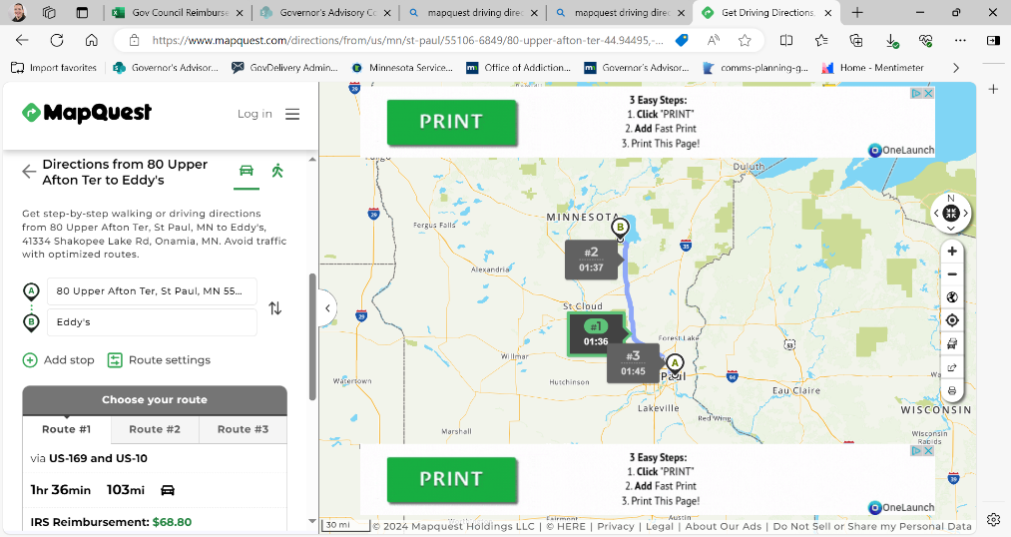

## Vendor’s Certification and Signature

Enter your signature and date.

|  |  |
| --- | --- |
| **Signature:** |  |
| **Date:** |  |

By signing above, you certify that:

1. You are a voting member of the Governor’s Advisory Council on Opioids, Substance Use, and Addiction;
2. The requests for compensation and/or reimbursement made on this form complies with the [Policy](https://mn365.sharepoint.com/:b:/r/sites/MMB-GACOSUA/Working/2025%20Governor%27s%20Advisory%20Council%20Business%20Expense%20Reimbursement%20Policy%20and%20Instructions.pdf?csf=1&web=1&e=h1Prac);
3. The expenses you have listed on this form have been incurred, are correct, and payment has not already been received; and
4. If requesting childcare expense reimbursement, you certify that the expense would not otherwise have been incurred.

Your signature **must** be either an authenticated digital signature (e.g., DocuSign; Abobe Digital Signature) or a handwritten “wet” signature (scanned copies are acceptable). **Typed signatures** or images of signatures copied and pasted onto the form **will not be accepted**.

## MMB payment authorization

*This section is to be completed by MMB staff only*

|  |  |
| --- | --- |
| **Item** | **Enter your information in this column** |
| **Signature:** (Office of Addiction and Recovery representative) |  |
| **Printed Name:** |  |
| **Title:** |  |
| **Signature:** (Fiscal Services Unit representative) |  |
| **Date:** |  |
| **Printed Name:** |  |
| **Title:** |  |
| **Fund:** |  |
| **FinDept:** |  |
| **AppropID:** |  |

Legal citations: [Minnesota Statutes 2024, section 4.046](https://www.revisor.mn.gov/statutes/cite/4.046#stat.4.046.5); [*Minnesota Statutes 2024, section 15.059*](https://www.revisor.mn.gov/statutes/cite/15.059#stat.15.059.3)