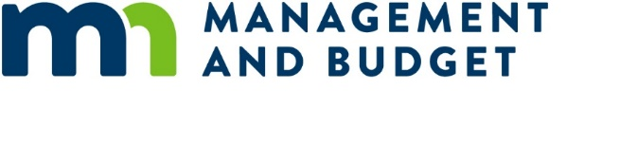

# Accepting Applications: Emerging Leaders and Senior Leadership Institutes

If you're interested in growing your leadership career with the State of Minnesota, you can bring your diverse background and unique experiences to these prestigious cohort-based programs offered by [Enterprise Talent Development (ETD](https://mn.gov/mmb/etd/leadership-development/series-training-courses/)):

* [**Emerging Leaders Institute (ELI):**](https://mn.gov/mmb/etd/course-search/#/detail/appId/1/id/202968) This seven-month program builds critical leadership competencies for state government. Participants will gain a deeper knowledge of public sector leadership, advance their own individual leadership effectiveness, and develop important skills, such as strategic thinking.
* [**Senior Leadership Institute (SLI):**](https://mn.gov/mmb/etd/course-search/#/detail/appId/1/id/202999) This is a four-month program. It prepares experienced managers and directors for higher leadership roles and equips them with tools to make an impact in today’s complex and challenging environment.

Both programs begin in September 2024. You must be employed by the state for a minimum of two years by September 13, 2024 to qualify for either program.

## Applications are due [DUE DATE FOR YOUR AGENCY]

The selection processes for both programs are highly competitive. To get started, discuss your interest in the program with your supervisor, as you will need their support to participate in this opportunity. Be sure to review the application process, program dates, and minimum qualifications on the [ETD website](https://mn.gov/mmb/etd/enrollment/apply-for-program.jsp) before applying.

### Use the following links to apply:

* [Emerging Leaders Institute (ELI) Application](https://mn.gov/mmb-stat/enterprise-talent-development/leadership-development-programs/ELI-Application-2023.pdf)
  + 2024_2025_emerging_leaders_institute_application_information
* [Senior Leadership Institute (SLI) Application](https://mn.gov/mmb-stat/enterprise-talent-development/leadership-development-programs/SLI-Application-2023.pdf)
  + 2024_2025_senior_leadership_institute_application_information

**[AGENCY] employees must submit their application before [DUE DATE AND TIME]**.

If you have any questions about either program or the application process, contact your Human Resources and/or Training and Development Teams. **[ADD CONTACT INFORMATION]**

## Join the Info Session Noon to 1 p.m., Thursday, May 2

Interested in applying? Want to encourage a colleague to apply? ETD will host an applicant information session at noon on Thursday, May 2. All perspective applicants and leadership teams are welcome to participate! ETD will be joined by recent ELI graduates, who will share their experiences in the program. This session will also review program curriculum, homework assignments, and the attendance policy.

At the end of the session, a representative from **[AGENCY]** will lead an optional break-out session to review our agency’s application process.

[Add this event to your calendar.](https://mn365.sharepoint.com/sites/MMB_ETDODTeam/Shared%20Documents/General/Application%20Process%20-%20ELI%20and%20SLI/ELI%20and%20SLI%20Prep%202024-2025/Webex_meeting.ics)

You can also reach out to [Enterprise Talent Development](mailto:ETD.Leadership.Shared.Mailbox.MMB@state.mn.us) (ETD) with questions about the programs, application process, or other skills development opportunities.

Here are two tip sheets for you to review and help you with your application process.

* [ELI and SLI Application Tips](https://mn.gov/mmb-stat/enterprise-talent-development/leadership-development-programs/tips-for-encouraging-applicants.pdf)
* [Letter of Recommendation Tips](https://mn.gov/mmb-stat/enterprise-talent-development/leadership-development-programs/Emerging-Leaders-Institute-Letter-of-Recommendation-Tips.pdf)