Keynote Session: Minnesota School Behavioral Health Conference
Thursday, November 5, 2026

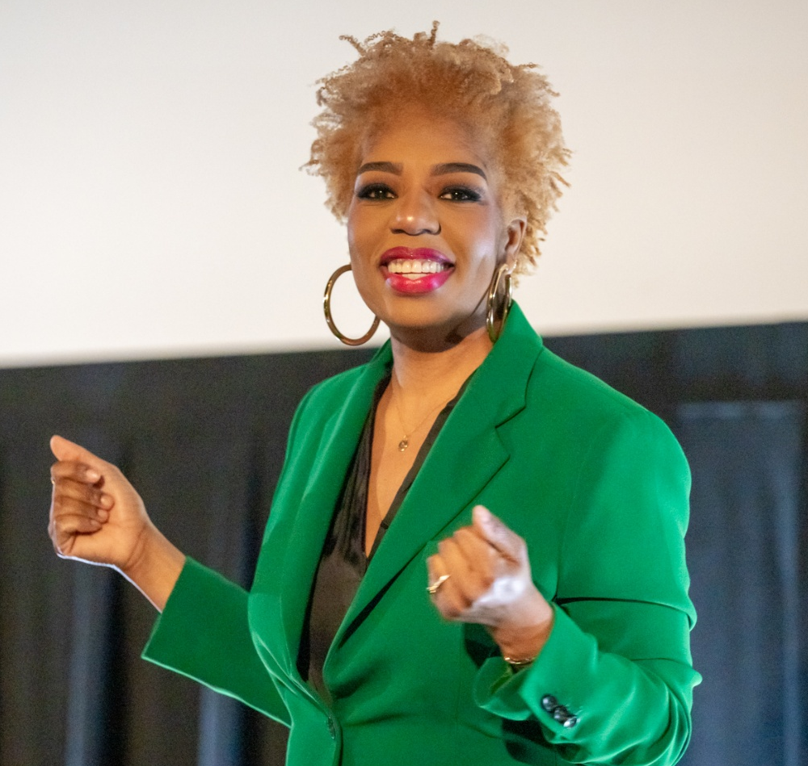
Seena Hodges (she/her) is a visionary CEO, speaker, strategist, and public voice committed to helping people see the world — and themselves — more clearly.
As the Founder & CEO of Bravely Seen™, Seena has spent nearly a decade helping individuals and organizations move beyond intention into purposeful, consistent action. Her signature From Ally to Accomplice® framework has guided thousands of people to confront the world — and their role in it — with greater insight, empathy, and responsibility.
A culture change strategist, Certified Public Manager, and certified IDI® and CliftonStrengths® administrator, Seena brings rigorous analysis, deep emotional intelligence, and the kind of joy that sustains long-term change. She holds an MFA from Columbia University and is currently pursuing a PhD in Management & Public Service at Hamline University.
Seena is the author of From Ally to Accomplice and has been recognized nationally for her leadership, including the Beloved Community Award from Hamline University and multiple honors as one of the Twin Cities' most influential leaders.

Courageous Clarity: For Times Like These
The hardest part of showing up isn’t the work, it’s the moment before. The moment when you have to tell the truth about where you are, what you’re carrying, and what you actually have to give. In this keynote, Seena Hodges makes the case that courage isn’t reserved for the bold or the unafraid. It’s available to anyone willing to pause long enough to name what’s real. And that pause, that single act of honest self-awareness, is where everything changes.

