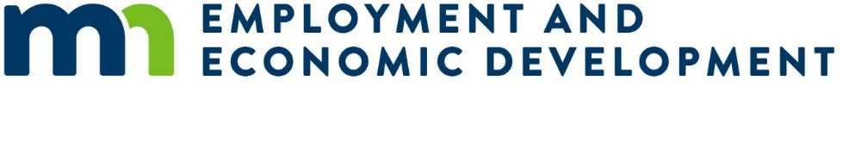
Addendum 1 – State Small Business Credit Initiative (SSBCI 2.0) Technical Assistance Service Providers
Date: August 21, 2026
This addendum containing the following revisions, additions, deletions, or clarifications is hereby made part of the Solicitation, including the Sample Contract and Exhibits if applicable.
- Question: Vendor ID/Supplier ID: How does a Responder obtain a Vendor ID/Supplier ID number? Is there a separate registration process that must be completed before submitting the proposal, or will a Vendor ID/Supplier ID be assigned during the contracting process if selected? I am specifically asking this question because Attachment E mentions one from the applying business.
  - Answer: StateWide Integrated Financial Tools (SWIFT) is the PeopleSoft based online financial, procurement, and reporting system used by the State of Minnesota. The SWIFT help desk email is swifthelpdesk.mmb@state.mn.us, and phone number is (651) 201-8100, option 2. Additional information can be found at https://mn.gov/mmb/accounting/swift/ A Responder would obtain a Vendor ID/Supplier ID number by working with the SWIFT help desk (separate registration process) and this can be obtained during the contracting process if selected.
- Question: Signatures: Does the proposal require a wet signature on all pages requiring a signature, or are electronic/digital signatures acceptable?
  - Answer: A valid electronic/digital signature authenticated by a third-party digital software, such as DocuSign or Adobe Sign is acceptable.
- Question: Attachment C: Can we reserve the right to amend the state's terms and conditions before signing the Agreement?
  - Answer: Refer to the RFP Attachment C: Exceptions to the State’s Terms and Conditions form to be completed with RFP responses.

