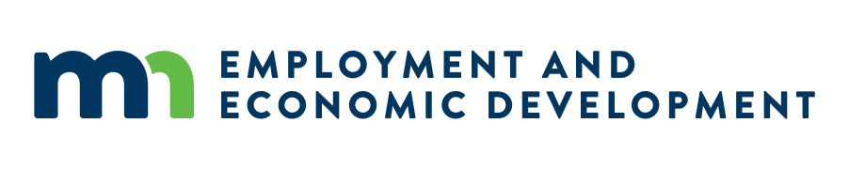

ATTACHMENT E: RESPONDER FORM

Workforce and Equal Pay Declaration Page
This form is required for all businesses executing government contracts under the following:

1. Select one:
☐ Businesses executing a contract with State or Metropolitan agencies in excess of $100,000 (Workforce Certificate) and if applicable $500,000 (Equal Pay Certificate)
☐ Businesses executing a contract with University of Minnesota for general obligation bond funded capital projects in excess of $100,000 (Workforce Certificate) and if applicable $500,000 (Equal Pay Certificate)
☐ Businesses executing a contract with Political Subdivisions for general obligation bond funded capital projects in excess of $250,000 (Workforce Certificate) and if applicable $1,000,000 (Equal Pay Certificate)

Select all that apply:

2. We are a Certificate holder:
☐ Workforce Certificate under the name: ______________________________________________________
☐ Equal Pay Certificate under the name: _______________________________________________________

3. We are applying/have applied for the following certificate(s):
☐ Workforce Certificate Application date (MM/DD/YYYY): ____________________
☐ Equal Pay Certificate Application date (MM/DD/YYYY): ____________________

4. We have not applied for one or both certificates:
☐ Our Company does not yet have a Workforce Certificate or Equal Pay Certificate. We acknowledge that a Workforce and, if applicable, Equal Pay Certificate, or approved exemption by MDHR is required before a contract can be executed.

5. We are Exempt:
☐ We attest to MDHR that we have not employed 40 or more employees on a single day during the prior 12 months in Minnesota or the state in where we have our primary place of business. MDHR may request the names of our employees during the previous 12 months, the date of separation, if applicable, and the current employment status and count.

6. Business Information
Vendor/Supplier ID | Business Name | Name of Contracting Agency
Authorized Signatory Name | Title | Date
Signature | Email | Phone

For assistance with this form, email the Minnesota Department of Human Rights Compliance.MDHR@state.mn.us

