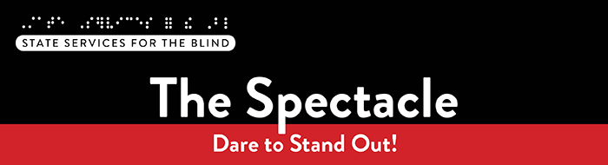

September 2026
Hello friends! It’s that time again—the newsletter that arrives with zero pop quizzes, no homework stress, and not a single advertisement. The Spectacle is released every other month during the school year and is packed with stories, tips, and opportunities designed just for you, whether you’re dreaming up your future, discovering new interests, or just here for a quick break in your day.
This month, we’re inviting you to upcoming events and opportunities, bringing you a mix of inspiration, real-life experiences from people in our community, and a few resources that might spark a new idea or help you build confidence in the goals you’re already chasing. Think of this newsletter as your monthly “life upgrade”—something fun, something helpful, and something that reminds you that your future is full of possibilities.
So, get comfy, grab your favorite snack (or two), and let’s explore what’s waiting for you in this edition!

What’s included this month?
- Meet a new staff member from the Youth Services team
- Fall Opportunities: Mississippi Canoe Trip, Saturday Independent Living classes, Tools for School workshop, Duluth Lighthouse for Vital Living’s 2026-2027 program, and more!
- Recent podcasts from Blind Abilities

A Note from SSB Counselors
Welcome to the new school year! We hope your summer was filled with rest and memorable moments. As the school year kicks off, we’re excited to connect and hear all about your adventures!
This is also when we update our records to keep the information about you and your team as accurate as possible. Keeping things up to date helps us coordinate smoothly with your family, school, and teachers. Don’t forget to include us in your IEP meetings—we’re here to support you every step of the way.
Calling all graduating seniors!! Be on the lookout for opportunities throughout the year dedicated to helping you plan for your next steps after high school. Whether you plan to go to college, attend a training program, or enter the workforce, know that we are here to help that transition go smoothly. We will offer various workshops this year to support your transition and look forward to seeing you there!

Meet our new Staff
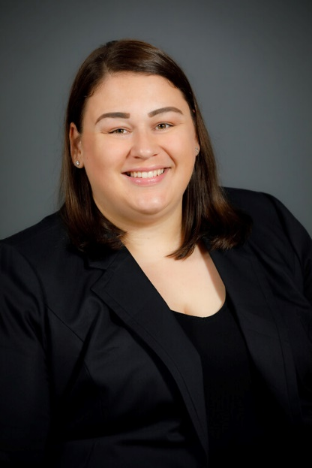
Hi! My name is Lindsay Escalera. I am a Vocational Rehabilitation Counselor serving blind, low vision, and DeafBlind Pre-ETS students ages 14-22 in the Twin Cities Metro area. I have worked at State Services for the Blind (SSB) for 5 years now. In my previous role, I worked as a Vocational Rehabilitation Counselor serving DeafBlind Pre-ETS students and adults in the Twin Cities Metro area. A fun fact about me is that I know American Sign Language (ASL). I started working with students with disabilities in 2010. From there, I continued working in the field while completing my bachelor’s degree in Communicative Disorders and Deaf Studies in 2012. After that, I graduated with my master’s degree in Rehabilitation Counseling in 2014. I like to use a person-centered approach when working with students. This allows me to find out what works well and what doesn't work well for them. This keeps the students at the center of the plan and supports. I support students in navigating Pre-ETS services, including job exploration counseling, post-secondary education counseling, workplace readiness training, instruction in self-advocacy, and work-based learning experiences. I enjoy helping students learn new things and figure out their strengths, interests, and abilities. I look forward to supporting my students and helping them achieve their vocational goals.
When I'm not working, I enjoy spending time with my family and friends. I like to go fishing (ice fishing, freshwater fishing, deep-sea fishing). I also love going to farmers' markets, baking, playing board games, reading, listening to music, and going on road trips.
Hear more from Lindsay on a recent podcast: Helping People Reach Their Goals: Lindsay Escalera’s Journey in Vocational Rehabilitation – Blind Abilities

Fall Opportunities

Mississippi River Canoe Trip – Sunday, September 20
SSB is partnering with Wilderness Inquiry for a canoe trip on the Mississippi River! The group will meet at Hidden Falls Regional Park – North Gate at 11 AM to learn about the Mississippi River and the land, do team-building activities, learn about canoe safety, and then paddle down the river while practicing teamwork and strong communication. A shuttle will return all participants to Hidden Falls by 3 PM.
Interested? Register for the September 20 Mississippi River Trip.
Questions? Contact Shane at shane.desantis@state.mn.us or call 651-358-5205.

Tools for School Workshop
SSB is hosting a Tools for School workshop to help students build the technology skills needed for success in higher education and the workplace. Please join us at the Minnesota Department of Education building on Friday, October 23rd, for a day of panels on assistive technologies that support the future success of blind and visually impaired students! Students, parents, and educators are invited! Register online for the Tools for School workshop to secure your seat!

Saturday Independent Living Classes – Starting This October!
We’re excited to announce a new series of Saturday Independent Living (IL) classes beginning on the second Saturday in October and continuing monthly through May. Classes will run from 9:00 a.m. to 12:00 p.m. and are designed to help you build everyday skills that support confidence and independence.
Throughout the year, we’ll explore topics such as clothing and personal hygiene, preparing cold and hot meals, dining skills, cleaning, using technology for independence, basic first aid and medication management, and even navigating a grocery store. Each session will offer hands-on learning and practical tips you can use right away.
If you’re interested in joining these sessions, please reach out to kia.sadler@state.mn.us to sign up. We’re looking forward to creating a fun, supportive space to learn, grow, and build useful skills together.

Duluth Lighthouse: 2026–2027 School-Year Program
The Lighthouse Center for Vital Living in Duluth offers a school-year program from October to June, featuring a blend of in-person weekend camps and weekly remote group sessions.
Program details for 2026–2027 will be posted soon at: School-Year Program

College planning and application help drop-in
October is College Knowledge Month in Minnesota, and to celebrate, the colleges and universities of Minnesota State are waiving their undergraduate application fees for the entire month, AND there are no essays required for applications. Stop by the SSB office in St. Paul on October 5th or November 2nd from 5 to 7 PM for assistance with college applications or any other college planning.

Resources and Activities

SSB Peer Ambassadors
Two SSB students are leading peer-to-peer programming across the state to support students who are blind, low vision, or DeafBlind. They are available for one-on-one peer discussions and will host virtual and in-person group activities.

EMPOWER VI
EMPOWER VI aims to equip transition-aged students with visual impairments living in rural communities, their families, and the transition professionals who serve them with virtual support to improve postsecondary education and employment outcomes. These virtual programs create opportunities for connection and support, especially for those in rural areas who may not have access to in-person resources.

SSB Communication Center
The Communication Center puts your books into accessible formats that work for you. Custom audio, e-text, DAISY markup, and Braille – we can do it! The Communication Center is Minnesota’s Accessible Reading Source – we’re here for you. Email us at ssb.audioservices@state.mn.us

PACER
PACER Center “enhances the quality of life and expands opportunities for children, youth, and young adults with all disabilities and their families so each person can reach their highest potential. PACER operates on the principles of parents helping parents, supporting families, promoting a safe environment for all children, and working in collaboration with others.”
Visit pacer.org/workshops to view a list of their upcoming workshops, including Social Security Disability: Applying and Qualifying for Benefits, Navigating the road to work: Building Supports, Understanding special education: Process and rights, Walking Together: Back-to-school and the special education journey, and much more!

Disability Hub MN
“Disability Hub MN is a free resource network that helps you solve problems, navigate the system, and plan for your future. We support you in creating your best life.” This website offers resources on disability benefits via the DB101 website and many employment resources for individuals with disabilities. Visit the Disability Hub website for more information. They have a chat feature and a call-in number for questions or specific resources.
Youth in Transition Toolkit – This toolkit will introduce you to Minnesota's youth in transition framework. Explore tools and resources you can use with the youth you support to plan for their best lives.

APH
APH CareerConnect is “an employment information resource offered by the American Printing House for the Blind for job seekers who are blind or visually impaired. CareerConnect provides employment information, career exploration tools, and job-seeking guidance for individuals with vision loss and the professionals who work with them.” Visit their website at aphcareerconnect.com to learn more. Check out their updated Getting Started Guides, featuring guides for families from birth to 3rd grade and 4th to 12th. Archived APH webinars are available on the APH ConnectCenter YouTube page.

Minnesota Association of Blind Students (MNABS)
MNABS comprises blind students from all walks of life—traditional, non-traditional, and everything in between. At our core, we’re more than just a division; we’re a community of friends supporting one another through the shared experiences of blind student life and beyond.
Whether you’re navigating academics, looking for professional development opportunities, or just seeking connection with others who “get it,” we’re here for you. Throughout the year, we host a variety of events—some social, such as our hot chocolate and white elephant holiday gathering, and others more focused on building confidence and advancing careers. For example, we’ve held an employment seminar where blind students and professionals from different fields shared their stories and insights.
Join our MNABS WhatsApp Community — come see what MNABS is all about, and how much stronger we are when we support each other. And if you’d like to learn more, have questions, or just want to say hello, feel free to reach out to anytime at students@nfbmn.org.

Blind Abilities Podcasts
Visit Blind Abilities online at http://www.BlindAbilities.com. You can also download the app from the Google Play Store or activate the Blind Abilities Alexa skill on your Alexa device by saying, “Alexa, enable Blind Abilities.”
Here are some of the people and topics featured on Blind Abilities recently:
- Tune in to hear from a student engaging in internships: From College to the Ballpark: Building a Career Through Internships and Initiative
- Come join the next volunteer event; hear from a recent volunteer night at Every Meal: 15,000 Meals, One Big Impact: SSB Pre-ETS Students Give Back
- Listen to students share their experience as a recent event: Explore, Connect and Grow: Students Discover Career Possibilities at Cragun’s Resort
- Check out this episode about self-recognition: Wellness Wednesday: You Deserve to Be Here: Recognizing How Far You’ve Come
If you know a student who is interested in sharing their achievements, Blind Abilities would love to feature their perspective. Send a note to info@blindabilities.com

Website Updates
Check out SSB’s Youth Services website to learn about upcoming events, access archived newsletters, read transition flyers, watch student videos, and more!

Tech Tidbits

On September 9th, Apple will host its annual iPhone event, where it is expected to announce the iPhone 18 series and its first foldable iPhone. Apple will likely also introduce new Apple Watches and other hardware.

Shortly after Apple's September event, they will also release new versions of macOS, iOS, iPadOS, and watchOS. SSB has been beta testing iOS 27, and there are some very nice features and improvements; it will support iPhone devices all the way back to the iPhone 11 series. Some new AI features will only work on newer devices, like the iPhone 15 Pro and later, and a couple of features will be exclusive to the iPhone 17 Pro and newer. One of Apple's best features, though, is overall performance improvements, even on older devices.

VoiceOver has some new Apple Intelligence features, like a new image description feature that lets VoiceOver describe your screen, an image on the screen, or something from your camera or Magnifier app. You can also ask specific questions about images, similar to apps like Be My Eyes.

Finally, Siri has seen a huge improvement. If you have ever used AI tools like ChatGPT or Google Gemini, Siri now works similarly. Siri can also look through email, text messages, Notes, and other Apple apps for specific information. No more need to scroll endlessly for that one email or note from a year ago.

There are too many more features and Siri improvements to describe here, but SSB encourages students to explore them themselves when iOS 27 releases in September. In October, SSB will also be hosting an event where you can learn more about these features, other AI tools, and wearables.
it easily.

Fast Forward: Potential and Possibilities – Steve Jacobson
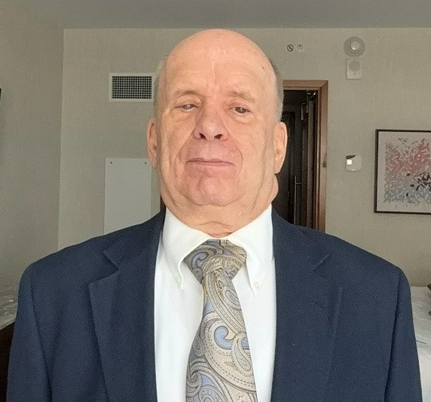
BACK To school From Beyond
It may surprise you to know that a guy who is about to turn 76 still thinks about going back to school in September. It just does not seem all that long ago that I was preparing to return to the Minnesota Braille and Sight Saving school and later to Augsburg College at the end of the summer. In more recent times, I remember my kids returning to school and the excitement and anxiety that came with it.
There is a lot about school that is challenging today for all students. However, there are particular challenges for those of us who are blind, whether we read braille or print. Sometimes school can seem distant from real life. I can’t change that with a few magical words, and I won’t engage in the standard lecture on the importance of education. Besides, I sort of hope you will read this to the end, and a lecture won’t accomplish that. Rather, I’d like to reflect upon how education has affected my life beyond school, hoping it will be useful.
I have been pretty lucky. For more than fifty years, I have worked in Information Technology in various roles, helped to raise two kids, and lived in a house that my wife and I owned. I don’t spend time thinking about how much better my life would have been if I was not blind because my life is very good as it is. That doesn’t mean I’ve never wished I could drive, but it just isn’t that important to me. What is exciting, though, is that there are many blind people who have done the same and much, much more. Still, I recognize I have been lucky. While there is an expression that says you make your own good luck, I don’t believe it is that simple. There are steps, though, that a student can take to increase the chances of experiencing good luck. Education is one of those steps.
When I was young, I was curious about such things as batting averages in baseball and how sports statistics were calculated. I noticed that math concepts came easier to me than to others. All of this led me toward pursuing a major in mathematics even though I was told that was not a good idea for a blind person. Fortunately, I knew there were blind math professors, and even though I didn’t think being a professor was my destination, it encouraged me to pursue that area of study. Majoring in math led to me getting jobs in information technology. Corporations in the 1970’s needed programmers so badly that they trained those with a math or business background to be programmers. School turned out to be a connection between my interests and a job. Math and computer programming is only one connection, and it is a less common connection now than it once was. Still, there are many connections between one’s interests and possible jobs. Education is actually a way to explore those connections to find a path that connects your skills and interests to a rewarding career.
Besides looking for those connections, another important part of my time in college was being able to refine my blindness skills. Learning the alternative techniques of blindness is different from gaining experience and confidence in them. That takes time and a lot of effort. Almost every job is easier if one has confidence in one’s travel skills, if one can take notes efficiently, and if one is knowledgeable in the assistive technology one uses. One can make a mistake in college and perhaps have to repeat a class which is serious. However, a mistake on the job can mean losing that job which can be much worse.
Believe it or not, all of these things cross my mind when September comes around. I wish I had fully realized this when I was in school, even though I did some of the right things by accident. Maybe sharing some of this will put you a little ahead of where I was. Even more important, though, is that It’s easy to think that life starts after one finishes school. As a student, one should have some fun, but at the same time, right now is the best time to explore connections and refine skills that will impact the rest of your entire life. Life is happening right now, and you can make a difference in your future!

Building BRIDGEs
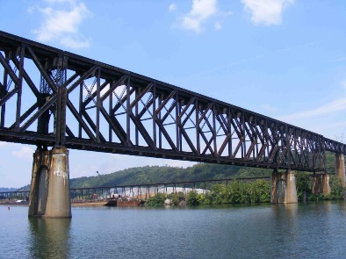
As students navigate the world of high school and begin thinking about the future, we offer services and resources that provide a foundation for success. Each of the core areas of our BRIDGE framework highlights an essential component that teenagers need in order to succeed after high school:

- Basic Skills
- Role Models
- Initiative
- Discovery
- Goal Setting
- Experiences

Vision Loss Disclosure
When should vision loss be disclosed to an employer? Every situation is different, and here are three resources that can help you decide this question:
- American Printing House: Disclosing Blindness/ Low Vision
- Job Accommodation Network: Disability Disclosure
- National Research and Training Center on Blindness and Low Vision: Who Needs to Know?: When and How to Disclose Vision Impairment

Ideas?
We are always looking for ideas you’d like to see featured in this newsletter. Please email shane.desantis@state.mn.us with any suggestions or brainstorming.

