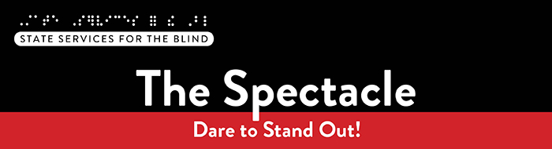

**September 2025**

# ****What’s included this month?****

* **Fall Opportunities**: Mississippi Canoe Trip, Intro to Social Security webinar, Duluth Lighthouse for Vital Living’s 2025-2026 program, Parent Meetup, and more!
* **Peer Ambassador**: SSB is hiring two new students for this paid leadership role.
* **Workshops:** Check out a list of upcoming sessions from the PACER Center.

# Just for Fun

Did you know that Minnesota is the only U.S. state where water flows in three different directions to three separate destinations? Rivers and streams flow north to the Hudson Bay in Canada, east to the Atlantic Ocean through the Great Lakes and St. Lawrence Seaway, and south to the Gulf of Mexico through the Mississippi River. Some may say Minnesota is the hydrological crossroads of North America.

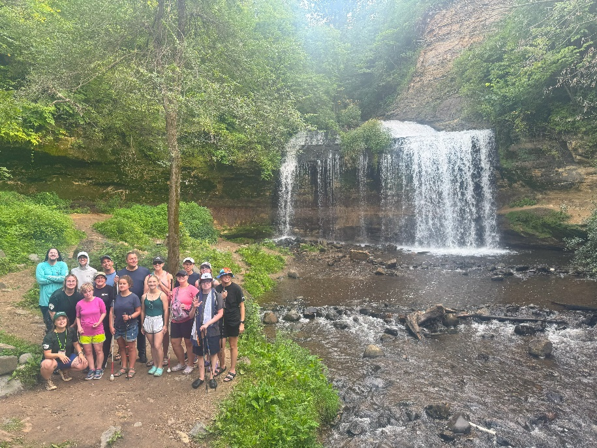Speaking of water, a group of students participated in a camping trip this August, hosted by SSB and Wilderness Inquiry. The adventure included canoeing on the St. Croix River, with a scenic stop at the Osceola Waterfall for hiking and exploration. Below is a picture of the group standing in front of the waterfall.

# Meet our new Multiple Systems and Pathways Navigator: Laila Nachar

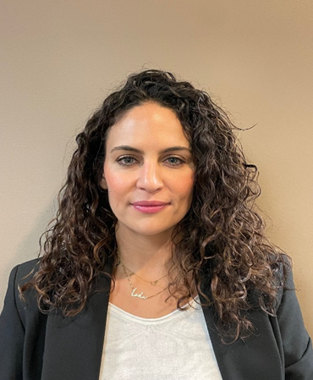Hello! I am Laila Nachar, and I am excited to be here. With over 12 years of experience in education, particularly in school psychology and well-being, I have developed a strong foundation to support the youth I advocate for. I hold both a master’s and a bachelor’s degree in psychology, which enhances my mental health and educational expertise.

I have a solid background working with multicultural youth and diverse populations from various regions. My passion for helping young people drives me to adopt a person-centered and innovative approach in service delivery. I am known for leading with empathy and focusing on the unique strengths, interests, and goals of each individual as we navigate the world of Pre-ETS.

Outside of work, you can find me enjoying the outdoors, participating in Pilates classes, and spending quality time with my family.

Tune into Blind Abilities podcast [A Spark for Success: Empowering Youth to Step Into Their Future](https://blindabilities.com/?p=9110) to hear more from Laila!

## A Note from SSB Counselors

Welcome to a new school year! We hope your summer was filled with rest and memorable moments. As the school year kicks off, we’re excited to connect and hear all about your adventures!

This is also the time we update our records to make sure we have the most accurate information about you and your team. Keeping things current helps us coordinate smoothly with your family, school, and teachers. Don’t forget to include us in your IEP meetings—we’re here to support you every step of the way.

## Fall Opportunities

🌊 Mississippi River Canoe Trip – Saturday, September 6  
SSB is partnering with Wilderness Inquiry for a canoe trip on the Mississippi River!

* Start: River Park in Brooklyn Park at 11:00 AM
* End: Kroening Nature Center at 2:00 PM

Interested? [Register for the September 6 Mississippi River Trip](https://registration.wildernessinquiry.org/groups/JPDv7YNK/registration-details?expires=1757221199&signature=fd1f599dfd6cfc3425a76c65f29c30f3c88b24dee53e8427db7ced1dab1543a6&printNow=)  
Questions? Contact Shane at [shane.desantis@state.mn.us](mailto:shane.desantis@state.mn.us) or call 651-358-5205.

📚 Duluth Lighthouse: 2025–2026 School-Year Program  
The Lighthouse Center for Vital Living in Duluth offers a school-year program from October to June, featuring a blend of in-person weekend camps and weekly remote group sessions.

Program details for 2025–2026 will be posted soon at: [School-Year Program](https://www.lcfvl.org/ytpschoolyear)

💡 Intro to Social Security Benefits – Informational Session

September 16th at 7:00 PM on Zoom

Learn how Social Security can support students with disabilities as they transition into adulthood. Whether you're exploring your options or already receiving benefits, this session will help clarify the process and available supports.

👉 [Register for the Intro to Social Security Benefits Meeting](https://www.zoomgov.com/meeting/register/sY6sD4spRVygw9DyIssjcQ)

👨‍👩‍👧 Parent Meetup – September 9 at 7:00 PM on Zoom   
Connect with other parents in our community! Join us for an informal virtual gathering.

🎟️ [Register for the Parent Meetup](https://www.zoomgov.com/meeting/register/TM6ZxHn3Rz2n1UEuQ8OL3Q)

# Resources and Activities

## SSB Peer Ambassadors

Two SSB students are leading peer-to-peer programming across the state to support students who are blind, low vision, or DeafBlind. They are available for one-on-one peer discussions and will host virtual and in-person group activities. Check out their podcast on [Blind Abilities: Peer Perspectives: How SSB Helps Students Build Independence and Explore Careers.](https://blindabilities.com/?p=8642)

Interested in becoming a peer ambassador? Contact Shane at [shane.desantis@state.mn.us](mailto:shane.desantis@state.mn.us) to inquire about the role.

## EMPOWER VI

The goal of [EMPOWER VI](https://www.empowervi.org/) is to equip transition-aged students with visual impairments living in rural communities, their families, and the transition professionals who serve them with the virtual supports to improve postsecondary education and employment outcomes. These virtual programs create opportunities for connection and support, especially for those in rural areas who may not have access to in-person resources.

## Bright Futures Vision

Bright Futures Vision is a student-led nonprofit organization that empowers young children who are blind or have vision loss, as well as provides support and resources for their families. Inspired by an older brother’s experience navigating life with vision loss, the founder wanted to create Bright Futures Vision to help young kids and connect families with the resources they need, as well as a community that understands their journey.

Our work focuses on :

* Partnering with local organizations to increase access to adaptive tools and learning opportunities
* Hosting workshops and events for kids, as well as parents
* Mentorship for kids as a learning experience

If you or someone you know could benefit from our resources—or if you’d like to collaborate—please contact brightfuturesvision25@gmail.com or follow us on Instagram @BrightFuturesVision

## SSB Communication Center

The Communication Center is here to put your books into accessible formats that work for you. Custom audio, e-text, DAISY markup, and Braille – we can do it! The Communication Center is Minnesota’s Accessible Reading Source – we’re here for you. Email us at [ssb.audioservices@state.mn.us](mailto:ssb.audioservices@state.mn.us)

## PACER

PACER Center “enhances the quality of life and expands opportunities for children, youth, and young adults with all disabilities and their families so each person can reach their highest potential. PACER operates on the principles of parents helping parents, supporting families, promoting a safe environment for all children, and working in collaboration with others.”

**📘 Upcoming Workshops:**

**Understanding Special Education Series: Process and Rights**  
🗓️ *September 11, 2025*  
🕛 *12:00 – 1:00 PM (via Zoom)*

This workshop provides parents with an introduction to the special education process and an overview of their parental rights. It will also cover the six main principles of the Individuals with Disabilities Education Act (IDEA).

👉 [Register now!](https://us06web.zoom.us/webinar/register/WN_jE6kAEIfQGeSDpJnef7I1g#/registration)

**Working Toward Positive Educational Outcomes: Mental Health and Special Education**  
🗓️ *September 17, 2025*  
🕛 *12:00 – 1:00 PM (via Zoom)*

This introductory session will help parents and caregivers understand the special education process, navigate disagreements within the IEP team, and prepare for a collaborative, mental health-focused IEP approach.

👉 [Register now!](https://us06web.zoom.us/webinar/register/WN_jlAkwG0DTiiiDyLShFk9eA#/registration)

📅 For a full list of upcoming PACER trainings and workshops, visit:  
🔗 [https://www.pacer.org/workshops/](https://www.pacer.org/workshops/?utm_source=chatgpt.com)

## ****Disability Hub MN****

“Disability Hub MN is a free resource network that helps you solve problems, navigate the system, and plan for your future. We support you in creating your best life.” This website offers resources on disability benefits via the [DB101 website](https://mn.db101.org/) and many employment resources for individuals with disabilities. Visit the [Disability Hub website](https://disabilityhubmn.org/?gad_source=1&gbraid=0AAAAAqsX9htK-FFuuSkisSXKpZZYhLudZ&gclid=Cj0KCQjw_JzABhC2ARIsAPe3ynpqmHIaQMwGli-SSVUE0Nu5cK-LgIlNFIdYDj03rNF8uF2ZzemqVRkaAhR0EALw_wcB) for more information. They have a chat feature and a call-in number for questions or specific resources.

[Youth in Transition Toolkit](https://disabilityhubmn.org/for-professionals/youth-in-transition/) – This toolkit will introduce you to Minnesota's youth in transition framework. Explore tools and resources you can use with the youth you support to plan for their best lives.

## APH

APH CareerConnect is “an employment information resource offered by the American Printing House for the Blind for job seekers who are blind or visually impaired. CareerConnect provides employment information, career exploration tools, and job-seeking guidance for individuals with vision loss and the professionals who work with them.” Visit their website at [aphcareerconnect.com](https://aphcareerconnect.org/) to learn more. Check out their new [*Getting Started Guides*](https://aphconnectcenter.org/familyconnect/getting-started-guides/)*,* featuring guides for families from birth to 3rd grade and 4th to 12th. Archived APH webinars are available on the [APH ConnectCenter YouTube page.](https://www.youtube.com/playlist?list=PLUj6DcM1nN3HCfWxJIMLPeD8roKZt8xyu)

## Minnesota Association of Blind Students (MNABS)

My name is Ben Zheng, and I’m the current president of the Minnesota Association of Blind Students (MNABS), a proud division of the National Federation of the Blind of Minnesota. MNABS is comprised of blind students from all walks of life—traditional, non-traditional, and everything in between. At our core, we’re more than just a division; we’re a community of friends supporting one another through the shared experiences of blind student life and beyond.

Whether you’re navigating academics, looking for professional development opportunities, or just seeking connection with others who “get it,” we’re here for you. Throughout the year, we host a variety of events—some social, such as our hot chocolate and white elephant holiday gathering, and others more focused on building confidence and advancing careers. For example, we’ve held an employment seminar where blind students and professionals from different fields shared their stories and insights.

We also maintain a treasury that helps fund student participation in enrichment opportunities, including the Midwest Student Seminar, the NFB National Convention, and the NFB of Minnesota’s State Convention!

To help foster more ongoing connection, we’ve recently created a WhatsApp community for MNABS members to stay in touch, share resources, and support one another. It’s still new and growing, and we’d love for you to be a part of it. By joining, you’ll gain a circle of peers who understand your journey, a space to ask questions and share ideas, and opportunities to connect with friends who want to see you succeed.

👉 [Join our MNABS WhatsApp Community](https://chat.whatsapp.com/I8X3eLBFGOPLCfk6Uyowgu) — come see what MNABS is all about, and how much stronger we are when we support each other. And if you’d like to learn more, have questions, or just want to say hello, feel free to reach out to me at any time at [students@nfbmn.org](mailto:students@nfbmn.org).

## Blind Abilities Podcasts

Visit Blind Abilities online at <http://www.BlindAbilities.com>. You can also download the app from the Google Play Store or activate the Blind Abilities Alexa skill on your Alexa device by saying, “Alexa, enable Blind Abilities.”

Here are some of the people and topics featured on Blind Abilities recently:

* Tune in to hear from the Peer Ambassadors: [Cruising Through Summer: Next Exit-College.](https://blindabilities.com/?p=9069)
* Hear from SSB staff about skills in the kitchen and a SSB cooking class: [Cooking Up Confidence: Ready, Set, Prep.](https://blindabilities.com/?p=8756)
* Listen to learn about SSB’s Communication Center: [From Audio Books, Braille to Broadcast: Behind the Scenes at State Services for the Blind – A Tour Through SSB’s Communication Center](https://blindabilities.com/?p=8717)
* Check out this episode about social connection: [Wellness Wednesday: Isolation – From Alone to A Little Less Lonely: Steps Toward Social Reconnection](https://blindabilities.com/?p=8727)

If you know a student interested in sharing their achievements, Blind Abilities would love to feature their perspectives. Send a note to [info@blindabilities.com](mailto:info@blindabilities.com)

## Website Updates

Check out [SSB’s Youth Services website](https://mn.gov/deed/ssb/teens/) to learn about upcoming events, access archived newsletters, read transition flyers, watch student videos, and more!

# Tech Tidbits

Envision recently announced its new Solos glasses, which are designed to work with its Ally iOS and Android app. The primary focus of these glasses is to assist with visual tasks such as reading text, describing scenes and items, and other visual activities. They are now taking pre-orders, and those who pre-order receive a year of their Ally premium subscription for free, along with a discount on the glasses.

[https://shop.letsenvision.com/collections/solos](https://gcc02.safelinks.protection.outlook.com/?url=https%3A%2F%2Fshop.letsenvision.com%2Fcollections%2Fsolos&data=05%7C02%7Cshane.desantis%40state.mn.us%7Cc870fd5503704ec30fc908dde4aff7a8%7Ceb14b04624c445198f26b89c2159828c%7C0%7C0%7C638918166617825982%7CUnknown%7CTWFpbGZsb3d8eyJFbXB0eU1hcGkiOnRydWUsIlYiOiIwLjAuMDAwMCIsIlAiOiJXaW4zMiIsIkFOIjoiTWFpbCIsIldUIjoyfQ%3D%3D%7C0%7C%7C%7C&sdata=UjlTPMCz%2BpYclTtlVMqb5sjnJpH3ynxMnJGQ7Ew1baY%3D&reserved=0)

Here is a good video podcast/interview on the Solos glasses with Carrie Accessibility

[https://www.youtube.com/watch?v=gKXti2Kb-yI](https://gcc02.safelinks.protection.outlook.com/?url=https%3A%2F%2Fwww.youtube.com%2Fwatch%3Fv%3DgKXti2Kb-yI&data=05%7C02%7Cshane.desantis%40state.mn.us%7Cc870fd5503704ec30fc908dde4aff7a8%7Ceb14b04624c445198f26b89c2159828c%7C0%7C0%7C638918166617845859%7CUnknown%7CTWFpbGZsb3d8eyJFbXB0eU1hcGkiOnRydWUsIlYiOiIwLjAuMDAwMCIsIlAiOiJXaW4zMiIsIkFOIjoiTWFpbCIsIldUIjoyfQ%3D%3D%7C0%7C%7C%7C&sdata=2HfarLf%2BvzdQ6luxmLwg%2BCHrbDurhUhUKj1klhEN15M%3D&reserved=0)

As another school year starts, remember some useful apps and tools that may be helpful for both high school and college:

Bookshare is an accessible reading service that has many digital textbooks and other reading materials, and SSB highly recommends that students have access to this service:

[www.bookshare.org](https://gcc02.safelinks.protection.outlook.com/?url=http%3A%2F%2Fwww.bookshare.org%2F&data=05%7C02%7Cshane.desantis%40state.mn.us%7Cc870fd5503704ec30fc908dde4aff7a8%7Ceb14b04624c445198f26b89c2159828c%7C0%7C0%7C638918166617860904%7CUnknown%7CTWFpbGZsb3d8eyJFbXB0eU1hcGkiOnRydWUsIlYiOiIwLjAuMDAwMCIsIlAiOiJXaW4zMiIsIkFOIjoiTWFpbCIsIldUIjoyfQ%3D%3D%7C0%7C%7C%7C&sdata=4h3QXUYGOXuyavoutqCnX4dPgF9Q87Ak8r3G3eqWfDA%3D&reserved=0)

Desmos is a commonly used calculator for school, and there are free graphing and scientific calculator apps available in the Google Play Store and Apple App Store. Students can also use Desmos on their computers from the Desmos website:

[www.desmos.com](https://gcc02.safelinks.protection.outlook.com/?url=http%3A%2F%2Fwww.desmos.com%2F&data=05%7C02%7Cshane.desantis%40state.mn.us%7Cc870fd5503704ec30fc908dde4aff7a8%7Ceb14b04624c445198f26b89c2159828c%7C0%7C0%7C638918166617875204%7CUnknown%7CTWFpbGZsb3d8eyJFbXB0eU1hcGkiOnRydWUsIlYiOiIwLjAuMDAwMCIsIlAiOiJXaW4zMiIsIkFOIjoiTWFpbCIsIldUIjoyfQ%3D%3D%7C0%7C%7C%7C&sdata=a5Gqe7PgyY7S584MACHGBRDk%2BtPeUa8zl%2FolHf0Kdnk%3D&reserved=0)

Windows Calculator is also a reliable free calculator built into Windows, offering several modes, including scientific and graphing modes.  Just type "calculator" into the Start Menu search box to find it easily.

# **Fast Forward: Potential and Possibilities – Lori Thompson**

I grew up in West Central Illinois and attended Spoon River Valley High School. I found out I had retinitis pigmentosa (RP) when I was 15 years old. I attended college in my thirties after having two children. I received my Associate of Arts Degree in Education from Spoon River College. My goal was to become a High School History teacher. Before going off to a University, I decided to attend BLIND Inc so that I would have the proper blindness skills to complete my bachelor’s degree successfully. After completing my Adjustment to Blindness training, BLIND Inc. offered me a position teaching Life Skills. I packed up my kids and moved to Minneapolis.

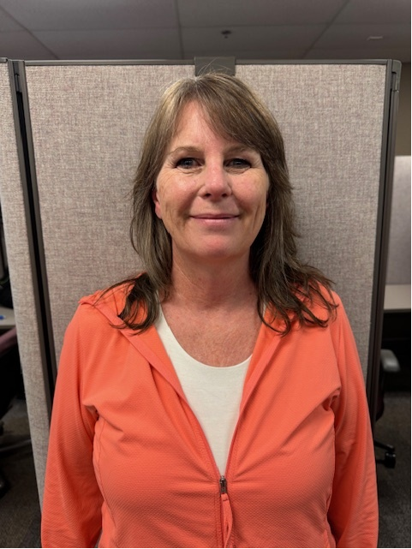In 2012, I took a position with the MN Board of Pharmacy. I worked as an Office and Administrative Specialist. A significant portion of my responsibilities included customer service and case management. Fast forward to 2022, and I took a position with State Services for the Blind. I am currently a Vocational Rehabilitation Technician (VR Tech). I support VR Counselors. I assist individuals with vision loss in identifying, obtaining, and maintaining employment. This involves providing guidance, coordinating services, and offering support and resources. I also procure the money for customers' blind services and ensure that the vendors who provide those services get paid.

There are many tools that I use to make me successful in my VR Tech position. Jaws, braille, Adobe Pro, and AIRA are just a few. I also have many different apps on my iPhone. I currently use a white cane for mobility, but I have also been a guide dog user.

Every blind person is different. We all have different needs and learning styles. It is not a one-size-fits-all when it comes to techniques and blindness tools. I listen to podcasts to stay up to date on my technology skills, and I love talking to my blind friends to see what they are using.

In my personal life, I am happily married and a mother of four great adult children and four beautiful grandchildren. I enjoy reading, cooking, and gardening. I try to travel whenever I get the chance.

This is a wonderful time in the world for people who are blind. The advancement of technology has been remarkable for all people who are blind. But if I could offer something to newly blind or the youth that is struggling, please get the blindness skills. Put on the sleep shades and try to block out the white noise that you are struggling with. You will build your confidence in your ability, and you will know exactly what you need and want to be successful.

# Picture of a well-built and stylish bridge. Building BRIDGEs

As students navigate the world of high school and begin thinking about the future, we offer services and resources that provide a foundation for success. Each of the core areas of our **BRIDGE** framework highlights an essential component that teenagers need in order to succeed after high school:

* **B**asic Skills
* **R**ole Models
* **I**nitiative
* **D**iscovery
* **G**oal Setting
* **E**xperiences

## Vision Loss Disclosure

When should vision loss be disclosed to an employer? Every situation is different, and here are three resources that can help you decide this question:

* American Printing House: [Disclosing Blindness/ Low Vision](https://aphconnectcenter.org/careerconnect/job-seekers/conducting-a-successful-job-search/disclosing-a-visual-impairment/)
* Job Accommodation Network: [Disability Disclosure](https://askjan.org/topics/Disability-Disclosure.cfm)
* National Research and Training Center on Blindness and Low Vision: [Who Needs to Know?: When and How to Disclose Vision Impairment](https://www.blind.msstate.edu/sites/www.blind.msstate.edu/files/2022-03/Who%20Needs%20to%20Know%20-%20Disclosing%20Your%20Vision%20Impairment.pdf)

## Media and Public Opportunities

* [Lighthouse Guild Tele-Support for Teens](https://lighthouseguild.org/support-services/telesupport-groups/for-teens/): Connect with other teens from across the country! Telephone support groups for high school students who are blind or have low vision are available every other Monday.
* APH created a list of podcasts that feature employment stories, career development tips, and insights into how blind and low vision individuals succeed in the workplace and life. Check it out at [Recommended Podcasts and Websites](https://aphconnectcenter.org/careerconnect/personal-employment-stories/recommended-podcasts-and-websites/).
* [Inspiring Stories of People Thriving With Vision Loss](https://ophthalmicedge.org/patient/inspiring-stories-of-people-thriving-with-vision-loss/)

## Ideas?

We are always looking for ideas you’d like to see featured in this newsletter. Please email [shane.desantis@state.mn.us](mailto:shane.desantis@state.mn.us) with any suggestions or brainstorming. J