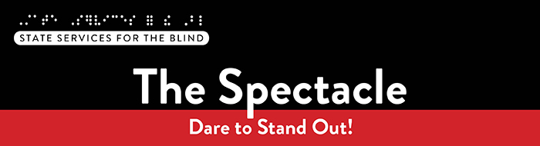

**May 2025**

# ****What’s included this month?****

* A list of various summer activities
* Resources from EMPOWER VI
* Recent podcasts from Blind Abilities
* Hear about MSAB’s International Studies Club trip to Sicily

# Just for Fun

Did you know the Minnesota State Fair is hosting its fifth annual *Kickoff to Summer at the Fair* event in May? From May 22nd to the 25th, select vendors will gather at the fairgrounds, with limited attendance to ensure a more relaxed and intimate experience than the bustling State Fair. Enjoy food from nearly 40 vendors, live music and entertainment (included with admission), shopping from over 30 specialty Minnesota merchants, Giant Slide rides, yard games, history tours, free parking, and much more! For all Minnesota State Fair lovers, visit [Kickoff to Summer at the Fair](https://www.mnstatefair.org/kickoff-to-summer/) to learn more and buy tickets.

## A Note from SSB Counselors

Hello, students! As another school year comes to a close, we hope you reflect on a year filled with learning, growth, and achievement. Finishing a school year is no small feat—celebrate your hard work and accomplishments! With summer ahead, we encourage you to explore activities that spark your curiosity and bring you joy, while also helping you continue to grow, build new skills, and strengthen your resume. Consider training programs, skill-building workshops, or experiences that align with your career goals. These opportunities can boost your confidence and lay a strong foundation for future success. We're here to support you—don’t hesitate to reach out! We’d love to connect and help you make this summer a meaningful step toward achieving your goals.

Take a look at the summer opportunities listed below, and let us know if you're interested!

## Summer Opportunities

Duluth Lighthouse Center for VitalLiving offers two summer camps where students can come together to learn, build confidence, and network. The first camp runs from Sunday, July 6 to July 13, and the second from Sunday, July 27 to August 3. For more information, visit [Lighthouse Summer Camps 2025](https://www.lcfvl.org/index.asp?SEC=7B153D98-7DFC-4A88-AFE0-A8A090E664AE).

Wilderness Inquiry Outdoor Opportunities

SSB is partnering with Wilderness Inquiry to host two exciting summer outdoor events:

* Canoeing the Mississippi River: Join us on Saturday, July 12, from 11 AM to 2 PM for a canoeing adventure. Whether you're a first-time paddler or experienced on the water, this is a great opportunity to get outdoors, meet new people, and enjoy nature.
* Camping at Afton State Park: From August 12 to 14, enjoy a two-night, three-day camping trip at Afton State Park. All camping gear is provided, and chaperones will be present.

If you're interested in either opportunity, contact Shane DeSantis at [shane.desantis@state.mn.us](mailto:shane.desantis@state.mn.us).

Vision Loss Resources offers adjustment to blindness training, helping individuals learn adaptive techniques for daily life. Topics include technology, typing, orientation and mobility, braille, cooking, and other essential daily living skills. Check out [visionlossresources.org](https://visionlossresources.org) to learn more!

Envision Level Up*:* This residential program takes place June 22–28 in Wichita, Kansas. It offers hands-on learning in various areas to help students with vision loss successfully transition into careers and develop the skills needed for college. More information can be found at [Envision Level Up Program](https://www.envisionus.com/youth-programs/level-up)

ReSOURCE/LEAP (Learn, Earn, and Prosper): Virtual work experiences and work readiness training. [Check out this video](https://www.youtube.com/watch?v=kPe6KkgBliQ&t=52s) to learn more about their virtual work experience program or contact SSB.

Helen Keller National Center (HKNC): HKNC offers six different youth programs at their headquarters in Sands Point, New York, and is available to work with students in their homes or communities. HKNC serves individuals with combined hearing and vision loss to work towards achieving goals and aspirations. To learn more, visit [HKNC Youth Programs](https://www.helenkeller.org/hknc/youth-programs/).

# Resources and Activities

## SSB Peer Ambassadors

Two SSB students are leading peer-to-peer programming across the state to support students with visual impairments. They are available for one-on-one peer discussions and will host virtual and in-person group activities. Check out their latest podcast on [Blind Abilities: Peer Perspectives: How SSB Helps Students Build Independence and Explore Careers.](https://blindabilities.com/?p=8642)

Want to learn more or connect with them? Reach out to Amy at [amyarias0508@gmail.com](mailto:amyarias0508@gmail.com) or Maddy at [major.madeline7@gmail.com](mailto:major.madeline7@gmail.com).

## Minnesota Association of Blind Students (MNABS) – Thriving Without Sight Workshop

M.N.A.B.S. hosts a Thriving Without Sight workshop on the second Sunday of each month from 7:00 to 8:00 PM on Zoom.

If you have any questions about MNABS or their workshops, feel free to reach out to the M.N.A.B.S. President, Ben Zheng, by emailing [students@nfbmn.org](mailto:students@nfbmn.org)

The link to join their workshops is [Reoccurring MNABS Thriving Without Sight Workshop Zoom Link](https://gcc02.safelinks.protection.outlook.com/?url=https%3A%2F%2Fnfb-org.zoom.us%2Fj%2F98691296598%3Fpwd%3DlH5Mgu1Rr9aov4h83qVNbnfq5ZDjsp.1&data=05%7C02%7Cshane.desantis%40state.mn.us%7C8748e391a37f4f59e42608dd6166064c%7Ceb14b04624c445198f26b89c2159828c%7C0%7C0%7C638773812994184905%7CUnknown%7CTWFpbGZsb3d8eyJFbXB0eU1hcGkiOnRydWUsIlYiOiIwLjAuMDAwMCIsIlAiOiJXaW4zMiIsIkFOIjoiTWFpbCIsIldUIjoyfQ%3D%3D%7C0%7C%7C%7C&sdata=DEPBdXtjPy2lw18klt7ioABQP8pKeXMP6InhxTzij10%3D&reserved=0).

## EMPOWER VI

The goal of [EMPOWER VI](https://www.empowervi.org/) is to equip transition-aged students with visual impairments living in rural communities, their families, and the transition professionals who serve them with the virtual supports to improve postsecondary education and employment outcomes. These virtual programs create opportunities for connection and support, especially for those in rural areas who may not have access to in-person resources. Below are brief descriptions of current programs with links to learn more.

*Virtual Mentorship*

EMPOWER VI is currently recruiting juniors and seniors who are blind or have low vision (from any U.S. state) for their 2025-2026 virtual [EMPOWER VI Mentoring Program](https://www.empowervi.org/mentorship). For more information about the program and to complete an application, visit: [Mentee Role and Application](https://www.empowervi.org/mentorship/mentee-role).

*Student Advisory Board*

EMPOWER VI is also seeking three high school students who are blind or have low vision to join their Student Advisory Board for the 2025-2026 school year. To learn more about this opportunity, visit: [Advisory Boards](https://www.empowervi.org/advisory-boards).

## SSB Communication Center

The Communication Center is here to put your books into accessible formats that work for you. Custom audio, e-text, DAISY markup, and Braille – we can do it! The Communication Center is Minnesota’s Accessible Reading Source – we’re here for you. Email us at [ssb.audioservices@state.mn.us](mailto:ssb.audioservices@state.mn.us)

## PACER

PACER Center “enhances the quality of life and expands opportunities for children, youth, and young adults with all disabilities and their families so each person can reach their highest potential. PACER operates on the principles of parents helping parents, supporting families, promoting a safe environment for all children, and working in collaboration with others.” For information on upcoming webinars and workshops, visit [PACER's workshops website](https://www.pacer.org/workshops/).

## ****Disability Hub MN****

“Disability Hub MN is a free resource network that helps you solve problems, navigate the system, and plan for your future. We support you in creating your best life.” This website offers resources on disability benefits via the [DB101 website](https://mn.db101.org/) and many employment resources for individuals with disabilities. Visit the [Disability Hub website](https://disabilityhubmn.org/?gad_source=1&gbraid=0AAAAAqsX9htK-FFuuSkisSXKpZZYhLudZ&gclid=Cj0KCQjw_JzABhC2ARIsAPe3ynpqmHIaQMwGli-SSVUE0Nu5cK-LgIlNFIdYDj03rNF8uF2ZzemqVRkaAhR0EALw_wcB) for more information. They have a chat feature and a call-in number for questions or specific resources.

[Youth in Transition Toolkit](https://disabilityhubmn.org/for-professionals/youth-in-transition/) – This toolkit will introduce you to Minnesota's youth in transition framework. Explore tools and resources you can use with the youth you support to plan for their best lives.

## APH

APH CareerConnect is “an employment information resource offered by the American Printing House for the Blind for job seekers who are blind or visually impaired. CareerConnect provides employment information, career exploration tools, and job-seeking guidance for individuals with vision loss and the professionals who work with them.” Visit their website at [aphcareerconnect.com](https://aphcareerconnect.org/) to learn more. Check out their new [*Getting Started Guides*](https://aphconnectcenter.org/familyconnect/getting-started-guides/)*,* featuring guides for families from birth to 3rd grade and 4th to 12th. Archived APH webinars are available on the [APH ConnectCenter YouTube page.](https://www.youtube.com/playlist?list=PLUj6DcM1nN3HCfWxJIMLPeD8roKZt8xyu)

## Blind Abilities Podcasts

Visit Blind Abilities online at <http://www.BlindAbilities.com>. You can also download the app from the Google Play Store or activate the Blind Abilities Alexa skill on your Alexa device by saying, “Alexa, enable Blind Abilities.”

Here are some of the people and topics featured on Blind Abilities recently:

* Tune in to hear from the Peer Ambassadors at [Peer Perspectives: How SSB Helps Students Build Independence and Explore Careers.](https://blindabilities.com/?p=8642)
* Hear from SSB staff about college student readiness: [Navigating College with Confidence: Tips for Students with Vision Loss](https://blindabilities.com/?p=8631).
* Listen to a recent [Wellness Wednesday Anchoring in the Now: Tools to Navigate Anxiety and Uncertainty.](https://blindabilities.com/?p=8646)
* Check out another [Wellness Wednesday: AI or not to AI, That is the Question That We Ask of Thee](https://blindabilities.com/?p=8652)

If you know a student interested in sharing their achievements, Blind Abilities would love to feature their perspectives. Send a note to [info@blindabilities.com](mailto:info@blindabilities.com)

## College Success Program

SSB is partnering with Envision's College Success Program to offer mentorship, meet-ups, learning, and advocacy. Students in college are paired with recent college graduates who are blind, low vision, or DeafBlind. Please email [shane.desantis@state.mn.us](mailto:shane.desantis@state.mn.us) with questions or to register.

## Website Updates

Check out [SSB’s Youth Services website](https://mn.gov/deed/ssb/teens/) to learn about upcoming events, access archived newsletters, read transition flyers, watch student videos, and more!

## FAFSA Update

The FAFSA application for the school year 2025 – 2026 is now available at <https://studentaid.gov/h/apply-for-aid/fafsa/>. Contact your SSB counselor if you have questions about the form or need assistance in completing it.

# Tech Tidbits

The CSUN Assistive Technology Conference happened in March, and new products and technology updates were shown. The Double Tap podcast and YouTube channel have live interviews and overviews of some of the technology shown at CSUN. [@DoubleTapVideo](https://www.youtube.com/@DoubleTapVideo)

Ally is a new AI digital assistant from Envision. It is currently free for IOS, Android, and the web. Ally is a live conversational assistant that can describe images from your phone's camera, assist in researching a topic, help learn a skill, or study for a test on a specific topic, and whatever else the user can imagine. Unlike talking to Siri or a current smart speaker, simply talk to Ally like you would a person, as if you were having a conversation. Ally is available in the IOS App Store, Google Play Store, or from [https://web.ally.me](https://web.ally.me/)

SSB recently presented a session on accessible AI tools to MDE, including quick demos of several tools like Ally. The archived presentation will soon be available on MDE's website, and is also archived [accessible AI tools](https://www.youtube.com/watch?v=GhkqvCjZB34)

In January, SSB also presented a session on game accessibility. It is available here: [SSB session on game accessibility](https://www.youtube.com/watch?v=qr8ZWwhJqj4)

# **Fast Forward: Potential and Possibilities – Mike Colbrunn**

*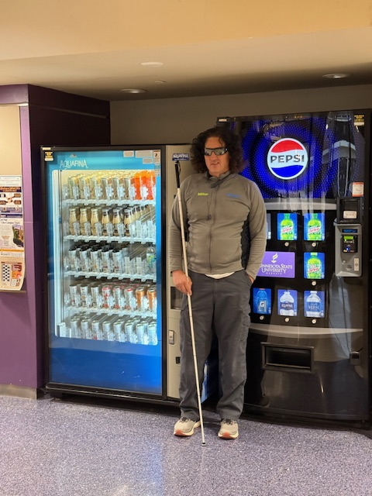“It is not in the stars to hold our destiny but in ourselves”* William Shakespeare. I love this quote. I think about it all the time; it is my compass. I am Mike Colbrunn, a husband, friend, father, grandfather, small business owner, entrepreneur, learner, dreamer, and blind person. All which individually I am very proud to be, but collectively, they make me complete.

To do this exercise, I am focusing on my career as a blind entrepreneur. But first, there is a little background. I was diagnosed with a rare form of macular degeneration at the young age of nine. I remember being very scared but not hopeless. I told myself right then and there that only I would determine my future! Fast forward to today, I am the proud owner of Big Snack Vending, located in Mankato, MN. Big Snack provides vending, convenience, and food service to over 20,000 individuals daily at eleven locations across Minnesota and includes State Universities, community colleges, prisons, USPS, FAA, and Full Food Service Dining at Camp Ripley. I operate these locations as a Licensed Blind Vendor - under the Randolph-Sheppard Act – as a participant in the Business Enterprise Program of Minnesota.

Although I am very hands-on and service machines, place and receive orders, and manage inventory, I am also the executive. In this role, I oversee project management, contract acquisition, administration, and managing people. Like most of you reading this, I use many assistive technologies. Since I am low vision, I utilize CCTVs and magnification software. Additionally, I love my Patriot Viewpoint and recently started using Ray Ban Meta glasses. All these products are critical in my day-to-day, but my iPhone is still my go-to. I can’t imagine a day without voiceover… Hahaha.

I love quotes, so here’s another: *“Start where you are. Use what you have. Do what you can.” by* Arthur Ashe. Going through Junior High and High School was very difficult. I didn’t have assistive technology; there wasn’t a lot of it, and it certainly wasn’t available to me. But what I did have was confidence in myself and a deep understanding that I wasn’t broken and needed to be fixed. I also believe you must pursue things you are interested in; I have always been creative, whether it be drawing, painting, writing, or physical activity. I believe you must continue to challenge yourself, and always set goals, even if they seem unrealistic. Stay busy and become an expert at something, anything; just be passionate about something.

I started with a quote; I will end with one “*Go confidently in the direction of your dreams. Live the life you have imagined.” –* Henry David Thoreau.

# Building BRIDGEs

Picture of a well-built and stylish bridge.
As students navigate the world of high school and begin thinking about the future, we offer services and resources that provide a foundation for success. Each of the core areas of our **BRIDGE** framework highlights an essential component that teenagers need in order to succeed after high school:

* **B**asic Skills
* **R**ole Models
* **I**nitiative
* **D**iscovery
* **G**oal Setting
* **E**xperiences

## Scholarships

Check out a list of scholarships for the 2025-2026 academic year on our website: <https://mn.gov/deed/ssb/teens/job-life-skills.jsp>.

## Vision Loss Disclosure

When should vision loss be disclosed to an employer? Every situation is different, and here are three resources that can help you decide this question:

* American Printing House: [Disclosing Blindness/ Low Vision](https://aphconnectcenter.org/careerconnect/job-seekers/conducting-a-successful-job-search/disclosing-a-visual-impairment/)
* Job Accommodation Network: [Disability Disclosure](https://askjan.org/topics/Disability-Disclosure.cfm)
* National Research and Training Center on Blindness and Low Vision: [Who Needs to Know?: When and How to Disclose Vision Impairment](https://www.blind.msstate.edu/sites/www.blind.msstate.edu/files/2022-03/Who%20Needs%20to%20Know%20-%20Disclosing%20Your%20Vision%20Impairment.pdf)

## Media and Public Opportunities

* [Lighthouse Guild Tele-Support for Teens](https://lighthouseguild.org/support-services/telesupport-groups/for-teens/): “You may feel like your vision loss or blindness will make your adjustment to an independent life difficult. But teenagers nationwide have successfully undergone that same adjustment, and we can help you connect with them. You will have the opportunity to talk about common social, emotional, academic, and practical concerns related to having vision loss.”
* APH created a list of podcasts that feature employment stories, career development tips, and insights into how blind and low vision individuals succeed in the workplace and life. Check it out at [Recommended Podcasts and Websites](https://aphconnectcenter.org/careerconnect/personal-employment-stories/recommended-podcasts-and-websites/).
* [Inspiring Stories of People Thriving With Vision Loss](https://ophthalmicedge.org/patient/inspiring-stories-of-people-thriving-with-vision-loss/)
* [Sports Teams Adopt Tactile Tech for Blind and Low-Vision Fans](https://www.msn.com/en-us/sports/basketball/sports-teams-adopt-tactile-tech-for-blind-and-low-vision-fans/ar-AA1CPCG4)

# MSAB in Sicily!

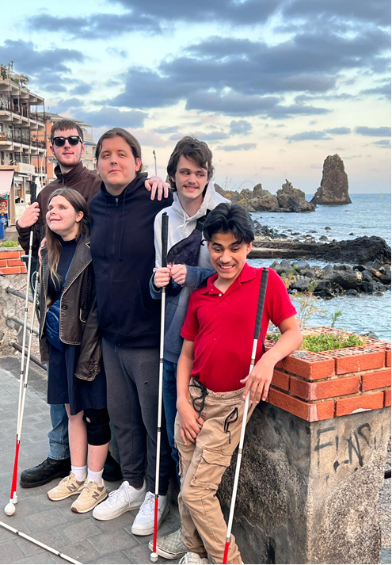In March, five students and two co-sponsors from the International Studies Club at the Minnesota State Academy for the Blind (MSAB) embarked on a once-in-a-lifetime trip to Sicily. Every other year, students in the club fundraise to cover their expenses for an international trip. The MSAB International Studies Club aims to help students:

* Develop self-awareness and independence
* Expand perspectives through global learning
* Explore educational aspects (geography, language, history) of new cultures
* Gain hands-on, sensory experiences by immersing in new cultures

Their journey was led by a guide from Seable, a London-based agency that provides accessible travel experiences for people with vision loss. Highlights of the trip included a boat tour exploring the island’s volcanic history, swimming and snorkeling in the Mediterranean, and hiking on Mt. Etna. Students also enjoyed horseback riding, interacting with farm animals, and visiting a tactile museum featuring 3D models of iconic landmarks.

They toured a lava rock castle and sampled local cuisine such as salmon pasta, pizza, and other traditional Sicilian dishes. The group also explored bustling markets and winding city streets. The journey was enriching, adventurous, and filled with cultural discoveries. Feel free to check out [MSAB’s Facebook](https://www.facebook.com/p/Minnesota-State-Academy-for-the-Blind-100054803720539/) page to learn more about their trip! And if you’re interested in a sighted guide vacation, check out [Seable Holidays](https://seable.co.uk/) and their guided vacations for people who are blind or have low vision.

## Ideas?

We are always looking for ideas you’d like to see featured in this newsletter. Please email [shane.desantis@state.mn.us](mailto:shane.desantis@state.mn.us) with any suggestions or brainstorming. ☺