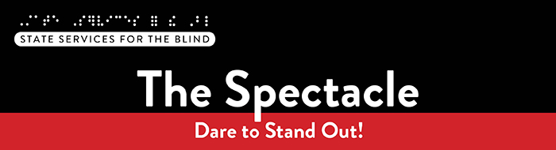

January 2026

What’s included this month?
- Invite: College Readiness Workshop on 1/13
- Save the Date: Penny Forward Career Climb Workshop April 17-19
- Casting opportunity: The Right Thing To Do

Just for Fun
Did you know Minnesota has more shoreline than California, Florida, and Hawaii combined—thanks to its 11,842 lakes and the mighty Mississippi! While California, Florida, and Hawaii combine for 12,915 miles of oceanfront, 54,515 miles of lakefront, and 101,488 miles of riverfront totaling 168,918 miles of shoreline, Minnesota boasts 138,400 miles of riverfront and 44,926 miles of lakefront totaling 183,326 miles of shoreline. That’s a lot of room for summer adventures.

A Note from SSB Counselors
We hope you had a fantastic end to 2025, celebrating the holidays and welcoming 2026! A new year often means a new semester—and with that comes an important reminder: please share updated grade reports with your counselor.
As part of our program, SSB asks students to provide grades twice a year. This helps us:
- Ensure you’re making progress toward earning a diploma or credential that supports your employment goals.
- Strengthen program funding.
- Highlight the incredible strides students like you are making toward academic and career success.
Please watch for our requests and help us meet program standards. Your achievements inspire us and pave the way for a brighter future!!

Winter and Spring Opportunities
College Readiness Workshop – Mastering Time Management
Whether you’re preparing for college or already enrolled, mastering time management is essential for academic and personal success. This workshop will help you develop practical skills, connect with peers, and set yourself up for success.
When: Tuesday, January 13, 2026 | 6:00–8:00 PM
Where:
- In-Person: State Services for the Blind, 2200 University Ave W #240, Saint Paul, MN 55114
- OR Virtual: Click here to join the meeting virtually
Penny Forward: Career Climb Workshop: April 17-19
This April, Penny Forward and SSB are partnering to offer Career Climb, a high-impact, in-person weekend workshop for blind, low vision, and DeafBlind students.
Career Climb is designed for students who want to strengthen their leadership confidence, build practical career tools, and gain clarity about their next steps. Over three immersive days, participants explore their strengths, practice professional communication, develop resumes and LinkedIn profiles, build financial decision-making skills, and connect with peers and mentors who understand their journey.
Students leave Career Climb with confidence, concrete tools, and a personalized 90-day action plan for career and financial success.
Please see the Career Climb Flyer for full details and contact your counselor to reserve your spot today!
Save the Date: Tools for School, May 15th
Join SSB and college staff to discuss tools needed for success in higher education. This name will be packed with instruction on assistive technology and its use to support success in the classroom and beyond. Be on the lookout for further information this winter and spring!

Resources and Activities

Audition for The Right Thing To Do: The Joe Mauer Story
Stages Theatre Company is in search of male youth actors (ages 10-18) who are blind or low vision to audition for our upcoming world premiere musical, The Right Thing To Do: The Joe Mauer Story.
The show features a lead character who is blind and is based on a real person, Mike Halley.
Auditions will be held the first week of February (2nd and 3rd) at the Hopkins Center of the Arts, with callbacks on February 4th. Audition tips and FAQs can be found at audition page. Rehearsals will take place in March with performances running from April to May.
No formal acting experience is required, though comfort with singing is a plus! Female students can audition. If cast as Mike, they will play it as a male character since the person it is based on is still alive, and this role will honor his story and experience.

EMPOWER VI
The goal of EMPOWER VI is to equip transition-aged students with visual impairments living in rural communities, their families, and the transition professionals who serve them with the virtual supports to improve postsecondary education and employment outcomes. These virtual programs create opportunities for connection and support, especially for those in rural areas who may not have access to in-person resources.

SSB Communication Center
The Communication Center is here to put your books into accessible formats that work for you. Custom audio, e-text, DAISY markup, and Braille – we can do it! The Communication Center is Minnesota’s Accessible Reading Source – we’re here for you. Email us at ssb.audioservices@state.mn.us

Scholarships and FAFSA Information
Check out a list of scholarships at SSB List of Scholarships. Scholarships for the 2026-2027 academic year are being created and will be updated soon. The 2026-2027 FAFSA is now available and can be completed at the FAFSA Application. If you need help completing the application, don't hesitate to get in touch with your SSB counselor for assistance.

PACER
PACER Center “enhances the quality of life and expands opportunities for children, youth, and young adults with all disabilities and their families so each person can reach their highest potential. PACER operates on the principles of parents helping parents, supporting families, promoting a safe environment for all children, and working in collaboration with others.”

Disability Hub MN
“Disability Hub MN is a free resource network that helps you solve problems, navigate the system, and plan for your future. We support you in creating your best life.” This website offers resources on disability benefits via the DB101 website and many employment resources for individuals with disabilities. Visit the Disability Hub website for more information. They have a chat feature and a call-in number for questions or specific resources.
Youth in Transition Toolkit – This toolkit will introduce you to Minnesota's youth in transition framework. Explore tools and resources you can use with the youth you support to plan for their best lives.

APH
APH CareerConnect is “an employment information resource offered by the American Printing House for the Blind for job seekers who are blind or visually impaired. CareerConnect provides employment information, career exploration tools, and job-seeking guidance for individuals with vision loss and the professionals who work with them.” Visit their website at aphcareerconnect.com to learn more. Check out their new Getting Started Guides, featuring guides for families from birth to 3rd grade and 4th to 12th. Archived APH webinars are available on the APH ConnectCenter YouTube page.

Minnesota Association of Blind Students (MNABS)
My name is Ben Zheng, and I’m the current president of the Minnesota Association of Blind Students (MNABS), a proud division of the National Federation of the Blind of Minnesota. MNABS is comprised of blind students from all walks of life—traditional, non-traditional, and everything in between. At our core, we’re more than just a division; we’re a community of friends supporting one another through the shared experiences of blind student life and beyond.
Whether you’re navigating academics, looking for professional development opportunities, or just seeking connection with others who “get it,” we’re here for you. Throughout the year, we host a variety of events—some social, such as our hot chocolate and white elephant holiday gathering, and others more focused on building confidence and advancing careers.
They also maintain a treasury that helps fund student participation in enrichment opportunities, including the Midwest Student Seminar, the NFB National Convention, and the NFB of Minnesota’s State Convention!
👉Join our MNABS WhatsApp Community — come see what MNABS is all about, and how much stronger we are when we support each other. And if you’d like to learn more, have questions, or just want to say hello, feel free to reach out to me at any time at students@nfbmn.org.

Blind Abilities Podcasts
Visit Blind Abilities online at www.BlindAbilities.com. Here are some of the people and topics featured on Blind Abilities recently:
- Tune in to hear from SSB’s O&M specialists: Orientation and Mobility: Building Confident Independence for Blind and Low Vision Students.
- Hear from two college students about college readiness: College 101: Student-Powered Advice to Help You Thrive in College.
- Listen and learn about BEP: Owning Your Future with State Services for the Blind: Inside the Business Enterprise Program.
- Two Paths, One Team: Meet the Peer Ambassadors of State Services for the Blind: Introducing Ava & Introducing Preston.
If you know a student who would like to share their achievements, Blind Abilities would love to feature their perspectives. Leave a message at 612-367-6093.

Website Updates
Check out SSB’s Youth Services website to learn about upcoming events, access archived newsletters, read transition flyers, watch student videos, and more!

Tech Tidbits
Here’s a reminder of some useful apps and tools that may be helpful for both high school and college:
Bookshare is an accessible reading service that has many digital textbooks and other reading materials, and SSB highly recommends that students have access to this service www.bookshare.org
Desmos is a widely used calculator for schools, and free graphing and scientific calculator apps are available on the Google Play Store and the Apple App Store. Students can also use Desmos on their computers from the Desmos website: www.desmos.com
Windows Calculator is a reliable, free calculator built into Windows, offering several modes, including scientific and graphing. Just type "calculator" into the Start Menu search box to find it easily.

Fast Forward: Potential and Possibilities – Allison O’Day
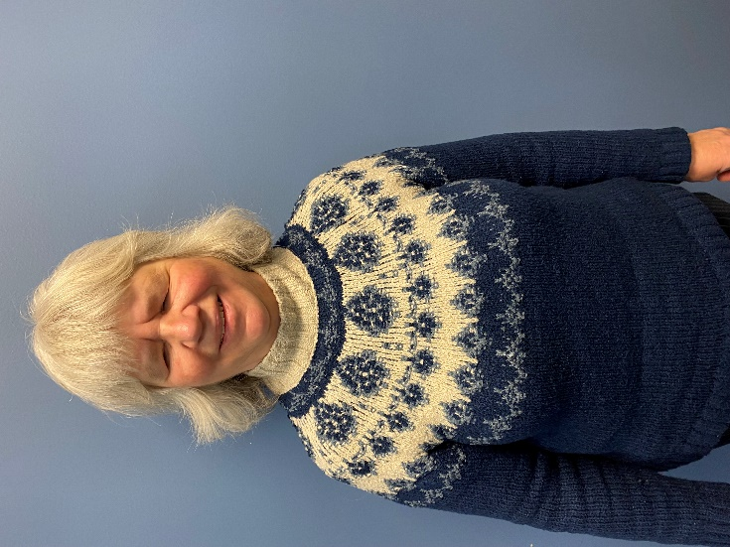
My name is Allison, I am 64 years old, and I have had limited vision all of my life.
I started grade school in Minneapolis in the 1960s when mainstreaming of students with vision loss was becoming the norm. I attended Minneapolis Public Schools and was fortunate to have some wonderful regular education classroom teachers and teachers of the blind and visually impaired. Most of these teachers were not willing to let my blindness be an excuse for not doing well in school. My parents also insisted that we (my sister has the same vision loss issue as me) participate in family outings and household tasks.
I attended Augsburg University, where I received a bachelor’s degree in math and chemistry. I received my degree before computers and iPhones were commonplace tools, and I often wonder how much easier and fulfilling my college education would have been if I had had these tools!
I started to work for State Services for the Blind while I was in school. I was asked, given my aptitude for reading braille, and especially the Nemeth braille code used to transcribe math and science, if I would be interested in being a proofreader. I took the required coursework from the Library of Congress and received my certification as a braille proofreader in 1988.
Fast forward to today, and I am still working in the Braille Section at State Services for the Blind. I proofread the majority of math and science textbooks transcribed for braille reading students in Minnesota, a job I still enjoy after 40+ years!
I have been married for almost 40 years and have two adult children and a grandson. When not working, I enjoy reading and cooking, and am a big fan of Wild hockey.
Some of my words of advice are this: 1. Don’t isolate yourself. Make friendships with sighted and non-sighted peers and participate in activities. 2. Use and stay current with the technology that is available. 3. Advocate for yourself. There will be many times in your life that you will need to do things differently from those around you, and you need to let those in charge know that. 4. Become a proficient reader. My opinion is that those who are good readers and writers enjoy greater success in their personal and working lives.

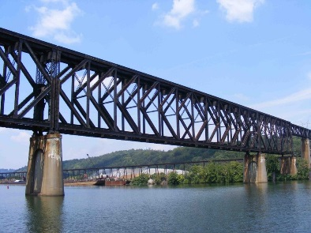
Building BRIDGEs
As students navigate the world of high school and begin thinking about the future, we offer services and resources that provide a foundation for success. Each of the core areas of our BRIDGE framework highlights an essential component that teenagers need in order to succeed after high school:

- Basic Skills
- Role Models
- Initiative
- Discovery
- Goal Setting
- Experiences

Vision Loss Disclosure
When should vision loss be disclosed to an employer? Every situation is different, and here are three resources that can help you decide this question:
- American Printing House: Disclosing Blindness/ Low Vision
- Job Accommodation Network: Disability Disclosure
- National Research and Training Center on Blindness and Low Vision: Who Needs to Know?: When and How to Disclose Vision Impairment

Media and Public Opportunities
- Lighthouse Guild Tele-Support for Teens: Connect with other teens from across the country! Telephone support groups for high school students who are blind or have low vision are available every other Monday.
- BlindNewWorld, powered by Perkins School for the Blind, is a first-of-its-kind social change campaign that empowers the blind and visually impaired community while demystifying blindness and breaking down barriers to inclusion in school, work, and the world at large. BlindNewWorld is a place for exchanging experiences, promoting advocacy, demanding accessibility, and fostering inclusion
- Blind Information Technology Specialists (BITS) mission is to empower blind and visually impaired individuals by providing a supportive and inclusive environment for technological growth and development.
- “The Key to Independence: 8 Life Skills for Teens” summarizes the skills teens need to live independently. This Positive Action website offers suggestions for teachers and parents to help students develop essential independent living skills.

Ideas?
We are always looking for ideas you’d like to see featured in this newsletter. Please email shane.desantis@state.mn.us with any suggestions or brainstorming. J

