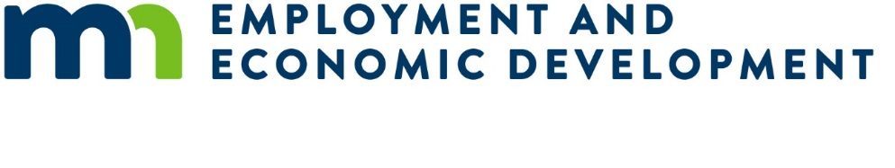
Addendum 1 – Extension for Submissions Regarding the Request for Proposal for Minnesota Small Business Development Centers for the Department of Employment and Economic Development (DEED)
This addendum containing the following revisions, additions, deletions, or clarifications is hereby made part of the Solicitation, including the Sample Contract and Exhibits if applicable.
Note: The RFP posted on August 21, 2025, was amended on October 9, 2025.
The RFP proposal end date is being extended from 4:30 p.m., Central Time, Monday, October 13, 2025, to 4:30 p.m., Central Time, Friday, October 17, 2025.
Listed below are the dates from section “3.2 Timeline” in the Request for Proposal that changed due to this extension.

3.2 Timeline
RFP posted on the DEED web site: Thursday August 21, 2025
Questions due no later than 4:30 pm Central Time: Wednesday September 10, 2025
LETTER OF INTENT (exhibit A) due no later than 4:30 pm Central Time: Wednesday September 10, 2025
Applications due no later than 4:30 pm Central Time: Monday October 13, 2025 Friday October 17, 2025
Committee begins review of applications: Tuesday October 14, 2025 Monday October 20, 2025
Selected applicants undergo pre-award risk assessment: Monday October 20, 2025 Monday October 27, 2025
Selected grantees announced; grant contract agreement negotiations begin: Friday October 31, 2025 Friday November 7, 2025
Work plans approved and grant begins: January 1, 2026

