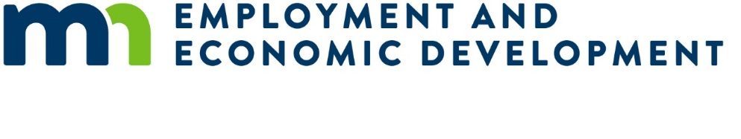

Small Cities Development Program (SCDP) 2026 Preliminary Proposal

Single-Family Rental Housing Rehabilitation Proposal

Submission Deadline
Applicants must submit one original and one copy of the Preliminary Proposal to the Department of Employment and Economic Development (DEED) on or before 4:00 pm, Wednesday, November 26, 2025.
Faxed or emailed applications will not be accepted.

Instructions
Applicants must review the Small Cities Development Program (SCDP) Application Guide from the SCDP Website (https://mn.gov/deed/government/financial-assistance/community-funding/small-cities.jsp).
This preliminary proposal is only for a “Single-Family Rental Rehabilitation Proposal”. Other types of rental housing or any other preliminary proposals are located on the SCDP Website.
Rehabilitation of renter occupied residential structures that are completely or primarily occupied by low-and-moderate income households will need to meet affordable rents during the life of the loan. Affordable rents should be clearly identified and appropriate to the community and persons served and shall not exceed HUD’s Section 8 Fair Market Rents.
Remove the brackets and the text inside them before entering your response.
- Property owners must enter into agreements for occupancy and rents before rehabilitation begins. Minimum rehabilitation standards to be applied are HUD’s Section 8 Housing Quality Standards (HQS).
- The maximum amount of SCDP assistance for a single-family rental is $25,000 per unit.
- The maximum percentage of SCDP assistance per single-family rental is 70% of the total project cost.
- The term for SCDP funds must be structured, at a minimum, as a five (5) year deferred loan (no yearly forgiveness).
- Target area must be citywide, regardless of population – no Plan B contingency areas.
- Single family residential rental units must be occupied by low-and-moderate (LMI) income households (80% of the county median income) and HUD rent restrictions must be met.
- Federal Davis-Bacon Act applies to buildings with eight (8) or more single-family rentals under one site.

Single-family rental – scattered site, stick built, and/or double-wide manufactured homes on a foundation
Applicant Name: [Enter response]

Project Description
Provide a brief description of the activity:

[Enter response]

Community Questions
Multi-community applications must include responses for all proposed communities.
Primary community: [Enter response]
- Population of primary community: [Enter response]
- Partnering community #2 (if applicable): [Enter response]
- Population of partnering community #2 (if applicable): [Enter response]
- Partnering community #3 (if applicable): [Enter response]
- Population of partnering community #3 (if applicable): [Enter response]

Need
- Number of rental single-family homes in the community: [Enter response]
- Number of dilapidated single-family rental houses that are not suitable for rehabilitation: [Enter response]
- Number of substandard, and suitable for rehabilitation, single-family rental houses: [Enter response]
- Number of property owners interested in the proposed program: [Enter response]
- Number of single-family rental houses owned by these interested property owners: [Enter response]
- Of these houses, number of single-family rental houses where property owners are interested in participating in the rehabilitation program: [Enter response]

Provide a brief description of the project need. At minimum, describe:
- Unique designations.
- Geographic or demographic concerns.
- Inadequate supply of existing housing stock, including lack of new housing stock, etc.
- Any previous grants, and how this grant could build on those results.
Narrative answer for project need: [Enter response]

Impact
- Number of single-family rental houses proposed for rehabilitation: [Enter response]
- Rental vacancy rate of city: [Enter response]
- If the rental vacancy rate is greater than 10%, provide narrative on what factors will improve the rental market: [Enter response]
Provide a brief description of the project impact. At a minimum, describe:
- The proposed target area expected impact on the community or communities,
- How did you determine the proposed number of homes to be served (unit goal),
- List the deficiencies identified,
- Any other projects of economic or community development, not associated with SCDP, that the community plans to undertake that could impact this project,
- What is the applicant’s plan to reach underserved groups in the community?
Narrative answer for project impact: [Enter response]

Cost Effectiveness
- Maximum SCDP assistance amount per single-family rental (cannot exceed $25,000): [Enter response]
- Percentage of SCDP assistance per single-family rental (cannot exceed 70%): [Enter response]
- SCDP average costs per single-family rental: [Enter response]
- Percentage of single-family rental SCDP assistance that is a deferred/forgivable loan: [Enter response]
- Term of deferred/forgivable loan (minimum 60 months): [Enter response]
- If the proposed financing will also include an SCDP funded installment loan, complete the following:
  - What percentage of the SCDP funds will be an installment (where regular payments are required) loan? [Enter response]
  - What is the length of the installment loan? [Enter response]
  - What is the interest rate of the installment loan? [Enter response]
Briefly describe the cost effectiveness of the project. At a minimum, describe:
- How the proposed program will encourage rental owner participation,
- Experience of the administrator in implementing SCDP or similar grants and staff capacity.
Description of cost effectiveness: [Enter response]

