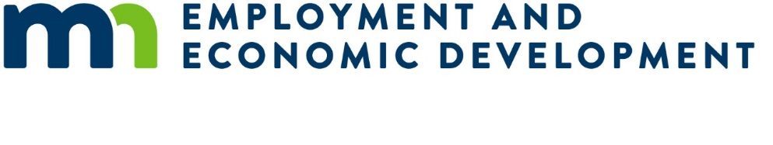

Small Cities Development Program (SCDP) 2026 Preliminary Proposal

Community Center Proposal

Submission Deadline
Applicants must submit one original and one copy of the Preliminary Proposal to the Department of Employment and Economic Development (DEED) on or before 4:00 pm, Wednesday, November 26, 2025.
Faxed or emailed applications will not be accepted.

Instructions
Applicants must review the Small Cities Development Program (SCDP) Application Guide from the SCDP Website (https://mn.gov/deed/government/financial-assistance/community-funding/small-cities.jsp).
This preliminary proposal is only for a Community Center Public Facility Proposal. Other eligible activity preliminary proposals are available on the SCDP Website.
Remove the brackets and the text inside them before entering your response.

Overall Guidance
- This activity is very broad and covers rehabilitation of senior centers, centers that serve the handicapped, youth centers, and other neighborhood facilities.
- Funds are used to rehabilitate deteriorated/deteriorating or address outdated buildings that pose a threat or hazard to the health and safety of residents.
- Community center projects are considered public facility projects - $600,000 is the maximum request for one community.
- The community center must be supported by the community through a resolution or council vote to proceed.
- Community centers are not eligible for grant funds if they hold Primary or General Elections. If a community center receives SCDP funding, it cannot be used for Primary or General Elections in perpetuity.
- Community center must benefit the entire community.
- Renderings and or floor plans must be attached.
- Include a map of community and of community center (photos recommended).
- The national objective that must be met for community centers is benefit low-and-moderate income (LMI) households on an area basis (LMA).
  - The LMA national objective can be met through the U.S. Census data or Community Income Survey.
    - The U.S. Census determination can only be used for a project when the benefit area is citywide and census data shows 51% or more of the people in the community are LMI.
    - A Community Income Survey must be conducted if city’s LMI is not at least 51%, LMI is over 51% but is not a city-wide project, or LMI is over 51% and residents outside of the city limits will benefit from the project. The Community Income Survey must show the project area is at least 51% LMI.
      - A sample community income survey form is available on the SCDP website – (Apply tab – SCDP Survey Results Spreadsheet – Example).

Community Center Preliminary Proposal
Applicant Name: [Enter response]

Project Description
Provide a brief description of the activity:

[Enter response]
Multi-community applications must include responses for all proposed communities.
- Primary community: [Enter response]
- Population of primary community: [Enter response]
- Partnering community #2 (if applicable): [Enter response]
- Population of partnering community #2 (if applicable): [Enter response]
- Partnering community #3 (if applicable): [Enter response]
- Population of partnering community #3 (if applicable): [Enter response]
If SCDP is the only source of funding, describe why other funds are not available to assist with the funding:
[Enter response]

How is the proposed community center cost effective, include description of other sources of funding?
[Enter response]

Community questions
Applicant/City: [Enter response]
Population of city: [Enter response]

Need
Was the national objective met through U.S. Census data or a community survey?
[Enter response – U.S Census Data or Community Income Survey (attach relevant documentation)]

Number of LMI residents in benefit area: [Enter response]

Identify the LMI percentage from the U.S. Census: [Enter response]

According to the U.S. Census, is the LMI for the community at least 51%:
[Enter response – Yes/No]

If census data shows that the LMI is below 51% and a Community Income Survey was conducted, was the LMI for the community at least 51%?
[Enter response – Yes/No]

Identify percentage LMI per survey: [Enter response]
Attach copies of the surveys and provide spreadsheet tabulation. (Apply Tab/SCDP Survey Results Spreadsheet – Example)

If there was a Community Income Survey, describe how and when the surveys were conducted (door to door, mailed forms, online or other methods):
[Enter response]
Provide the U.S. Census county and tract code (http://www.ffiec.gov/Geocode/default.aspx) of the proposed project.
- U.S. Census 3-digit county code: [Enter response]
- Tract code (XXXX.XX): [Enter response]
Does the community have an existing center/facility?
[Enter response – Yes/No]
Will the center/facility exclusively serve the applicant?
[Enter response – Yes/No]
What is the age of the current community center?
[Enter response]
What is the current condition of the community center?
[Enter response]
Will the activity involve rehabilitation of a present center/facility?
[Enter response – Yes/No]
Will the activity involve converting an existing building or space into a center/facility?
[Enter response – Yes/No]

Community Impact
Who are and/or will be the users of center/facility?
[Enter response]
What is the applicant’s plan to reach underserved groups in the community?
[Enter response]
What is the square footage of proposed community space to be utilized?
[Enter response]
What community activities will be available at the community center?

[Enter response]

Cost Effectiveness
Have cost estimates considered Davis-Bacon wage rates and Build America, Buy American implementation costs?
[Enter response – Yes/No]
How will all operating and maintenance costs of the facility be covered?

[Enter response]
Will there be user fees or membership fees?
[Enter response – Yes/No]
If user fees will be implemented, describe the costs and conditions.

[Enter response]

