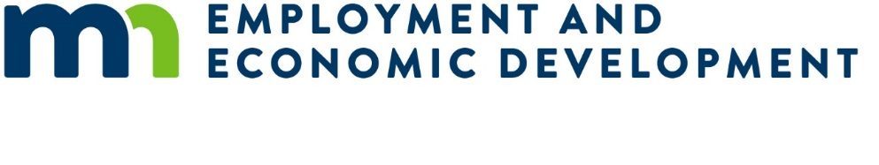

Small Cities Development Program (SCDP) 2026 Preliminary Proposal

Multi-Family Rental Housing Rehabilitation Proposal – Freestanding

Submission Deadline
Applicants must submit one original and one copy of the Preliminary Proposal to the Department of Employment and Economic Development (DEED) on or before 4:00 pm, Wednesday, November 26, 2025.
Faxed or emailed applications will not be accepted.

Instructions
Applicants must review the Small Cities Development Program (SCDP) Application Guide from the SCDP Website (https://mn.gov/deed/government/financial-assistance/community-funding/small-cities.jsp).
This preliminary proposal is only for a Multi-Family Rental Rehabilitation Proposals for free standing structures on scattered sites. Other types of rental housing or any other preliminary proposals are located on the SCDP Website.
Rehabilitation of renter occupied residential structures that are completely or primarily occupied by low-and-moderate income households will need to meet affordable rents during the life of the loan. Affordable rents should be clearly identified and appropriate to the community and persons served and shall not exceed HUD’s Section 8 Fair Market Rents.
Remove the brackets and the text inside them before entering your response.
- Property owners must enter into agreements for occupancy and rents before rehabilitation begins. Minimum rehabilitation standards to be applied are HUD’s Section 8 Housing Quality Standards (HQS).
- The maximum amount of SCDP assistance for multi-family rental is $12,500 per unit.
- The maximum percentage of SCDP assistance per building is 70% of the total project cost.
- The term for SCDP funds must be structured, at a minimum, as a five (5) year deferred loan (no loan forgiveness for 5 years).
- Target area must be citywide, regardless of population – no Plan B contingency areas.
- National objective of at least 51% of the units must be occupied by low-and-moderate (LMI) income households (80% of the county median income) and HUD rent restrictions must be met.
- Federal Davis-Bacon Act applies to buildings with eight (8) or more units.

Multi-family rental – free standing structures on scattered sites
Applicant Name: [Enter response]

Project Description
Provide a brief description of the activity:

[Enter response]

Community Questions
Multi-community applications must include responses for all proposed communities.
- Primary community: [Enter response]
- Population of primary community: [Enter response]
- Partnering community #2 (if applicable): [Enter response]
- Population of partnering community #2 (if applicable): [Enter response]
- Partnering community #3 (if applicable): [Enter response]
- Population of partnering community #3 (if applicable): [Enter response]

Need
- Total number of multi-family buildings in the city: [Enter response]
- Number of multi-family buildings that are in standard condition: [Enter response]
- Number of dilapidated multi-family buildings that are not suitable for rehabilitation: [Enter response]
- Number of substandard, but suitable for rehabilitation multi-family buildings in the city: [Enter response]
- Number of property owners that are interested in the program: [Enter response]
- Number of multi-family buildings owned by these interested property owners: [Enter response]
- Number of buildings with common areas that are ADA compliant, interested property owners only: [Enter response]
- Number of non-ADA compliant units of interested property owners: [Enter response]
Provide a brief description of the project need. At minimum, describe:
- Unique designations.
- Geographic or demographic concerns.
- Inadequate supply of existing housing stock, including lack of new housing stock, etc..
- Any previous grants, and how this grant could build on those results.
Narrative answer for project need: [Enter response]

Impact
- Number of multi-family rental buildings proposed for rehabilitation: [Enter response]
- Number of units in the multi-family building(s): [Enter response]
- Rental vacancy rate of the city: [Enter response]%
- If community vacancy rate is more than 10%, provide narrative to what factors will increase demand for rehabilitated rental units: [Enter response]
- How many of the properties are eight (8) or more units: [Enter response]
- How many of the properties are more than four (4) stories: [Enter response]
- For buildings with more than four (4) units, is substantial rehabilitation proposed as defined by 24 CFR 5.100?
[Enter response – Yes/No]
- For building with more than four (4) units with substantial rehabilitation proposed, is there justification to include installation of broadband infrastructure as defined by 24 CFR 570.202(g)?
[Enter response – Yes/No]

Provide a brief description of the project impact. At a minimum, describe:
- The proposed target area expected impact on the community or communities.
- How did you determine the proposed number of multi-family rental buildings to be served (unit goal).
- List the identified deficiencies.
- Any other projects of economic or community development, not associated with SCDP, that the community plans to undertake that could impact this project.
- What is the applicant’s plan to reach underserved groups in the community?
Narrative answer for project impact: [Enter response]

Cost Effectiveness
- Maximum SCDP assistance per unit (cannot exceed $12,500): [Enter response]
- Average SCDP cost per unit: [Enter response]
- Percentage of SCDP assistance per building (cannot exceed 70%): [Enter response]%
- Percentage of SCDP assistance as a deferred or forgivable loan: [Enter response]%
- Forgivable/deferred loan terms (minimum of 60 months from project completion): [Enter response]
- If the proposed financing will also include an SCDP funded installment loan, complete the following:
  - What percentage of the SCDP funds will be an installment (where regular payments are required) loan? [Enter response]
  - What is the length of the installment loan? [Enter response]
  - What is the interest rate of the installment loan? [Enter response]
Briefly describe the cost effectiveness of the project. At a minimum, describe:
- How the proposed program will encourage multi-family building owner participation.
- Experience of the administrator in implementing SCDP or similar grants and existing capacity.
Description of cost effectiveness: [Enter response]

