# Opposing Cuts to Developmental Disabilities Act Funding

Protecting the Promise

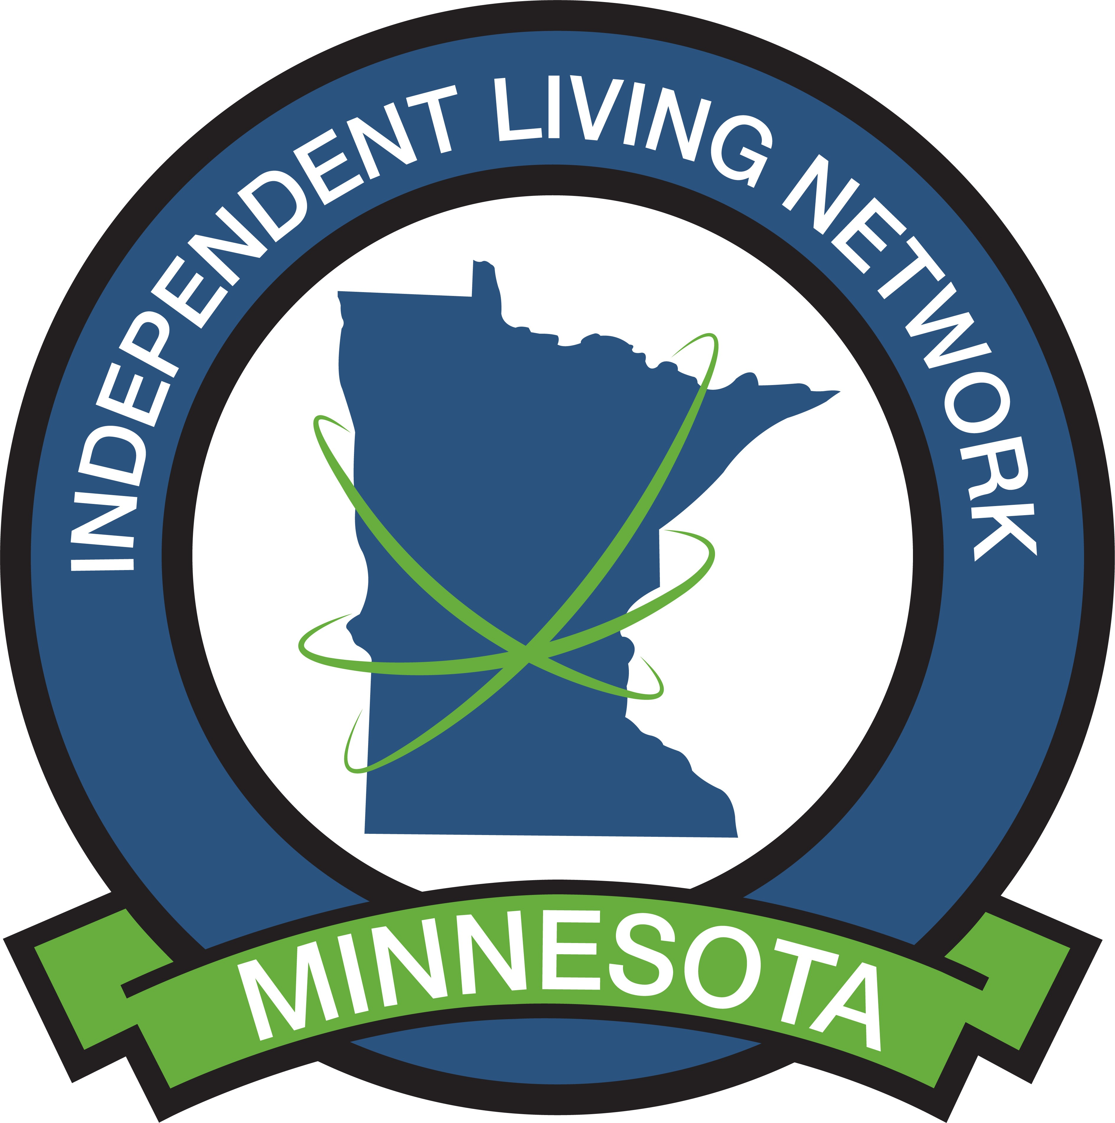

**Issue:** Proposed cuts to the Developmental Disabilities Assistance and Bill of Rights Act (DD Act) funding threatens essential services for thousands of individuals with disabilities in Minnesota and nationwide. The leaked budget memo from the U.S. Department of Health and Human Services includes a proposal to eliminate the Administration on Community Living and defund the national network of support established by the DD Act. This network comprises University Centers for Excellence in Developmental Disabilities (UCEDDs), Developmental Disabilities (DD) Councils, and Protection & Advocacy (P&A) systems. In Minnesota, these critical roles are fulfilled by the Institute on Community Integration (ICI), the Governor's Council on Developmental Disabilities, and the Minnesota Disability Law Center (MDLC), respectively.

**Background:** The DD Act, originally passed in 1970, was transformative in shifting our country away from institutionalization towards systems that prioritize community living, independence, and self-determination for people with disabilities. The P&A system, in particular, was created as a national promise after horrific conditions in state institutions came to light, ensuring abuses would "never again" go unreported and unchallenged. P&A organizations often possess unique legal authority to enter institutions unannounced to monitor conditions, preventing physical abuse, medical neglect, sexual assault, and preventable deaths. Without this vital access, people will die.

**Impact of Proposed Cuts in Minnesota:** The loss of DD Act funding would be devastating for Minnesota's disability community. The triad of programs serves thousands of persons with disabilities each year:

* **The Institute on Community Integration (ICI):** Conducts groundbreaking research, delivers statewide and national training, and translates knowledge into real-world improvements across education, healthcare, employment, and community living. ICI drives measurable outcomes that directly improve lives, from early autism diagnosis to developing inclusive education practices and supporting transition to adulthood.
* **The Governor's Council on Developmental Disabilities:** A powerful driver of inclusion, equity, and opportunity, providing training, education, and advocacy that empowers people with developmental disabilities and their families. The Council fulfills federal goals of capacity building and systems change.
* **The Minnesota Disability Law Center (MDLC):** Beyond its crucial Protection & Advocacy work, MDLC provides legal representation for over 1,000 people with disabilities annually and reaches many more through education and systems change efforts.

**Economic Inefficiency:** Economically, DD Act funding is a small, yet highly effective, investment. Supporting people to live and work in the community reduces costly institutional care, strengthens local economies, and prevents expensive crises. Dismantling this efficient, coordinated infrastructure would be wasteful and ineffective, forcing states to rebuild fragmented efforts that would ultimately cost more and deliver less.

**Recommendation:** MNSILC recommends protecting this vital legislation that ensures continued progress toward independence, inclusion, and the fundamental human rights of individuals with disabilities.

**Contact Information:**

Jo Erbes Coordinator | Minnesota Statewide Independent Living Center Phone: 612 518 1497 | [mnsilc1215@gmail.com](mailto:mnsilc1215@gmail.com)

**Resources:**

* Governor’s Council on Developmental Disabilities  
  https://mn.gov/mnddc/
* Institute on Community Integration

https://ici.umn.edu/

* Minnesota Disability Law Center

https://mylegalaid.org/disability-law-center/