# Employment matters. Pass it on.

Employment for All

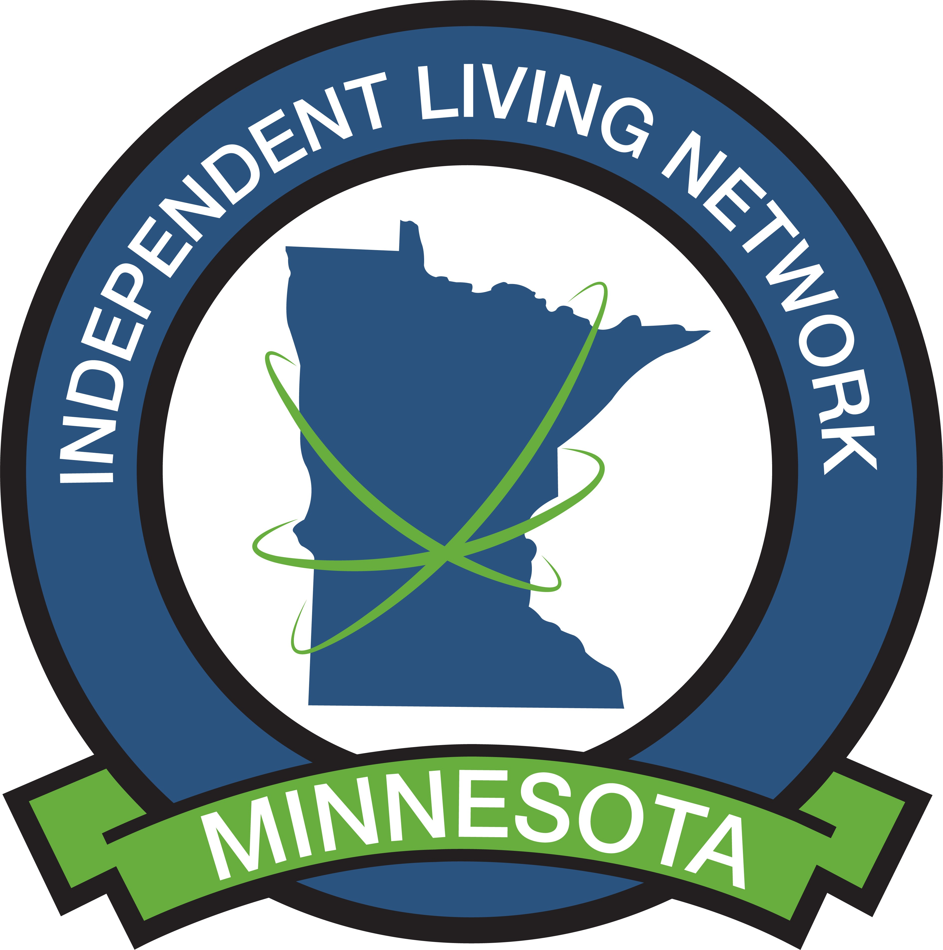

# Employment is about more than just a paycheck, it’s about dignity, inclusion, and opportunity. For people with disabilities, meaningful employment supports financial independence, reduces reliance on public benefits, and enhances physical and mental health. It builds self-confidence, supports community integration, and helps shift perceptions about the capabilities of disabled individuals.

When employment systems are equitable, everyone benefits businesses access an often-overlooked talent pool, and society reduces long-term costs through increased productivity and decreased demand for crisis services.

Inclusion is about removing as many barriers as possible, providing accommodation when needed, and creating a welcoming culture in the workplace for all. With some work and some creative solutions, we could: improve the quality of life for many, the size and skill of the talent pool and quite frankly the bottom line of businesses and the state.

**Barriers to Employment**

People with disabilities face systemic barriers to employment. These barriers compound and often result in high unemployment or underemployment rates in the disability community.

* **Lack of accessible transportation**, this can be limiting in flexibility, safety, reliability and affordability especially in rural and underserved areas. The impact is lack of flexible scheduling, limited career advancement and dependence on others for success
* **Inadequate accommodations** in hiring, onboarding, and workplace environments. Average accommodations are highly affordable and easily result in ROI in a short time. (1)
* **Discrimination and stigma** about disability, ability, and productivity. HBR states “Despite empirical evidence to the contrary, perceptions remain that disabled employees are less competent, less productive, require more supervision, and are more expensive and more dependent, which results in lower levels of both employment and promotion.” (2)
* **Benefit disincentives**, such as income thresholds that penalize work, loss of health benefits (or significant cost increase) and loss of supports
* **Limited access to inclusive education** or training pathways tailored to real-world opportunities. This ties strongly to accessibility, accommodation, cost and transportation.

**Systems and Strategies That Support Disability Employment**

* **Vocational Rehabilitation Services** (state agencies funded under the Rehabilitation Act) help prepare people for employment but may be under-resourced or difficult to access. (3)
* **Developmental Disabilities Councils** support systems change to remove barriers and increase inclusion (4)

# Disability Networks or Employee Resource Groups (ERGs): These groups provide a platform for employees with disabilities to connect, share experiences, and advocate for their needs.

# Customized Employment approaches match individual skills and interests to specific job tasks, often carving roles that wouldn’t otherwise exist (5)

# Inclusive hiring initiatives, like Microsoft’s Autism Hiring Program, demonstrate the benefits of proactively recruiting disabled talent. (6)

# Peer mentoring and supported employment programs increase retention and job satisfaction.

# Partnerships with transit providers, as seen in Minnesota’s Lyft pilot with Dakota County, reduced transportation barriers and increased access to work (7)

# Policy Recommendations

* Fully fund Vocational Rehabilitation and transition services.
* Enforce and expand ADA protections in hiring and advancement.
* Phase out subminimum wage nationally.
* Require states to braid funding across systems (VR, education, Medicaid, workforce boards).
* Incentivize creative solutions like microenterprise and self-employment models.
* Invest in affordable and accessible transportation as an employment tool.
* Reform benefits planning tools so work doesn’t mean risk of losing supports.

Now is the time to embrace the incredible diversity, skill sets and talent of our full population.

**Contact Information:**

Jo Erbes Coordinator | Minnesota Statewide Independent Living Center Phone: 612 518 1497 | [mnsilc1215@gmail.com](mailto:mnsilc1215@gmail.com)

**References:**

1. **MN Council on Disability:** https://www.disability.state.mn.us/technical-assistance/employment/employment-fact-sheet/
2. **Harvard Business Review:** https://hbr.org/2024/11/research-the-stigma-disabled-people-face-during-negotiations
3. [**MN Department of Employment and Economic Development:**](https://www.duluthnewstribune.com/news/minnesota/we-cant-take-it-anymore-vulnerable-minnesotans-left-without-options-after-companies-drop-medicaid-rides)  https://mn.gov/deed/job-seekers/disabilities/
4. **Governor’s Council on Developmental Disabilities:** https://mn.gov/mnddc/
5. **MN DEED:** https://mn.gov/deed/job-seekers/disabilities/partners/guide/contracted-services/services/customized/
6. **Microsoft:** https://www.microsoftalumni.com/s/1769/19/interior.aspx?gid=2&pgid=1119&sid=1769
7. **goMarti:** www.goMARTI.com