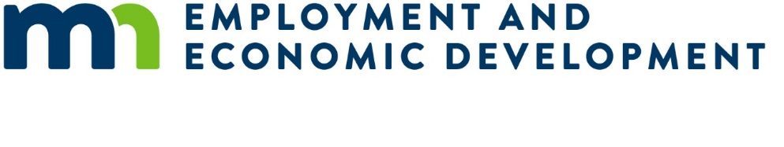

Questions and Answers Regarding the Advancing the Future MedTech Workforce Request for Proposals (RFP)

Question: The budget forms linked in the RFP does not appear right.
Answer: The budget forms linked in the RFP are not correct. While we are unable to immediately correct the link in the RFP due to accessibility issues, we have provided the correct link under the RFP announcement posted at https://mn.gov/deed/about/contracts/open-rfp.jsp. The correct budget forms are in an Excel format rather than a PDF.

Question: We will be working with another training organization that is not an accredited educational institution. Should that organization’s participation be described under Section 1.B. Other Educational Partners, or under Section 10. Linkages?
Answer: Section 1.B. is intended to describe partnerships with other schools and/or institutions of higher education whose primary purpose is to provide formal instruction and learning experiences. Other organizations that provide training, but don’t necessarily meet the definition of an educational institution should be included in Section 10. Linkages. Linkage organizations also typically include organizations that are involved in activities such as outreach and recruitment of trainees, counseling and the provision of supportive services for trainees, and coordination of job development and job placement activities. Ultimately, the most important thing is that your grant application includes information on other partnering organizations and their role in the project; which section the information is provided under won’t have an impact on the scoring of the application.

Question: Can you provide more information on Appendix D. Letters of Support?
Answer: Letters of Support may be included in your grant application but are not required. While Letters of Support do not factor into the scoring of grant applications, they could potentially make a difference if multiple grant applications score very closely.

