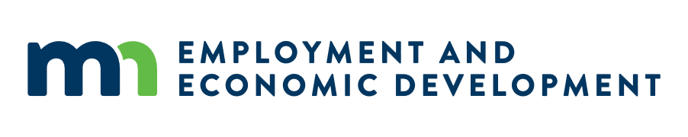
Emerging Entrepreneur Loan Program
Request for Proposals
Frequently Asked Questions
Updated May 12, 2026
- What is a SWIFT supplier ID on the application?

The SWIFT supplier ID is your organization’s official registration record in Minnesota’s system, allowing access to payment and invoice information through the Supplier Portal known as the StateWide Integrated Financial Tools (SWIFT). Anyone who does business with Minnesota is considered a vendor and must have a SWIFT supplier ID as payments are sent via the account information registered through this system.

- Is this program for an existing or starting organization?

The organization may submit an application provided that all eligibility requirements outlined in the Request for Proposal are met. There are no provisions that prohibit a new organization from applying.

