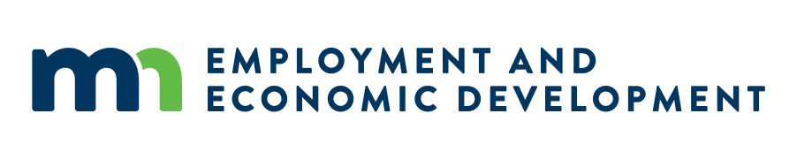

July 8, Broadband Development Training Series: Navigating PLUS (Permitting, Land Use, and State Systems)

U.S. Army Corps of Engineers Regulatory Program Introduction for Broadband Infrastructure
- Wednesday July 8, 11 a.m. – 12 p.m. CT
- No registration required! See the Teams meeting link to join July 8 at 11am CT below
This presentation will provide an overview of the U.S. Army Corps of Engineers (USACE) Regulatory Program as it relates to broadband infrastructure deployment under the Broadband Equity, Access and Deployment (BEAD) program in Minnesota. To better support efficient project planning, we will cover the regulatory framework and statutory authorities applicable to fiber deployment across the State. Specifically, we will address when a permit is required, and which waters are subject to federal jurisdiction. The presentation will also include real-world examples of fiber projects that require USACE review and those that do not. For projects requiring a permit, we will walk through the federal permitting process. This includes an overview of permit types, required forms and delineations, our new Regulatory Request System (RRS), and the specific information needed for a complete and timely review This session will be recorded and posted to the OBD Webinars and Recorded Events webpage.
Please email deed.broadband@state.mn.us with any questions or accessibility requests.

Join the meeting here:
Meeting link: https://teams.microsoft.com/meet/238857302836255?p=Bg1GdjhOUQNHezMeQG
- Meeting ID and Pass Code: 238 857 302 836 255 and Mr9LE9bx
- Dial in by phone: +1 651-395-7448,355659526# United States, Minneapolis
- Join on a video conferencing device: Tenant key, mn@m.webex.com and Video ID, 116 667 581 5

Presenters
- Hi! My name is Rachel Gralnek, and I have been working with the US Army Corps of Engineers for 6 years. I am a project manager that has experience with many different types of projects including fiber optic lines. I finished my biology degree at Macalester College in 2020. In my free time, I like to walk my dog, read, and travel
- Hi there! My name is Jeremy Lessard, I have been working with the Corps for about 3 years now out of the Maine Project Office and am currently on a detail with MVP which started up this past June. Prior to joining the Corps in 2023, I’ve had the pleasure of working as an environmental consultant and professional wetland scientist in the Northeast on linear transportation, electrical utility, and natural gas pipeline infrastructure projects. As a biologist and nature nerd at heart, I find joy in birding, hiking, and outdoor recreation.
- Hi! I’m Raelene Hegge and I am a regulatory specialist with St Paul USACE. I started with the corps in 2021, and I have worked on a variety of infrastructure projects. I went to UW-River Falls and earned BS Biology degree. Prior to working for the corps, I worked as a Soil Conservationist with the Natural Resources Conservation Service, where I helped landowners develop and implement conservation plans to improve soil health, water quality, and wildlife habitat. In my spare time, I enjoy fostering dogs, camping, hiking, biking, landscaping, and anything water-related except fishing.

