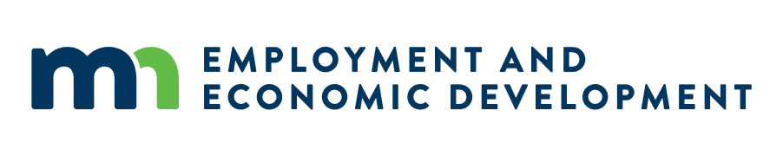

Meeting Minutes: Broadband Task Force, April Meeting
Date: 04/29/2026
Location: Heritage Center of Brooklyn Center

Attendance
- Task Members Present: Chair Teddy Bekele, Briana Mumme, Paul McDonald, Melissa Wolf, Marc Johnson, John Twiest, Daniel Lightfoot, Steve Fenske, Brian Hood, Adam Hutchens, Ini Augustine, and Bruce Crane
- Task Members Absent: Gail Hedstrom, Phil Stalboerger, and Dave Wolf
- Others Present: Attendees of the Connecting One Minnesota 2026 Broadband Summit

Meeting Notes
The meeting began with a welcome from Task Force Chair, Teddy Bekele and roll call. Chair Bekele gave an overview of the key content that informed the 2025 annual report. The aims of the Task Force subgroups, Affordability, Economic Opportunity, and Workforce Development and Mapping, Policy, and Funding were discussed, including their approaches to writing recommendations that ensure affordability; maximize economic opportunities; cultivate a skilled workforce; invest in digital skills and adoption; and support continued broadband mapping efforts and advocating for sustained funding of successful programs like the Line Extension Connection Program.
Bree Maki (Executive Director, OBD) also welcomed national leaders from the event attending the working lunch. Updates were provided on the BEAD program and Line Extension Connection Program. The Line Extension Connection program is currently accepting bids through May 22 by 1:30 p.m. CT for a fast-tracked round.
The remainder of the time was spent with Task Force members discussing with national leaders and other attendees of the event in small groups the following:
- From a national vantage point, what stands out most about Minnesota’s broadband approach, whether our funding strategy, partnership models, and digital equity efforts, or statewide coordination, and how do you see the “Minnesota Model” showing up or influencing conversations nationally?
- (BEAD has now gone through multiple rounds of federal reinterpretation and restructuring, and all states, including Minnesota, have had to repeatedly adapt their plans, scoring, and program design to align with NTIA’s evolving requirements. When you think back to when BEAD was authorized more than four years ago, is this what you envisioned the program implementation would look like?
- What data, partnerships, or community‑driven insights are most essential for making smart, targeted broadband investments that reach unserved and underserved areas?
- What information to decision‑makers need to support efforts from your discussions?
The meeting adjourned at 12:55 p.m.

Next Meeting, May 21
Date: 05/21/2026
Time: 10 a.m. CT
Location: Virtual Teams Meeting

