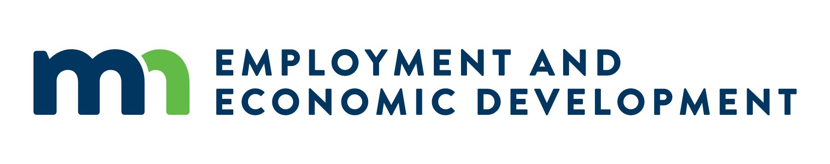

Meeting Minutes: Broadband Task Force, January Meeting
Date: 01/22/2026
Location: Virtual, Teams meeting

Attendance
- Task Members Present Virtually: Chair Teddy Bekele; Ini Augustine; Bruce Crane; Steve Fenske; Gail Hedstrom; Brian Hood; Adam Hutchens; Marc Johnson; Daniel Lightfoot; Paul McDonald; Briana Mumme; John Twiest; Dave Wolf; Melissa Wolf
- Task Members Absent: Phil Stalboerger
- Others Present Virtually: Senator Aric Putnam; Joe Rokala; Ann Treacy; Carol Bossuyt; Bree Maki; Megan Messerole; Steven Kraus; Samantha Ernst; Karrie Jansen; Fayet Turrito; Deven Bowdry; Michael Wimmer; Kemal Nezarevic; Diana López; Steve Schwerbel; Brian Isom; Joe Buttweiler; Boern Vang; Megan Moudry; Emily Feely; Todd Kruse; Jennifer Dennis; Mika Baer; Sarah Mihalow; and Anna Norcutt Preuss

Meeting Notes
The meeting began with a welcome from Task Force Chair, Teddy Bekele. The minutes from the December 2025 meeting was voted on and approved.
A legislative preview for 2026 was provided by Deven Bowdry (Government Relations Director, Department of Employment and Economic Development). The upcoming session begins February 17, and it will be a policy and bonding year as the budget was passed last year. DEED’s budget items are confidential until the governor releases those and so far, this year, those are minimal. Budget items won’t come out until March after the February forecast comes out and we get an idea of what that picture looks like. Expect more informational hearings in committees, and that broadband will be up for at least one informational hearing this year. Questions were asked about how things may be passed; and a clarification on the Broadband Task Force recommendations being separate from the OBD informational presentation
Senator Putnam (Chair Senate Agriculture, Veterans, Broadband, and Rural Development) attended for a legislative discussion on broadband and dig into the content of the 2025 Broadband Task Force Annual Report and recommendations. The Task Force provided an overview of the annual report, which has recommendations to chart a clear path forward in modernizing affordability programs, expanding digital literacy and device access, investing in local workforce development, continuing mapping efforts, and sustaining targeted funding for last-mile connections.
Questions and discussion from Senator Putnam included those on how workforce training is going and if there have been impacts from the changes to this during the last legislative session; and questions around more specifics on permitting concerns.
The Office of Broadband Development (OBD) provided overview and updates from Bree Maki (Executive Director, OBD). On the federal Broadband Equity, Access, and Deployment (BEAD) program, OBD is currently awaiting National Institute of Standards and Technology (NIST) approval, which is delaying progress on BEAD implementation and creating uncertainty for grantees. OBD is working to balance federal BEAD requirements with state laws while addressing challenges such as eligibility, only 76,000 of the 155,000 unserved locations by state standards meet BEAD criteria. Internet Service Providers (ISPs) have expressed concerns about BEAD contract terms, including restrictions that could limit future access to federal funds. Additional complexities include upcoming NTIA guidance on AI requirements, which NTIA has said they will define “onerous” by March 11, and a six-month window to finalize contracts after signing.
OBD is actively verifying maps and collaborating with Tribal partners to ensure accuracy. Consent is needed from Tribal partners in to contract with ISPs on BEAD. OBD met with Tribal partners on verifying broadband serviceable locations (BSLs). OBD cares about maps being accurate regardless of what programs move forward and ensuring we are a resource to our Tribal partners. If OBD doesn’t get consent from a Tribal partner, OBD will not move forward with locations for BEAD funding.
OBD continues to provide resources and updates, including specialty mapping for counties, upcoming conferences, and the 2025 annual report. Nationally, states must provide information to NTIA on how effective the grant was for the Digital Equity and Access Planning Grant for an audit. Not a specific concern for Minnesota, but OBD wants to raise awareness NTIA is doing that work and this is likely setting up for the Capacity grant.
Recent state grant activity includes 48 Line Extension projects, with 37 closed and 11 in progress, delivering over 2,200 locations. CPF-funded projects must be completed by 2026, with new awards issued in December 2025 and plans for a fifth round using rolled over funds for quickness and efficiency. Currently, Border-to-Border rounds 7–10 are open, with 141 grants in total and 51 already closed. OBD remains focused on efficient fund use, accurate reporting, and supporting ISPs through these transitions.
The OBD annual report was submitted and will be posted soon and linked an upcoming OBD email blast. Questions were asked and resources will be shared on national conferences that may be of interest to Task Force members
OBD’s Megan Messerole (Broadband Environmental and Land Use Coordinator, OBD) joined Bree Maki to present an overview of environmental and permitting processes for broadband projects. This included an overview of the creation of the Minnesota Broadband Charter Group, which was formed involving multiple state agencies and to improve collaboration and efficiency around permitting for broadband projects. From this, and recognizing the complexity of permitting, OBD created and filled the new role, Broadband Environmental and Land Use Coordinator, to assist ISPs with compliance.
Broadband deployment requires numerous permits, including DOT right-of-way, DNR utility crossing licenses, stormwater permits, and cultural resource reviews under Minnesota laws. OBD works with grantees and agencies to complete these permits before construction. Cultural resource compliance involves desktop reviews and, if needed, field surveys, with input from SHPO, OSA, MIAC, and MHS. Potential impacts such as trenching through archaeological sites, tree clearing, and soil compaction were highlighted. Early coordination and GIS tools, including ArcGIS and Lidar, are critical for identifying sensitive areas and avoiding delays. Federal BEAD-funded projects add complexity, requiring compliance with NEPA, NHPA Section 106, and the Endangered Species Act.
OBD will continue to support broadband grantees by facilitating agency connections, conducting initial screenings, and assisting with formal consultations. The presentations slides on environmental permitting is available on the Broadband Task Force webpage.
Chair Bekele opened the floor up to questions and comments from Task Force members and other attendees.
The meeting adjourned at 12 p.m.

Next Meeting, Month
Date: 02/18/2025
Time: 10 a.m. – 12:30 p.m.
Location: Virtual, Teams meeting.

