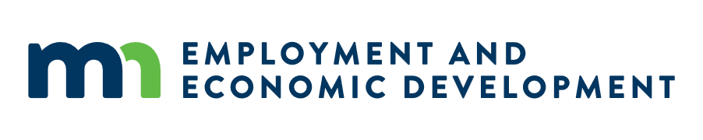

Agenda: Broadband Task Force, April Meeting
Date: 04/29/2026

In-Person Meeting
- This meeting will take place during Connecting One: Minnesota 2026 Broadband Summit. This meeting will be held in-person and is open to anyone from the public to attend, however, tickets are required to enter. Registration is available and open through April 24 here: https://mn.gov/deed/events/connecting/.

12:00 p.m. – 12:15 p.m.
Welcome and introduction from Teddy Bekele, Chair, Minnesota Governor’s Task Force on Broadband, approval of minutes from February Task Force meeting, and roll call.

12:15 p.m. – 12:25 p.m.
Office of Broadband Development (OBD) welcome to National Leaders and overview and updates from Bree Maki (Executive Director, OBD).

12:25 p.m. – 12:45 p.m.
Working lunch with at-table discussion between Task Force subcommittees and National Leaders.
- Affordability, Economic Opportunity, and Workforce Development
- Mapping, Policy, and Funding

12:45 p.m. – 12:50 p.m.
Open the floor to other business and meeting wrap-up.

