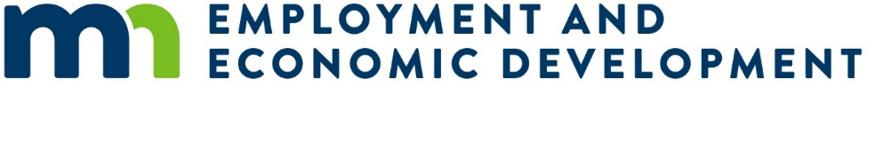

**Addendum 1 - Questions and Answers Regarding the Broadband Equity Access and Deployment Request for Proposals (RFP)**

*Note: The RFP posted on February 14, 2025 and was amended on February 25, 2025.*

*The Pre-Qualification end date is being extended from Thursday, February 27, 2025 to Thursday, March 13, 2025.*

*The Subgrantee selection subround 11a is being changed from March 10, 2025-April 7, 2025 to March 24, 2025-April 21, 2025.*

*The OBD defined project areas posted is being changed from April 23, 2025-May 21, 2025 to May 7, 2025-May 21, 2025.*

***Questions:***

*FAQ Form link: FAQs should be submitted using this form* [*https://forms.office.com/pages/responsepage.aspx?id=RrAU68QkGUWPJricIVmCjA4DiC_nFNpHmvjyxugkpX5UMERFNEhTOVhCSUxBM1RDQlNDR0FaOUxQRC4u&route=shorturl*](https://gcc02.safelinks.protection.outlook.com/?url=https%3A%2F%2Fforms.office.com%2Fpages%2Fresponsepage.aspx%3Fid%3DRrAU68QkGUWPJricIVmCjA4DiC_nFNpHmvjyxugkpX5UMERFNEhTOVhCSUxBM1RDQlNDR0FaOUxQRC4u%26route%3Dshorturl&data=05%7C02%7CMichelle.M.Rebholz%40state.mn.us%7C23d982a7a9994d18506608dd55d687ef%7Ceb14b04624c445198f26b89c2159828c%7C0%7C0%7C638761102352418136%7CUnknown%7CTWFpbGZsb3d8eyJFbXB0eU1hcGkiOnRydWUsIlYiOiIwLjAuMDAwMCIsIlAiOiJXaW4zMiIsIkFOIjoiTWFpbCIsIldUIjoyfQ%3D%3D%7C0%7C%7C%7C&sdata=xcVBxuRNVkKLqNbTvXgYSpeNJmq0u0FWx%2FbWbDBLZmk%3D&reserved=0)*. FAQs will be updated weekly to accommodate NTIA review of answers to all questions. Plan to submit all questions related to Pre-Qualification by Thursday March 6, 2025 to allow for a timely response.*