
Data on Minnesota Exports for Second Quarter 2026 – Published September 2026
For More Information: Mary Haugen (mary.haugen@state.mn.us)

Minnesota Exports Rebound – Up 14% – in Second Quarter
- Minnesota’s exports of goods (including agriculture, mining and manufacturing) reached nearly $6.6 billion in the second quarter – representing a jump of 14% (or up over $800 million) between the second quarters of 2025 and 2026.
- U.S. exports grew at a similar rate of 15% in this period, with 41 states generating export growth.
- The state’s manufactured exports alone increased 13%, while U.S. manufactured exports gained 9%.
- For the first half of 2026, Minnesota exports rallied to grow 2% (compared to the same period in 2025), while U.S. exports increased by 15%.

Figure 1. Exports Grow for Majority of States
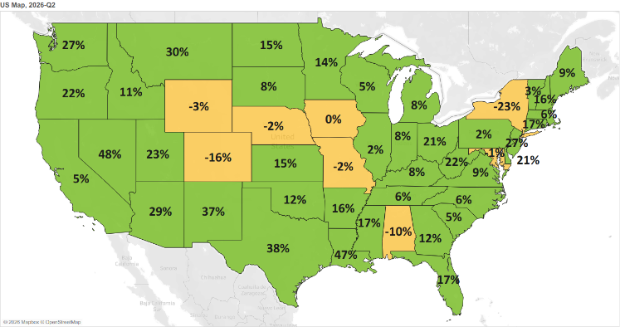
Decline 0% Growth
MN: +14%
U.S.: +15%
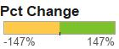

All Major Global Regions Post Strong Growth, Led by North America and Europe
- Exports to North America surged 23% to $2.6 billion fueled by continuing strong demand in Mexico (up 34%) and a rebound in exports – including exports of mineral fuel and oil (up 38%) – to Canada (up 14%).
- Large gains in European markets ($1.5 billion, up 11%) were contributed by markets such as Austria (up $30 million), Germany (up $26 million), Belgium (up $25 million) and Spain (up $19 million).
- Minnesota sales to Asia were up 6% to $1.7 billion. Exports strengthened to Malaysia (up 51%), Japan (up 10%) and Indonesia (up 25%) – more than offsetting weakened sales to India, Thailand and Taiwan.
- Minnesota businesses made remarkable advances in the Caribbean, Central America and South America ($418 million, up 14%; led by Costa Rica (up 43%)) and Africa ($73 million, up 51%; led by Algeria (up 63%)).

Figure 2. Export Trends for Minnesota’s Top 10 Markets, Second Quarter 2026
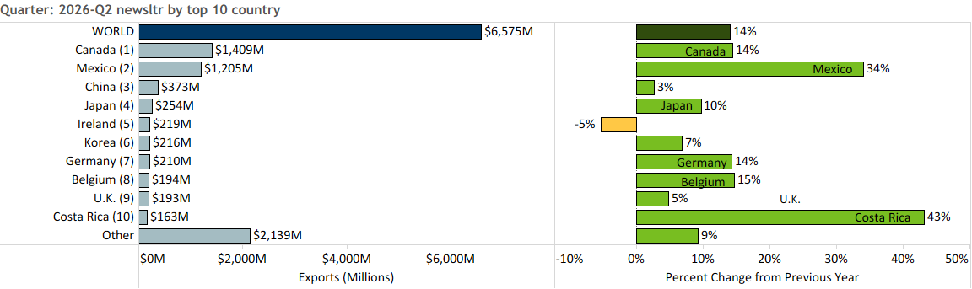

Electrical Equipment, Oil Seeds and Machinery Lead in Export Gains
- Minnesota exports jumped 14%, bolstered by strong growth across diverse categories, including electrical equipment (up 21%), oil seeds, misc. grain (up 116%), machinery (up 13%) and vehicles (up 20%).
- Electrical equipment exports swelled to $1.2 billion, with integrated circuits (up 61%), electrical switches (up 44%) and insulated wire, cable (up 37%) among the critical growth segments. The U.K. (up 58%), Canada (up 38%), Mexico (up 29%) and China (up 19%) contributed the largest gains.

- Robust sales of soybeans to Mexico ($131 million, up 154% or up $79 million) propelled the growth of oil seeds, misc. grain (up 116%).
- Machinery exports (up 13%) were largely driven by Mexico (up $77 million) and Canada (up $36 million), but also strengthened to Ukraine, Singapore and Netherlands. Key growth products included heating/cooling equipment (up 274%), computer parts (up 35%) and semiconductor production machines (up 47%).
Figure 3. Top Markets for Machinery

- Mexico (up 33%; 34% market share) and Canada (up 14%; 48% market share) drove the state’s export growth of vehicles (up 20%). Passenger vehicles (up 58%) and vehicle parts (up 30%) gained the most traction.
- High-growth markets for optic, medical products – such as to Costa Rica (up 71%), Belgium (up 25%) and Malaysia (up 52%) outweighed the slump in demand in Taiwan, China and Korea. Exports of instruments for medical, surgical uses; physical/chemical analysis and measuring liquids or gases boosted growth the most.
- Sales of fertilizers ($118 million, up 56%) were propelled by Canada, the primary market for these goods.
- Mineral fuel, oil (e.g. motor fuel, industrial oils) sales rebounded ($61 million, up 110%), with solid gains across Mexico ($18 million, up 257%), Brazil ($12 million, up from $58,000) and Canada ($18 million, up 38%).
- Exporters of food by-products (up 24%) expanded their reach in Mexico (up 63%) and Korea (up 87%). Segments such as soybean oilcake and starch/sugar manufacturing by-products expanded the most.
- In contrast, exports of ores, slag, ash ($94 million, down 25%), meat ($76 million, down 19%), railway equipment ($4 million, down 80%) and sugar, confectionary ($22 million, down 38%) tumbled.

Figure 4. Export Trends for Minnesota’s Top 10 Products, Second Quarter 2026
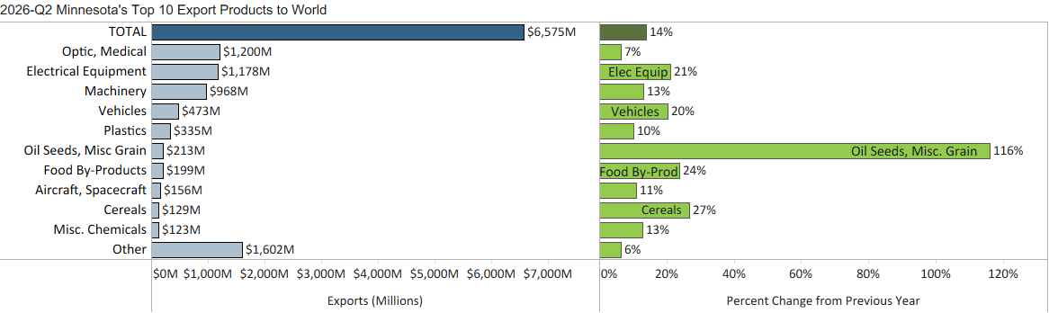
Minnesota Export Statistics reports track the state’s trends in exports of goods and is prepared for the Minnesota Trade Office by DEED’s Economic Analysis Unit (Thu-Mai Ho-Kim). The quarterly and annual reports primarily cover export data based on the Harmonized Tariff System (Schedule B), collected by the Foreign Trade Division, Census Bureau, U.S. Dept of Commerce and accessed through USA Trade Online (Census Bureau) and Trade Data Monitor (TDM). Historical reports are available on DEED’s website at “Export and Trade Statistics” (http://mn.gov/deed/data/export-stats/).

