
Data on Minnesota Exports for First Quarter 2026 – Published June 2026
For More Information: Mary Haugen (mary.haugen@state.mn.us)

Minnesota Exports Drop to $5.8 Billion, Down 8% in First Quarter
- Minnesota’s exports of goods (including agriculture, mining and manufacturing) slipped 8% since the first quarter of 2025, to $5.8 billion in the first quarter of 2026. The persistent slide in mineral fuel, oil sold to Canada (down $628 million) drove this trend; excluding these exports to Canada, Minnesota’s other exports grew 2%.
- In contrast, U.S. exports grew 15% in this period, with almost 30 states increasing their exports.
- For manufacturing alone, the state’s exports fell 9%, while national exports jumped 17%.
- Businesses faced much ongoing uncertainty, including changing tariff policies and impacts of immigration policies on the business environment.

Figure 1. Majority of States Show Export Growth
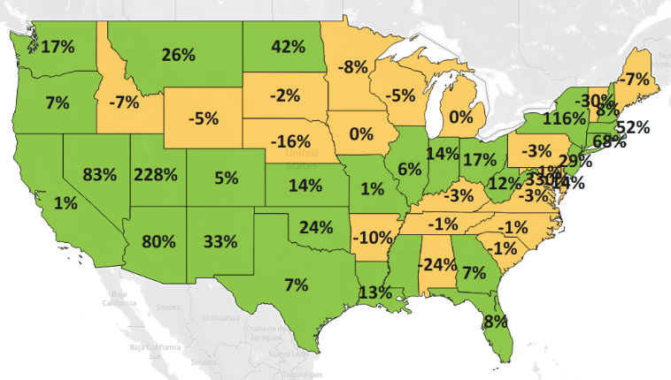
Decline 0% Growth
MN: -8%
U.S.: +15%
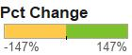

Strong European and Latin American Markets Offset Some Declines in Canada and Asia
- Exports to North America declined 23% to $2.1 billion. Strong gains to Mexico (up 18%) were offset by steep declines to Canada (down 41%). Vehicles and machinery weakened to Canada but strengthened to Mexico.
- Minnesota sales to Asia dipped 3% to $1.6 billion. Exports expanded over 40% in Singapore ($116 million, up 45%), India ($114 million, up 41%) and Malaysia ($107 million, up 42%), but struggled in other leading markets such as to China (down 23%), Taiwan (down 29%) and Indonesia (down 16%).
- European markets ($1.4 billion, up 11%) shined – with the U.K. (up 26%), Turkey (up 65%), Germany (up 13%), Poland (up 57%) and France (up 17%) generating the largest export gains in the first quarter.
- Minnesota businesses successfully boosted sales to the Caribbean, Central America and South America ($382 million, up 10%), Africa ($53 million, up 20%) and the Australia-Pacific region ($116 million, up 5%).

Figure 2. Export Trends for Minnesota’s Top 10 Markets, First Quarter 2026
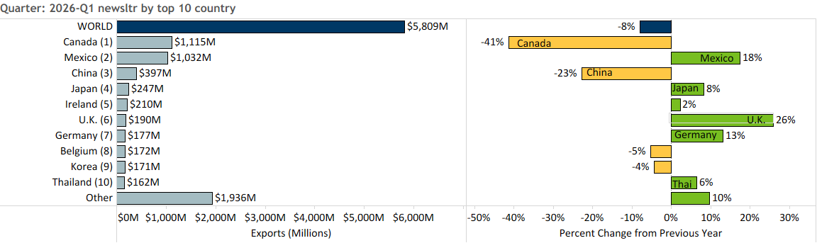

Decline in Mineral Fuel/Oil Masks Growth in Electrical Equipment, Oil Seeds, Fertilizer
- Minnesota exports decreased 8%, driven by the substantial contraction in mineral fuel, oil (down 94%) sales. Other products contributing to the overall decline were ores, slag, ash; sugar, confectionary; and machinery.

- Exports of mineral fuel, oil (such as motor fuel and industrial oils) plunged, as exports of these goods to Canada shrank by nearly $630 million.
- Ores, slag, ash (down 82%) slumped as exports to Canada, the main market, sank by $28 million.
- Decreased sales of sugar and glucose products to Mexico (down $26 million) drove sugar, confectionary exports to fall by 62%.
- Machinery exports (down 2%) swelled to Mexico (up 41%), Singapore (up 143%) and Germany (up 38%) but receded to China and Canada
Figure 3. Top Electrical Equipment Products

- Electrical equipment exports topped $1 billion and surged to the U.K. (up 62%), Germany (up 61%), Korea (up 97%) and Taiwan (up 103%). Integrated circuits, electric generating sets and switches gained the most.
- Robust demand for soybeans and other oil seeds in Mexico (up 84%) and Korea (up 127%) propelled growth in exports of oil seeds, misc. grain ($126 million, up 35%).
- Exports of fertilizers ($79 million, up 45%) gained traction in Canada (up 48%), the dominant market.
- Sellers of food by-products (up 9%) made large strides in Mexico (up 21%), Korea (up 52%) and Vietnam (up 29%). Segments such as soybean oilcake and preparations for animal feed expanded the most.
- Global sales of machinery were mixed, jumping to Mexico (up 41%), Singapore (up 143%) and Germany (up 38%); but buckling in China, Canada and UAE. Vigorous export growth in heating equipment and computers helped mitigate declines in pumps and centrifuges, filters.
- Global sales of optic and medical products were flat. While growing demand boosted exports to Costa Rica, Malaysia, Turkey and Japan, depressed conditions prevailed in Taiwan, Korea and China.
- Other products such as prepared cereal, flour products ($66 million, up 22%), cereals ($62 million, up 19%), aluminum ($39 million, up 34%) and organic chemicals ($23 million, up 70%) also exhibited export growth.

Figure 4. Export Trends for Minnesota’s Top 10 Products, First Quarter 2026
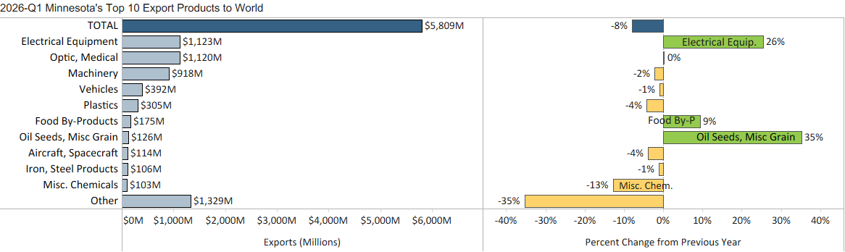
Minnesota Export Statistics reports track the state’s trends in exports of goods and is prepared for the Minnesota Trade Office by DEED’s Economic Analysis Unit (Thu-Mai Ho-Kim). The quarterly and annual reports primarily cover export data based on the Harmonized Tariff System (Schedule B), collected by the Foreign Trade Division, Census Bureau, U.S. Dept of Commerce and accessed through USA Trade Online (Census Bureau) and Trade Data Monitor (TDM). Historical reports are available on DEED’s website at “Export and Trade Statistics” (http://mn.gov/deed/data/export-stats/).

