
Data on Minnesota Exports for Fourth Quarter 2025 – Published May 2026
For More Information: Mary Haugen (mary.haugen@state.mn.us)

Minnesota Exports Fall 10% to $5.7 Billion in Fourth Quarter
- Minnesota’s exports of goods (including agriculture, mining and manufacturing) declined to $5.7 billion in the fourth quarter of 2025, sliding 10% since the fourth quarter of 2024.
- Sharply depressed sales of mineral fuel, oil sold to Canada persisted; excluding these exports to Canada, Minnesota’s other exports dipped 2%.
- In contrast, U.S. exports grew 9% during this period, despite challenging trade policies and tariffs. Exports grew for more than half of states.
- For all of 2025, the state’s exports fell 13%, while U.S. exports jumped 6%.

Figure 1. Mixed Performances Across States
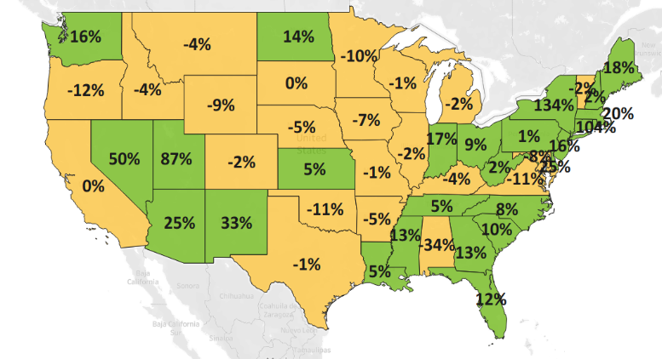
Decline 0% Growth
MN: -10%
U.S.: +9%
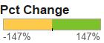

Exports Surge to Europe, Help Offset Sharp Decline to North America
- Exports to North America tumbled 26% to $2.1 billion, falling sharply to Canada (down 37%) but slightly to Mexico (down 3%). Mineral fuels exports to Canada (down 97%, or by $540 million) drove the overall trend.
- Minnesota sales to Asia ($1.6 billion, down 4%) shrank modestly. Impressive export gains to Korea ($214 million, up 30%), Japan ($259 million, up 17%), Thailand ($146 million, up 27%) and Malaysia ($106 million, up 30%) were offset by adverse trends in China (down 27%), Taiwan (down 32%) and Vietnam (down 11%).
- Sales to Europe ($1.4 billion, up 10%) showed stellar growth. The U.K. (up 26%), Italy (up 40%), Belgium (up 15%), Germany (up 13%) and Spain (up 82%) generated the most notable export gains.
- Minnesota businesses strengthened exports to the Caribbean, Central America and South America ($353 million, up 5%) – led by Costa Rica ($136 million, up 18%) and Dominican Republic ($24 million, up 66%) – and to Africa ($69 million, up 13%) – led by South Africa ($38 million, up 82%) and Algeria ($11 million, up 79%).

Figure 2. Export Trends for Minnesota’s Top 10 Markets, Fourth Quarter 2025
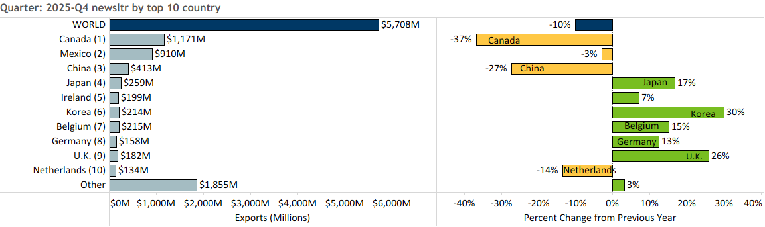

Widespread Slump Across Major Product Categories, Growth in Limited Areas
- Minnesota exports dropped 10% in the fourth quarter as major products – such as mineral fuel, oil (down 95%), ores, slag, ash (down 85%), machinery (down 7%) and misc. chemicals (down 26%) – lost more traction.
- Exports of mineral fuel, oil (including motor fuel) sank, as exports of these goods to Canada, the dominant market, plunged $540 million.
- Weak demand for iron ores in Canada (down 85%) triggered lackluster exports of ores, slag, ash; while China (down 63%) steered the steep slide in exports of misc. chemical products.
- Slumping markets for machinery included China (down 31%), Israel (down 82%) and Mexico (down 11%). Impacted segments included air conditioners, machines working with textiles, centrifuges/filters and printing equipment.
Figure 3. Top Markets for Machinery

- Electrical equipment exports (up 26%) swelled to the U.K. (up 114%), Korea (up 157%), Thailand (up 56%) and Germany (up 54%) – boosted by surges in demand for integrated circuits (up 73%), specialized equipment (up 103%), electrical switches (up 38%) and heating equipment (up 91%).
- With a combined market share of nearly 60%, Canada (up 208%) and Mexico (up 80%) uplifted exports of cereals ($139 million, up 46%) – which mainly consisted of corn (maize) (up 123%) and wheat (up 23%).
- Mexico’s demand for soybeans (up 99%) spurred growth in oil seeds, misc. grain. Both Canada and Mexico fueled export growth of dairy, eggs, honey ($52 million, up 44%; such as butter, whey products, milk and cream) and miscellaneous edible preparations ($31 million, up 31%; such as protein concentrates and yeast).
- Performances across markets for optic, medical products (down 3%) were mixed. Sales leaped to Costa Rica, Japan and Belgium but plummeted to Taiwan, China, Korea and Mexico.
- Global sales of aircraft, spacecraft performed remarkably in Canada, UAE, Germany and Korea; while global sales of railway equipment ($19 million, up 198%) were propelled by Mexico ($13 million, up from $117,000).

Figure 4. Export Trends for Minnesota’s Top 10 Products, Fourth Quarter 2025
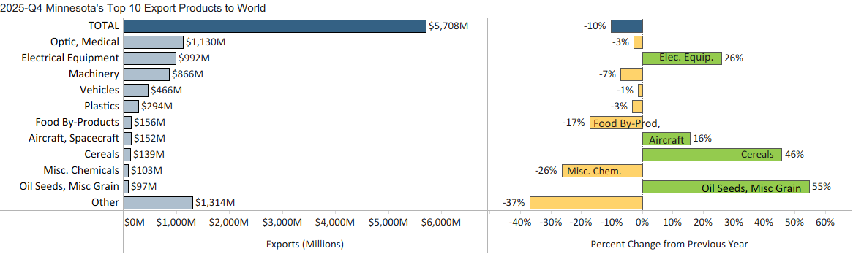
Minnesota Export Statistics reports track the state’s trends in exports of goods and is prepared for the Minnesota Trade Office by DEED’s Economic Analysis Unit (Thu-Mai Ho-Kim). The quarterly and annual reports primarily cover export data based on the Harmonized Tariff System (Schedule B), collected by the Foreign Trade Division, Census Bureau, U.S. Dept of Commerce and accessed through USA Trade Online (Census Bureau) and Trade Data Monitor (TDM). Historical reports are available on DEED’s website at “Export and Trade Statistics” (http://mn.gov/deed/data/export-stats/).

