
Data on Minnesota Exports for Third Quarter 2025 – Published January 2026
For More Information: Mary Haugen (mary.haugen@state.mn.us)

Minnesota Exports Slide 14% to $5.7 Billion in Third Quarter
- Minnesota’s exports of goods (including agriculture, mining and manufacturing) declined to $5.7 billion in the third quarter 2025, sliding 14% since the third quarter of 2024.
- U.S. exports grew 4% during this period. State trends were mixed, with half of states gaining.
- U.S. businesses continued to face a range of challenging trade policies and tariffs.
- For the first nine months of 2025, compared to the same period in 2024, state exports have fallen 13%, while U.S. exports have grown about 4%.

Figure 1. Mixed Performances Across States
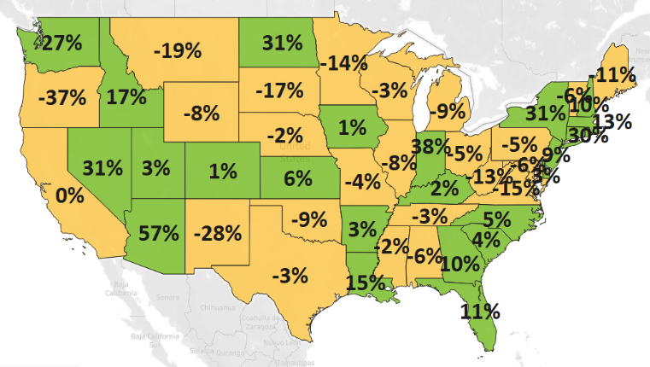
Decline 0% Growth
MN: -14%
U.S.: +4%
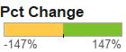

Large Declines to North America and Asia Offset Strong Growth in Europe, Middle East
- Exports to North America dropped 26% to $2.2 billion, contracting to Canada (down 32%) and Mexico (down 15%). Plunging exports were concentrated in mineral fuels for Canada, but more widespread for Mexico.
- Minnesota sales to Asia ($1.6 billion, down 15%) also shrank. Exports to leading Asian markets buckled – such as to China (down 24%), Japan (drop 20%), Taiwan (down 31%) and Malaysia (down 25%), in contrast to impressive export performances by India ($104 million, up 52%) and Singapore ($111 million, up 21%).
- Sales to Europe ($1.3 billion, up 7%) were robust – with Germany (up 24%), the U.K. (up 20%), Switzerland (up 46%), Turkey (up 60%) and Italy (up 15%) generating the largest export gains.
- Minnesota businesses also successfully boosted sales to the Middle East ($136 million, up 11%) – led by Saudi Arabia ($53 million, up 105%) – and to Africa ($46 million, up 6%) – led by Nigeria ($6 million, up 124%).

Figure 2. Export Trends for Minnesota’s Top 10 Markets, Third Quarter 2025
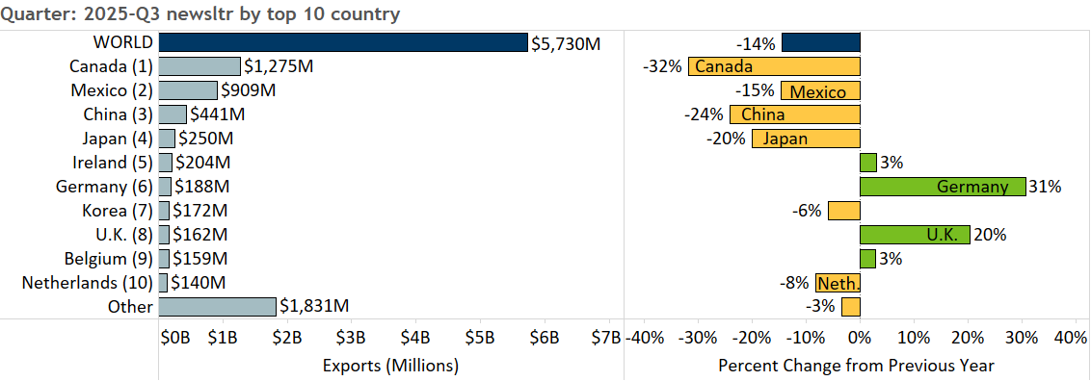

Widespread Slump Among Major Product Categories, Growth in Limited Areas
- Minnesota exports dropped 14% as leading products lost significant ground: mineral fuel, oil (down 93%), machinery (down 11%), vehicles (down 20%), ores, slag, ash (down 24%) and misc. chemicals (down 31%).

- Exports of mineral fuel, oil (including motor fuel) sank, as exports of these goods to Canada, the dominant market, fell over $500 million.
- Electrical equipment exports were fueled largely by the U.K. (up 61%), Switzerland (up 51%) and Ireland (up 59%). Strengthened demand for integrated circuits, switches and batteries helped offset depressed sales of generators, diodes and transistors.
- With a market share of 97%, Canada uplifted fertilizer exports ($68 million, up 39%).
Figure 3. Top Markets for Electrical Equipment

- Canada and Mexico fueled export growth of dairy, eggs, honey ($59 million, up 69%; led by fresh chicken eggs, milk and cream) and miscellaneous edible preparations ($36 million, up 46%; such as sauces, condiments and protein concentrates).
- Aircraft, spacecraft ($175 million, up 3%) were spurred by Germany ($43 million, up 478%), as well as by India, Argentina and Canada. These exports largely consisted of civilian aircraft, engines and parts.
- Sales of machinery (down $111 million) slumped in China (down 46%), Japan (down 68%) and Mexico (down 17%); while those of vehicles (down 20%) lost traction in Australia (down 83%) and Mexico (down 24%).
- As dominant markets, Canada (down 24%) triggered the decrease in exports of iron ores, while China (down 63%) drove the steep slide in misc. chemical products, as sales of diagnostic or laboratory reagents tumbled.
- Performances across markets for optic, medical products (down 3%) were mixed. Surging sales to Ireland, Singapore, Costa Rica and Malaysia contrasted with severe declines to Taiwan, Korea and China. While exports of medical, surgical instruments and orthopedic, artificial body parts made robust gains, those of measuring instruments and testing equipment tumbled.
- Sales of plastics (particularly of plates, sheets and film) dropped the most to Canada, Mexico and China.

Figure 4. Export Trends for Minnesota’s Top 10 Products, Third Quarter 2025
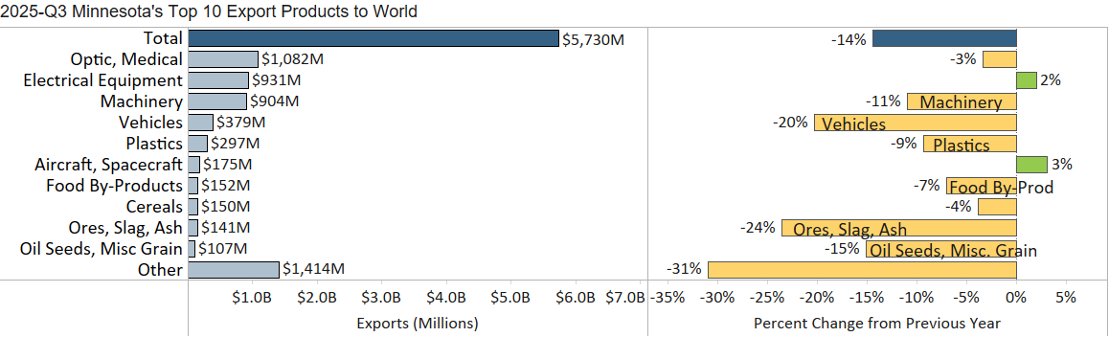
Minnesota Export Statistics reports track the state’s trends in exports of goods and is prepared for the Minnesota Trade Office by DEED’s Economic Analysis Unit (Thu-Mai Ho-Kim). The quarterly and annual reports primarily cover export data based on the Harmonized Tariff System (Schedule B), collected by the Foreign Trade Division, Census Bureau, U.S. Dept of Commerce and accessed through USA Trade Online (Census Bureau) and Trade Data Monitor (TDM). Historical reports are available on DEED’s website at “Export and Trade Statistics” (http://mn.gov/deed/data/export-stats/).

