**Data on Minnesota Exports for First Quarter 2025 – Published May 2025**

**For More Information**: ***Mary Haugen (mary.haugen@state.mn.us)***

# Minnesota Exports Slip 6% to $6.3 Billion in First Quarter

* Minnesota exports of goods (including agriculture, mining and manufacturing) declined to $6.3 billion in the first quarter 2025, slipping 6% compared to the first quarter of 2024.
* U.S. exports grew a modest 3% during this period, with more states experiencing export gains (30) than declines (20).
* U.S. exporters of goods are facing ongoing challenges of changing tariff policies on U.S. imports and retaliatory tariffs by other countries on U.S. exports, as well as concerns about general economic conditions.

#### Figure 1. Over Half of States Have Export Gains

US Map of states with trends 2024-Q1 to 2025-Q1
State Percent Change 2024-Q1 to 2025-Q1
Minnesota -6%
United States 3%
Alabama 2%
Alaska 18%
Arizona 27%
Arkansas 4%
California 8%
Colorado 2%
Connecticut 3%
Delaware 31%
Dist of Columbia -1%
Florida 5%
Georgia 14%
Hawaii 56%
Idaho 22%
Illinois 0%
Indiana -2%
Iowa -7%
Kansas -3%
Kentucky 20%
Louisiana 2%
Maine 12%
Maryland -14%
Massachusetts 6%
Michigan 1%
Mississippi 0%
Missouri 7%
Montana -5%
Nebraska -2%
Nevada 12%
New Hampshire -15%
New Jersey -8%
New Mexico 173%
New York 5%
North Carolina -1%
North Dakota 5%
Ohio -7%
Oklahoma 4%
Oregon -1%
Pennsylvania -3%
Rhode Island -3%
South Carolina -14%
South Dakota -11%
Tennessee -7%
Texas 2%
Utah -29%
Vermont 41%
Virginia -13%
Washington 4%
West Virginia -7%
Wisconsin 2%
Wyoming 7%



**Decline 0% Growth**

***MN: -6%***

***U.S.: +3%***

Map color legend. yellow for decline, green for growth

## *Weaker Trends Across Most Regions, But Growth in Middle East and Selected Markets*

* Exports dropped to **North America** ($2.8 billion, down 7%), as sales slumped to **Mexico** (down 16%) and **Canada** (down 3%). Exports of **cereals, vehicles, machinery** and **food by-products** declined the most.
* Demand also sank to **Asia** ($1.6 billion, down 9%), driven by **China** (down 8%), **Malaysia** (down 30%), the **Philippines** (down 43%) and **Indonesia** (down 29%) and despite remarkable gains in **Vietnam** (up 43%).
* The **Middle East** ($141 million, up 12%)was another bright spot. The state’s exports surged to **Israel** ($46 million, up 27%) and **Saudi Arabia** ($28 million, up 22%) driven by **machinery**; and to **Yemen** ($7.5 million, up from $15,000) due to demand for **wheat**.
* Sales also grew 17% to **non-EU** **European** markets – led by **the U.K.** (up 23%) and **Switzerland** (up 11%).
* Minnesota businesses maintained market share in **Africa** and the **Caribbean, Central America and South America** region; but lost ground in **EU** markets overall (down 5%) and **Australia** ($100 million, down 31%).

#### Figure 2. Export Trends for Minnesota’s Top 10 Markets, First Quarter 2025

double bar chart
MN Exports to top 10 markets, 2025-Q1
Product Exports (millions) Percent Change, 2024-Q1 to 2025-Q1
WORLD  $6,313  -6%
Canada (1)   $1,903  -3%
Mexico (2)   $878  -16%
China (3)   $514  -8%
Japan (4)   $228  2%
Ireland (5)   $205  4%
Belgium (6)   $182  6%
Korea (7)   $179  -9%
Germany (8)   $156  -19%
Thailand (9)   $152  -8%
U.K. (10)   $151  23%
Other  $1,764  -8%

## *Widespread Decline, But Growth Areas include Mineral Fuel, Oil Seeds and Egg Exports*

* Exports of leading products tumbled, with **vehicles** (down 25%), **cereals** (down 63%), **optic, medical** (down 5%) and **food by-products** (down 26%) falling the most sharply between the first quarters of 2024 and 2025.
* Contributing the most to these declines were decreased exports to **Mexico** of **cereals** (down $30 million) and **vehicles** (down $66 million); to **North American** markets of **food by-products** (down 37%); and to **Korea** (down 20%) and **China** (down 9%) of **optic, medical products.**
* Strong export growth in **mineral fuel, oil;** **dairy, eggs, honey;** **oil seeds, misc. grain**; **albumin, starch, glue;** and **pharmaceuticals** helped sustain the state’s exports this quarter.
* With a market share of 97%, **Canada** generated the growth in exports of **mineral fuel, oil** ($660 million, up 4%).

Figure 3. Export Markets for Dairy, Egg, Honey

* Swelling **Canadian** demand for **fresh chicken eggs** ($23 million, up from $313,000)steered the strong export performance in **dairy, egg, honey** products ($57 million, up 85%).
* Exports of **oil seeds, misc. grain** ($93 million, up 36%; largely consisting of **soybeans**) jumped to **Mexico** ($42 million, up 105%), the state’s leading export market for these goods, and to **Canada** ($16 million, up 54%).
* Growth in **albumin, starch, glue** exports ($76 million, up 42%) was propelled by **Canada** ($13 million, up 91%) and markets in **Asia** ($25 million, up 70%). These goods were largely **albumin products** ($42 million, up 107%; such as **concentrated whey protein products**) and **adhesive products** ($17 million, down 10%).
* Robust growth in **pharmaceutical goods** ($75 million, up 30%) was led by **European markets** such as **Belgium**, **Italy, the U.K.** and **Ireland**. **Immunological products** ($40 million, up from less than $2 million) drove growth.
* Gains in **plastics** ($318 million, up 4%) were spurred by Asia, including to **China, Thailand,** **Taiwan** and **India;** while **Canada,** as the primary market, directed the surge in **iron ore** ($34 million, up 44%) exports.

#### Figure 4. Export Trends for Minnesota’s Top 10 Products, First Quarter 2025

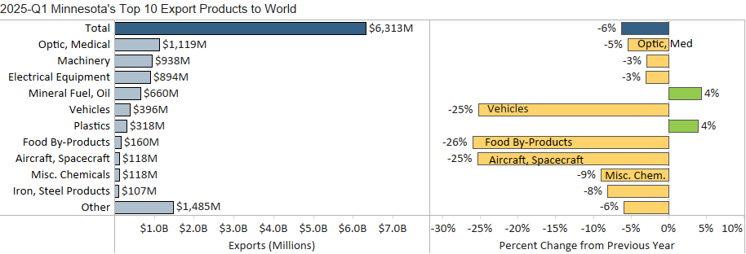

|  |
| --- |
| Minnesota Export Statistics reports track the state’s trends in exports of goods and is prepared for the Minnesota Trade Office by DEED’s Economic Analysis Unit (Thu-Mai Ho-Kim). The quarterly and annual reports primarily cover export data based on the Harmonized Tariff System (Schedule B), collected by the Foreign Trade Division, Census Bureau, U.S. Dept of Commerce and accessed through USA Trade Online (Census Bureau) and Trade Data Monitor (TDM). Historical reports are available on DEED’s website at “Export and Trade Statistics” (<http://mn.gov/deed/data/export-stats/>). |