
Annual Data on Minnesota Manufactured Exports – Published in March 2026
For More Information: Mary Haugen (mary.haugen@state.mn.us)

State Exports Decreased by 13% to $23.5 Billion in 2025
- Minnesota exported nearly $24 billion in agricultural, mining and manufactured goods to about 200 countries in 2025. The state’s exports declined 13% between 2024 and 2025 – lagging U.S. export growth of 6% in the same period.
- About half of the state’s overall export decline was driven by exports of mineral fuel and oil to Canada, which plunged $1.7 billion in 2025.
- Minnesota ranked 23rd highest in export value among states, unchanged from 2024.
- Global sales of goods and services by over 8,000 exporting Minnesota businesses supported about 101,500 jobs in the state. (2023, Census and ITA)
Figure 1. Export Gains for 27 States and U.S.
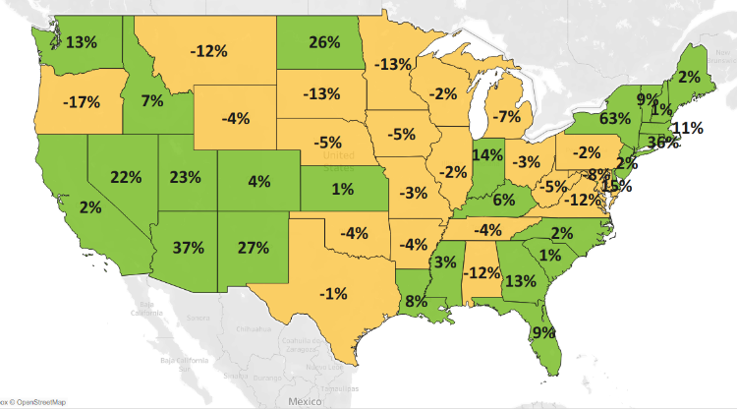
MN: -13%
U.S.: +6%
Decline 0% Growth
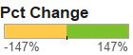

Widespread Weaker Demand in North America and Asia Triggers Large Export Slide
- Minnesota exporters (and importers) struggled to gain traction in 2025. Businesses continued to face unpredictable trade policies, challenging economic conditions and ongoing uncertainty.
- Exports to North America shrank 24% to $9.2 billion in 2025 – down nearly $3 billion, fueled by restraint in Canada and Mexico. Exports to Asia slipped 9% as demand slid in China, Taiwan and the Philippines.
- Bright spots of regional growth included European markets outside the EU – driven by the U.K. and Switzerland; and the Caribbean and South America, led by Argentina, Chile and the Dominican Republic.
- While the state’s sales were somewhat stable to the European Union ($4 billion, up 1%) and Africa ($208 million, up 1%), they faltered to Australia (down 24%) and the Middle East (down 7%).
Figure 2. Exports to Minnesota’s Top 10 Markets in 2025
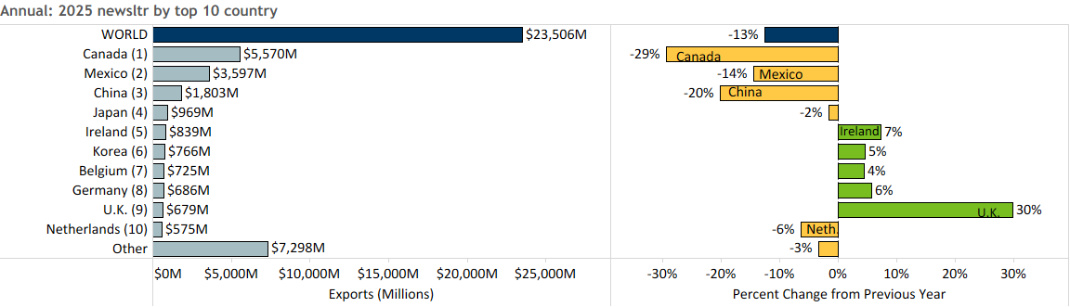

Mineral Fuel & Oil, Vehicles, Machinery and Optic & Medical Goods Fall Sharply
- Global sales of some of Minnesota’s core products – such as mineral fuel, oil (down 69%), vehicles (down 19%), machinery (down 10%) and optic, medical products (down 5%) – tumbled between 2024 and 2025.
- Exports of mineral fuel, oil (including motor fuels) plunged $1.7 billion – reversing the spike of 115% in 2024 and driven by Canada.
- Exports of vehicles sank 19%, triggered by steep losses to Mexico (down 24%) and Australia (down 79%).
Figure 3. Top Markets for Electrical Equipment

- Slumping machinery sales to core markets – Mexico, China and Canada – contrasted with strong gains to Saudi Arabia (up 280%), Korea (up 35%) and the Dominican Republic (up 126%). Sales of computers, engines and specialized machinery slid, while those of heating machinery and computer parts swelled.
- Markets for optic, medical goods were mixed: declines in China, Taiwan and Korea far exceeded gains to Belgium, Costa Rica and Singapore. Weaker sales of testing devices (down 51%) and measuring instruments (down 30%) outweighed the notable growth of medical and surgical instruments (up 9%).
- Electrical equipment exports showed strength and resilience, boosted by robust markets like the U.K. (up 101%), Korea (up 62%), Ireland (up 51%) and Switzerland (up 30%). Critical growth segments included integrated circuits (up 24%), batteries (up 40%), switches (up 20%) and generators (up 14%).
- Notable high-performing food & ag-related exports included dairy, eggs, honey ($222 million, up 62%), oil seeds, misc. grains ($396 million, up 15%) and misc. food ingredients ($137 million, up 28%).
- Exporters of pharmaceuticals (up 23%) branched out in the U.K. (up 389%) and Italy (up 852%), while those of albumin, starch, glue (up 19%) made large strides in Germany (up 100%) and India (up 131%).

Figure 4. Exports of Minnesota’s Top 10 Products in 2025
Minnesota Export Statistics tracks the state’s trends in exports of goods and is prepared for the Minnesota Trade Office by DEED’s Economic Analysis Unit (by Thu-Mai Ho-Kim). The quarterly and annual reports primarily cover export data based on the Harmonized Tariff System (Schedule B), collected by the Foreign Trade Division, Census Bureau, U.S. Dept of Commerce and accessed through USA Trade Online (Census Bureau) and Trade Data Monitor (TDM). Historical reports are available on DEED’s website at “Export and Trade Statistics” (http://mn.gov/deed/data/export-stats/). The U.S. Department of Agriculture (USDA) publishes alternate agricultural export data based on different methodology. USDA estimated that Minnesota exported $8 billion in ag and food products in 2024 and ranked 4th highest among states. The International Trade Administration estimates jobs supported by U.S. exports of goods and services, while the Census Bureau collects data on the number of identified exporters. Export data on services industries are limited; Minnesota’s services exports were estimated at $13 billion in 2023 by the Coalition of Services Industries.
