**Clear Form**

Request for DCT Data

**Purpose**

Use this form if you are requesting inspection or copies of data about yourself from Direct Care and Treatment (DCT).

**Instructions**

Complete and submit this form to:

**Direct Care and Treatment**

**Attention: Data Request**

**3200 Labore Road, Suite 104,**

**Vadnais Heights, MN 55110-5186**

DCT will not honor this form unless all fields are complete. Please be specific. Please print.

**SECTION 1**

DATE OF REQUEST

**SECTION 2: Requestor Information – Information about you**

|  |  |  |  |  |  |
| --- | --- | --- | --- | --- | --- |
| FIRST NAME | | MIDDLE INITIAL | LAST NAME | | DATE OF BIRTH |
| STREET ADDRESS | | | CITY | STATE | ZIP CODE |
| PHONE NUMBER | EMAIL ADDRESS | | | | |
| MAXIS/PMI/NPI/CASE NUMBER (as applicable) | | | | | |

**SECTION 3: Description of Data**

Use the space provided to describe what data you want DCT to release. Be specific.

**Program/Service Areas:** I am requesting DCT release data related to my participation in the following programs:

OTHER:

OTHER:

OTHER:

OTHER:

Describe the information about you that you want to inspect or for which you want copies.

**SECTION 4: Format**

I am requesting access to data in the following way:

 In person inspection  Paper Copies  Electronic Copies Sent via Email

*Note: Inspection is free, but DCT may charge for copies.*

Attention. If you need free help interpreting this document, call the number in the box above.

 Amharic

Arabic Image of Arabic language

Image of Cantonese language



Bengali

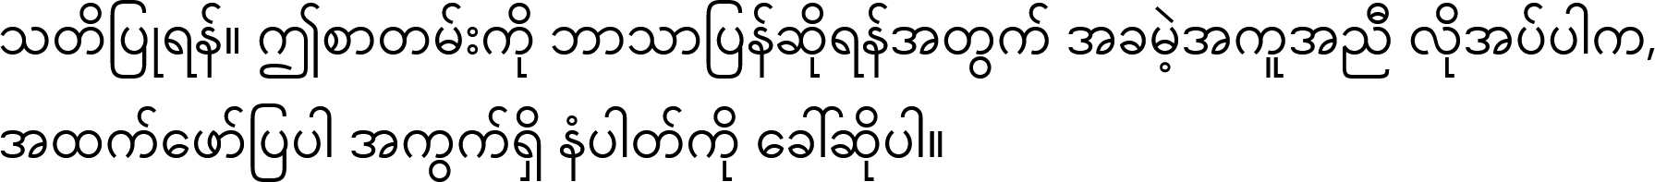

Burmese

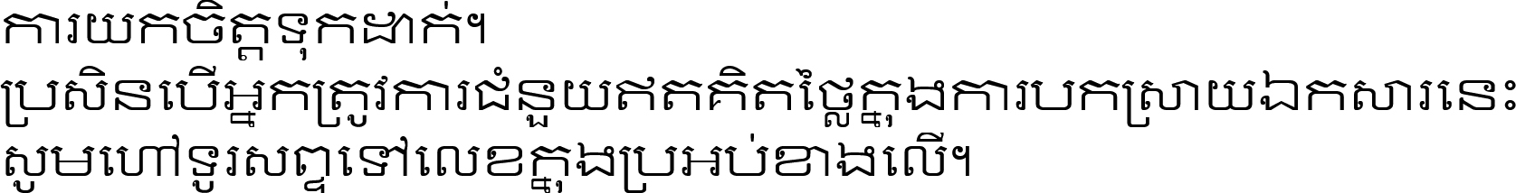

Cambodian

Cantonese (Traditional Chinese)

wáŋ. héčiŋhaŋ niyé wačhíŋyAŋ wayúiyeska ki de wówapi sutá, ečíyA kiŋ wóiyawa ed ophíye waŋ. Dakota

Paunawa. Kung kailangan mo ng libreng tulong sa pag-unawa sa kahulugan ng dokumentong ito, tawagan ang numero sa kahon sa itaas.

Filipino (Tagalog)

Attention. Si vous avez besoin d’aide gratuite pour interpréter ce document, appelez le numéro indiqué dans la case ci-dessus. French



Gujarati



Hindi

Lus Ceeb Toom. Yog tias koj xav tau kev pab txhais lus dawb ntawm cov ntaub ntawv no, ces hu rau tus nab npawb xov tooj nyob hauv lub npov plaub fab saum toj no. Hmong

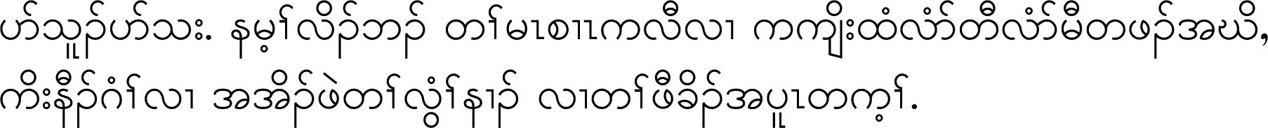

Karen



Korean



Kurdish Sorani

Baldarî. Ger ji bo wergerandina vê belgeyê hewcedariya we bi alîkariya belaş hebe, ji kerema xwe bi hejmara li qutiya jorîn re telefon bikin. Kurdish Kurmanji

Hoȟpíŋ. Tóháŋ waŋží thí wíyukčaŋpi kiŋ yuhá níyuŋspe héčha čhéya, lé tkíčhuŋ kiŋ k'é náŋpa opáwiŋyaŋ. Lakota

Image of Mandarin language



Lao

Mandarin (Simplified Chinese)

Pa̱lɛ rɔ piny: Mi gööri luäk lɔrä kɛ luɔ̱c kä mɛmɛ, yɔtni nämbär ɛmɔ tëë nhial guäth ɛmɛ. Nuer

Mah Biz'sin'dan.

Keesh'pin nan'deh'dam'mun chi'wee'chi'goo'yan chi'nis'too'ta'man oo'weh ooshii'be'kan.

Ishi'kidoon ah'kin'das'soon ka'ooshi'bee'kadehk ish'peh'mik ka'shi ka'ka'kak. Ojibwe

Hubachiisa:-Yoo barreeffama kana hiikuuf gargaarsa bilisaa barbaaddan, lakkoofsa saanduqa armaan olii keessa jirun bilbilaa Oromo

Atenção. Se você precisar de ajuda gratuita para interpretar este documento, ligue para o número na caixa acima. Portuguese

Внимание! Если Вам нужна бесплатная помощь в переводе этого документа, позвоните по телефону, указанному в рамке выше. Russian

Pažnja. Ukoliko vam je potrebna besplatna pomoć u tumačenju ovog dokumenta, pozovite broj naveden u kvadratu iznad. Serbian

Fiiro gaar ah. Haddii aad u baahan tahay caawimo bilaash si laguugu turjumo dukumiintigan, wac lambarka ku jira sanduuqa sare. Somali

Atención. Si necesita ayuda gratuita para interpretar este documento, llame al número que aparece en el recuadro superior. Spanish

Zingatia. Iwapo unahitaji msaada usio na malipo wa kutafsiri hati hii, piga simu kwa namba iliyo kwenye kisanduku hapo juu. Swahili



Tigrinya

Увага! Якщо Вам потрібна безкоштовна допомога в перекладі цього документа, зателефонуйте за номером, вказаним у рамці вище. Ukrainian

Xin lưu ý: Hãy liên hệ theo số điện thoại trong ô trên nếu bạn cần bất kỳ sự hỗ trợ miễn phí nào để hiểu rõ về tài liệu này. Vietnamese

Àkíyèsí. Tí o bá nílò ìrànlówọ́ pẹ̀lú tí tú mọ̀ àkọ̀ọ́lẹ̀ yìí, pe nọ́mbà tó wà nínú àpótí tí wà ló kè. Yoruba

LB (7-24)

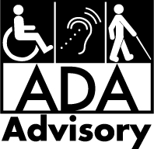

For accessible formats of this information or assistance with additional equal access to human services, email us at [DHS.info@state.mn.us,](mailto:DHS.info@state.mn.us) call 651-431-2000, or use your preferred relay service.

ADA1 (3-24)