MN WAPLink User Guide
Effective Date: July 1, 2026
Updated: June 17, 2026
Weatherization Works


Contents
MN WAPLink User Guide 1
Summary of changes from July 2025 version 5
How to use this guide 5
Finding content 5
WAPLink Introduction and set-up 6
General navigation 6
Priority Point set-up 7
User management 7
Security Groups 9
Customer search 10
Section 1: Program management 11
Adding or managing tasks and alerts 11
Email alerts and templates (currently state function only) 11
Costing setup 12
Documentation 20
Section 2: Client intake and management 22
Household eligibility - Client List/Eligibility List 22
Waitlist 23
Setting schedules 24
Additional housing information 26
Section 3: Home information 28
Entering and reviewing home information 28
Deferral Queue 28
Section 4: WAPLink – Audit 30
Beginning the audit input process 30
Co-funding ECMs 42
NEAT audit data entry 42
MHEA audit data entry (differences from NEAT only) 64
Multifamily project entry 72
EAPWX Expansion Measure specific guidance 76
Audit events 79
Callbacks 80
Section 5: Standalone events 82
Definition of standalone event 82
Quality Control Inspection tests 83
Additional information and resources 83
Section 6: ​Final steps-Completion, closeout, and locking jobs 83
Overview 83
Section 7: Fiscal management 87
Fund/grant management and braiding instructions 87
Budgets 89
FSRs 91
Cash requests 91
Section 8: Procurement 93
Vendor management 93
Documentation Entry tab 96
Document specific information 99
Employee Entry tab 101
Employee document specific information 103
Section 9: Monitoring 104
Section 10: Reports 104
My Reports 104
Custom Reports 105
Appendix A: Definitions 107
General 107
Inventory and Settings (a.k.a. “Library”) 107
NEAT Key Parameters definitions 108
MHEA Key Parameters definitions 109
Stages and Statuses definitions 111
WA Active Measures 112
Appendix B: Document standards 113
Documentation standards 113
Site Drawing requirements 113
Appendix C: Measures – updated policy language 114
Energy Conservation Measure (ECM): 114
Incidental Repair Measure (IRM): 115
Health and Safety Measure (HSM) 116
General Heat Waste (GHW) 117
Appendix D: Notes from NEAT input process 118
Home components 118
Appendix E: Energy audit diagnostic tests 123
Appendix F: QCI Diagnostic tests 124
Appendix G: ASHRAE guidance updates 126
Frequently Asked Questions (FAQ) 126
Appendix H: Air Sealing guidance updates 130
Frequently Asked Questions (FAQ) 130
Appendix I: Policy Guidance additions MN WAP Policy Manual 137
Section 1: Program management 137
Section 2: Eligibility and service requirements 137
Section 3: Dwelling eligibility 137
Section 4: Audit event 137
Appendix J: Expire Alert quick reference table 140
Appendix K: Checklists 141
Dwelling Eligibility for Priority List Checklists 141
Audit Checklists 141
Form C Checklist – Combustion Safety 141
Form H Checklist – Health and Safety 141

Summary of changes from July 2025 version
Based on input from Service Providers, Commerce has made the following changes to the user guide:
- New structure: This structure streamlines the step-by-step WAPLink processes, includes references to source documentation, and moves definitions, general information, and updates to policy to an appendix. Relevant appendices are accessible from their respective location in the main body via linked cross references.
- Updated and additional content based on service provider feedback
- Updated references to WA and WAPLink, as appropriate
- Additional links to source material: Some source material (such as references to the policy manual) has been converted to links to the original material
- Inclusion of temporary procedures made permanent
- Added Definitions appendix
- Verified process accuracy where applicable

How to use this guide
This guide is intended for Weatherization coordinators, field and admin staff who use WAPLink.
Within WAPLink, there are various ways to get to the same place. This guide is intended to walk users through the entire Weatherization process, from client intake, to energy audit, to work order creation, to closeout, to reporting and tracking and is broken into sections that generally align with the WAP Policy Manual. In many instances, this will follow the navigation in the left pane of WAPLink but note that there are points in the guide that depart from this sequence.
For the most up-to-date information, use the web-based version of this guide.

Finding content
To find content and navigate the document:
- Use CTRL+ F to open the Navigation panel.
- To find specific content:
  - Use the white box to type any word or phrase you are looking for, making sure it’s spelled correctly
  - Use the arrows below the white box to find all the instances of the word or phrase you used within the document
- You can access the nested table of contents, including links to each section with a header, at any time
  - Under the white box are three options: Headings, Pages, and Results. Choose the Headings options to show all of the headings in order.
  - Use the arrows to expand to see more or collapse to see fewer headings
  - Click on the heading of the section you wish to navigate to.
- Continue to refer to WAPLink Hub for Frequently Asked Questions (FAQ’s) and other resources.

WAPLink Introduction and set-up

General navigation
The menu is located on the left side of the screen. You can minimize the menu by clicking the arrow at the very top left of the screen.
Options within the menu include:
- Customer Search
- Contact Center
- Today’s Tasks/Alerts
- My schedule
- Agency schedule
- My Reports
- Custom Reports
- Document Center
- Client List
- Waitlist
- WAPLink (click on downward arrow for subcategories)
- My SP (click on downward arrow for subcategories)
- My SP Setup (click on downward arrow for subcategories)
- WAPLink Help
All screens operate in similar ways. Most functions require the user to click New to create something new and Save to save your work.
The following are common functions within WAPLink:
  - New
  - Save
  - Cancel
  - Delete
  - Minimize
  - Maximize

Within the audit section, there are additional functions:
  - Information
  - Copy
  - Images
  - Measures

Priority Point set-up
The primary priority points are set up by Commerce based on information provided by each Service Provider. Additional points can be added by the SP following WAP Policy 2.2.

Setting up additional points and adding points to client record

Set up additional points

WAPLink process
- Go to WAPLink
- Click on Settings
- Click on WL Add Points
- Click New
- Enter the Category (description of the priority)
- Enter Point Text (name)
- Enter Additional Points (point value)
- Enter Point Ordering (priority order)
- Click Save

Add Points to client record

WAPLink process
- Click on the client
- Click Add Points
- Choose the points to add
- Click Save

User management

Adding users, password reset, deactivating users, and signatures

Adding users to WAPLink
Training Resource: LITT People Entry on Vimeo

WAPLink process
- On the left-hand side, expand My SP Setup
- Scroll down to Security and expand
- Click on WAPLink People
- A form will open. Click New on the top of the menu.
- Fill out the appropriate fields
- Click Save
- Then click on Security Definitions. A new window will open.
- Click New
- At the bottom of the window use the dropdown to assign the Security Group
- Select System Admin. Note: We will continue to work on security groups for the live version.
- Click Save
- System Admin should now appear under the Security Group
- Repeat steps 8-11. This time, select WAPLink as the security group
- Click User Password Reset. This will prompt the user to change their password when they login
  - You should get a prompt to verify to force a user to reset the password
  - Select Yes
  - A message will appear in the lower right corner of your screen saying Password Reset Request completed
- Provide users with their usernames and ask them to login, using only username
  - Click Enter and WAPLink will force the user to add password

User password reset

WAPLink process
- On the left-hand side, expand My SP Setup
- Scroll down to Security and expand
- Click on WAPLink People
- Choose the employee
- Click on User Password Reset
- A popup will ask if you want to force the user to reset their password when they next login; click Yes
- When the user next logs in, they will enter their username then click Enter

Deactivate user login

WAPLink process
- On the left-hand side, expand My SP Setup
- Scroll down to Security and expand
- Click on WAPLink People
- Choose the employee
- Click on Deactivate User Login
- A popup will ask you to verify you want to deactivate the selected user, click Yes

WAPLink person signature

WAPLink process
- On the left-hand side, expand My SP Setup
- Scroll down to Security and expand
- Click on WAPLink People
- Choose the employee
- Click on WAPLink Person Signature
- Using your mouse, sign the lower half of the screen, click Submit
  - Note: Only the employee has access to this signature

Security Groups
This allows you to control what each user has access to by adding or removing them to security groups or giving them certain individual rights.

Security Group assignment and modification
Training Resource: https://vimeo.com/682980374/c943121487

Add Security Group for employees

WAPLink process
- Click on WAPLink People
- Click on the employee’s name
- Click on Security Definitions
- Click New
- Choose the Security Group from the dropdown list
- Click Save

Delete Security Group for employees

WAPLink process
- Click on WAPLink People
- Click on the employee’s name
- Click on Security Definitions
- Click on the Security Group you wish to remove
- Click Delete

Add individual rights

WAPLink process
- Click on WAPLink People
- Click on the employee’s name
- Click on Security Definitions
- Click Security Overrides
- Choose the Security Definition from the dropdown list
- Choose the Rights (N – No Access; R – Read Only; D – Read/Write, No Delete; W – Read/Write/Delete)
- Click Save

Add additional Security Group

WAPLink process
- Security groups are limited to those currently set up. If you need an additional group, send a request to Commerce and include the name of the group and screen access categories, and rights. Commerce will decide whether an additional group is warranted.

Customer search
A search database for clients that have been moved to the Waitlist. Clients can be searched by any of the fields as long as that information is available.
Note: The search field phone # only recognizes numbers with hyphens. The client’s number in their customer portal must include hyphens if you want to use this search feature.

WAPLink Process
The customer search also allows you to find clients that may not appear in the home queue. This can happen if the client is manually created, e.g. not imported from eHEAT. You’ll need to follow these steps to schedule the client.
- Click on Customer Search
- Enter the client’s Household ID
- Click Search
- Double click on the client
  - The customer report screen will open
- Click on Wx Link
  - The points call list screen will display
- Click Schedule

Section 1: Program management

Adding or managing tasks and alerts
You can manage your tasks and alerts for today or for other dates by selecting another day, week, or month.
- Click on Today’s Tasks/Alerts from the lefthand navigation pane or dashboard.
- Select the day, week, or month you are interested in
- From there you can Add or Complete tasks
- To delete, click Complete to bring up the list of tasks, select the tasks(s), click Save
- To add a task, click Add, enter the task details, click Save

Email alerts and templates (currently state function only)
The purpose of this module is to identify and alert staff, via email, when certain financial management functions have been conducted. Notify Commerce when changes are needed.

Adding and editing email alerts
This function is managed by Commerce and allows them to set up alerts to push out to SP staff. SPs are unable to view or edit these.

Email templates
SPs can set up email and customize templates to send with work orders or communicate with a vendor.
Create a template

WAPLink process
- Go to My SP Setup
- Click on Email Templates
- Click New
- Enter Template Name
- Enter Template Type
- Type the message into the text box
- Click Save

Access the template

WAPLink process
- Go to Waitlist
- Click on the client
- From the tab that opens, click on the mailbox icon
- Enter the From email address
- Enter the To email address
- Enter the Subject Line
- Choose the Template
- Click Show for font styles and modification
- Click Send

Costing setup
The costing setup is a major component to determine what installations will meet program guidelines.

Inventory
Inventory is a list of all materials and their prices that can be pulled into kits or work orders, which used to be located in the WA Library. For definitions of inventory and various settings, refer to Appendix A: Definitions.

Inventory search
The Inventory functionality can be used to keep track of in-house inventory. It can also be used as simply a database for items that are commonly used. Items from the Inventory list are used to populate work orders, WL measures, and kits.
Inventory items can either be entered from an existing State list or can be entered manually.

WAPLink process
- Click WAPLink to open the dropdown menu
- Click Inventory
- Click Inventory Search to open the Inventory Viewer window
- Use this window to enter key words into the search bar to find items on the Statewide or Agency inventory lists

Add items from the State list to your agency inventory

WAPLink process
- Select the Statewide radio button
- Select an item from the list
- Click Add to Agency Listing button
- Enter desired product details, quantity, and costing information.

Create your own inventory items

WAPLink process
- Select the Statewide radio button
- Type any key into the search bar. The New button will appear above the search bar.
- Enter desired product details, quantity, and costing information
Note: To remove an inventory item, click the Remove to Agency Listing button.

Adding agency inventory

WAPLink process
- Select the Statewide radio button at the top left of the window
  - This will display any inventory entered statewide that is available to add
- Search for the product you are adding to inventory in the Search field at the top left
  - If your search result doesn’t show the desired item, select new that now appears
    - This will open a blank record to then add an inventory item
    - The only required fields are item number and description
- The remaining fields to enter include:
  - an inventory category that can be added to from file maintenance
  - a UPC code lookup that can add manufacturer details based on the database info for the UPC code
  - the option to link the inventory item to a WA 10 material for both NEAT and MHEA
- Select Save at the top left
  - This will enable the location view, adjustments, and PO view at the bottom of the inventory window. Location view shows an inventory count for all inventory locations for your agency added through file maintenance.
- The Adjustments button will allow editing of all inventory items to be the most up to date count
  - Note: This can also be the first step in adding existing inventory
  - To add an item, select new at the top left and then choose a location in the dropdown
- Edit the new on hand field which will replace whatever the current on hand count is
- Edit the reason field to describe the need for the modification
- Click Save and the inventory will be updated
  - PO view will display any open purchase orders for that specific inventory item

Inventory price update
This page is used to update prices of multiple inventory items efficiently.
Note: The search function box, if used, will tab itself down into the inventory and start overwriting your existing prices.

WAPLink process
This page is used to update prices of multiple inventory items efficiently.
- Click on an item
- The New Cost column will become editable
- Update costs and click Save
- The updated costs will be used for any work orders created after the updated prices are saved
  - The cost will also be updated in any WL measures that include the item

Settings
Settings includes various lists of measures and their costs, which were previously located in the WA Library. For definitions of inventory and various settings, refer to Appendix A: Definitions.

WAPLink Setting Group
WL Setting Group creates the NEAT and MHEA grouping for the agency that each library belongs to. By making a setting group, you then can choose this group on following screens and links to each of the related settings.
Note: This must be updated annually by the Service Provider and is recommended to use the Program Year (PY) within the designation. This allows you to create a new Setting Group with updated WA Insulation, WA Active Measures, and WA Measure Costs each year.

WAPLink process
- Click on WAPLink
- Click on Settings
- Click WL Setting Group
  - The WA Setting Group screen will appear
- Select a Setting Group Name
- Select Copy/Archive
  - WA Setting Copy/Archive screen will appear
- Create a New Setting Group Name
  - Ex: PY26 [agency] NEAT
- Select agency
- Select ‘No’ for Archive After Processing
  - If ‘Yes’ is selected for archive, after processing, it will make the previous library only available on jobs that had it selected and saved.
  - Selecting ‘No’ is recommended until current jobs are completed and after 7/1 the old setting group can be archived.
- Click on Process
  - Your new setting group will appear under the Setting Group Name
  - Now you can navigate to WA Measure Cost to update pricing for the new program year with the new setting group.
- Repeat steps for MHEA Setting Group
- To Copy or Archive your current WL Setting Group, select the appropriate Setting Group Name and click on the Copy/Archive button on the top
  - From here, you can simply archive the current Setting Group, and it will hide it from being used on all new projects
  - If you are preparing for your new Program Year, you can create a copy by entering a New Setting Group Name and either select Yes or No to Archiving After Processing for your old Setting Group. Select your agency name, if not already selected and then select Process.
Reminder, ensure you select NEAT if it is a NEAT Setting Group.

WA Fuel Cost (Statewide – non-editable)
The WA Fuel Costs are the statewide fuel prices that will be used in any NEAT or MHEA audit and are updated annually. For more information on WA Fuel costs, refer to Appendix A: Definitions.

WA Insulation (non-editable)
This form allows you to name and characterize custom user-defined insulation types, which allows you to define additional insulation types for each component to meet local needs.

WAPLink process
- Click on WA Insulation under the Settings dropdown in WAPLink
- Select the appropriate Setting Grouping
- Scroll to the appropriate Usage. Options include: attic spaces, knee walls, walls, floor, sill spaces, and foundation walls.
Notes:
The engine does not average the cost per R across library entries (R11, R19, etc.) and multiply by the Added R value entered by the user. Rather, it employs linear interpolation or extrapolation based on the two library R-values that bracket or are closest to the requested value. Essentially,
  - If the requested Added R matches a standard library value for which costs have been supplied, the NEAT engine uses that cost directly.
  - If the requested Added R falls between two library R-values, the engine performs linear interpolation between those two costs.
  - If the requested Added R falls outside the range of provided library values, the engine performs linear extrapolation using the nearest two values.
- When you enter a description string and R (or R/in) value in this form, NEAT and MHEA will include cost detail records for those types in the WL Measures tab for the associated measures.
- The Added Insulation Type fields on the Walls, Unfinished Attics, Finished Attics and Foundations forms in the NEAT and MHEA building description allow specification of the type of insulation to be considered when insulating these components.
- Below these insulation type names are blank, editable fields into which you may enter the names of additional insulation types of your choosing. To the right of these material names are numeric fields giving the R-values per inch or total R-Value of the material you are defining. The R-values have dimensions h-ft2 -F/Btu. Entries in these fields permit your defined insulation types to have the physical characteristics needed by the NEAT audit that you desire. Required for named insulation types.
- For the program to seriously consider use of an insulation type you add, a reasonable cost must be entered on WA Measures Cost form corresponding to the envelope component using the insulation.

WA Key Parameters (Statewide–non-editable)
The WA Key Parameters are statewide fields that provide the flexibility of modifying some of NEAT’s and MHEA’s inputs and assumptions. These are updated annually by Commerce and designated by the appropriate Program Year.
Refer to Appendix A: Definitions for NEAT and MHEA Key Parameters.
Note: Some Key Parameters require specific security levels to edit. Reach out to WAP if you need to edit a field but are unable to.

WA Active Measures (Non-editable)
WA Active Measures is used to enter information about the measures you want NEAT and MHEA to consider while evaluating an audit. The “Library” measures are those which have been programmed into NEAT and MHEA, as opposed to any user-defined measures you may have generated as a WL Measure.
For definitions of Measure Name and Active, refer to Appendix A: Definitions.

WAPLink Process
Select the appropriate Setting Group for either NEAT and MHEA to access the list of Measures which displays the Engine Number, Measure Name, and whether the measure is Active or not.

WA Measures Cost
Each measure listed on the WA Active Measures form has the measure life and an associated cost. NEAT and MHEA use these costs for evaluating the cost effectiveness of measures. On this form, the cost components for a measure are restricted to three entries: Material, Labor, and Other.
Notes:
Paying close attention to the “Units” of the “Other” cost component will assist you in deciding when it is appropriate to use this entry for any specific measure. The entries in the Units column are required, though they are permitted to be zero, if no material has zero cost per unit for all three components. The total cost for a measure will be the sum of the costs from the three components, using the quantities in the units indicated from the specific audit being evaluated.
- Most of the insulation measures, cooling system, and lighting retrofit measures have multiple materials that may be used in installing the measure. In such instances, each material will have its own set of Material, Labor, and Other cost components.
- Separate entries may be made for the dollar cost per unit to purchase the material and the dollar cost per unit for labor to install the material.
  - Both NEAT and MHEA simply add these two quantities together (they always have the same “Units” associated with them) in determining the cost of installing the measure. The third component to the cost for each material, “Other,” will likely have different units than the material and labor components. Entry in this column may be handled differently in NEAT versus MHEA and may not be appropriate for many measures in NEAT.,

WA Measure Setting – Life (non-editable)
The WA Measure Settings expands on the WA Active Measures and includes the measure life. NEAT and MHEA allow you to change the “life” of each measure.
Note: The lifetimes in the programs as shipped reflect industry standards and will likely be sufficient for your use.
- If you have documented cause to alter them, you may do so on this form.
- For some measures, the life may depend on the specific material being used in your program.
- Lifetimes for “Lighting retrofits” are in thousands of hours burn time for the replacement compact fluorescent, not years.

WL Measures (a.k.a. “User-Defined Measures”)
WL Measures, previously known as User-Defined Measures, can be used to predefine weatherization activities that are not addressed within the library measures but commonly encountered during an audit. For a definition of WL Measures refer to Appendix A: Definitions.
Also accessible from this form is a library of predefined health and safety measures. These are measures associated with specific health and safety hazards which may be observed during an audit.
Note: Activities that you define (those other than the library health and safety measures) may or may not have energy savings associated with them.
- Those without energy savings are referred to as “itemized costs.” They may be repair costs, administrative costs, etc.
- Those for which you have assigned energy savings will be considered exactly as any of the library measures defined in the program.
They will be ranked by SIR and recommended only if their SIR meets the established criteria. Additional input is required for this type of user-defined measure, as described below.
The WL Measures form is divided into three sections:
- General task description on the top of the form,
- Materials/Labor Details sub-form in the middle, and
  - This sub-form is multi-component, allowing any number of material or labor components to be associated with each user-defined measure.
- Measures record navigation block, the Measure Comment field, the “View” drop-down list and the “All User Measures Costs” button at the very bottom of the form.
Users can either add WL measures from an existing State list or they can create their own.

WAPLink process: Add a measure from the State list
- Open WL Measures
- Check the Add State Measure Mode box
- Use the search bar or scroll to identify the desired measure
- Select the measure and confirm you would like to add it
- To remove a State Measure, open the measure and click the Remove State Measure from Agency button
- To see your agency’s list of WL measures, uncheck the Add State Measure Mode box on the WAPLink Measure Viewer screen

WAPLink process: Create your own WL measure
- Open WL Measures
- Enter the measure name. This is the only required field.
- For both state measures and manually entered measures, you can select criteria that apply to the measure by using the drop downs and check boxes on the WAPLink Measure Entry screen
  - Choose whether the measure can be used in NEAT, MHEA, and/or EA-Quip (multiple can be selected)
  - Choose whether the measure can be used for an Audit, Standalone, or Pre-WX work order
- A WL Measure can be linked to a library measure from the audit run. When the audit returns the linked library measure, the Default Kit from the linked WL Measure will auto populate into the work order.
- Click the WA 10 Links button on the WAPLink Measure Entry Page
- Select the Library Measure(s) to link
- Click Save
WL Measures can either include just a Material amount and a Labor amount (more common for contractor-based agencies), or it can include detailed lists of individual materials (more common for crew-based agencies).

WAPLink process: Material/Labor costing only
- From the WAPLink Measure Entry screen, click the Materials/Labor button
- Enter your Material, Labor, and Other (optional) amounts. Including GL codes (entered in file maintenance) is optional.
- Click Save

Manual Measure Cost Limit
The maximum allowed value for a Manual Measure is $10,000.
This limit is established by ORNL (Oak Ridge National Laboratory) as part of the development of WAv10. During system design, reasonable maximum values were defined for select inputs to ensure modeling consistency and data integrity.
The purpose of the $10,000 limit is to:
- Allow sufficient flexibility for typical single-measure costs
- Establish a practical upper boundary for manual entries
- Encourage a secondary review when costs exceed typical ranges
If the total cost of a measure exceeds $10,000, the measure must be split into multiple Manual Measures. The combined total of the split measures must equal the full project cost.
This approach ensures accurate cost representation while remaining within system constraints.

Building Kits
A kit is a breakout of materials and labor pricing within a measure to speed up data entry for work orders. It’s not required, and you can simply enter that info each time you create a work order instead.
Note: WAP is aware of bugs in this section and is troubleshooting the issue.

WAPLink process
- From the WAPLink Measure Entry screen, click the Materials/Labor button.
- Enter your Material, Labor, and Other amounts. Including GL codes is optional.
- Click Save
- Click the Kit Details button
- Click New
- Enter a Kit Label and click Save
- Click the Edit button
- Add line items into your kit. To add materials from your inventory:
  - Click New
  - Click the Material radio button
  - Click the Search button to view and selected materials from your inventory.
  - Enter Quantity. If you have a cost and/or unit of measure associated with a material in your inventory, it will auto populate.
- To keep line items in a certain order within the kit, use the Ordering box to number the line items
- Click Save
- Repeat process for each line item added to the kit
- If you would like a note to be associated when the kit is used in a work order, click Kit Notes and enter your note. Click Save.
- Multiple kits can be associated with the same WL Measure. To create additional kits, use either the New or Copy button at the top of the WL Measure Kit screen to build additional kits.
Note: To use the WA 10 Links functionality, you need to select a default kit. If you used Material/Labor costing only, you would need to make a kit and check the Default Kit box. The kit can simply have Material and Labor line items.

Documentation

Uploading documents

Creating a document type and uploading documents to the Case Document Job screen

WAPLink process
- Select My SP Setup from the lefthand navigation pane
- Click File Maintenance
- Select Entry Values D-E (Figure 1)
Figure 1. File Maintenance window
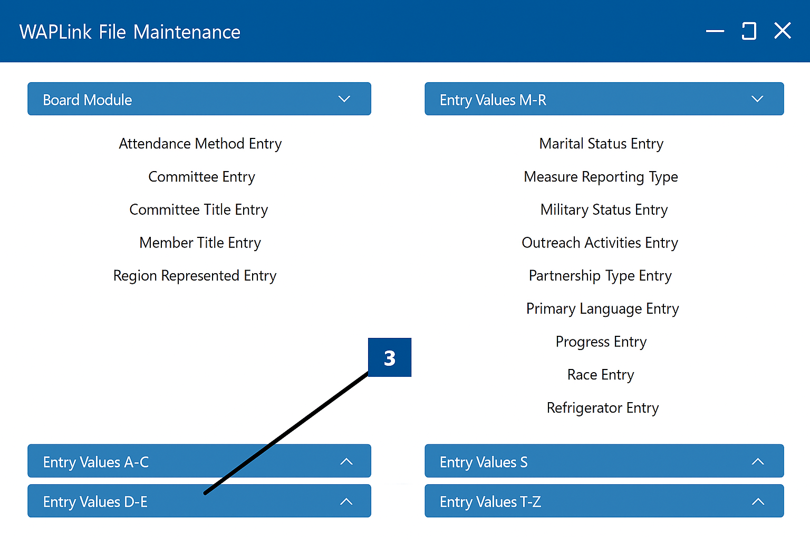
- Click Document Type Entry
- Select Document Type
- Click New
- In Document Type, name the document
- Select the agency this file applies to
- Click Save
  - You will see the document you created on the left side of the window

Displaying the document

WAPLink process
To display the document, you created you must make it available.
- Select the document you’d like to make available
- Select Availability
- Click New
- Under the Section header
  - Click Case Management
  - Click Save
- Under the Section header
  - Click Customer Intake
  - Click Save

Uploading the document

WAPLink process
Now you can upload the completed document to the Case Document Job screen.
- Click on the client in the Home Queue
- Click on the document icon
Figure 2. WAPLink Job window document icon
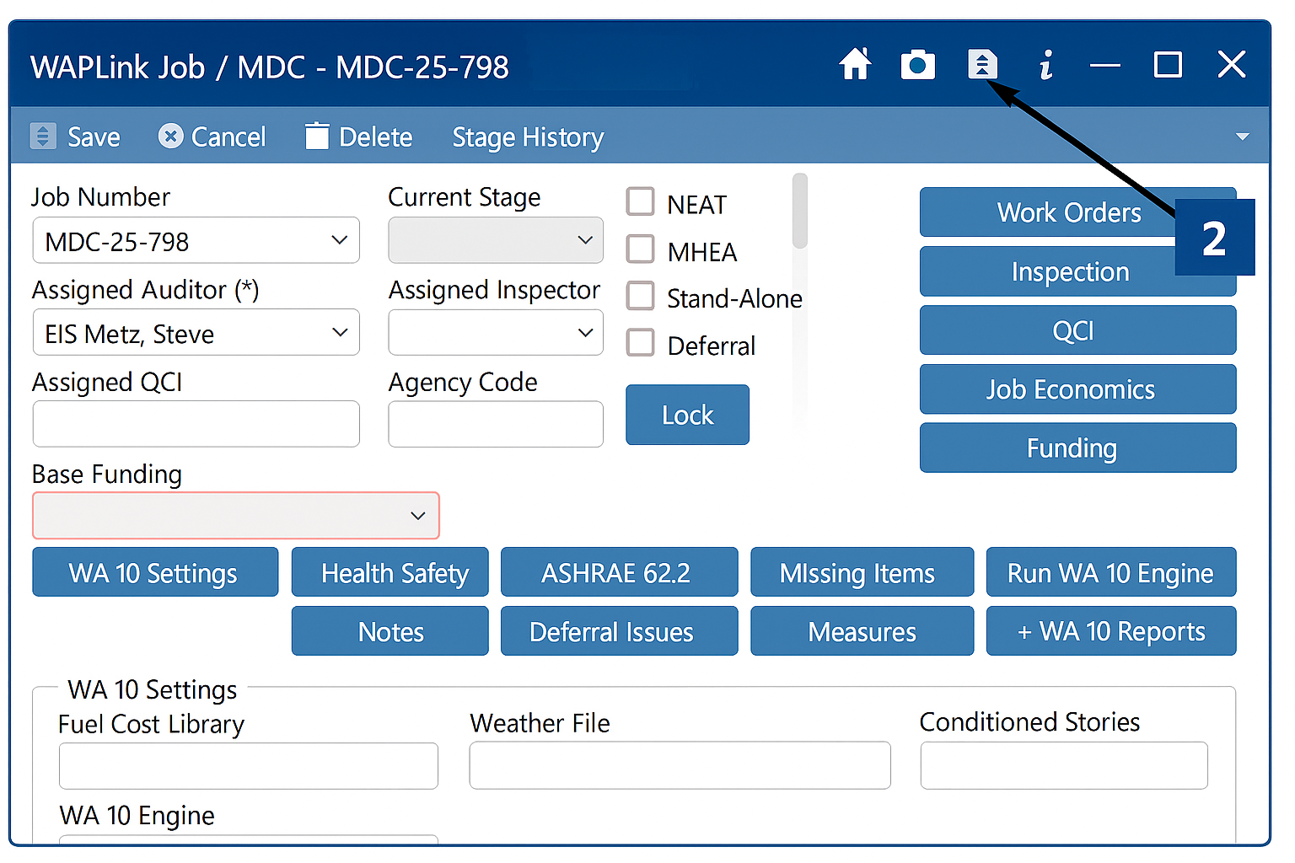
- Click New
- Under Document Type, select the corresponding document
- Select Browse
- Click Save

Section 2: Client intake and management

Household eligibility - Client List/Eligibility List
The Client List/Eligibility List is the definitive list of households that are income-eligible for weatherization services. Besides some situations with multifamily buildings, the Client List/Eligibility List serves as the sole source of eligible clients for the program. WAPLink is regularly updated with household data from eHEAT on a nightly basis. All information from eHEAT is locked in WAPLink and cannot be edited. If any client information is inaccurate, you will need to contact your local EAP service provider to have it updated.
- On the left-hand side, click on Client List
  - The Eligibility List screen will appear
- Enter any relevant data and click Search.
  - If the search is successful, the client will populate
    - If the client does not show up, then the client is either not in the system, not eligible, or data was entered incorrectly
    - If a blank client is required because the building is categorically eligible, reach out to Commerce to create a blank client
  - To select the client, click on the client you want to view
  - You will be able to see all the available information regarding the client, review their WAP Application, or move them to the Waitlist
  - WAP Application will include:
      - Date application was approved
      - Primary and secondary applicant
      - Contact info
      - Household member details
      - WAP priority categories
      - Dwelling/ ownership info
      - Utility information
      - Household fuel consumption data (if available)
      - Eligibility
      - LIHEAP eligible means the HH meets the EAP income & housing type guidelines and EAPWX funds may be used
      - USDOE means HH meets the USDOE income guidelines and USDOE funds may be used
Once on the Waitlist, you can move them to Deferral, Denial, or Not Interested list, or schedule them.

Waitlist
The Waitlist is used to move clients from the client list to the next step in the audit process. From this screen you can move a client to Deferred, Denied, No Interest, or Scheduled.
Training Resource: Outreach/Point list on Vimeo
- Click on Waitlist
- Click on the radio button for the status of the client (Active, Deferred, Denied, No Interest, Scheduled)
- You can sort the list by entering the information in the Filters or by clicking any of the headers. to sort the list
- Once you identify the HH you want to manage, double click on it
- This opens the Points Call List. You will see the house information, category, and associated points. From this tab, you can schedule the client, defer, deny, or mark the client not interested, or add notes.
  - Note: If the client is scheduled, you will need to click Resent to Active
- When complete, click Save

Setting schedules

Scheduling clients
At this point, the agency will schedule the client for the Energy Audit.
- On the left side of the screen, click on Waitlist
- This will bring up the WAPLink Waitlist screen. Enter any applicable information and click on the Search button on the right side of the screen.
- This will bring up all the applications that have been verified and waiting to be scheduled for Weatherization. Double click on the customer that needs to be scheduled.
- This will bring up the WAPLink Points Call List for the client. The agency can call the client to schedule the Audit and find out if the client wants to have Weatherization. At this point, there are three options.
Figure 3. WAPLink Points Call List with Schedule circled
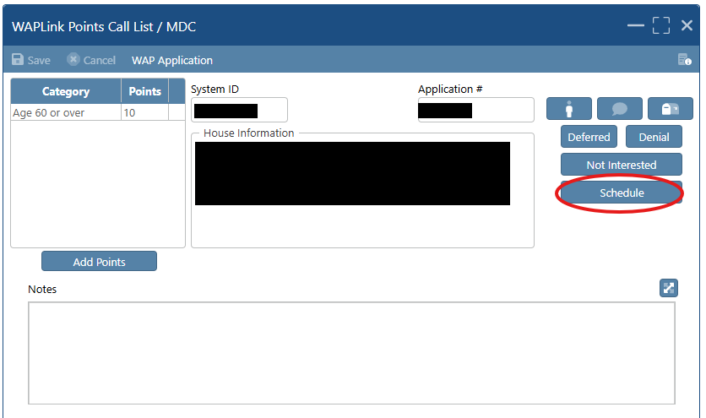
  - If the Client is called and does not want weatherization, then the agency will choose the Not Interested button on the right side of the screen
    - Answer the Please be Advised Question
      - Note: if the client said they were not interested in weatherization, choose Yes
    - This will remove the client and return the agency to the WAPLink Points List.
  - If the client informs you that they have a reason why weatherization cannot proceed, such as an active renovation project or the home is for sale, then click Deferred or Denial and move the client from the Waitlist.
  - If the client is interested and there is no reason to deny or defer services, then the client can be scheduled. Click the Schedule button on the right side of the screen (Figure 3).
    - This will bring up the Schedule Entry screen
    - Click on the New button at the top of the screen
      - Enter the Start Date/Time
      - Select Energy Audit from the Appointment Type dropdown
      - Choose the Agency Representative who is calling to schedule the audit
      - Click on Confirm in the Agency Confirmation box
      - Click on Confirm in the Customer Confirmation box
      - Click Save
        - If the client suggests a new date /time, the agency can enter the latest date/time in the box
        - Click Save
        - If the agency has already called the client and set up a Start Date/ Time, repeat 1 – 4 above
      - Click on Confirm in the Customer Confirmation box
      - Click on Save at the top of the screen. This will take you back to the WAPLink Points Call List for this customer.
      - Click on the X at the top of the screen

My schedule
When clients are scheduled for an audit, it populates your personal WAPLink calendar.
Training Resource: Schedule on Vimeo

View your calendar

WAPLink process
- Click on My Schedule
- Click on a day to view the calendar events for that day

Add event to calendar

WAPLink process
- Click on My Schedule
- Click on Add
- Enter the Event Description, date/time of event and add notes
- Click Save

Agency schedule
This view allows you to see the events for the entire agency.
Training resource: Schedule on Vimeo

View agency calendar:
- Click on Agency Schedule
- Click on a day to view the calendar events for that day

Add event to calendar
- Click on My Schedule
- Click on Add
- Enter the Event Description, date/time of event and add notes

Table 1. Client stages and definitions
Client Stage*  *These stages are not required and do not affect other areas of the system. Client stages may be used to keep track of job status. | Deﬁnition
Audit | Audit is conducted and being written up and work orders being created
Closeout | Last stage, after QCI for ﬁnal review stage
Completed | All work is completed, ready for closeout
Schedule | Schedule for audit or inspection
Work Order | Work is issued and being completed

Additional housing information

Safe at Home (SAH) Program

Implementing the Safe at Home (SAH) program
Reminder: Per Policy 2.3 SAH files and paperwork must be locked in a secure location, with access limited to the WAP Coordinator.

WAPLink process
- When a SAH client is identified for service, the Service Provider Coordinator must contact Commerce via email at weatherization.commerce@state.mn.us to request the client record be moved into WAPLink.
  - The request must include only the Client ID and County where the client resides.
  - Commerce will facilitate the process and notify the Service Provider Coordinator when the transfer has been completed.
  - After the client has been imported into WAPLink, the Service Provider staff member will communicate the client’s address to Commerce to be added into WAPLink. Once the developer has added the address, Commerce will notify the Service Provider.
  - If any other private data is required for an inquiry, the request must be made via encryption or uploaded to Box.com.
- Delete the Household Member names (First and Last) from the WAPLink Customer information screen.
- Replace the First Name and Last Name with the HH#
  - In the example below, the First and Last names have been replaced by a seven-digit number, in this case, all zeros.
Figure 4. Example of first and last names replaced with household number
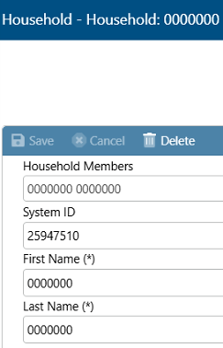
- Select the check box Hide Sensitive from Search
  - This will prevent SAH clients from appearing in the WAPLink Customer Search function. Only the staff member who creates the customer can view the SAH client.
- Repeat steps 2-4 for all Household Members
  - This will prevent names from showing up on work orders
- Navigate to the Address screen
- Delete the imported address (most likely a PO box)
- Enter the real physical address
  - This will populate on work orders for crews/contractors
  - Ensure real names and addresses are never on the same document

Section 3: Home information
WAPLink Home Information provides details after a client has been scheduled for work. Users can check whether a home has been previously weatherized and access various queues that correspond to the client's workorder and production stage.

Entering and reviewing home information

Home information
This section provides information regarding the home and various queues where clients may be found.

Retrieving information

WAPLink process
- From the left-hand navigation, click WAPLink
- Click Home Information

Address history
To check if an address has been previously weatherized, you can verify via Address History.

Verification

WAPLink process
- Click on Address History
- Enter the address
- Click Search
  - If nothing comes up, the address is either not been previously weatherized or entered incorrectly.

Deferral Queue

Tasks within the Deferral Queue

Adding client to Deferral Queue
Note: You can enter deferrals from the Home queue but the functionality is limited in that Home queue; deferral entries do not appear to link the notes to the Deferral queue.

WAPLink process
Double click on the client’s name from the Waitlist
- Click the Deferred button
- Click Yes to “Are you sure you want to Defer this Application?”
- Click New
- Enter the deferral details (Deferral Issue Date, Stage, Condition, and Issue are required fields)
- Click Save

View the Deferral Queue

WAPLink process
- Click on Deferral Queue in left hand navigation under WAPLink, Home Information
- Enter the client Name or County or just press enter to see the entire list
- Click on the individual client to see the details or Remove From Queue

Section 4: WAPLink – Audit
This section covers the audit process from scheduling the audit through callbacks.

Beginning the audit input process
Note that data entry should follow site documentation standards. These are outlined in Appendix B: Document standards.

Normal process
- On the left side of the screen, navigate to WAPLink, Home Information, then Home Queue
  - This will bring up the WAPLink Home Queue screen
- Click on the client to begin the energy audit
- Select the appropriate Audit Event Type: NEAT, MHEA, Stand-Alone, Deferral, Priority List, etc.
- Assign Auditor
- Choose the Current Stage from the dropdown
- Enter the Agency Code
  - Agency code is for the agency to use a unique job number if they don’t intend to use the generated job numbers. It allows it to be searched by that code in the home queue and show on reports by that agency code.
- Select the Base Funding from the dropdown
  - This allows you to select the primary Federal funding source such as DOE or IIJA.
- Click Save

Priority List process

Create the PL audit event

WAPLink process
- Select the client in Home Queue
- Navigate to the client’s WAPLink Job menu
- Select Priority List and choose the appropriate Audit Event Type based on building type:
  - NEAT
  - MHEA
  - Low-Rise 5+
- Click Save

Download and complete required checklists

WAPLink process
- Download the applicable Checklists by housing type from Appendix K: Checklists:
  - Dwelling Eligibility
  - Form A – Audit Checklist
    - Form C – Combustion Safety Checklist
    - Form H – Health and Safety Checklist
- Complete the Dwelling Eligibility Checklist:
  - If the Service Provider (SP) answers False to any question, stop the PL process and proceed with a standard audit
  - If the SP answers True to ALL questions, continue the PL process

Upload documentation

WAPLink process
- Complete Forms A, C, and H
- Upload and save all checklists to the Client File in WAPLink (in the top right of the window, use the paper icon with the folded corner)
- Enter WAPLink data
- Complete all applicable fields in:
  - WA 10 Settings
  - ASHRAE 62.2
  - Notes (as needed)

Work orders
Work orders are automatically populated with the download. Measures can be copied to a new work order so it can be created if there are multiple trades and vendors associated with the job.
The SP is required to go through all measures and properly document any details around the measure, appropriate quantities and/or measurements, and estimated costs (whether set price or bid). If a measure is not completed because it physically cannot be done or is optional, the SP is to properly document, with notes and photos, and zero out the measure in WAPLink.
All statuses are required by MN WAP policy and all work is required to be completed as usual in accordance with SWS and other applicable codes and requirements.

Create work orders

WAPLink process
In the WAPLink Job menu, navigate to the Work Order tab.
- Create measures using either:
  - WAPLink Measures, or
  - Manual Measures
- The SP must:
  - Review all measures,
  - Document measure details,
  - Enter accurate quantities and measurements, and
  - Provide estimated costs (set price or bid)
- Measures that are optional or physically cannot be completed should not be created in WAPLink
- All work must meet SWS, applicable codes, and program requirements

Label measures

WAPLink process
- Label all measures using the following prefixes based on Form A:
  - PLM – Mandatory
  - PLO – Optional
- Use Quick Entry to edit measure names when using WAPLink measures
  - Example: PLM – Air Sealing

Finalize work orders
A solid, well-built energy audit and model is essential for accurate work orders and effective project delivery. The audit should closely reflect the expected scope of work, as costs and measurements between the audit and work orders should generally align.
At the same time, do not let the pursuit of perfection delay progress. Some variance is expected, and adjustments can be made as needed.
Before releasing work orders, if there are significant differences between the audit model and work order costs, update your inputs, re-run the audit, and re-generate the work orders. Otherwise, you risk measures dropping or changing.
To improve alignment, review your measure libraries for accuracy and use the additional cost fields as needed.

For agencies using a bidding process, once a winning bid is accepted, update the audit to reflect the awarded bid and re-run the audit to confirm the project remains cost-effective.
If alignment issues continue, it may be necessary to re-evaluate your pricing structure, audit procedures, and contractor or crew processes.

WAPLink process
- Assign the appropriate crew or contractor
- Complete the required Work Order Stage and Issue Date

Verify work order details

WAPLink process
- Open the appropriate HH in the Home Queue grid (Figure 5)
Figure 5. Work order highlighted
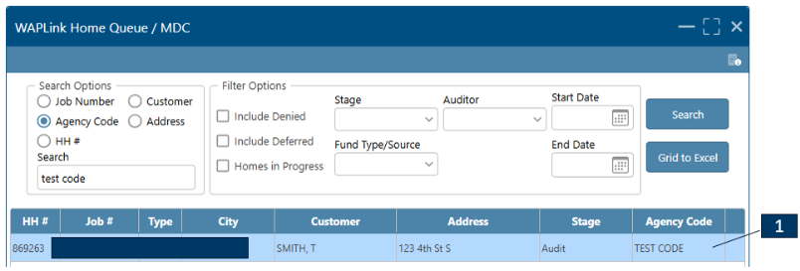
- Select Work Order
- Select the appropriate work orders (Figure 6)
Figure 6. List of work orders
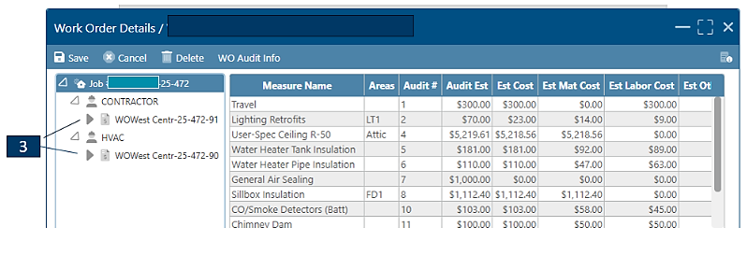
- When the work order is marked Active, the Issued Date is automatically populated (Figure 7)
- This date represents the official Notice to Proceed (job awarded)
- The Issued Date is editable, if necessary

Recording completion and invoice

WAPLink process
- When the contractor completes the work, update:
  - Completed Date = contractor’s completion date
    - Invoice Date = date the invoice was received or date of invoice
- Change Work Order Stage to Ready to Inspect
- The work order will now appear in the Inspection Queue
- Final costs can be entered before or after the inspection
Figure 7. Work Order Details page with Active status and Issue Date shown
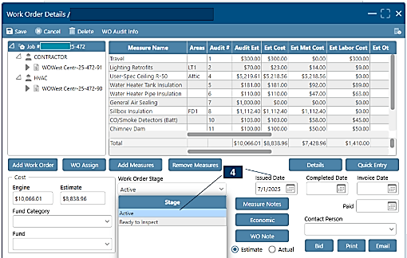
Figure 8. Work Order Details page with dates populated and Ready to Inspect indicated

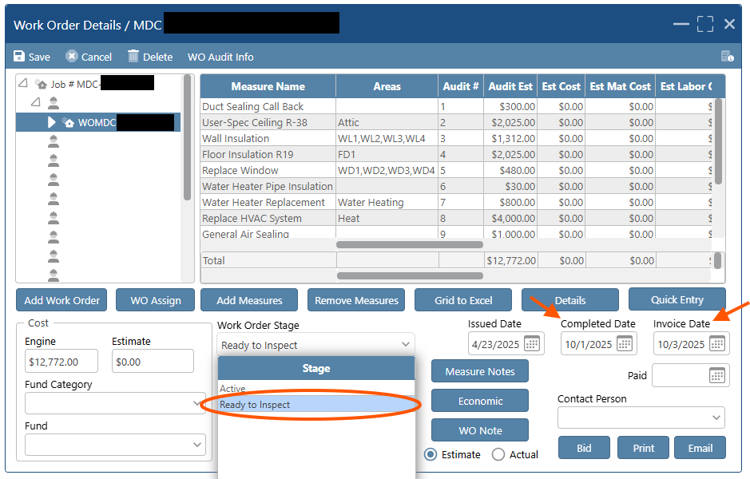

Inspection

WAPLink process
- Inspections may occur:
  - Per work order as jobs are finished, or
  - After all work is complete (agency discretion)
- Navigate to the Inspection from WAPLink Job menu or Inspection Queue, search for the household (HH), and select it (Figure 9)
Figure 9. WAPLink Job window with Inspection button indicated
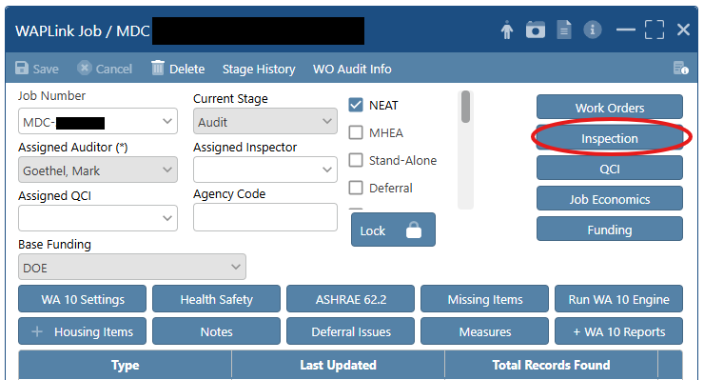
Figure 10. Inspection Queue window
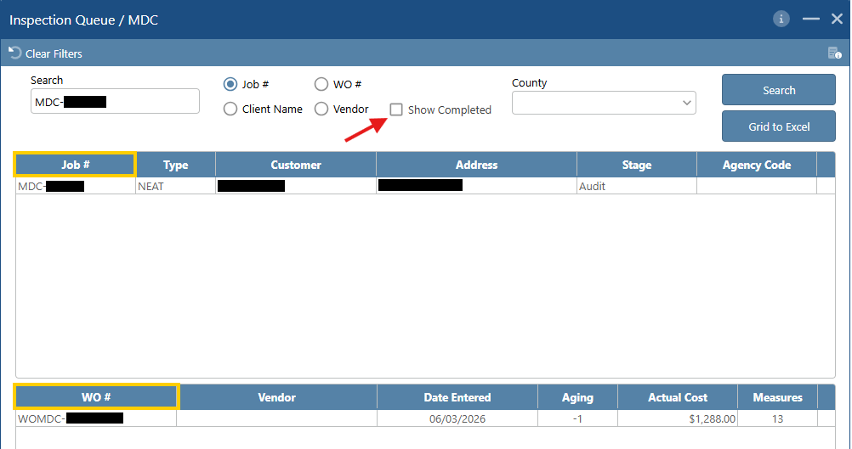
- The top half of the screen shows HH search results; the bottom half lists applicable work orders.
- If a work order seems to be missing, check Show Completed to display all inspection records with Pass/Fail status (Figure 10)
- Re-entering the HH may prompt: “Inspection Records are marked Passed. Do you want to update these records?” Selecting Yes will remove previous Pass/Fail statuses. Selecting No will keep existing statuses.

Reviewing measures

WAPLink process
- Select a work order to view measures, costs, SIRs, and dates
- For each measure:
- Mark Pass or Fail.
- The system will prompt you to move the measure/work order to the QCI Stage.
- A Completed Date is required for all measures. This represents the inspection date. This can only be added after you make a Pass/Fail selection. (Figure 11)
- If you update Pass/Fail statuses, it will also remove inspection data – if you have inspection notes, do not overwrite statuses.
Figure 11. Inspection form
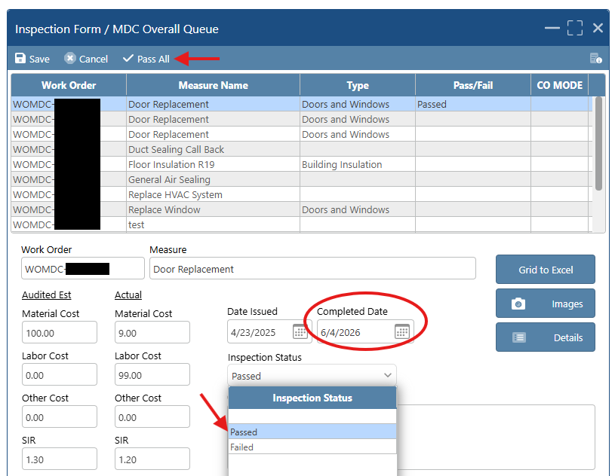
- Options:
- Pass All at once → then adjust any failed measures
- Move to QCI Stage now or later (agency choice)
- Households can be moved back and forth between Inspection and QCI stages if needed

***Known issue
  - SIRs are incorrectly showing on Inspection Form (ex. 1.30 and 1.20), this is still being reviewed by the developer.
  - Completed Dates may vary by measure. There is currently no “Copy All” function.
  - If a measure initially fails but then is corrected and passes, the system overwrites and we lose that history. We will work to capture that data for the file.
See ​Final steps: Completion, closeout, and locking jobs.

Change orders and re-running Energy Model

Overview
When a contractor is performing the work, a Change Order Form is required whenever the scope of work deviates from the issued work order. This includes the addition or removal of measures or any changes in measure costs from the agreed-upon bid or established price list.
When a Service Provider employee is performing the work, a Change Order Form is required when a measure is added or removed, or when the total work order cost changes by more than 15% from the issued work order.
Follow the process outlined above.
If you need to add or remove an Energy Conservation Measure (ECM) or Incidental Repair Measure (IRM), you must re-run the audit and regenerate the work order. Adding or removing a Health and Safety Measure (HSM) does not require an audit re-run.
A change in cost for an ECM or IRM does not require re-running the audit; however, you must ensure that the measure continues to meet SIR requirements at the work order level.
Minor model adjustments may be acceptable with proper documentation and an explanation for the deviation. If there is a significant change to the original model, the audit should be re-run and new work orders generated.
Re-running an audit after work orders have been issued should be limited, as it can cause measures to drop or introduce errors into the work order. Commerce recognizes that re-running may occasionally be necessary; in such cases, communication is expected if measures are dropped or fall below required thresholds. Braiding or co-funding of measures may be needed in some situations.
In all cases, the Change Order Form must be fully completed, reflect the updated scope of work and associated costs, provide justification for the change, and be included in the client file.
Commerce will continue to evaluate this process to ensure consistency and maintain the integrity of program implementation.

WAPLink process
- Open the work order and select Details in the bottom right corner (Figure 12)
Figure 12. Work order details window
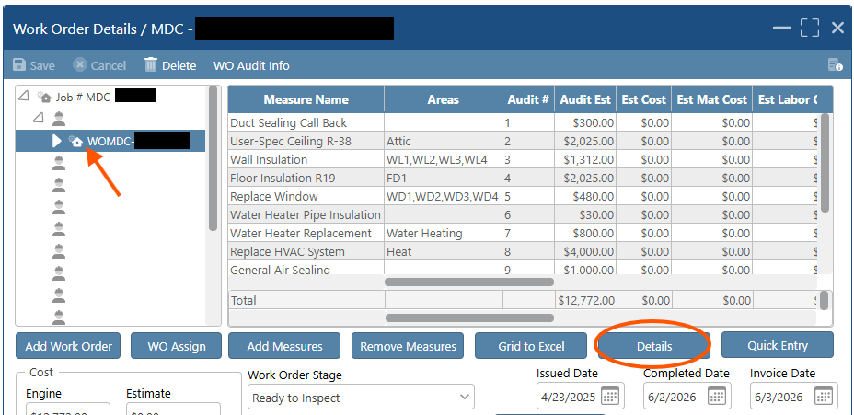
- Enter actual costs to represent the change
- Enter applicable notes
- Select Change Order and assign it a numerical value (Figure 13)
Figure 13. Bottom of Work Order Details window
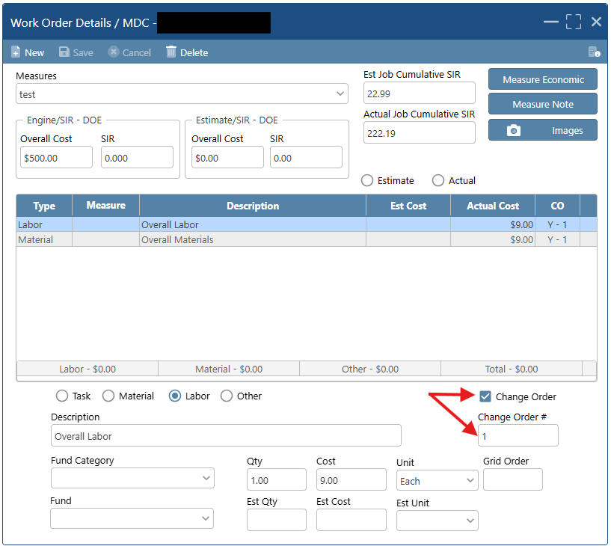

- Complete the Change Order Form
  - Once the SP has completed the checklists in WAPLink, they will move to the work order

Travel guidance
Travel costs interact directly with the model. They must be included in the audit, and they need to be incorporated into the cumulative SIR. This requirement applies primarily to crews, since contractors typically build travel costs into their bids.

Entering travel costs WAPLink process
- In the WAPLink Job menu for a household, select Measures
- Select Travel and Include in SIR so it will interact with the Job SIR
Note: You will see red outlined boxes (required) for Energy Savings information. You can ignore this, and the audit will still process.

Measure considerations
This section provides notes and instructions for the process of entering data about measures into WAPLink. For updated policy language for Energy Conservation Measures, Incident Repair Measures, Health and Safety Measures, and General Heat Waste, refer to Appendix C: Measures – updated policy language.

Energy Conservation Measure (ECM) WAPLink process
For Audit Events:
- Enter data from the energy audit into the WAPLink software
- Generate recommended measures
- For each identified ECM, use the current State Plans (Appendix A, State Plans) and the Allowable Measures Chart (Audit Event) (Appendix B, Field Guidance) to determine if it is an allowable activity.
- If there is a change in the cost of an ECM, the updated cost must be entered into WAPLink to determine if the SIR is still 1.0 or greater for DOE funded measures, or 0.75 or greater for EAPWX funded measures, before proceeding.

Reminder: ECMs are not allowed in a Standalone Event.

Incidental Repair Measure (IRM) WAPLink process
IRM's are determined during engine run and notes can always be added in the work order.
When filling out details in the audit or work order, ensure that the WL measure type is set to “Incidental Repair Measure.”
For Audit Events:
- In Measures, click the Manual Measures radio button
- Check IRM
- Check or uncheck Include in SIR
- Enter a measure description
- Enter Cost
- Enter Material Cost
- Enter Labor Cost
- Enter Energy Savings
- Choose an energy unit
- Enter a number for Life
- Choose a fuel type
- Option to add materials
- Option to add comments
- Click Save.
Reminder: IRMs are not allowed for Standalone Events.

Health and Safety Measure (HSM) WAPLink process
For HSM you can enter information pre-audit run in the measures tab, or post audit run in the work orders.
When filling out details in the audit or work order, ensure that the measure type is set to “Health and Safety”.
For Audit Events:
- In Measures, click the Manual Measures radio button
- Check Health and Safety
- Enter a measure description
- Enter Cost
- Enter Material Cost
- Enter Labor Cost
- Option to add comments
- Click Save

General Heat Waste (GHW) WAPLink process
Note: GHW should be categorized as a Conservation Measure.
For Audit Events:
- In Measures, click the Manual Measures radio button
- Check GHW
- Check or uncheck Include in SIR
- Enter a measure description
- Enter Cost
- Enter Material Cost
- Enter Labor Cost
- Enter Energy Savings
- Choose an energy unit
- Enter a number for Life
- Choose a fuel type
- Option to add materials
- Option to add comments
- Click Save
Reminder: GHW measures are not allowed for Standalone Events.

Co-funding ECMs
Co-funding can be done by knowing the Present Life of Energy Savings for each measure which can be found on the work order under details of a measure and measure economics and creating additional manual measures as an HSM.

WAPLink Process
Air Sealing Example:
- From the audit, create both:
  - A standard General Air Sealing measure, and
  - A manual HSM measure titled General Air Sealing (ECO).
- Create the work order.
- For the DOE-funded General Air Sealing measure:
  - Enter estimated costs that are no less than the Present Life of Energy Savings (found under measure details and economics) to ensure an SIR of 1.0.
- For the ECO-funded HSM measure:
  - Allocate the additional costs to this measure and assign the ECO funding source.
- Confirm that the measure economics still reflect a Job SIR of 1.0.

NEAT audit data entry

Initial steps
- Click on WA 10 Settings
- Complete the following items:
  - Fuel Cost Library: Choose the current PY Fuel Cost Library
  - Key Parameters: Choose the current PY Statewide NEAT Key Parameters
  - Weather File: Choose the closest Weather file to the location of the client’s home. The WEATHER LOCATION city you choose will not always be the geographically closest city to your client. It might even be in another state. You are looking for the weather file that most closely approximates your client's location's Heating Degree Days (HDD) and Cooling Degree Days (CDD).
  - Active Measure File: Choose the current agency NEAT file
  - Conditioned Stories: Enter the number of floors that are heated and cooled, including basements if significant portion is above grade. Enter a value between 1 and 4 and can be entered in decimal form (e.g. 1.5).
  - Average # of occupants: Enter the number of occupants in the home
  - Floor Area: Enter the square footage of the floor area that is conditioned
  - Inf Height: Enter the infiltration height which is measured from the lowest point above grade (excludes window wells) to the highest point of the conditioned space (ceiling or peak), per ASHRAE 62.2.
  - # Bedrooms: Enter the number of bedrooms
  - Year Built: Enter the year the home was originally built. If the number is pre-1978, lead details button will show, and you can enter information regarding lead documentation and/or testing
  - Must click Save before you are allowed to continue.
- Click the + Housing Items button
- Complete all applicable components related to the home as listed below

Home components data entry steps

Walls
Training resource: Wall Entry Instruction Video
Note: Walls of the same wall type, stud size, exterior type, exposure, orientation, and R value, and added insulation type can be grouped into single walls. Site drawings, wall codes, or wall comment field should explain which wall sections from the dwelling make up each “wall.”
SPs typically have a variety of added insulation types in their WA Insulation library to account for differences in the price of insulating walls with different types of cladding or methods. Information provided to crews and contractors insulating walls should include all information necessary for them to perform the measure efficiently and effectively.

WAPLink process
- Click New
- Wall Code: Input a unique Wall Code for each wall
- Wall Type: Choose the construction type of wall system
- Stud Size: Choose Stud Size from the dropdown
- Exterior Type: Choose the Exterior Type from the dropdown
- Exposed To: Choose the Exposed To from the dropdown. Note – a buffered wall is defined a wall that is exposed to an unconditioned, but enclosed space, such as a garage or porch.
- Orientation: Choose the Orientation of the wall from the dropdown
- Height: Enter the wall height here
- Length: Enter the wall length here
- Gross Area (sq ft): Calculate the wall area H x L and enter it here
- Existing Insulation
  - Type: Define the Existing Insulation using the Type dropdown
  - R-Value: Input the type and R-value of Existing Insulation. One wall of each home must be inspected for insulation levels. If there is an addition, the addition walls must be inspected. Sometimes it is hard to accurately assess the R-value of installed fiberglass batt insulation, except by the estimated year of installation. Use the following for 2x4 walls based on year:
    - Pre-1975 – R9
    - 1975-1995 – R11
    - 1995 to present – R13
- Added Insulation
  - Type: Select the type of added insulation from the dropdown
  - Added Cost ($): If there are additional costs to insulate this particular wall beyond the price defined in the library, enter those costs here. Examples could include the additional cost of blowing from the inside or repairing the necessary siding before adding insulation.
- Enter the comment section for any comment clarification that is needed
- Click Save
- If adding additional walls, you can either click New or you can click Copy and edit any information that is different
- Once complete, click on the next section such as Door or Window or the X at the top right corner of the Wall screen to close this window

Windows
Training resource: Window Entry Tutorial Video
Notes:
- Repair or replacement must be chosen for consideration and/or evaluation.
- Whether to model a prime window for repair or replacement is up to the auditor’s discretion based on the documented existing conditions.
- Single pane windows without storm windows must be evaluated for storm window installation.
  - A storm window with no prime should be modelled as a single pane window. It should be evaluated for replacement as a windows measure.
  - If there is no SIR for replacement, it should be evaluated for sash replacement as an Infiltration Reduction measure.
- Window repair or replacement measures must be done according to the Allowable Measures Chart.
- Not every window crack results in air leakage.
- Window glazing should only be repaired or replaced when glazing is either missing, or a crack, hole, or the window itself allows air leakage.
To model basement windows, follow the following process, unless the space is unconditioned:
- Walls Form: Describe concrete block wall(s) in the orientation of basement windows. Enter. Gross Area (sq ft) = Total area of basement windows in that orientation + 1.01. This is to ensure that net wall area exceeds 1 sq ft.
- Windows Form: Describe basement windows and link them to the new walls.

WAPLink process
  - Click New
  - Window
    - Window Code: Input a unique Window Code for each window
    - Window Type: Choose the appropriate selection from the dropdown list
    - Frame Type: Choose the appropriate type from the dropdown
    - Glaze Type: Choose the appropriate type from the dropdown
    - Storm Window Type: Choose the appropriate from the dropdown
- Leakiness: Choose the most appropriate leakiness level for this window. Provide an estimate of how leaky the window is.
  - The choices are Very Tight, Tight, Medium, Loose, and Very Loose. Typical selections by window type are listed below.
  - Degrade the leakiness one level if 2 to 9 sq. in. of glass is missing in the window and two levels if 9 to 25 sq. in. of glass is missing. Specify the window to be Very Loose if more than 25 sq. in. of glass is missing in the window.
  - Upgrade the leakiness one level if a storm window in average or better condition is installed
  - Any deviation from the leakiness definitions found below should be justified in the window comment section
            - Jalousie window – The leakiness of a jalousie window is typically Loose
            - Awning window − The leakiness of an awning window that has a single sash of glass and a latching/locking mechanism that seals the window by forcing the sash against the frame and any installed weather stripping is typically Tight. Such a window is often called a casement window if it is hinged on the side or a hopper window if it is hinged on the bottom. The leakiness of an awning window with 2 or 3 sashes of glass or without a latching/locking mechanism is typically Medium.
            - Slider window and sliding glass door − The leakiness of a vertical slider window is typically Medium if it is older and Tight if it is newer. The leakiness of a horizontal slider window or sliding glass door is typically Medium.
            - Fixed window, door window, and skylight – The leakiness of a fixed window, door window, or skylight is typically Very Tight.
    - Interior Shading: Choose the appropriate type from the dropdown
    - Exterior Shading: Choose the appropriate from the dropdown. If Overhang or Awning is selected, the Horizontal Projection (in) from the exterior wall and Distance from Lintel (in) above the window is required.
    - Wall Code: Choose from the dropdown the Wall Code for the wall on which this window exists
    - Width: Enter the Width (in) of the window
    - Height: Enter the Height (in) of the window
  - Click the appropriate Retrofit Options / Additional Cost information. Options are:
    - Evaluate All
    - Weatherize Window
    - Replace Window
      - Glazing Type: Choose the glazing type from the dropdown
      - Enter Chart for U-values and SHGC Default values
Glazing Type | U-Value | SHGC
Double Pane | 0.32 | 0.40
Double Pane Low-E | 0.32 | 0.40
    - Add Storm
    - Add Awning
    - Add Exterior Shading
  - Enter the comment section for any comment clarification that is needed
  - Click Save
  - If adding additional windows, you can either click New or you can click Copy and edit any information that is different
  - Once complete, click on the next section such as Door or Wall or the X at the top right corner of the Window screen to close this window

Doors
Notes: In WAv10, you cannot input a door and connect it to a buffered wall. For this, when inputting doors into WAPLink, do not input a door attached to a buffered wall (refer to Modeling doors on buffered walls and sliding glass doors with the Oak Ridge National Laboratory (ORNL) schema change*). Repairs to doors on a buffered wall can be done under infiltration reduction, GHW, or as an HSM if it is an attached garage.
If door glass has a surface area of more than 25%, you must model the glass separately in the window section and remove the surface area from the door area.

WAPLink process
- Click New
- Door
  - Door Code: Input a unique Door Code for each door
  - Door Type: Choose the appropriate type from the dropdown
  - Area (sq ft): (is auto-calculated once entered; double check to ensure it is correct)
  - Storm Door Condition: Choose the appropriate one from the dropdown list. Remember: The storm door is considered only due to its ability to block air movement. NEAT treats deteriorated the same as none. The distinction allows you to convey additional information.
  - Leakiness: Choose the appropriate Leakiness from the dropdown list. Provide an estimate of how leaky the door is. The choices are Tight, Medium, and Loose.
    - Tight doors will have the door and frame squared, no warping, functioning weather stripping in good condition around the door, a good seal at the threshold, no holes or structural damage, and latches that keep the door securely shut. If windows exist in the door, they will be fixed and well- sealed. Primary door glazing over 25% should be modelled as a separate window.
    - Medium doors will have some characteristics of loose doors but retain substantial integrity. However, they would likely benefit from air sealing efforts.
    - Loose doors will exhibit many, if not most, of the following problems: door and/or frame out of square, warping, weather stripping missing or severely damaged, no seal at the threshold, holes or significant structural damage, and latches that do not keep the door securely shut.
  - Height: Enter Height (in)
  - Width: Enter Width (in)
  - Wall Code: Choose the Wall Code for the wall on which this door exists.
- Number on the wall.
- Replacement: Select replacement options, if applicable
- Enter the comment section for any comment clarification that is needed
- Click Save
- If adding additional Doors, you can either click New or you can click Copy and edit any information that is different
- Once complete, click on the next section such as Window, Unfinished Attic, or Finished Attic or the X at the top right corner of the Door screen to close this window

Modeling doors on buffered walls and sliding glass doors with the Oak Ridge National Laboratory (ORNL) schema change*
A schema change recently went into effect that has changed the way doors on buffered walls and sliding glass doors can be modeled in WAPLink.
WAPLink will block the audit if a door is modeled on a buffered wall or if a sliding glass door is entered in the in the doors input screen.
Changes Include:
- Doors on buffered walls should be left out of the energy model.
- If work needs to be done on these doors, it can be achieved as a General Heat Waste Measure, Health and Safety Measure, or General Air Sealing Measure.
- Add notes to WAPLink for doors on a buffered wall.
- Sliding glass doors should no longer be modeled in the door input screen.
- Sliding glass doors should be modeled as a window in the windows input screen.
- This ORNL schema change is permanent and will be included in future user guide updates.
*Language from ORNL:
As a reminder, the code push includes important input schema updates designed to address reported issues within the WAweb-API. These updates include the following changes:
- Doors on buffered walls – this configuration previously passed input schema checks and would produce results without error. However, this is an invalid configuration and will no longer be permitted/accepted as of the update.
- Sliding Glass Doors in “Doors” section – sliding glass door inputs will be removed from the "Doors" section, as they are more appropriately described and retrofitted within the "Windows" section. This change ensures proper categorization and consistency across the schema.

Unfinished attics
For detailed information on procedure for Unfinished Attics refer to Appendix D: Notes from NEAT input process.
Note: there is no option 2 for use in MHEA, and the opportunity to achieve R60 in a manufactured home attic is unlikely. MHEA calculates the value and cost to fill the space available.

WAPLink process
- Click New
- Unfinished Attic
  - Code: Input a unique Attic Code for each Unfinished Attic
  - Attic Type: Choose the appropriate Attic Type from the dropdown list.
  - Joist Spacing (in): Enter the Joist Spacing (in). NEAT does not use this number.
  - Area (sq ft): Enter the attic area. In many homes, this will be the same as the conditioned area of a single-story home. If there are multiple attics, the sum of all attics must equal the area of the floor above which the attic sits.
  - Roof Color: From the dropdown, select either:
    - White, Reflective, or Shaded
    - Normal or Weathered
- Existing Insulation
  - Type: Choose the Existing Insulation Type from the dropdown.
  - Depth: Enter the depth (in) of existing insulation.
    - Note that depth is in inches, not in R-value. If the insulation is degraded, has many gaps, or is uneven, calculate the actual R-value and convert that back into inches. If this is done, explain it in the comments. If there is more than one type of existing insulation, choose the type that seems to be in the majority. Combine them when calculating depth, ensure the R-value is best represented, and mention them in the comment section.
- Added insulation
  - Measure: Choose Measure #1. If there is more than one attic, each must have its own measure number.
  - Type: Choose the appropriate Added Insulation Type from the dropdown list
  - Add R-Value: it is optimal to leave inputs for Added R-Value Blank. Added R-Value is a mandatory input that forces NEAT to provide the requested R-Value of insulation regardless of SIR. It will appear in the Recommended Measures as User-Spec Ceiling, even if the SIR is below 1.0.
  - Max Depth (in): It is Optional to leave Max Depth blank. Max. Depth MUST BE entered for attics that are floored or cathedral or any other circumstance when the width of the joist limits the depth. Input the total floor joist or roof rafter width. Do not use this input for any open attic space. If there are any additional costs, you may add them to the additional cost field. If Other is chosen, provide a comment in the field provided.
  - Additional Cost ($): There will usually be Additional Costs with attics. All additional costs must be explained in the comments. Additional Costs may include items such as:
    - Dams for hatch, flue pipes, and/or separating attic areas
    - Baffles
    - Extra time to maneuver through a tight attic area
    - Labor cost to remove client’s stored goods
    - Cost to insulate and air seal an existing attic hatch
    - Blocking of joist cavities under floored attics
    - The following are NOT Additional Costs:
      - Roof repairs (this should be an Incidental Repair)
- Enter the comment section for any comment clarification that is needed
- Click Save
- If adding additional attics, you can either click New or you can click Copy and edit any information that is different.
- Once complete, click on the next section such as Door or Foundation or the X at the top right corner of the Unfinished Attic screen to close this window.

Finished attics
The Gable End Walls of a typical Finished Attic must be modeled as Exterior Walls under the Wall Section.
Note: If the space has a limited space such as a floored attic or cathedral ceiling, the auditor MUST input Max Depth. If there are any additional costs, you may add them to the additional cost field. If Other is chosen, provide a comment in the field provided.
Most inputs here are the same as on the Unfinished Attics page, except the steps outlined below. There are three things to note:
- When modeling the Roof Rafters, you must input Max Depth. Use the height of the rafters
- NEAT understands that the outer ceiling joist is an unconditioned space. Do not model this area as a separate attic under the unfinished attic.
- If a measure is not provided (SIR<1.0).

WAPLink process
- Click New
- Finished Attic
  - Code: Input a unique Attic Code for each Finished Attic
  - Attic Type: Choose the appropriate one from the dropdown. Most finished attics have all four elements described here, and each type must be modeled individually (using the new button at the top left to create a new record for each). However, to save time, it is acceptable to combine the square footage area of both areas of the same type (say, Knee Walls and Roof Rafters) into a single record, noting it in the comment section.
- Added Insulation
- Measure: Choose a separate measure number for each element of a finished attic
- Enter the comment section for any comment clarification that is needed.
- Click Save
- If adding additional attics, you can either click New or you can click Copy and edit any information that is different.
- Once complete, click on the next section such as Door or Foundation or the X at the top right corner of the Finished Attic screen to close this window.

Foundation
To help auditors determine the best pressure-thermal boundary for a home, and to ensure a consistent measure selection particularly in relation to weatherization of unfinished basements, no foundation should be modeled as unintentionally conditioned. Instead, it should be modeled as conditioned or unconditioned depending on where the thermal/pressure boundary will be deemed to be.
Note: Rim joists that are not accessible should not be included in the perimeter to insulate calculation. All foundations that can feasibly be insulated per code requirements should be modelled for added insulation. Fiberglass rim joist insulation that has potential mildew, signs of moisture, and/or staining, should be removed and rims modelled as perimeter to insulate.

WAPLink process
- Click New
- Foundation
  - Foundation Code: Input a unique Foundation Code for each foundation
  - Measure Number: This field groups items so that all items in the group are encompassed in a single SIR calculation and recommendation. Rim joists that are not accessible should not be included in the insulation calculation.
  - Type: Choose the appropriate Foundation Type from the dropdown list. Complete the fields below that are highlighted gray with a red ring (these will vary based on foundation type).
    - Conditioned: A conditioned space is heated and/or cooled directly or indirectly through a permanently open doorway
    - Non-Conditioned: Unvented and non-conditioned. Usually, it's a non- conditioned basement. It could also be a closed crawlspace.
    - Vented Non-Conditioned: This is a typical vented crawlspace. If there are foundation vents, they are vented.
    - Uninsulated or insulated slab: Always choose Uninsulated unless you know otherwise
    - Exposed Floor: This is an overhang (such as a cantilevered floor) or the foundation of a house that sits on stilts or piers
- Floor
  - Floor Area (sq Ft): Enter floor area (sq ft)
  - Existing Insulation R-value: Enter the R-value of the insulation currently installed in the floor area.
  - Added Insulation Type: Select the appropriate Insulation type to be installed if NEAT recommends insulation. All foundations that can feasibly be insulated per code requirements should be evaluated for additional insulation.
  - Additional Cost ($): Enter any additional cost of insulating this item. Enter the total, not the cost per square foot. This cost is not generally associated with insulation and thus needs to be accounted for in the Measure Cost Library. A Negative Addition cost will subtract from the computed cost. If a cost is entered, briefly explain the reason for the additional cost in the comment section.
- Foundation Wall
  - Height (ft): Enter the wall height enclosing the foundation space (i.e., the basement or crawlspace wall) in feet units. Enter the average height if the height of the wall is not uniform.
  - Height Exposed (%): Enter the percentage of the height that is exposed to the outside air (i.e., is above grade) or the average percentage if the exposure is not uniform.
  - Perimeter (ft): Enter the total external perimeter of the foundation wall in feet
  - Existing Insulation R-Value: Enter the R-value of the insulation currently installed in the foundation wall
  - Added Insulation Type: Select the insulation type NEAT recommends. Select None if the condition prohibits insulating this section and note those conditions in the comment section.
  - Additional Cost ($): Enter any additional cost of insulating this item. Enter the total, not the cost per square foot. This cost is not generally associated with insulation and thus needs to be accounted for in the Measure Cost Library. A Negative Addition cost will subtract from the computed cost. If a cost is entered, briefly explain the reason for the additional cost in the comment section.
- Sill
  - Floor Joist Size (in): Enter the floor joist size (i.e., the band or rim joist) in inches. The level of insulation that will be evaluated for addition to a floor is restricted to those that allow the total existing and added insulation to fit within the joist depth.
  - Perimeter (ft): Enter the total external perimeter of the foundation wall in units of feet.
  - Existing Insulation R-Value: Enter the R-value of the insulation currently installed in the sillbox area.
  - Added Insulation Type: Select the insulation type NEAT recommends. Select None if the condition prohibits insulating this section and note those conditions in the comment section.
  - Additional Cost ($): Enter any additional cost of insulating this item. Enter the total, not the cost per square foot. This cost is not generally associated with insulation and thus needs to be accounted for in the Measure Cost Library. A Negative Addition cost will subtract from the computed cost. If a cost is entered, briefly explain the reason for the additional cost in the comment section.
- Enter the comment section for any comment clarification that is needed
- Click Save
- If adding additional foundations, you can either click New or you can click Copy and edit any information that is different
- Once complete, click on the next section such as Finished Attic, Unfinished Attic, or HVAC or the X at the top right corner of the Foundation screen to close this window

Modeling exposed floors in WAPLink
Dense packing approach
To dense pack an exposed floor with blown insulation, model it as sheathed. See Sec. 14-2 of the Retrofitting Minnesota Field Guide.
Fiberglass batts approach
To install fiberglass batts, model the exposed floor as unsheathed.
Whichever treatment is applied to the exposed floor, the auditor should document what they did and why they did it in the comments section of the foundation tab.

HVAC
For detailed information on HVAC procedure refer to Appendix D: Notes from NEAT input process.

WAPLink process
- Click New
- Existing Equipment
  - HVAC System Code: Input a unique HVAC System Code for each HVAC entry
  - Equipment Type: Choose the appropriate type from the dropdown list
  - Location: Choose the appropriate location of the above equipment from the dropdown list
  - Primary Fuel Type: Choose the appropriate fuel type from the dropdown list
  - Backup Fuel Type: Choose the appropriate backup fuel from the dropdown list if applicable
  - Input Units: Choose the appropriate units from the dropdown list
  - Year Manufactured: Input the year the unit was manufactured. It can be found on the model plate. It is coded into the model or serial number. An excellent website to find the year of manufacture of any HVAC unit is http://www.building-center.org.
- Required Heating System Details
  - Heating EFF: Enter the Value as a whole number, then choose the appropriate unit from the dropdown list. This goes for the Cooling Side as well.
  - Output Capacity: Enter the value as a whole number, then choose the appropriate unit from the dropdown list. Cooling data must be entered for both central and room cooling systems. Cooling system replacement can be evaluated as an EAPWX expansion measure.
  - Fraction of load Served %: This is the percentage of the home’s conditioned floor area that is heated or cooled by this unit. If there is more than one unit, estimate the percentage from each. The total must add up to 1.00.
  - Equipment Features: Check off if the equipment has the features listed
    - Atmospheric Burner
    - Automatic Vent Damper. Do not evaluate, just document their existence.
    - Pilot Light
    - IID (Intermittent Pilot Ignition Device)
    - Pilot light remains on throughout the summer
  - Year Installed: If known, input the year installed
  - Maintenance Status: Choose the appropriate maintenance status of the system from the dropdown list
    - Annual Professional Maintenance: A professional comes out yearly to clean and maintain the unit to meet manufacturer specifications. Filters are replaced regularly.
    - Seldom or Never Maintained: Filters are replaced regularly, and a professional is only called out when there is an issue with the system
    - Not working: The system does not work at all
- Replacement System
  - Install Smart Thermostat: Check the Required box and the Include in SIR Box. Put in the Heating Nighttime Setback Temp (1 to 10) and the Dailey Setback Hours (1 to 12). Include Additional Cost, if needed.
  - Tune Up: Check the Required box and the Include in SIR box. Put in the Efficiency Temp Heat % and the Efficiency Temp Cool %. Note - 1-2% improvement is typical and that 2-5% is possible if the unit is old and not maintained Add in any additional cost if needed.
  - Replace the Equipment: Click on Replace the Equipment
    - If a replacement system will be installed using funds from another funding source, model the new system as the existing unit and note this in the Comments Section. The auditor will need to determine the efficiency and size of the new unit.
    - If a replacement system will be installed using H&S funds, follow the health and safety heating system replacement procedure
    - Select the replacement mandatory option for health and safety heating system replacements. This will result in WAPLink creating a measure with an SIR less than 1.0 in the Recommended Measures list. Do not upload this measure into the work order. The result will be that the energy savings of the new heating system will still have interacted with the predicted energy savings and SIRs of the energy conservation measures and incidental repair measures and the measure will not show up on the Measures with SIRs less than 1.0 report.
    - Create a WL Measure cost for the health and safety heating system replacement. Upload this itemized cost into the work order.
  - Equipment Type: Choose the appropriate Equipment Type from the dropdown list of the replacement
  - Primary Fuel Type: Choose the appropriate fuel type from the dropdown list
  - Backup Fuel Type: Choose Back up Fuel Type, if applicable
  - Heating EFF: Enter the value as a whole number. choose the appropriate unit from the dropdown list. This goes for the Cooling Side as well.
  - Output Capacity: Enter the value as a whole number. Choose the appropriate unit from the Dropdown list for heating and cooling systems.
  - Replacement Life: Must enter 20 as default for gas heating replacement, or 15 years for ASHP and cooling replacements, or 18 years for other heating types
  - Fraction of load Served %: This is the percentage of the home’s conditioned floor area that is heated or cooled by this unit. If there is more than one unit, enter the percentage from each unit.
  - Also Replaces: Input Which units are being replaced.
- Enter the comment section for any comment clarification that is needed
- Click Save
- If adding additional HVAC systems, you can either click New or you can click Copy and edit any information that is different.
- Once complete, click on the next section such as Foundation or Duct or the X at the top right corner of the HVAC screen to close this window.
Notes:
- To include EC motors on the furnace air handler as a retrofit, or part of a new furnace install, this WL Measure must be created, or the installation will need to be done as a Manual Measure at the audit level. The Energy Savings have been predetermined and must be used as they appear in the examples below. The cost per unit would need to reflect the pricing found in your service area. If the EC motor is installed on a pre-existing furnace, the motor itself would have a parts warranty. If it is installed as part of a furnace replacement it would be included under the furnace parts and labor warranty. It should come installed in the furnace in the furnace from the manufacturer. The cost of the EC Motor upgrade should be deducted from the total cost of the furnace installation that is entered into the HVAC window of WAPLink.
- Annual Energy Savings: Homes with Central AC: 248 kWh Annual Energy Savings, Homes without Central AC: 170 kWh.
- The measure life (yr) will be changed before processing the audit to reflect the likely lifespan of the existing furnace (and therefore the replacement motor). This is the only part of the measure that will be unique for each job. The life (yr) of the existing furnace will be 20 years minus the actual age of the furnace. For example, an 8-year-old furnace will have a life of 20 years minus 8 years = 12 years. Furnaces 20 years or older that do not qualify for replacement do not need to be evaluated for an EC motor retrofit. Any other reason preventing the retrofit of an EC motor must be documented in the comments section of WAPLink HVAC window.
- For electric heat, performance studies show that there is increased loss through the envelope (typically an exterior wall) where that equipment is installed. The increased envelope loss equals approximately 2% of the equipment output. Thus, it is recommended to enter 98% instead of 100%.

Ducts
For FAQs on modelling ducts, return registers, calculating R, and air/duct leakage, refer to Appendix D: Notes from NEAT input process.

WAPLink process
- Click New
- Ducts
  - Duct Code: Input a unique Duct Code for each type of duct
  - Duct Type: Choose the appropriate Duct type of duct
    - Supply Duct: Duct that transports conditioned air into the home
    - Return Duct: carries air from the room back to the air handler
  - HVAC System Served Heating: Choose the appropriate HVAC system from the dropdown. This will depend on what was entered in the HVAC section under the Heating input.
  - HVAC System Served Cooling: Choose the appropriate HVAC system from the dropdown. This will depend on what was entered in the HVAC section under the Cooling input.
  - Duct Location: Choose the appropriate location for the ducts from the dropdown list
  - Surface Area: The User Default button will be checked off, and the calculation is now embedded into the WAPLink software.
    - If the agency chooses to measure the duct:
      - Can combine the sections of the duct work that have the same shape (i.e., round, rectangular)
      - Will need to know the Length (ft), Width (in), Height (in) and Diameter (in)
      - Need to input the above information in the Comment section
      - Round: Area = Pi * (D/12) *L
      - Rectangular = Area = (W*2 + H*2) / 12*L
      - Flat Oval = Area = (Pi*H + 2 * W) / 12 * L
  - Insulation R-value: Enter the existing R-value of the insulation on the ducts
  - Check the User Default Box
  - Number of Return Registers: Enter the number of Return Registers to the HVAC system.
- Added insulation
  - Measure Number: Each duct type must have a different Measure Number and Duct Shape
  - ADDED R-value: Input the R-value that needs to be added to ductwork
  - Additional Cost ($): This is to be input if there is an unusual and unique extra cost to insulate or repair. You must explain the additional cost in the comment section.
- Enter the comment section for any comment clarification that is needed
- Click Save
- If adding additional Duct, you can either click New or you can click Copy and edit any information that is different.
- Once complete, click on the next section such as HVAC or Infiltration or the X at the top right corner of the Duct screen to close this window.

Air Leakage/Infiltration

Infiltration WAPLink process
- Whole House Blower Door Measurements
  - Enter the Air Leakage Rate (cfm) and House Pressure Difference (Pa) for the Before Weatherization (Existing) column.
  - Enter the Air Leakage Rate (cfm) and House Pressure Difference (Pa) for the After Weatherization (Existing) column.
- Costs
  - Enter the Infiltration Reduction ($) cost
- Select the blue Blower Doors button on the right side of the window and select New
  - General Info
    - Enter the Date and Conducted During
  - Enter Blower Door Measures
  - Click Save
  - Close this window
- Select the blue Zonal Pressure button on the right side of the window and select New
  - Enter the appropriate details of the Zonal Pressures and select save for each test
  - Close this window
- Select the blue Pressure Pans button, if applicable, on the right side of the window and select New
  - Enter the appropriate details of the Pressure Pans and select save for each test
  - Close this window
- Select the blue Room Pressure Balances button, if applicable, on the right side of the window and select New
  - Enter the appropriate details of the Room Pressure and select save for each location
  - Enter the comment section for any comment clarification that is needed
  - Click Save
- Complete information for Duct Sealing if applicable or move to the next section such as Duct or Water Heating or the X at the top right corner of the Air/Duct Leakage screen to close this window.
Note: Ducts inside the building envelope do not need to be modeled for duct sealing in WAPLink National Energy Audit Tool (WAPLINK-NEAT) as an energy conservation measure. Ducts outside the building envelope must be modeled for duct sealing in National Energy Audit Tool (WAPLINK-NEAT) as an energy conservation measure. For more information on duct leakage, refer to Appendix D: Notes from NEAT input process.

WAPLink process
- Leakage Method: Check the Evaluate Duct Sealing to get additional funds for duct sealing. Extra on-site measurements will be required.
- Duct Leakage Method: Choose the appropriate leakage method from the dropdown list:
  - Whole House Blower Door Measurements
  - Blower Door Subtraction Measurements
  - Duct Blower Measurements
- Duct Sealing ($): Enter the cost amount associated with duct sealing.
- Duct Operating Pressures: (NOTE: Remember that you must perform the Duct Operating Pressure Test.
  - For Duct Operating Pressures, enter the Before Duct Sealing supply and return duct operating pressures with respect to the space surrounding the ducts, in units of Pascal, measured during normal conditions with the air handler fan on. These measurements can be taken by inserting pressure probes through small holes drilled in the supply plenum (near the air handler) and the return plenum. The holes should be repaired afterwards. For After Duct Sealing, add 5 Pa more than the Before Duct Sealing value.
  - Before Duct Sealing: Both Supply and Return static pressures need to be measured in the field. Typically, one is measured and then the other. Testing does not have to be simultaneous. Static duct pressures are measured with the furnace air blower on. The blower door must not be running.
    - Supply static pressure: Inserting the manometer hose in the supply plenum is best. If this is not possible or practical, insert the hose in the nearest supply register and place the hose as close as you can to the plenum. You can close the register through which you are testing or tape it shut to get a better reading.
    - Return static pressure: Inserting the manometer hose in the return plenum is best. If this is not possible or practical, insert the hose in the nearest return register and place the hose as close as you can to the plenum.
- Before Duct Sealing (Existing): Input the data as measured in the field
- After Duct Sealing (Target or Actual): For duct sealing, typically a reduction of 300 CFM or less would be expected, except where catastrophic leaks are present
  - If you don’t believe the above target is achievable, write in your adjusted target
  - You MUST explain your reasoning for this in the comments section
- Duct Sealing Cost: Input amount needed for duct sealing
  - NEAT will not accept $0 for duct sealing. If you cannot achieve a duct sealing measure with an SIR, then uncheck Evaluate Duct Sealing. See below for more information.
  - Explain in comments that you attempted duct sealing but could not get the measure with an SIR
  - Your comment will remain even after you uncheck Evaluate Duct Sealing, as will the data you entered
- Click Save
Once complete, click on the next section such as Duct or Water Heating or the X at the top right corner of the Air/Duct Leakage screen to close this window
Figure 14. Duct Sealing data entry points
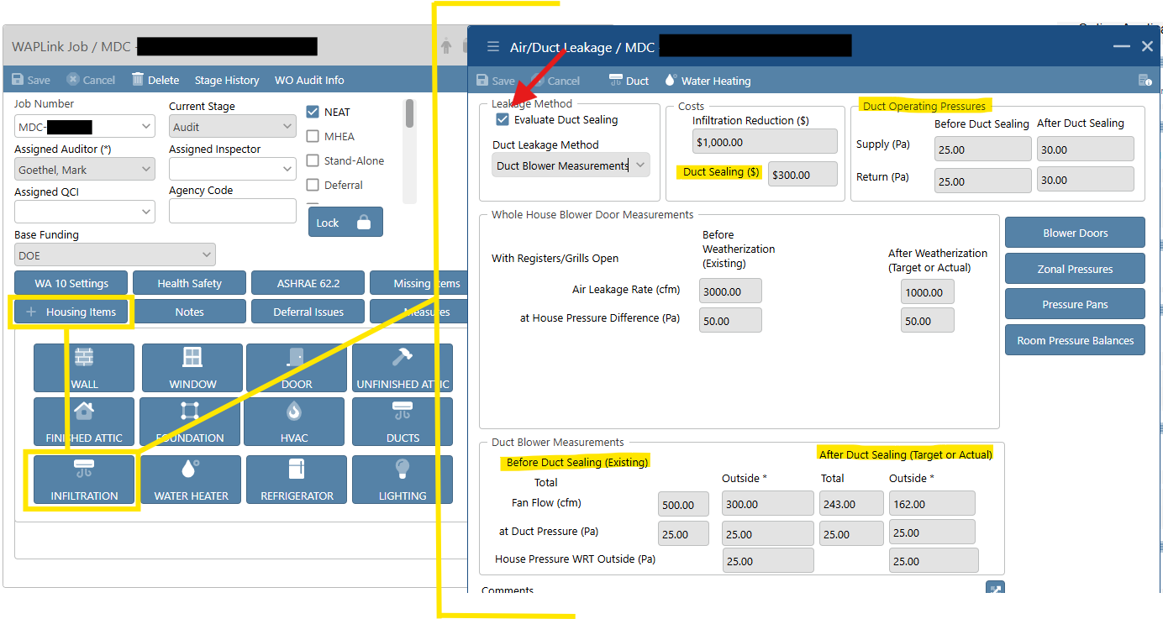

Water heater
Note: Manufacturer and Model numbers are required unless tag is missing or unreadable. If auditor is unable to locate existing data information, refer to Table 2 below.
Table 2. Water Heater Efficiency Guidance
Type of Water Heater | Age Estimate | Energy Factor (EF) | Recovery Efficiency
Gas Storage (Conventional) | Pre-1990s | 0.50-0.55 | 0.75 - 0.85
Gas Storage (Conventional) | 1990s-2005 | 0.55-0.60 | 0.78 - 0.82
Gas Storage (Conventional) | 2005-2015 | 0.60-0.67 | 0.78 - 0.83
Electric Storage | Pre-2000s | 0.85-0.88 | 0.98 - 0.99
Electric Storage | 2000s-2015 | 0.88-0.95 | 0.98 - 1.0
Gas Power-Vent Storage | 2000s-2015 | 0.65-0.70 | 0.82 - 0.85
Heat Pump | 2009-2014 | 2.0 - 2.5 | 2 - 2.5
Heat Pump | 2015-2020 | 2.5 - 3.2 | 2.5 - 3.2
Heat Pump | 2020s | 3.2 - 4.0 | 3.2 - 4.0
Gas Tankless (non-condensing) | 2000s-2015 | 0.78-0.82 | NA
Gas Tankless (condensing) | 2010s | 0.90-0.94 | NA

Note: For Multiple/Tandem Water Heaters combine the tank sizes together and make notes. Ex. (2) 50 gallons units= 100 gallons. Add data for one in WAPLink and put notes regarding the other in the comments.
Pipe insulation SIR does not change and should be divided across the SIR. However, by combining, the model should give more SIR for tank insulation to share across the two.

WAPLink process
- Note there is no option to click New
- Existing Equipment
  - Equipment Type: Choose the type from the dropdown
  - Fuel: choose the fuel type from the dropdown
  - Location: Choose the location where the domestic water heater is located from the dropdown
  - Rated Input: enter rated inputs
  - Size (Gal): enter the size of the storage tank
  - Input units: Choose Input Units from the dropdown
  - Energy Factor: You must enter the Energy Factor of the water heater. See chart above for guidance.
  - Recovery Efficiency (%): Must enter the Efficiency as a decimal. See chart above for guidance.
  - Check if the Water Heater Wrap is present.
    - NEAT will not provide a water heater wrap if this is checked. Do not model a water heater wrap as a present if there is no room for it. You must model the water heater without a wrap and note in the comment section that there is no room for the wrap to provide photo documentation.
  - Check if the Water Heater Pipe Insulation is Present.
    - NEAT will not provide water heater pipe insulation if this is checked. Only select this if there is at least 5 feet of insulation on the pipes exiting the water heater.
- Original Tank Insulation: Enter either:
  - R-Value
  - Thickness (in): Type of internal tank insulation. This is rarely marked on the tag. You can measure existing insulation by removing an access cover and measuring thickness & type
  - Type: Fiberglass or Polyurethane
- Shower Heads
  - Enter the number of showerheads in the home
  - Shower Use: per day (min/day)
  - Avg. GPM: (gallons per minute)
    - GPM must be measured or taken from the manufacturer’s data on the showerhead
    - If using manufacture data, you can typically assume 10-15 minutes per resident
    - If measuring, use a container of known volume and a stopwatch to determine gallons per minute
- Enter the comment section for any comment clarification that is needed.
- Replacement
  - All water heaters must be evaluated for replacement to see if an SIR for replacement can be achieved
  - Manufacturer: Choose the Manufacturer from the dropdown
  - Model: Choose the Model from dropdown
  - Equipment Type: Choose the equipment type from the dropdown
  - Fuel: Choose Fuel Type from dropdown
  - Input Units: Choose Input Units from dropdown
  - Rated Input: enter rated inputs
  - Size (Gal): enter the size of the storage tank
  - Input units: Choose Input Units from the dropdown
  - Energy Factor: Per manufacturer
  - Recovery Efficiency (%): Must enter the % of Efficiency
  - Lifetime (yr): Must Enter in 13 As Default
  - Installation Cost ($): You must enter the installation cost
- Click Save
- Once complete, click on the next section such as Infiltration or Refrigerator or the X at the top right corner of the Water Heating screen to close this window

Refrigerator

WAPLink process
- Click New
- Existing Equipment
  - Manufacturer: Choose Manufacturer from the dropdown. All refrigerator data should be entered.
  - Style: Choose the style of the refrigerator from the dropdown
  - Defrost: Choose Defrost Type from dropdown
  - Model: Choose Model from the dropdown
  - Location: Choose the location of the refrigerator
  - Size (cu ft): enter the size of the refrigerator
- Consumption
  - Adjusted Consumption
    - kWh/yr: Go online to find an estimate of fridge usage
    - Age: Find the manufacturer’s tag in the serial number
    - Door Seal Condition: If you choose POOR, take photos. (If you Metered the fridge, enter the following data Label Consumption and door seal condition will be ignored)
  - Metering Consumption
    - Metering Minutes: Enter the number of minutes you metered the fridge (must be 120 minutes or more significant)
    - Meter Reading (kWh): (This is rarely higher than 0.4 kWh)
      - If you noticed a spike during metering, that may indicate the fridge entered a Defrost Cycle during metering
      - Includes defrost cycle box should be used when metering
- Enter the comment section for any comment clarification that is needed
- Replacement
  - Manufacturer: Choose Manufacturer from the dropdown (if manufacture is not in the drop-down, leave blank)
  - Style: Choose the style of the refrigerator from the dropdown
  - Defrost: Choose Defrost Type from dropdown
  - Model: Choose Model from dropdown. If the model is not listed, leave it blank.
  - Size (cu ft): enter the size of the refrigerator. Replacement refrigerators should be like for like.
  - kWh/yr: Go online to find an estimate of fridge usage. This entry is not required if you are using metered consumption data.
  - Height (in): Enter in the Height if known. You can leave it blank.
  - Width (in): Enter the Width if known. You can leave it blank.
  - Depth (in): Enter in the Depth if Known. You can leave it blank.
  - Lifetime (yr): use the default 15.
  - Installation Cost: Must enter the cost of installation.
  - Additional Cost: Additional costs could include labor, delivery, and/or recycling. If there is, make sure to clarify it in the comment section.
- Optional section: Available space dimensions
  - Height (in): Enter in the Height if known. Optional section. You can leave it blank.
  - Width (in): Enter the Width if known. Optional section. You can leave it blank.
  - Depth (in): Enter in the Depth if Known. Optional section. You can leave it blank.
- Click Save
- Once complete, click on the next section such as Water Heating or Lighting or the X at the top right corner of the Refrigerator screen to close this window

Lighting

WAPLink process
- Click New
- General Info
  - Lighting Code: Input a unique Lighting Code
- Existing Equipment
  - Existing Lighting System: Choose them from the dropdown. All bulbs attached to the dwelling, both interior and exterior (including attached garages) shall be modeled.
  - Usage (Hrs./day): The number of hours the lights are used during the day. Only light bulbs that are used for ≥1 hour a day should be modeled for replacement. All lightbulbs should be modeled if they are being replaced through CIP or EAPWX Measure Expansion.
  - Number of Existing Lamps: Enter the number of bulbs. (Use the following input and can group them if all the bulbs are the same wattage for the home.)
  - Wattage of Existing Lamps (watts/lamp): Enter the wattage of existing bulbs
- Replacement
  - Type: choose the replacement type from the dropdown
  - Usage (Hrs./day): The number of hours the lights are used during the day. (Use from the above usage)
  - Quantity: Use the number of existing bulbs from above
  - Size (watts): Use this table to help you choose the appropriate LED equivalent wattage:
Incandescent | CFL | LED
100W | 26W | 18W
75W | 18W | 9W or 13W
60W | 13W | 7W
40W | 7W | 5W
  - Usage (Hrs./day): Use the usage from above
  - Lifetime (hrs.): Enter the default of 30,000
  - Labor Cost: Must enter in Labor Cost
  - Material cost: You must enter the material cost
  - Other Cost: Enter the comment section for any comment clarification that is needed
- Click Save
- If adding additional Lighting, you can either click New or you can click Copy and edit any information that is different
- Once complete, click on the next section such as Refrigerator or Health and Safety or the X at the top right corner of the Lighting screen to close this window

Final NEAT steps

Health and Safety
Note: When filling out details in the audit or work order, ensure that the measure type is set to “Health and Safety.”

WAPLink process
- Click New
- Fill in every box with information about the home.
- Click Save
- Click on Measure on the top right side of the window.
- Click New
- At this point, you have two options: you can choose to do WAPLink Measure or Manual Measures
  - WAPLink Measure
    - Hit the down arrow, scroll through the listing, and find what you want to add.
    - Do not click on Include in SIR
    - Click Save
    - Repeat the above three steps until all Health and safety items are added to the system
  - Manual Measure
    - Enter in the Measure Description and Cost
    - Click Save
    - Click on Include in SIR
    - Repeat the above three steps until all Health and safety items are added to the system
- Enter the comment section for any comment clarification that is needed
- Click Save
- Once complete, click the X at the top right corner of the Health and Safety screen to close this window

ASHRAE 62.2

WAPLink process
- Click on ASHRAE 62.2 tab
- Complete all necessary fields
- Refer to the FAQ for additional guidance
- Enter the comment section for any comment clarification that is needed
- Click Save
- Once complete, click the X at the top right corner of the ASHRAE screen to close this window

Measure

WAPLink process
- Click New
- Select WAPLink Measure or Manual Measure
- Select the appropriate Measure Type
  - Health and Safety
  - Deferral Mitigation
  - EXP Measure
  - IRM
  - GHW
  - Travel
  - Include in SIR. If selecting Include in SIR, you must enter:
    - Energy Savings
    - Energy Unit
    - Life
    - Fuel
  - Complete Measure Description
  - Enter Material and Labor costs. This will autofill the Cost field.
  - Select Kit, if applicable
  - Enter the comment section for any comment clarification that is needed
  - Click Save
  - Once complete, click the X at the top right corner of the Measure screen to close this window

Run WA 10 Engine

WAPLink process
- Before running the audit in the WA 10 Engine, click the Missing Items Button. This screen will let you know what items are missing.
- Click on Run WA 10 Engine
- Click Yes
- Click on Process Audit
- The date submitted should have the date and time. Process Status should say “Finished”, and Measures Returned should have a number if successful.

Creating work orders
Now that the Energy Audit has been completed, it is time to create the work orders for the audit.

WAPLink process
- Once the audit is run, click on the finished audit at the top of the Audit Process screen
- Create Work Order in the bottom right of the screen
- From this screen, there are three options to send the audit to: the crew, a vendor, or out for a bid
  - Crew
    - Select the box on the right side of the screen
    - Click the Crew button
    - Then choose the crew from the drop-down that shows up next to the crew button
- Click Save
- Repeat steps 1 and 3 for vendors and bids
- Click on the Assigned /Unsent
- Click on the box on the right side
- Click the Create Work Orders/Bids button at the top
- Click the X at the top right of the screen

Editing work orders

WAPLink process
- Once the Work order is created, you will return to the main screen and click on Work Orders
- On the Work Order Detail Screen, click on the work order you want to work on. Then, double- click the measure name you wish to work within the box on the right.
- Click New
- From this screen, you will enter the Task, Material cost, Labor cost, and any other work order costs.
  - Click on the Task and Select Search. This will bring up the SWS List and help you choose the correct SWS associated with this task.
    - Choose Qty needed
    - Choose unit type. Make sure that the correct unit type is chosen.
    - Enter the cost for the task being performed
    - On the top right, click the Measure notes and enter notes into the measure
      - You must enter the Measure note into the Work Order. You need to be specific in detail about what needs to be done.
  - Click on the Material and select Search. This will bring up the agency's inventory if the agency has inventory stored in WAPLink.
    - Choose Qty needed
    - Choose unit type
      - Make sure that the correct unit type is chosen
    - Enter the cost for the task being performed
  - Click on Labor. Enter the description of the labor that is being performed.
    - Choose Qty needed
    - Choose unit type
      - Make sure that the correct unit type is chosen
    - Enter the cost for the task being performed
- Repeat steps above until all work orders are done
- Click the X in the top right corner

Work order status

WAPLink process
- Once the work has started, change the status to Active
- Click Save after you change the status
- Click the X in the top right corner of the screen
- Once the vendor or the crew completes the Work Order, return to the Home Screen and repeat Step 16 but change the status to Inspection.

MHEA audit data entry (differences from NEAT only)
Note: It is common practice to use NEAT for single-family homes, including manufactured homes when they do not meet the definitions prescribed for MHEA (single- or double-wide with up to one addition). That is not to say that a standard triple-wide cannot be modeled with MHEA. However, whenever there are two additions or significant modifications such that the home is difficult to describe with MHEA, then NEAT provides the flexibility to describe these more complex conditions.

Inputting data from Mobile Home Site Assessment

Procedure
Manufactured Housing Code and Alteration Requirements:
- Identify the manufacture date
- Minnesota Code: label or seal
- Housing and Urban Development (HUD) code: Data plate or compliance certificate provided by the seller when the manufactured home was purchased.
- Record in the comments box of the MHEA audit in WAPLink
- Alteration
- For all manufactured homes: As a part of all manufactured home energy audits, identify any pre- existing alterations to the manufactured structure and document it in the WAPLink software.
- For manufactured homes covered by HUD or Minnesota Code: Complete weatherization activities as indicated by the MHEA audit to the extent they return the home to the manufacturer’s specifications.
- For pre-code homes: Complete weatherization activities as indicated by the MHEA audit, taking care that activities do not damage any of the manufactured home’s systems as indicated by the policy above.
Refer to policy 4.4.4.3 of the MN WAP Policy Manual regarding exceeding R values for manufactured homes.

Initial steps
Mobile Home Site Assessment process

WAPLink process
- Click on WA 10 Settings
  - Length (ft): Enter the Length of the Mobile Home
  - Width (ft): Enter the Width of the Mobile Home
  - Height (ft): Enter the Height of the Mobile Home
  - Inf Height: Enter the infiltration height measured from the floor to the highest point of the ceiling in the interior of the home, per ASHRAE 62.2
  - Wind Shielding: Choose the Wind Shielding of the Mobile home from the dropdown
    - A well-shielded home may be surrounded by thick vegetation, in a small valley that seldom experiences windy conditions, or is closely surrounded by other homes and buildings.
    - A normally shielded home may be one that is found in a typical manufactured home housing park where there are surrounding homes and some surrounding vegetation.
    - An exposed home has no surrounding vegetation or buildings to protect it from the wind.
  - Home Leakiness: Choose the Leakiness from the dropdown (This is a judgment call from the Blower Door Number)
    - Home Leakiness Loose: Over 2200 CFM
    - Home Leakiness Medium: 1200-2200 CFM
    - Home Leakiness Tight: Under 1200 CFM
  - Check the box if the domestic water heater is outside.
  - Check the box if the window screens are removed during the wintertime (ask the client)
  - Wind Shielding Factor: This is automatically entered when you select the weather station file.
- Click Save to continue
- Click on the + Housing Items button and complete as listed below

Housing Items
The following processes are for housing items that differ from the NEAT process.

Shell Walls

WAPLink process
- Wall
  - Stud Size: Choose Stud Size from the dropdown
  - Orientation: This is the Orientation of the long wall
  - Wall Ventilation: Choose the appropriate one from the dropdown list. In almost all cases, the proper response will be Not Vented. Vertically corrugated metal siding can be considered vented.
  - Uninsulatable Wall Area (SqFt): Enter the Uninsulatable Wall Area
  - Added Insulation Cost ($): In most cases, there will be no Insulation Cost. This is to be input if there is an unusual and unique extra cost to insulate this wall beyond the price defined in the library. Examples could include the additional cost of blowing from the inside or repairing the necessary siding before adding insulation.
- Existing Insulation: Define the Existing Insulation. MHEA allows for the possibility of more than one type of insulation. Enter the thickness of each, with a 0 where there is none.
  - Batt/Blanket (in): enter in the Amount (Enter in 0 if none)
  - Loose Fill (in): enter in the Amount (enter in 0 if none)
  - Foam Core (in): Enter in the Amount (enter 0 if none)
- Carport/Porch Present: Check the Box if the Mobile home has a Carport/Porch Roof
  - Length (ft): enter in the length
  - Width (ft): enter the width
  - Orientation: Choose the orientation of the Carport/Porch Roof
- Click the Save button at the top left of the page
- Click the X at the top right of the Wall page

Shell Windows
Training resource: approved-doors-and-windows.pdf

WAPLink process
- # Of Windows (top right): Enter the number of windows for each Direction for the exact dimensions. (Put 0 in the other direction if there are none).
  - North
  - South
  - East
  - West
  - Roof

Shell Doors

WAPLink process
- Facing North: Enter how many doors are on the North side of the home. (Enter 0 if the code is for a door facing a different Direction)
- Facing South: Enter how many doors are on the South side of the home. (Enter 0 if the code is for a door facing a different Direction)
- Facing East: Enter how many doors are on the East side of the home. (Enter 0 if the code is for a door facing a different Direction)
- Facing West: Enter how many doors are on the West side of the home. (Enter 0 if the code is for a door facing a different Direction)

Shell Ceiling
Ceiling information for MHEA addition is not identical to the ceiling information for the main attic. This is by design by ORNL. Per ORNL: MHEA’s inclusion of separate inputs for building additions, this is an intentional design choice used to capture differing construction details of additions relative to the main structure. This allows for increased flexibility in modeling additions.

WAPLink process
- Ceiling Information
  - Roof Type: Choose the appropriate roof type from the dropdown. For a better visual of each roof type, refer to Figure 14 below.
  - Roof Color: Choose the Roof color from the dropdown list. Almost always Normal or Weathered. (Choose White, Reflective, or shaded only if the roof color is clean enough to function as a white roof or is mostly shaded)
  - Joist Size: Choose a Joist Size (For a Flat Roof)
  - Height of Roof at Center (in): Input Height from the top of existing insulation to the roof's highest point. (For Bowstring Roofs)
  - Insulation to Add at Center (in): Input total available height from ceiling to roof ridge. (For Pitched Roof)
  - Added Cost ($): Enter any additional cost of insulating this item. Enter the total, not the cost per square foot. This cost is not generally associated with insulation and, thus, needs to be accounted for in the Measure Cost Library. A Negative Addition cost will subtract from the computed cost. If a cost is entered, briefly explain the reason for the additional cost in the comment section.
- Define the Existing Insulation.
  - Batt/Blanket (in): enter in value. Enter in 0 if there is none.
  - Loose Fill (in): enter the value. Enter in 0 if there is none.
  - Foam Core (in): enter in value. Enter in 0 if there is none.
- Cathedral Ceiling Information
  - Cathedral Ceiling (%): If the home has Cathedral Ceilings, calculate the percentage of the total floor area with cathedral ceilings.
    - [(Cathedral room length / total mobile length) x 100]
  - Step Wall Orientation: Choose the orientation of the step wall from the dropdown. (rare)
- Click the Save button.
- Click on the X in the top right corner of the Ceiling screen.
Figure 15. Manufactured Home Roof Types
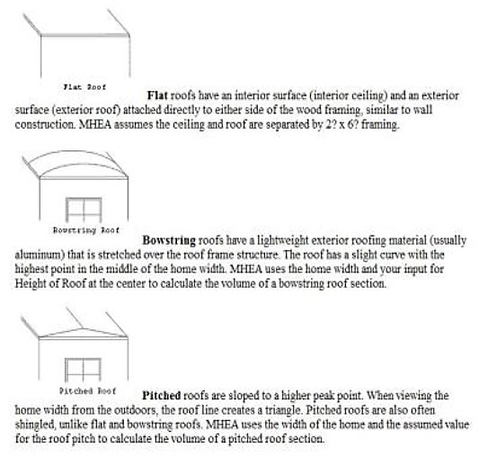

Shell Floor
Insert a note about this component being unique to manufactured homes.
Training resource: https://mn.gov/commerce-stat/wap/MHEA_Floor_Repair_Tool.xlsx

WAPLink process
- Floor information
  - Floor Joist Direction: Choose whether the joist runs Widthwise or Lengthwise
  - Check if there is a mobile home skirt present. If it covers only part of the home, the auditor must decide whether to call it present or not. Consider its ability to prevent wind across the belly.
- Wing Description
  - Floor Wing Joist Size: Choose the appropriate size from the dropdown
  - Wing Batt/Blanket Insulation Location: Choose the appropriate Location for the Batt/Blanket insulation from the dropdown
  - Batt/Blanket Thickness (in): Input the thickness of the Batt/Blanket
  - Loose Insulation Thickness (in): Input the thickness of the Loose insulation
- Belly (Center) Description
  - Floor Belly Joist Size: Choose the appropriate size from the dropdown
  - Belly Cavity Configuration: Choose the configuration from the dropdown. (Rounded is most common)
  - Condition of Belly: Choose the belly condition from the dropdown.
  - Maximum Depth of Belly Cavity (in): input the maximum depth. (Measure from the deepest part of the belly, if rounded.)
  - Belly Batt/Blanket Insulation Location: Choose the appropriate Location for the Batt/Blanket insulation from the dropdown
  - Batt/Blanket Thickness (in): Input the thickness of Batt/Blanket.
  - Loose Insulation Thickness (in): Input the thickness of loose insulation present.
- Enter any comments in the comment section
- Click the Save button at the top left of the screen
- Click the X on the top of the right side of the FLOOR MHEA screen to exit

Addition
Shell Elements of the Addition must be modeled here separately from the Shell Section.

WAPLink process
- All inputs are essentially the same as what you have input preciously in the Mobile home Shell with one exception:
  - Wall Addition
    - Configuration Information
      - Wall Configuration: There are three choices here, and they all refer to the slope of the ceiling within the addition
        - Maximum height at the interior wall: The ceiling is shed type and slopes away from the mobile home
        - Maximum Wall Height in Center of Addition: Cathedral ceiling
        - All Addition Walls are the Same Height: the ceiling is flat

Air/Duct Leakage
Notes: Ducts in the floor or attic cavities are considered outside the building envelope and will be modeled in WAPLINK Manufactured Home Energy Audit (MHEA) tool as an energy conservation measure. All ducts that have an SIR of 1.0 or greater (or .75 or greater with EAPWX) will be sealed in accordance with SWS. The method of duct sealing will depend on the location of the leak in the duct.
In modeling duct sealing and duct insulation outside the building envelope in MHEA:
- Include duct sealing as part of a furnace replacement measure.
- Limited duct sealing may be modeled as a health and safety measure with reference to correcting issues with depressurization and natural drafting appliances.
- Model per guidance below for an Energy Conservation Measure.

WAPLink process
- In the Air/Duct Leak category Leakage Method box, select the Evaluate Duct Sealing box and select Pressure Pan Measurements from dropdown
Figure 16. Data entry locations for Step 1
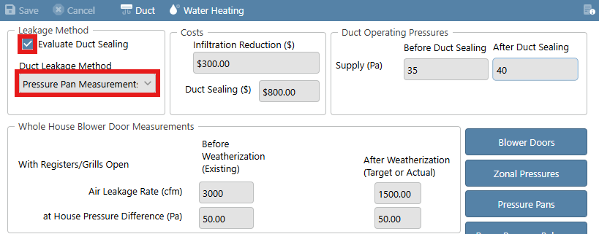
- Enter the data for Duct Blower Measurements and Duct Operating Pressures
Figure 17. Data entry locations for Step 2
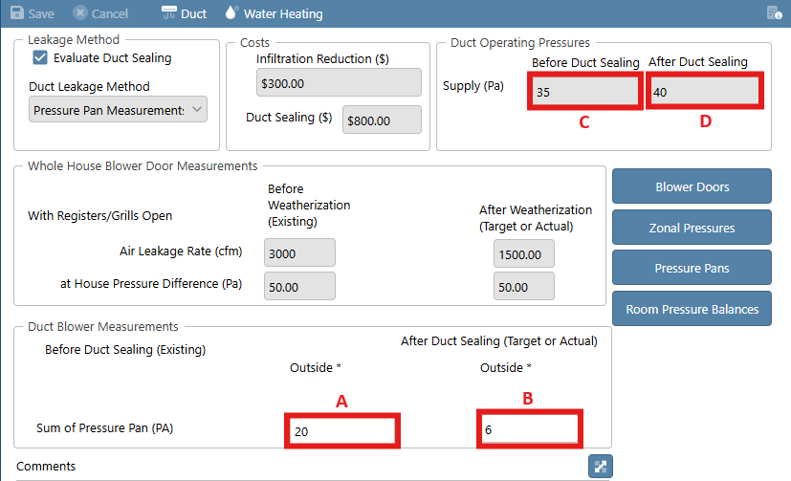
  - Before Duct Sealing – With the house depressurized to 50 Pa (WRT the outside) measure the pressure difference between each supply register and the house with a pressure pan and manometer. Enter the sum of all the measurements.
  - After Duct Sealing – Enter the total number of supply duct registers in the home
  - Before Duct Sealing - With the air handler fan on, use a manometer and long static pressure probe to measure the supply duct pressures (WRT the interior) at the register nearest and farthest from the furnace for each supply trunk. Enter the average of the readings.
Figure 18. Register test locations
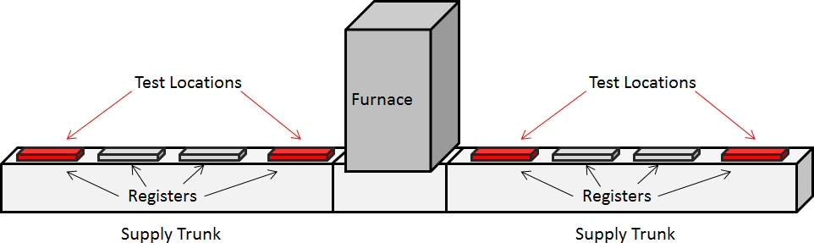
  - After Duct Sealing – Add 5 Pa to the Before Duct Sealing pressure and enter here
- Seal the following areas (shown in red in Figure 18) as SIR allows in the following order:
  - Furnace/Plenum connection
  - Boots
  - Plenum termination
  - Branch connections
  - Crossover connections
  - Any other large holes
Figure 19. Sealing order
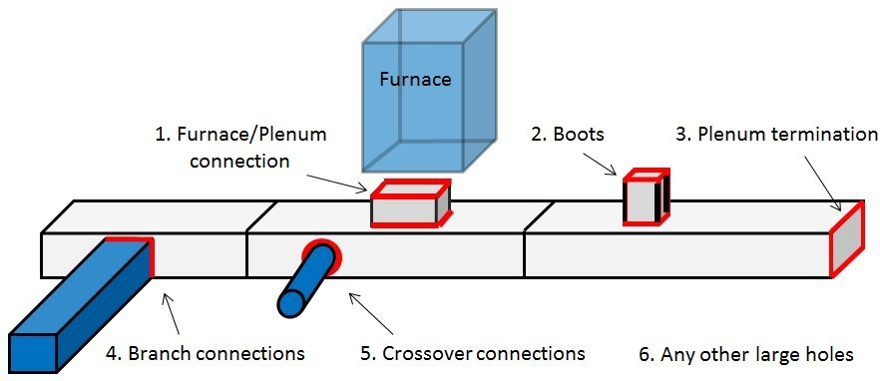
- Leakage Method: Check the Evaluate Duct Sealing to get additional funds for duct sealing. Extra on-site measurements will be required.
  - Evaluate Duct Sealing. It MUST be checked if pressure pan results show greater than 3.0 Pa.
- Duct Leakage Method: Choose the appropriate Leakage method from the dropdown list
- Infiltration Reduction Cost ($): Enter the amount you wish to receive for ALL air sealing measures on this home
- Duct Sealing ($): Enter the amount for costs associated with duct sealing
- Duct Operating Pressures: (NOTE: Remember that you must perform the Duct Operating Pressure Test. Defaults will not be accepted but on very rare occasions.)
  - Before Duct Sealing. Both Supply and Return static pressures need to be measured in the field. Typically, one is measured and then the other. Testing does not have to be simultaneous. Static duct pressures are measured with the furnace air blower on. The blower door must NOT be running.
    - Supply static pressure: Inserting the manometer hose in the supply plenum is best. If this is not possible or practical, insert the hose in the nearest supply register and snake the hose as close as you can to the plenum. You can close the register through which you are testing or tape it shut to get a better reading.
    - Return static pressure: Inserting the manometer hose in the return plenum is best. If this is not possible or practical, insert the hose in the nearest return register and snake the hose as close as you can to the plenum.
  - Before Weatherization: Enter the blower door result achieved at pre-audit
  - After Weatherization: Enter the target blower door result. Remember to always use 50 if your manometer was set to Pa/CFM@50
  - Before Duct Sealing (Existing): Input the data as measured in the field
  - After Duct Sealing (Target or Actual):
    - Total Leakage: 12% of the total conditioned floor area of the home
    - Leakage to Outside: 8% of the total conditioned floor area of the home
  - When Duct Sealing is checked, the method will always be by Pressure Pan in a Mobile Home. In the Duct Blower Measurement Section:
    - Before Duct Sealing Duct Pressure (Pa): Total of all pressure pan readings add together go here under the Outside * column (refer to A in Figure 16 above)
    - After Duct Sealing Target Duct Pressure (Pa): is the total number of registers in the mobile home. Go to the Outside * column. (refer to B in Figure 16 above)
  - Duct Sealing Cost: Input amount needed for duct sealing. SIR must be 1.0 or greater.
  - NEAT/MHEA will not accept $0 for duct sealing. If you cannot achieve a duct sealing measure with an SIR ≥ 1.0, then uncheck Evaluate Duct Sealing. See below for more information.
    - In Comments, indicate if you attempted duct sealing but could not get the measure with a SIR above 1.0.
    - Your comment will remain even after you uncheck Evaluate Duct Sealing, as will the data you entered to attempt duct sealing.
  - Note that it is allowable to use Infiltration funds to seal ducts.
  - Click the Save button
  - Click on the X at the top right corner of the Air/Duct Leakage screen.

Multifamily project entry

Buildings with 2-4 units
Service Providers may weatherize multifamily buildings containing two or more units. Weatherization is designed to take place with a whole building as a system approach. A single unit within a multi-unit building may not be weatherized.
For a multifamily building to be weatherized, at least 66% (50% for duplex and four-plex, and with Commerce approval, certain multifamily buildings that meet requirements found in WPN 22-12) of units in the building must meet one of the following:
- Are income eligible dwelling units, or
- Will become an eligible dwelling unit within 180 days under a Federal, State, or local government program for rehabilitating the building or making similar improvements to the building, or
- Meet the WAP Multifamily-Specific categorical eligibility criteria as outlined in in the Multifamily Procedures Guide (Appendix C, Energy Modeling).
- To model a dwelling in WAPLink, a minimum of one client that resides in the building must be in WAPLink.
  - If an eligible building does not have a client on Energy Assistance (EA), Commerce has the ability to create blank clients in WAPLink for Service Providers.
For a building to be considered a 2-4 unit multifamily building, there must be complete separation between units. From an eligibility and reporting approach, each unit is considered an individual dwelling and must follow reporting requirements. Due to the variety to 2-4 unit buildings, the following guidance may not cover all possible scenarios. Service Providers are encouraged to include Commerce in decisions on 2-4 unit buildings that are unique and do not fit into the guidance below.

Import a client

WAPLink process
- Locate the eligible client from the Waitlist
  - Schedule the client
  - Select NEAT and 2-4 Units in the WAPLink Job menu
  - Enter a building description in the Notes section
    - Select the Notes button in the WAPLink Job screen and enter the type of 2-4 unit building that is being modeled (e.g. Side-by-side duplex, Stacked duplex)
- If the building is categorically eligible and has no client on EA, reach out to Commerce with documentation proving eligibility.
  - Commerce will review the building and create blank clients in WAPLink if approved.
  - Once created, locate the blank client in Customer Search
  - Schedule the client
  - Select NEAT and 2-4 Units in the WAPLink Job menu
  - Enter a building description in the Notes section
    - Select the Notes button in the WAPLink Job screen and enter the type of 2-4 unit building that is being modeled (e.g. Side-by-side duplex, Stacked duplex)

Energy Model

WAPLink process
- Model the entire building in WAPLink as one audit. This will create the most accurate energy model.
  - Enter the building inputs and process the audit
  - Heating plants should be entered with the appropriate fraction of load
    - Do not use the Also Replaces function in the HVAC tab if there are multiple heating plants
  - Utilize REDCalc for ASHRAE calculations
    - Save a copy of the REDCalc calculation to the client file

Work orders

WAPLink process
- Create work orders based on the recommended measures and health and safety needs
  - Each unit should have its own work order (e.g. Unit 1, Unit 2, Whole building)
  - A whole building work order may be needed depending on the building type
    - Shared measures can have costs split between units (e.g. attic insulation)

Reporting

WAPLink process
- Enter the unit counts in the WA 10 Settings eligibility boxes (EAP Eligible, Cat Eligible, Ineligible, Vacant)
- Add Household numbers of the other EAP eligible clients into the WAPLink Job Notes screen
- Demographics
  - Demographics must be reported for all dwellings
    - Enter the entire building’s demographics into the Multifamily Entry template available on the Commerce WAP website.
      - Upload the template to the client file

Closeout
Lock the job following the closeout guidance in ​Final steps: Completion, closeout, and locking jobs.

Buildings with 5+ units
Service Providers who wish to complete 5+ multifamily projects must use the following procedure to track multifamily projects and create work orders. This will involve importing an eligible client or having Commerce create a blank client, creating the appropriate type of event, and developing all the work orders from a single job in WAPLink. This procedure is intended to be similar to the previous process in WA desktop.
Now that the multifamily functionality in WAPLink is operational, Service Providers will be required to retroactively create multifamily projects for tracking purposes.
Follow the instructions below to begin the multifamily WAPLink procedure.

Import a client
Import a client that resides in the multifamily building that is also currently WAP eligible (approved eHEAT application). To do this, follow the instructions in Household eligibility until you get to the Home Queue.
Once you get to the Home Queue, use the instructions below.

WAPLink process
- From the Home Queue, create the appropriate type of audit for the project
- Select one of the following:
  - Low Rise 5+
  - High Rise 5+
  - Also select Priority List if applicable
- This client will act as a “Master Client File” for all of this building’s multifamily work order generation and unit tracking.
- Only import one client for each multifamily project

Generate work orders
Follow this process to generate a workorder for a multifamily building.

WAPLink process
- Create a Whole Building work order
- Select Work Orders
- Select Add Work Order. This will act as the “Whole Building” work order, or the work order for shared measures (e.g. Attic Insulation, Common Area Lighting).
- If more than one Whole Building work order is needed, simply select Add Work Order
- Assign a Crew or Vendor
- Select Add Measures
  - Create a Manual Measure
  - In the Measure Description enter Whole Building
  - The Components field is optional, but will populate in the Areas field
- Select Details
- Edit information as needed such as Material, Labor, and Notes
- Assign costs centers
- Create individual work orders for each unit
  - Select the Add Work Order button
  - This will act as the individual unit work order (e.g. Smoke alarm, ASHRAE fan)
  - Select Add Measures
    - In the Measure Description input the Unit number (e.g. Unit 1)
    - The Components field is optional, but will populate in the Areas field
  - Add Manual Measures for each unit’s needs (e.g. Smoke Alarm, ASHRAE fan)

Release work orders
Release work orders individually or as a master work order to the selected contractors after the procurement process.

WAPLink process if bidding
- Select the Bid button and send the PDF to contractors who are invited to bid on the project
  - This will create a work order without costs or SIRs
- When a contractor has been selected, click the Print button
  - This will create a work order with costs which can be sent to the awarded contractor

Enter unit counts

WAPLink process
- In the WA10 Setting screen, four boxes will appear on the bottom right:
  - EAP Eligible
  - Cat Eligible
  - Ineligible
  - Vacant
- Enter the number of units in the appropriate box
  - The sum of these four boxes should equal the total number of units
  - If a client can be entered into multiple boxes, only enter them into one box
    - For example, if a client is EAP Eligible and Cat Eligible, only enter them into EAP Eligible

EAPWX Expansion Measure specific guidance
The following sections outline procedures and WAPLink instructions for EAPWx Expansion Measures. For more information on EAPWx Expansion Measure Policy, please refer to the 25e_EAPWX_Expansion_Addendum.pdf.

Audit event measures

Mold and moisture remediation with EAPWX funds

WAPLink Process
In the audit, create a WL measure and mark as EXP.

Energy modeling of LED lightbulbs not required when using EAPWX funds
The number of bulbs per bulb type must be included in a work order measure(s). If WAP staff install bulbs, a WAPLink Work Order should be created with the service provider as the contractor.

WAPLink Process
In the audit, create a WL measure and mark as EXP.

Energy Conservation Cooling Measures Using EAPWX Funds

WAPLink Process
Contact Commerce for guidance.

Audit Event Preferred Measures (Standalone Event Allowable)

Health and Safety Cookstove Replacement Using EAPWX Funds

WAPLink Process
Contact Commerce for guidance.

Health and Safety Cooling Measures Using EAPWX Funds

WAPLink Process
Contact Commerce for guidance.

Standalone or Audit Event Measures

EAPWX Heating Plant Replacement for Energy Conservation
Note: EAPWX measure expansion heating system replacements for energy conservation can be completed as a Standalone Event or as part of an Audit Event. When part of an audit event, Service Providers must follow the process below.

WAPLink Process
- Select Replace the Equipment for HVAC or Replace Water Heater for water heaters for health and safety replacements. This will result in WAPLink creating a measure with an SIR less than 1.0 in the Recommended Measures list.
  - The result will be that the energy savings of the new heating system will be documented in the Recommended measures but will not affect the cumulative SIR.
- Create an itemized cost for the EAPWX measure expansion heating system or water heating system replacement
- Upload this itemized cost into a work order
- Select the measure type as HVAC
- Select sub measure type EXP Heating System Replacement
- If completing as only a Standalone Event, the Work Order Type should be Standalone and Standalone Type should be Expansion Measures.

EAPWX Water Heater Replacement for Energy Conservation
PROCEDURE: EAPWX measure expansion water heating system replacements for energy conservation can be completed as Standalone Events or as part of an Audit Event. When part of an audit event Service Providers must follow the following procedure:

WAPLink Process
- Select the replacement mandatory option for heating system or water heating system replacements. This will result in WAPLink creating a measure with an SIR less than 1.0 in the Recommended Measures list. Do not upload this measure into the work order.
  - The result will be that the energy savings of the new heating system will still have interacted with the predicted energy savings and SIRs of the energy conservation measures and incidental repair measures and the measure will not show up on the Measures with SIRs Less Than 1.0 report.
- Create an itemized cost for the EAPWX measure expansion heating system or water heating system replacement
- Upload this itemized cost into a work order
- Select the measure type as Baseloads
- Select sub measure type as EXP Water Heater Replacement
- If completing as only a Standalone Event, the Work Order Type should be Standalone and Standalone Type should be Expansion Measures.

EAPWX Cold-Climate Air Source Heat Pump (CCASHP) Installation for Energy Conservation
PROCEDURE: EAPWX measure expansion for CCASHP installations for energy conservation can be completed as Standalone Events or as part of an Audit Event must be standalone work orders in Weatherization Assistant. These standalone work orders may be created as standalone events or part of an audit event. When part of an audit event Service Providers must follow the following procedure:

WAPLink Process
- Select the replacement mandatory option for heating system or water heating system replacements. This will result in WAPLink creating a measure with an SIR less than 1.0 in the Recommended Measures list. Do not upload this measure into the work order.
  - The result will be that the energy savings of the new heating system will still have interacted with the predicted energy savings and SIRs of the energy conservation measures and incidental repair measures and the measure will not show up on the Measures with SIRs Less Than 1.0 report.
- Create an itemized cost for the EAPWX measure expansion CCASHP system installation.
- Upload this itemized cost into a work order.
- Select the measure type as HVAC Systems
- Select sub measure type as EXP CCASHP Installation
- If completing as only a Standalone Event, the Work Order Type should be Standalone and Standalone Type should be Expansion Measures.

Audit events
This section provides instructions on how to input data into WAPLink for Audit Events. For more information on diagnostic tests, refer to Appendix E: Diagnostic tests for audit events.

Energy audit diagnostic tests
Note: CAZ Depressurization tests are not required in dwellings where all space and water heating plants are electric.

DWH testing

WAPLink process
- In Housing Items, select Water Heating
- On the right side of the window, select the blue Operational Tests button
  - Enter the readings for Audit and Inspection
  - Enter the comment section for any comment clarification that is needed
  - Click Save
- On the right side of the window, select the blue Vent Tests button
  - Venting Information
    - Damper Type: Select the appropriate option from the dropdown menu.
    - Chimney Type: Select the appropriate option from the dropdown menu.
    - Flue Type: Select the appropriate option from the dropdown menu.
    - Flue/Damper Diameter: Enter the Damper Diameter
    - Damper Condition: Select the appropriate option from the dropdown menu.
    - Chimney Condition: Select the appropriate option from the dropdown menu.
    - Flue Condition: Select the appropriate option from the dropdown menu.
    - Combustion Air Intake: Select the appropriate option from the dropdown menu.
  - Normal Operating Conditions Draft Measurements
    - Enter the readings for Audit and Inspection.
  - Enter the comment section for any comment clarification that is needed.
  - Click Save
- On the right side of the window, select the blue Inspections button
  - Fuel Related
    - Check the following boxes as applicable:
      - Insufficient Clearance From Combustibles
      - Gas Leak Present
      - Fuel Shutoff Valve Note Present
      - Drip Leg Not Present
    - Electronic Service Switch Good: Use the dropdown to select the appropriate condition of the switch
  - Water Related
    - Enter the Hot Water Temp(F)
    - Check the following boxes as applicable:
      - Supply Temp Adjustment Needed
      - Pressure Relief Piping Needed
      - Water Leak Present
      - Other Water Heating Problem
  - Enter the comment section for any comment clarification that is needed.
  - Click Save

HVAC testing

WAPLink process
This process is not yet developed.

QCI diagnostic tests

Types of tests

WAPLink Process
This process is not yet developed.

Callbacks

Submitting callback event information for approval and entering in WAPLink

US DOE Callback
General procedure information is available here: WPN 11-3.

WAPLink process
This process is not yet developed.

EAPWX Callback

WAPLink process
- Submit a request to Commerce that includes the proposed scope of work, including all cost estimates, non-US DOE resources to be used, photographs, warranty, client notes, insurance information, and other pertinent information.
- If approved:
  - If the client is currently eligible, create a Callback Event in WAPLink
  - If the client is not currently eligible, submit a request to Commerce to add the client to the Home queue. When the client is added to Home queue, create a Callback Event in WAPLink.
- Add measure details to the callback work order
- Complete the approved scope of work
- Inspect the completed work in accordance with Section 4.6. An on-site inspection by a Commerce staff member may also be required.
- Notify Commerce that the callback work is completed and submit pictures of the completed work. Commerce may require additional reporting.

Section 5: Standalone events

Definition of standalone event
A Standalone Event is a method of delivering services in the Weatherization Assistance Program (WAP) that focuses on the health and safety measures related to a dwelling’s space and water heating systems. A standalone event can be funded with either EAPWX or Propane funds and has different requirements than an Audit Event.

Procedure for standalone events
All Standalone Events must be created in WAPLink.
Note: Do not change an Audit Event work order name or measure type to create a Standalone Event work order.

Creating a standalone work order
The best practice is to begin with the Standalone work order before initiating the audit event, when possible. When filling out measure details in the work order. Conduct work in accordance with the Standard Work Specifications and SWS Aligned Field Guide (See Appendix B, Field Guidance - Retrofitting Minnesota, Standard Work Specification - Aligned Field Guide).

WAPLink process
When the client is selected from the Home Queue, follow these steps to create a Standalone Work Order:
- From the WAPLink Job menu, select Stand-Alone and
  - Choose the appropriate Standalone Type:
    - Emergency Standalone
    - Non-Emergency Standalone
    - Expanded Measures
- Click Work Orders, you will be prompted if you want to create the specific work order, click Yes
- Click Add Work Order
  - The work order name will reflect the selected Standalone Type
- Assign a Crew or Vendor
  - Click Add Measures
  - Create either a WAPLink Measure or Manual Measure
- Go to Details and:
  - Edit as needed (e.g., Material, Labor, Notes)
  - Assign Costs Centers, and enter the following:
    - Fund Category (e.g., EAPWX A2124 H & S)
    - Fund (e.g., EAPWX A2124)

Adding an audit event after a standalone has been created

WAPLink process
To add an Audit Event after a Standalone Work Order exists:
- Select the client from the Home Queue
- Within the WAPLink Job menu, uncheck the Standalone box and Standalone Type
- Select the desired Audit Type and click Save:
  - NEAT
  - MHEA
- Enter audit input data
- Process the audit
- Create additional work orders as needed

Quality Control Inspection tests
Information on policy and procedure for Quality Control Inspection tests can be found in Appendix F: QCI Diagnostic tests.

Additional information and resources
- Hierarchy of Housing Needs
- Crawlspace Guidance
- Solid fuel fired appliance and chimney guidance
- Appendix G: ASHRAE guidance
- Appendix H: Air Sealing guidance
- Appendix I: Policy Guidance additions MN WAP Policy Manual
- Appendix J: Expire Alert quick reference table
- Appendix K: Checklists

Section 6: ​Final steps-Completion, closeout, and locking jobs

Overview
There are three final stages which follow a job; after all work has been completed, after QCI, and after the fiscal closeout.

Initial steps
These initial steps are common for Job Completion, Fiscal Closeout, and Locking Jobs

WAPLink process
- ​Select WAPLink from the lefthand navigation pane
- ​Select Home Information
- ​Click Home Queue
- ​Search by Customer, Address, or Household Number
- ​Double click desired Household in grid

​Job completion
​When the onsite inspection of an audit job is complete and passed, the date of that inspection is noted in the QCI Entry screen. Commerce uses the inspection date for reporting purposes. That means that all jobs are counted in the quarter they are inspected (even when fiscal closeout is completed later).

WAPLink process
- Select QCI
  - The QCI Entry screen will appear
- Select or type in the Inspection Date
Figure 20. Inspection data populated in QCI Entry window
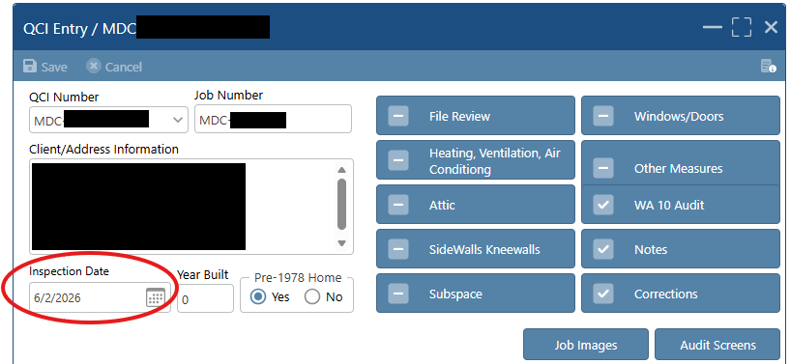

Fiscal Closeout

WAPLink process
- Select Base Funding in the main WAPLink Job screen
  - Base Funding is defined as the primary federal funding source
- Select Funding
  - The Job Close Out screen will appear
- Select a measure within Measure Name
- Click the Fund
- Assign Function/Category
- Assign Fund
- Click Save
  - This must be done for every measure

There should be no errors (yellow or red) if funds are assigned correctly.
The red error indicates unauthorized braiding, while the yellow shows a fund that hasn’t been assigned.

Locking jobs
Lock the job once invoices are paid and the final Quality Control Inspection fiscal review process is complete. Once the job is locked, no changes can be made to the file (without a request to Commerce).

WAPLink process
- Select QCI ​
- Complete the bottom half of the QCI entry (Figure 19)
  - Sign the signature field
  - Check the acknowledgement
- Select WAPLink Job screen
- Click Lock
  - No changes can be made once this step is complete

Figure 21. QCI entry screen
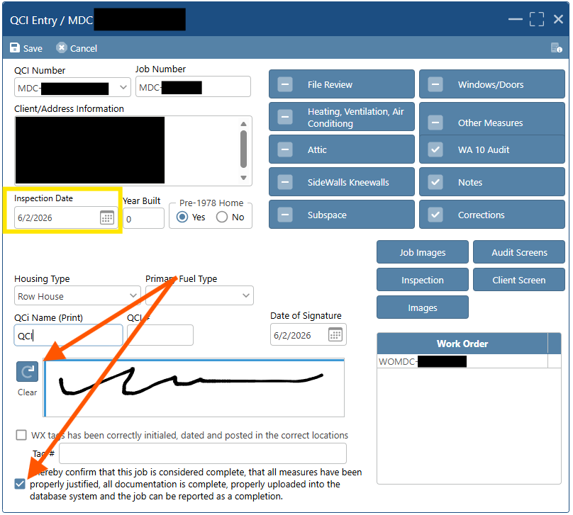

Section 7: Fiscal management

Fund/grant management and braiding instructions
Definitions of terms used in this section can be found in Appendix A: Definitions.

Add new funds

General information

WAPLink process
- Go to My SP
- Click on Fund/Grants
- Click WAPLink Fund/Grant Entry
- Click New
- Enter the following (* = required field)
  - Fund/Award Name*: The name you identify the fund as (i.e. CenterPoint Energy)
  - Agency Program*: Weatherization
  - Fund Status (Open, Frozen, Closed): Open allows the fund to be utilized
  - Fund Type/Source*: This is the funder
  - Fund/Award Year: Program Year
  - Start Date*: Start of the grant
  - End Date*: Start of the grant
  - GL Fund Code: No entry done at this level
  - Original Amount*: Add the allowable spending limit, which are the direct service funds based on an approved budget in WAPLink, or per the funder if it is an ECO/Utility fund
    - If no funds are entered, you will not have funds to draw from and will not be able to lock the job
  - Amendments: This field will populate when amendments are made to the Original Amount. Not currently used in Minnesota.
  - Current Balance: Shows the balance of funds available, once entry is saved
    - Current Balance is a sum of the sublevel categories
    - Current Balance only reduces after job is locked
  - State Funds Only Checkbox: State Use Only
    - Locks the page so that only Commerce can update
  - Click Save when all entries are complete
  - Other options on this page
    - Documents: Can add and store fiscal documents
    - Tasks/Alerts: Can be used to add a fiscal related alert/task and assign to a specific staff member
    - Fund Access: Can be used to limit specific employees that can use a particular fund
    - Counties: Can limit which counties that can use a particular fund

Adding fund category

WAPLink process
- Click Add button found on the bottom left of the WAPLink Fund/Grant Entry screen
- ​At least one Fund Category must be added
- The following steps are repeated for each function chosen:
  - Click New
  - Choose a Function from drop down list. These are direct service cost categories only.
  - Amount: Enter the amount of the direct service funds allowed for use for this Function
  - Average/Unit: Adjusts based on the Direct Service (DS) entered in the Amount field; this field shows the DS divided by the Projected Units
    - Note: This does not follow Commerce’s ACPU formula
  - Projected Units: Enter PY unit goal for the fund
  - GL Code: May be used to add the Agencies General Ledger Code for the fund categories
  - Ledger Entry: Click to add funds
    - Click New
    - Enter Entry Name (i.e. Starting amount)
    - Enter Type: Choose modification - this will default to Debit
    - Posting Date: The date you are adding the funds
    - Start Date: Start of the grant
    - End Date: End of the grant
  - Base: Check this box if the fund is allowed to be used as the primary fund to be braided with or when only that fund will be used on a job
  - Deferral: Check this box when the fund is allowed for deferral mitigation and so that a Deferral Mitigation Work Order can be created for the visit type in the WAPLink Job window
  - Update Status as needed:
    - Open allows use of the funds
    - Freeze puts a hold on the funds
    - Close closes out the funds

Add or edit braiding

WAPLink process
- From the WAPLink Fund Category Entry screen, click New or click on the Fund Category (each Fund Category must have braiding added)
- Fund Braid: Choose a fund that is allowed to braid with the Fund Category (main fund)
- Allowable Category Braid: Check all the boxes next to each of the categories that are allowed for use with the Fund Braid chosen
- You will repeat the last two steps for each item in the Fund Braid dropdown (as applicable)
- Click Save

Funding alerts

WAPLink process
- Final fund assignment occurs in the job close out screen
  - A balance that covers the amount you are assigning to the fund in Job Close Out must be present in the Current Balance on the WAPLink Fund/Grant Entry screen
  - Braiding must be set up for each Fund Category
    - Red highlighted text indicates there is an issue with either the braiding or that funding limits were not entered
    - Yellow: Not all of the amount of the final cost has been allocated to a fund

NFAs
When a new NFA is available, you will see an exclamation point next to NFA on the left navigation pane. The WX Manager will also receive a Task alert.

View your NFA

WAPLink process
- Go to My SP
- Click on Financial Management
- Click on NFAs
- Select the Program Year from the drop down
- Click on the version number of the NFA you wish to view
- Click NFA Report
- Click Submit Report Request (you may also schedule it to print later or check the email upon completion box to have it send you an email version)
- Click My Reports (left hand navigation pane)
- Click the line item you wish to view
- Click View
- To see the history of what has occurred on the various NFA versions, click the NFA version, then select the History Icon

Budgets

Budget tasks

Budget questions

WAPLink process
- Go to My SP
- Click on Financial Management
- Click on Budget Questions
- Choose the Program Year
- Choose the Funding Source
- Click on the question you wish to answer
- Enter your response in the Answer box
  - Note: The options to copy last year’s answers, found at the top of the page, is available for each question.
- Press Enter to save and move to the next line item
- Click the Submit button to submit the budget questions to Commerce
Budget planning questions must be answered prior to submitting the corresponding budget.

View the budget

WAPLink process
- Go to My Agency
- Click on Financial Management
- Click on Budgets
- Either double click the line item or enter the Funding Source
- To view the activity for this budget, click History

Submit the budget

WAPLink process
- Either double click the line item or enter the Funding Source
- Click the line item you wish to update
- Enter the amount of allocation, for each line item, in the Standard Amount box
  - The Currently Allocated amount will sum the amounts as they are entered, for each category. Admin and T&TA will auto fill with the allocated amount
- Click Save
  - If the box remains red, the total amount for that category does not match the Allocation Limit and must be adjusted
- When complete, click Submit Budget
- You may include a note with the budget. To add a new note, click Notes, add your notes to the New Note area, click Save. To alert Commerce of the presence of the note, click Mark for Review
- You can review, print, or save the budget planning Q & A
  - Click Budget Questions Report
  - Go to My Reports in the left-hand navigation
  - Click on the report you created
Commerce will be alerted when there is a budget to review and approve. Once approved, the person/people set up in Email Setup will receive an alert.

FSRs

Tasks to complete FSRs

View FSR

WAPLink process
- Click My SP
- Click Financial Management
- Choose FSRs
- Click the Funding Source line item
- Click FSR Report
- Click Submit Report Request
- To view the FSR report, click Document Center on left hand navigation

Enter FSR

WAPLink process
- Click My SP
- Click Financial Management
- Choose FSRs
- Click New
- Choose Program Year
- Choose Funding Source
- Choose FSR Month/Year
- If final FSR of the PY, check the Final FSR box
- Click Save
- Click Yes to load the new FSR
- Enter current expenditures
- Press Enter to save and move to the next line item
- When complete, click Submit
- Click Yes

Cash requests

Tasks to complete cash requests

View cash requests

WAPLink Process
- Click My SP
- Click Financial Management
- Choose Cash Requests
- Choose Program Year
- Choose Status
- Click the CR# line item you wish to view

Cash request entry

WAPLink process
- Click My SP
- Click Financial Management
- Choose Cash Requests
- Choose Program Year
- Click New
- Enter the Period Start and Period End dates
- Click Save
- Choose the Funding Source from the upper right corner of the grid
- Enter the amounts for each category in the lower left corner of the grid
- Click Save
- Repeat 8 – 10 for each fund
- When complete, click Submit

Fiscal documents

WAPLink process
This section is used to add and store fiscal documents.
- Click My SP
- Click Financial Management
- Choose Fiscal Documents
- Click New
- Click Upload File
- Choose the file you wish to upload
- Click Open
- Choose a Document Type from the dropdown (optional)
- Click Save
- Click the View Document button to view the document

Section 8: Procurement

Vendor management

Vendor management tasks

General

WAPLink process
- Click My SP Setup
- Click Vendors

Activate an existing vendor

WAPLink process
- Look for an existing vendor with a matching Federal Tax ID
  - Sort by clicking either the Vendor column (alphabetical) or Fed. Tax ID column (numerical)
  - If a vendor, with a matching Tax ID, is on the list, you may activate them
- Click on the name of the vendor you want to activate
  - If there is a check mark in the Activated column, they are already active for your agency
  - Click the Activate Vendor button
  - You will get a pop-up stating: “Are you sure you want to Activate this Vendor?”
  - Click Yes
  - There will be a check mark in the Activated column indicating they are now active for your agency

Enter a new vendor

WAPLink Process
If the vendor is not on the list, add a new Contractor, Crew, Utility, or Inventory.
- Click New
- Fill in the Vendor name
- Enter the Fed. Tax ID (must be 9 digits)
- Select Contractor, Crew, Utility or Inventory
- Select Vendor type: Building Shell/Other or Mechanical
  - If Mechanical, you must select the sub type Check all that apply
    - Electrical (includes Solar Contractors)
    - Plumbing; and/or
    - HVAC
  - If the vendor is not a Contractor or Crew, do not choose a type or sub- category
  - If you wish to change the vendor type, you must contact Commerce
- Minority, Woman or Veteran Owned: Select Yes or No from the dropdown
- Add a date if the contractor received a retention incentive
- Click Save
  - Note: After entering the vendor’s name and Tax ID, and clicking save, WAPLink checks for an existing vendor with the same Tax ID. If the Vendor is found in the statewide system, a notice alerting you that the vendor you are trying to create already exists.
    - After clicking Save, a pop-up will state “A Vendor has been found with this Federal Tax ID. Do you want to Activate that Vendor for your SP?” Click Yes
- Highlight the vendor
- Click the Services Provided Button; Choose all that apply
- Add a Price Book by clicking New and enter relevant data (optional)
- Click Save
- Click the Locations button
- Click New
- Add Location (i.e. Main Office, city where located)
- Enter the Address
- Click Save
- Click Activate Location (will automatically activate the vendor if adding via New)
- Add Contacts (bottom half of the page)
- Click New
- Enter the First Name, Last Name, email and choose the Contact Type (required)
- Enter the phone and fax (optional)
- Click Save
- You may repeat steps 13-23 to add additional locations or contacts
- You will now see a check mark in the Activated column
- Add Vendor and Employee documentation (refer to Documentation Entry tab and Employee Entry tab)

Delete a vendor

WAPLink process
A vendor can be deleted and will not affect other Service Providers using that vendor. A check to verify this will occur and if other Service Providers are using that vendor, will deactivate for only your agency.
- Click on the vendor's name
- Click Delete
- Answer Yes to “Are you sure you wish to delete this record?”

Vendor status review

WAPLink process
- Highlight the vendor and review the Status column
  - Eligible Vendor: Indicates all information is complete
  - Doc. Incomplete: Indicates additional documentation is required for eligibility to be complete
  - Ineligible Vendor: Indicates there are expired documents
  - Inactive Vendor: Indicates the vendor is not active for your agency
- Determine what information needs to be updated or completed
- Click on the Documentation tab
- Click View Issues - This will provide a complete list of missing or incomplete documents or information
- Update information as needed.
For the Expire Alert Quick Reference Table, refer to Appendix J: Expire Alert quick reference table.

Optional features (main vendor entry screen)

Place on probation

WAPLink process
You may want to place a vendor on probation, rather than deactivate them
- Click Deactivate Vendor
- Popup will ask “Are you sure you want to place this vendor on Probation?”
- Click Yes
- You will now see a check mark in the Probation column on the grid
- You will not be able to assign this vendor jobs
Note: This function is only visible to and effects the SP putting them on probation.

Internal notes

WAPLink process
- Notes are SP specific and can only be viewed by the SP entering the note
- Notes regarding a vendor’s likes/dislikes, issues to watch, or general information, can be entered here. These can be viewed by other Service Providers.
- To view or add a note, click on Internal Notes at the top of the page. Compose the note and click Save
- Notes can only be edited or deleted by Commerce

Don’t share
When Don’t Share is checked, the vendor will not be visible, in the grid, to other Service Providers. Other Service Providers will only see them when they begin to enter a vendor with the same Tax ID.

Vendor chat (currently not in use)
Vendor chat is used to communicate with a vendor via email. This feature can only be used with activated vendors.

WAPLink process
- Click Vendor Chat
- Type your message
- Click the arrow to send
- Reply notifications will be shown in the WAPLink – Vendor Chat window
  - The Vendor Name on the main screen will be highlighted to indicate an unread chat is available

Login settings (currently not in use)
Login settings are used to provide vendors with access to view and update their profile and upload documents.

WAPLink process
- Click on the Vendor name (vendor must be active)
- Click on Login Settings
- Click Add User (answer Yes to the popup question)
- Enter the Admin user’s email address
- Click Save
- An Admin Username will be automatically assigned
- Click Password Reset (answer Yes to force this user to reset their password when they next log in
- Check Allow Vendor Login for WAPLink
- No other boxes will be checked at this time

Documentation Entry tab

Overview
- Documents unique to each Service Provider include the contract between SP and vendor, insurance, and workers compensation. All other documents are shared, and each document must be approved by each SP.
- Based on the type of vendor you choose, only the relevant documents will populate.
- Duplicate entries indicate that there is a soon to expire document and this is a placeholder for the new document.

Functions

Required Field alerts

WAPLink process
- If a vendor status is Doc Incomplete or Ineligible, there are issues with one or more document
- Click the View Issues tab at the top of the page. This provides a list of issues identified and that need to be resolved to make the vendor eligible.

Expired/Expiring Vendor alerts

WAPLink process
- If you have an expiring vendor, an alert will be sent. To receive an alert, a user must have the Receive Vendor Alerts checkbox marked in WAPLink People.
- Alerts are built in and will flag when a document is soon to expire or is expired. An alert will be sent when a vendor goes from Eligible Vendor to Expiring Vendor or from Eligible Vendor/Expiring Vendor to Ineligible Vendor. When the Vendor goes from Ineligible Vendor/Expiring Vendor to Eligible Vendor, it will mark any existing alerts for that vendor as completed.
  - Yellow highlight indicates document it is soon to expire. Soon to expire alerts are set by Commerce and vary by document (see the Expire Alert Quick Reference Table for individual document alert timeframes).
  - Red highlight indicates document is expired. This makes the vendor ineligible; you will not be able to use this vendor until documentation is updated.
Note: Expired documents are archived and visible only when Show Archived, at the top of the page, is checked.
Expiring dates and documents will run concurrently with new documents until expiration, at which time the expired document will be archived.

Document entry

WAPLink process
- Click on the vendor’s name
- Click on the Documentation tab
- Click on the document name
- Enter the Start and End Dates or check the Not Needed box
  - Start dates must be either in the past or today’s date
  - End dates must be in the future
- The following documents give you the option of a check box indicating it is not needed or not applicable. Notes explaining the reason for checking the box are required for some items.
  - Workers Compensation Insurance when not applicable (requires a note)
  - EPA Lead Firm Certification when not applicable (for mechanical contractors or vendors not doing any lead-related work.) (Adding a note is optional)
  - Asbestos Contractor and Firm Certification when not applicable (Adding a note is optional)
- Click Save after each entry

Notes folder (Documentation tab)

WAPLink process
- Notes entered from the Documentation tab are related to a specific document
- Notes are specific to the selected item in the grid and aren’t used in determining the vendor’s status or any colors in the grid
- You must first click on the document and then click on the Notes folder to add a note
- Notes can only be edited or deleted by Commerce
- Only the Service Provider entering the information and Commerce can view it

Attach a document

WAPLink process
- Attachments are required for each entry except when the Not Needed box is checked
  - Save the documents in a location that is easily accessible such as on your desktop or an easily accessible folder on your computer
- Highlight the document name
- Click Attach. This will open a file browser.
- Navigate to the location of the file you would like to upload
- Highlight the appropriate file and click Open
- Click Save
- A checkmark will populate in the Attached column indicating the attachment is present

View an attachment

WAPLink process
- Click on the line of the document you wish to view
  - There must be a check mark in the Attached column indicating an attachment is present
- Click View

Delete a document
This option is available as a separate security definition and those in the System Admin security group can delete documents or assign the task to others. If a document is deleted, that is still needed, it will add a blank record back to the grid.

WAPLink process
- Click on the line you wish to delete
- Click Remove
- A pop-up stating, “Are you sure you want to Remove this Document?”
- Click Yes

Add a new document when previous document is expired/expiring

WAPLink process
- Click on the document you wish to add or update
- Click Create New Document
  - A duplicate document is created
  - Note that the Create a New Document option will only be available when Not Needed was previously checked. Otherwise, the system will add the new document automatically once it is shown as expiring (when you see the yellow).
- Click on the duplicate line item
- Enter the required information
- Click Save
- Upload the attachment

Document specific information

Tasks for entering document specific information

Contract between SP and Contractor (includes SWS verification)

WAPLink process
- Enter the start and end date of the contract
- Upload the contract and SWS Verification if separate
- Will not be present for a Crew
- Click Approve

Contractor License/Bond

WAPLink process
- Enter start and end date of the firm license or bond
- Shell: Upload the license (assumes bond)
- Mechanical/HVAC: Upload the Bond
- Electrical or Plumbing: Upload the license (at least one of the employees must have an individual license for this to be an eligible vendor)
- Click Approve

Insurance certificate (property damage, bodily injury, liability)

WAPLink Process
- Enter the start and end date of the liability insurance
- Upload the insurance document
- Click Approve

Workers’ Compensation

WAPLink process
- When the vendor has employees, the Insurance Certificate must include evidence of Workers Compensation coverage or separate documentation must be uploaded
  - If the Workers Compensation information is not included in the Insurance Certificate:
    - Enter the Workers Compensation Insurance start and end date
    - Upload the Workers Compensation Insurance document
  - If Workers Compensation information is included on the Insurance Certificate:
    - Check the Not Needed box
    - Add a note in the Not Needed Reason box noting the reason it’s not needed
    - Attachment is not required when the Not Needed box is checked
- Click Approve

Debarment check

WAPLink process
- Debarment verification must be completed annually. These expire, in WAPLink, one year from the completion dates.
- Enter the date conducted
- Upload the document
- Will not be present for a Crew
- Click Approve

EPA Lead Firm Certification

WAPLink process
- EPA Lead Firm Certification is required for all building shell contractors
- Enter the start and end date
- Upload the EPA Lead Firm Certification document
- If the Mechanical Contractor or vendor does not perform any work requiring lead- safe practices and certification is not required, check the Not Needed box and document the reason it’s not required in the Notes (recommended)
- EPA Certification Information can be found at http://cfpub.epa.gov/flpp/ searchrrp_firm.htm
- Click Approve

Asbestos contractor and firm certification

WAPLink process
- Required only when the contractor does asbestos work
- Enter start and end date
- Attach the Asbestos Contractor and Firm Certification document
- If the contractor or vendor does not perform asbestos work, check the Not Needed box
- Add a note in the Notes box (recommended)
- Will not be present for a Crew
- Click Approve

Employee Entry tab

Employee entry tasks

Employee entry overview

WAPLink process
- Everyone entering a client’s home, including a working owner or sole proprietor, must be listed in the Employees tab.
- Employees and associated documents are shared between Service Providers. Each Service Provider must approve each document.
- All the required documentation for Asbestos and Lead must be completed in the Vendor Documentation tab (dates and attachment), for the associated employee documentation to flag as required.
- Click Approve after each document entry

Required field alerts

WAPLink process
- Red highlight indicates the field is required (date and/or attachment) and must be completed for a vendor to be eligible
- Grey highlight indicates the information is not required

Expiration alerts

WAPLink process
- Expires date automatically calculates based on the date(s) entered
- Documents that only require a date conducted, will only show the date in the Start Date column
- Yellow highlight indicates it is soon to expire
- Red highlight indicates it is expired or missing

Add employees

WAPLink process
- Click on the Employee Documentation tab
- Click New
- Enter the First Name and Last Name (required)
- Enter the Phone and Email (recommended)
- Click Save
- Add additional employees by repeating these steps

Employee documentation Entry

WAPLink process
- Click on the employee’s name
- Click on the line with the name of the document
- Enter the Start and End Dates
  - Start dates must be either in the past or today’s date
  - End dates must be in the future
- Click Save after each entry

Attach/upload a document

WAPLink process
- Click on the employee’s name
- Highlight the document name
- Click Attach. This will open a browser window.
- Navigate to the location of the file you would like to upload
- Highlight the appropriate file and click Open
- Attachments must be in the form of a PDF or JPEG
- Click Save
- A checkmark will populate in the Attached column indicating the attachment is present

View an attachment

WAPLink process
- Click on the line of the document you wish to view
  - There must be a checkmark in the Attached column indicating an attachment is present
- Click View

Delete a document

WAPLink process
- Click on the line you wish to delete
- If the line was previously approved, click Unapprove
- Click Remove
- A pop-up stating, “Are you sure you want to Remove the Document?”
- Click Yes

Add a new document when previous document is expired/expiring

WAPLink process
- Click on the document you wish to add or update
- Click Create New Document
  - A duplicate document is created above the current document
- Click on the document you wish to update
  - Enter the Start and End Dates
  - Click Save
- Upload the attachment
- Note that the Create a New Document option will only be available when all required fields and uploads are complete for the existing document

Employee document specific information

Processes for providing employee documents

Employee criminal background check (optional)

WAPLink process
- Enter the date the Background Check was conducted
- No document attachment is required
- Click Approve

EPA Lead Certified Renovator

WAPLink process
- For each Certified Lead Firm, at least one employee must have an EPA Lead Renovator Certification for the vendor to be eligible
- Enter the Start and End Date
- Attach the EPA Lead Renovator Certification document
- Click Approve

Lead-safe work training
All employees must have either lead-safe work training or have EPA Lead Renovator Certification. When Lead Renovator Certification is entered, lead-safe work training will not show on the grid as an option, as it is included in the certification.

WAPLink process
- Enter the Lead-Safe Work Training start and end date and attach documentation of training.
  - This training may have been conducted internally by the Contractor; in this case, the contractor should provide documentation attesting to this training including an outline of topics addressed and date of training
- Document will show on the grid, but not be required, when EPA Lead firm certification is entered for the Contractor on the main Documentation tab.
- Click Approve

Asbestos certification

WAPLink process
- Asbestos Certification is required for all employees of a vendor who performs asbestos work
- Document will show on the grid, but not be required, when Asbestos Contractor and Firm Certification information is entered for the Contractor in the main Documentation tab
- Enter the Asbestos Certification date(s) and attach documentation
- Will not be present for a Crew employee
- Click Approve

Section 9: Monitoring
This cannot currently be completed within WAPLink. Please contact Commerce with questions.

Section 10: Reports

My Reports
My Reports are the pre-created reports users can select. These include:
- Quarterly Program Report
- WL Claim Report
- WAPLink Job Expense Report
Training Resource: My Reports on Vimeo

Quarterly Program Report
The quarterly program report tracks job completions and provides key reporting metrics required by the U.S. Department of Energy.

WAPLink Process
- Click on My Reports on the left-hand navigation
- Click New
- Select the Weatherization dropdown
- Select Quarterly Program Report
- Select the Fund Type
- Click Submit Report Request

WL Claim Report
The WL claim report tracks individual fund source expenses. It displays labor and material costs, fund source, award number, production stage, and budget categories.

WAPLink Process
- Click on My Reports on the left-hand navigation
- Click New
- Select the Weatherization dropdown
- Select WL Claim Report
- Enter a start date and end date
- Click Submit Report Request

WAPLink Job Expense Report
The WAPLink job expense report allows you to review job expenses for the whole job. It displays work orders, assigned crew or contractors, actual costs, and all dates and statuses.

WAPLink Process
- Click on My Reports on the left-hand navigation
- Click New
- Select the Weatherization dropdown
- Select WAPLink Job Expense Report
- Enter a start date and end date
- Click Submit Report Request

Custom Reports
Custom reports or ad hoc reports are custom reports created by the user.
Definitions:
- Query category – Who can view the report (statewide, agency, user).
- Criteria - The data points and rules used to run the report. These are the inputs that tell the system what to search for.
- Fields – The data you want the system to display in the report. These are the outputs.
- AND Conditions – Logical operators where all conditions must be true. If even one condition is false, the whole rule is false.
- OR Conditions – Logical operators where at least one condition must be true. If any of them are true, the whole rule is true.

WAPLink Process
- Click on Custom Reports on the left-hand navigation
- Click New
- Enter a Query Name
- Select Query Category
- Enter a description (not required)
- Click Save
  - This query is now saved and can be edited in the future
- Select the query you’d like to edit
- Click Criteria
  - Click Add
    - Fill in required rules and save
- Click Fields
  - Double click on the item to see it populate into the selected fields
  - Ensure the same section and group within criteria is also selected in fields
  - You can select as many fields as you’d like, and it will not affect the report
- Click Submit Query

Appendix A: Definitions
Click the following links to return to Inventory, Settings, WA Fuel Cost (Statewide – non-editable), WA Key Parameters (Statewide–non-editable), WA Active Measures (Non-editable), WL Measures (a.k.a. “User-Defined Measures”), or Fund/grant management and braiding instructions

General
System Admin: Coordinator/Director level; Highest level of security and should be assigned to 1 – 2 high level staff. This security level can modify all other security groups/staff.
Fiscal: Financial functions primarily executed by fiscal staff.
Office Support: Duties primarily performed by office/support staff.
WAPLink: Duties primarily performed by technical/field staff.

Inventory and Settings (a.k.a. “Library”)
Library: A term used in WA for the collection of inventory libraries and measure libraries. In WAPLink, it’s broken up into:
Inventory: A list of all materials and their prices that can be pulled into kits or work orders

Settings
WA Fuel Cost (Statewide – non-editable): The WA Fuel Costs are the statewide fuel prices that will be used in any NEAT or MHEA audit. These costs will be updated annually and are designated by the appropriate Program Year. The costs are made up of Fuel Type, Unit of Fuel and Unit of Cost, and the Heat Content of the fuel.
Within the WA Fuel Cost, the Price Indices are embedded for each fuel type. Fuel price indices are used to adjust the dollar savings of measures to account for anticipated changes in fuel prices over their life. This is made up of both the Price Index as well as the Uniform of Present Worth (UPW) Factor. The Price Index is the projected Price Indices based on national averages across the US and the UPW is computed from the price indices and the Real Discount Rate entered in Key Parameters.
WA Insulation (non-editable): Where they have default and user-added insulation types and their respective R values
WA Active Measures: Where you can activate and deactivate different measures
WA Measures Cost: The prices that the engine uses for running the audit. These are essential for SPs to update because modelling relies on correct information.
WL Measures: Here, SPs can get into more detail about certain measures and change how they link to the audit. This is also SPs create kits.
WL Add Points: This allows you to increase or decrease priority for deciding when to weatherize.
There are several other options, including WA Setting Group, WA Fuel Cost, WA Key Parameters, and WA Measure Settings, that have limited or no customization options.

NEAT Key Parameters definitions
Real Discount Rate: The rate at which dollars saved in the future are discounted to a worth in current dollars and is supplied by DOE.
Minimum Acceptable SIR: The savings to investment ratio (SIR) for an individual measure below which the measure will not be recommended. A minimum SIR of 1.0 has been specified by DOE but allowance of 0.75 for EAPWX funds.
Heating and Cooling Setpoints for Daytime and Nighttime (F): The assumed thermostat set-points in the house being audited. NEAT has been designed to make recommendations based on typical occupancy. The set-point values should not be altered to reflect any unusual lifestyles of the occupants.
New Shower GPM (gal/min): The flow rate in gallons per minute of replacement shower heads used in your program.
Single Defrost kWh: The electrical energy in kWh assumed consumed by the existing refrigerator’s defrost cycle. The value is used to adjust the metered consumption of the refrigerator if the user indicates that the metering period included a defrost cycle.
R-Value Uninsulated "Other" Wall (h-ft2 -F/Btu): The R-value associated with an uninsulated wall given Wall Type “Other” on NEAT’s Walls form.
Annual Outside Film Coeff (Btu/h-ft2 -F): The winter/summer average film coefficient assumed for exterior surfaces.
Base Free Heat from Internals (Btu/h): The heat from lights and appliances that is released into a home. NEAT adds to this base amount the heat generated by as many as two adults (276 Btu/h per adult) and one child (224 Btu/h) for every occupant above two in number.
R-Value Exterior Siding “Other” (h-ft2 -F/Btu): The R-value associated with the Exterior Type (siding) “Other” on NEAT’s Walls form.
New DWH Blanket R-Value (h-ft2 -F/Btu): The insulation R-value used to wrap water heaters in the Water Heater Tank Insulation measure.

MHEA Key Parameters definitions
Real Discount Rate: The rate at which dollars saved in the future are discounted to a worth in current dollars and is supplied by DOE.
Minimum Acceptable SIR: The savings to investment ratio (SIR) for an individual measure below which the measure will not be recommended. A minimum SIR of 1.0 has been specified by DOE but allowance of 0.75 for EAPWX funds.
Heating and Cooling Setpoints for Daytime and Nighttime (F): The assumed thermostat set-points in the house being audited. NEAT has been designed to make recommendations based on typical occupancy. The set-point values should not be altered to reflect any unusual lifestyles of the occupants.
Spending Limit ($): The average per dwelling expenditure of financial assistance allowed under the Weatherization Assistance Program as prescribed in the annual program guidance. If this limit is exceeded for a specific dwelling, a warning will be printed under the “Special Notes” section of the Recommended Measures Report (see Section 12.2, Recommended Measures Report).
Interior Floor R-Value: Summer, Winter (h-ft2 -F/Btu): The R-value of the interior floor components, excluding insulation, for the summer and winter seasons. The floor components may simply include the flooring material, floor covering, and the surface resistance of the air. Refer to literature related to approximating R-values of building components for further detail.
Evaporative Cooler Actual Saturating Eff (%): The saturating efficiency of the evaporative cooler. Refer to manufacturer’s literature or literature describing evaporative cooler operation for actual saturating efficiency values.
Density of Loose Cellulose and Fiberglass Insulation (lbs/ft³): The anticipated density of cellulose and fiberglass insulation to be installed. These values are used with the Bag Size entries that follow to determine the number of bags of insulation necessary to perform the associated insulation retrofits.
Saturating Eff for Evaporative Tune Up (%): The saturating efficiency after a tune-up has been performed on an evaporative cooler.
Saturating Eff for Evaporative Rplcmnt (%): The saturating efficiency of a replacement evaporative cooler. The manufacturer’s literature should help indicate the new evaporative cooler saturating efficiency.
Bag Size for Loose Cellulose and Fiberglass Insulation (lb.): The weight of the bags of cellulose and fiberglass insulation purchased to perform the insulation retrofits. These values are used with the Installed Density entries above to determine the number of bags of insulation necessary to perform the associated insulation retrofits.
Batt Blanket, Loose, Rigid, Foamcore Insulation R-value Per Inch (h-ft2 -F/Btu-in): The R-value per inch for the insulation to be used in MHEA energy calculations. This value is used to evaluate the insulating effect of existing insulation described on the input forms as well as the insulating effect of new insulation added during weatherization. Note that rigid insulation is typically found in the roof section and that foamcore insulation is typically found in the wall sections of the manufactured home.
Cooling System Fan Power (Watts): The fan power of the cooling system fan. This value is used in the equipment cooling capacity and equipment energy consumption calculations.
Door U-value: Wood with Solid Core, Wood with Hollow Core, Standard Manufactured Home Door (Btu/h-ft2 -F): The U-value for each type of door. These values are used to evaluate the insulating effect of the existing doors described on the input screens. Note that MHEA assumes a standard manufactured home door has a solid core and vinyl or fiberglass skin.
U-value of replacement door (Btu/h-ft2 -F): The U-value for a replacement manufactured home door. This value is used to evaluate the insulating effect of the replacement doors.
Interior Wall R-Value: Summer, Winter (h-ft2 -F/Btu): The R-value of the interior wall components, excluding insulation, for the summer and winter seasons. The wall components may simply include the interior wall material and the surface resistance of the air. Refer to literature related to approximating R-values of building components for further detail.
Home Leakiness—Tight, Medium, and Loose (cfm): The pre-retrofit blower door readings in CFM at 50 Pa pressure differential which are associated with the selection of Home Leakiness on the Audit Information form of the MHEA audit (see “Home Leakiness” in Section 8.2, Audit Information). The values are used if none are entered for “Before Weatherization (Existing) Air Leakage Rate and House Pressure” on the Air and Duct Leakages form of the audit (see Section 11.2, Ducts and Infiltration: Air and Duct Leakages).
Low Flow Shower Head Flow Rate (gal/min): The flow rate in gallons per minute of replacement shower heads used in your program.
Interior Ceiling R-Value: Summer, Winter (h-ft2 -F/Btu): The R-value of the interior ceiling components, excluding insulation, for the summer and winter seasons. The ceiling components may simply include the ceiling material and the surface resistance of the air. Refer to literature related to approximating R- values of building components for further detail.
Water Heater Wrap Added R-Value (h-ft2 -F/Btu): The R-value of insulation used to wrap water heaters in the Water Heater Tank Insulation measure.
Outside Wall R-Value: Summer, Winter (h-ft2 -F/Btu): The R-value of the outside wall components for the summer and winter seasons. The wall components may simply include the exterior wall material and the surface resistance of the air. Refer to literature related to approximating R-values of building components for further detail.
Free Heat from Interior Sources: Day, Night (Btu/h): The heat released into a home from activities taking place within the home, including cooking, hot water use, appliance use, and lighting. MHEA assumes daytime hours of 8:00 AM through 8:00 PM with the remaining hours considered to be during the nighttime.
Refrigerator Defrost Cycle Energy (kWh): The electrical energy in kWh assumed consumed by the existing refrigerator’s defrost cycle. The value is used to adjust the metered consumption of the refrigerator if the user indicates that the metering period included a defrost cycle.

Stages and Statuses definitions
The tables below provide definitions for the States and Statuses section in WAPLink.

Dates definitions

Work order dates definitions
Issued Date: This is the date the work order is issued to the contractor/crew
Completed Date: This is the date the contractor/crew completes the work
Invoice Date: This is the date invoice is received
Paid: This is the date on the check

Inspection queue dates definitions
Date Issued: Pull through from work order or is the issued date of the work order
Completed Date: Date the work order passed

QCI queue dates definitions
Inspection Date: Date onsite ﬁnal inspection occurred
Date of Signature: Final QCI date, including ﬁle and ﬁscal review

Stages definitions

Work order stage definitions
Active: Work issued or work is currently being completed
Ready to Inspect: Work is complete, and ready for onsite inspection
QCI: Work has passed and is ready for QCI stage

Client stage definitions
Note: these stages are not required and do not affect other areas of the system. Client stages may be used to keep track of job status.
Audit: Audit is conducted and being written up and work orders being created
Closeout: Last stage, after QCI for ﬁnal review stage
Completed: All work is completed, ready for closeout
Schedule: Schedule for audit or inspection
Work Order: Work is issued and being completed

WA Active Measures
Measure Name: This is the name the library measure will be identified by in all locations throughout the program, including audits, work orders, and all reports that might be printed. Note that the measure names of similar measures may differ in NEAT versus MHEA.
Active: Selection of this checkbox indicates your desire that the program consider this measure when forming its recommendations. Even if selected here, however, a measure will not be recommended unless it is cost-effective or is a measure that has been declared mandatory and is so designated within a specific audit. Fiscal Management
Fund/Award Name: A name you identify with for the fund (i.e. CenterPoint Energy)
Fund Type/Source: The funder (DOE, DOE IIJA, LIHEAP, State, Utility, Utility Service Provider, Agency)
Fund Category/Function: The direct service categories allowed for use with this fund (Energy Conservation, Owner Contribution, Incidental Repair, Wx Readiness, H & S, Other, H & S SA)
Fund Braid: Fund Category and their Function that are allowed to be braided with the main Fund Type/Source

Appendix B: Document standards
Return to Beginning the audit input process

Documentation standards
WAPLink data entry and site drawing documentation should reflect the following standards:
  - Data Accuracy: Data gathered by Energy Auditors and Quality Control Inspectors must ensure accurate energy modelling in WAPLink and must provide cost and materials estimates that allow contractors and crews to perform their work efficiently and effectively.
  - Sufficient Documentation:
    - Documentation should provide colleagues and monitoring agencies familiar with the Weatherization Assistance Program with sufficient information to understand the relevant conditions in a home and the scope of work.
    - Documentation should provide crews and contractors with sufficient information to clearly understand the scope of work and the materials required to perform that work.
    - Documentation requirements will avoid duplication of effort whenever possible.
  - Program Compliance: Data should be gathered and documented such that each Weatherization project can be performed according to Minnesota Weatherization Assistance Program (MN WAP) Policy.

Site Drawing requirements
  - Attic, Foundation and Wall dimensions
  - Attic, Foundation and Wall Square footage calculations
  - Door and Window dimensions
  - Cardinal Direction/Orientation
  - Information that will affect the scope of work
  - Information needed by crews or contractors to perform their work properly

Appendix C: Measures – updated policy language
Return to Measure considerations
All measures (ECM, IRM, HSM, & GHW) that can be done within the program guidelines shall be done. A complete list of measures can be found in the Allowable Measures Chart (Audit Event) (AMC) - (Appendix B, Field Guidance). Listed below are measures with additional, specific policies related to them.
Note: It is beyond the scope of WAP to bring existing homes up to current code. Only where installation of weatherization measures triggers a code compliance issue, are we required to bring items in a home up to code standards. Specific exceptions are outlined in the Health and Safety portion of the US DOE State Plan.

Energy Conservation Measure (ECM):
As defined in WPN 19-5, an Energy Conservation Measure (ECM) is “a procedure, including materials and installation, which is considered or performed for its anticipated energy savings.”
POLICY: ECMs are to be evaluated based on a Savings to Investment Ratio (SIR), which is equal to the energy savings over the life span of the measure divided by the total cost of the installation. The energy savings are calculated by the WAv10 engine, and the cost is entered into WAPLink. Estimated energy conservation measure costs must be reasonable and accurate representations of the costs in a Service Provider's service territory. All ECMs with an SIR of 1.0 for US DOE or 0.75 for EAPWX (LIHEAP) or greater must be completed.
There are instances where a measure can be considered either an Energy Conservation Measure, a Health and Safety Measure, or an Incidental Repair Measure. Where a measure has the potential to be an ECM, always attempt to cost justify the measure using your energy audit procedures prior to considering it for a Health and Safety Measure (HSM) or an Incidental Repair Measure (IRM).
The regulatory purpose of this program is to save energy for our clients while maintaining their health and safety. When a potential measure meets an SIR of 1.0 or greater, it must be categorized as an ECM per 10 CFR 440.16(h).
In homes that utilize both US DOE and EAPWX funds, a minimum of one ECM per fund is required. If a home utilizes both EAPWX and EAPWX Carryover funds, each fund must have an ECM.
ECMs must be installed in the order of descending SIR with the following exceptions:
Major health and safety issues must first be addressed.
Any solar PV systems must be installed coincidently with or after other weatherization work, not in advance of weatherization work.
Air sealing measures must be done before insulation.
WAPLink process
For audit events:
- Enter data from the energy audit into the WAPLink software.
- Generate recommended measures.
- For each identified ECM, use the current State Plans (Appendix A, State Plans) and the Allowable Measures Chart (Audit Event) (Appendix B, Field Guidance) to determine if it is an allowable activity.
If there is a change in the cost of an ECM, the updated cost must be entered in WAPLink to determine if the SIR is still 1.0 or greater for DOE funded measures, or 0.75 or greater for EAPWX funded measures, before proceeding.

Reminder: ECMs are not allowed in a Standalone Event.

Incidental Repair Measure (IRM):
As defined in WPN 19-5, an Incidental Repair Measure (IRM) is a repair necessary for the effective performance or preservation of newly installed weatherization materials, but not part of a standard installation. IRM installations must be associated with a specific ECM or group of ECMs. IRMs must be justified by written and photo documentation in the client file. IRM costs must be included the SIR calculation of the total package of weatherization measures.
POLICY: Justification for IRM’s must be noted in WAPLink, including an explanation of their need and relationship to a specific conservation measure or a group of conservation measures. The cost of all IRMs is added to the cost of all ECMs combined to calculate a cumulative job SIR. The resulting cumulative SIR calculation for the total job cost must be 1.0 or greater for DOE funded jobs. If the job is funded by EAPWX only, the total job SIR must be 0.75 or greater. Estimated incidental repair measure costs must be reasonable and accurate representations of the costs in a Service Provider's service territory.
Incidental Repairs are limited to those activities listed in the Allowable Measures Chart (Audit Event) and costs must result in a cumulative job SIR of 1.0 or greater.
WAPLink process
For audit events:
- Identify and document any necessary IRM and the associated ECM(s).
- For each IRM, use the State Plan (Appendix A, State Plans) and the Allowable Measures Chart (Audit Event) (Appendix B, Field Guidance) to determine if it is an allowable activity.
- If the cumulative job SIR is less than 1.0, or 0.75 for jobs exclusively funded with EAPWX funds, use the current State Plan (Appendix A, State Plans) and the Allowable Measures Chart (Audit Event) (Appendix B, Field Guidance) to determine if the IRM can be installed as a Health and Safety Measure as identified in Section 4.2.3 of the Policy Manual.
- In DOE funded jobs where the cumulative SIR remains less than 1.0 because of IRM costs, remove the IRM and the associated ECM(s) with the lowest SIR until the cumulative SIR is 1.0 or greater.
- When filling out details in the audit or work order, ensure that the WAPLink (WL) measure type is set to “Incidental Repair Measure.”
Reminder: IRMs are not allowed for Standalone Events.

Health and Safety Measure (HSM)
As defined in WPN 19-5, a Health & Safety Measure (HSM) is a procedure, including materials and installation, “necessary to maintain the physical well-being of the occupants and/or weatherization workers where the actions MUST be taken to effectively perform weatherization work, or the actions are necessary as a result of weatherization work.”
POLICY: All Audit Events must include an assessment of the health and safety issues of the home. Clients must be provided with a written notice of identified health and safety risks, including those that go beyond the scope of WAP.
The Health & Safety portion of the current State Plan (Appendix A, State Plans) and the Allowable Measures Chart (Audit Event) (Appendix B, Field Guidance) give detailed guidance on what health and safety activities are allowed. Service Providers are responsible for managing costs to stay within the average cost per unit over a program year. For PY24 the US DOE average is $2,000 and the EAPWX average is $3,500. The Health and Safety Average for the US DOE WAP IIJA is $1,435 for the life of the grant.
The Allowable Measures Chart (Audit Event) (AMC) also provides details on when written justification for specific measures is required in the Health and Safety tab of the file.
Health and Safety appliance replacements may be justified by comparing the cost of replacement versus the cost of repair. Factors such as anticipated useful life and condition of the appliance should be considered. In such cases, a cost comparison between replacement and repair justifying the course of action must be placed in the client file.
Health and Safety Measure repair limits are per fund source. See the Allowable Measures Chart (Audit Event) for repair limits.
WAPLink process
For audit events:
- Identify and document existing and potential health and safety hazards.
- Provide written notification of the health and safety hazards to the property owner in rental dwellings and to the client in both rental and owner-occupied dwellings. Include all information relevant to the hazard.
- For each identified hazard, use the current State Plan (Appendix A, State Plans) and the Allowable Measures Chart (Audit Event) (Appendix B, Field Guidance) to determine if correction of the hazard is an allowable activity within the resource limitations of the program.
- Identify if the hazard should be mitigated before, during, or after weatherization activities.
- Determine whether to proceed with weatherization or defer weatherization until the hazard is mitigated. When filling out details in the audit or work order, ensure that the measure type is set to “Health and Safety.”

General Heat Waste (GHW)
As defined in WPN 23-6 Attachment 1, GHW weatherization materials have been determined by US DOE to be generally cost effective, and do not require justification by a site-specific energy audit. GHW reduction materials are intended to be relatively low-cost items that are quickly and easily installed.
POLICY: Minnesota GHW measures include furnace and air conditioner filters and limited air sealing (weatherstripping, door sweeps, and caulking). Total GHW measure costs will not exceed $250 per dwelling. Additional caulking and weatherstripping are allowable as air infiltration reduction measures.

WAPLink process
For audit events:
- Weatherstripping and door sweeps shall only be installed as a GHW measure on entry way doors and attic hatches between conditioned and unconditioned spaces and when existing weatherstripping is missing, of poor quality, or poorly installed.
- Weatherstripping and door sweeps installed as a GHW measure shall follow the SWS and be made of quality, durable materials designed to withstand the elements. Mechanically fastened weatherstripping and door sweeps and/ or durable rubber sweeps designed to fit certain metal and fiberglass prime doors shall be preferred. Non-mechanically fastened weatherstripping will only be used when mechanically fastened weatherstripping is not physically feasible.
- Installed furnace and air conditioning filters will be the highest MERV rating allowable by local code and that is deemed not overly restrictive to the existing duct system.
- To add a GHW measure, select the measures button in the client window, select New, and then either WAPLink (WL)Measure or Manual Measure. Check the box “GHW” measure. Click Save.
Reminder: GHW measures are not allowed for Standalone Events.

Appendix D: Notes from NEAT input process
Click the following links to return to Unfinished attics, HVAC, Ducts, or Air Leakage/Infiltration

Home components

Unfinished attics
Information on unfinished attics originally appeared section 9.2 of the Weatherization Assistant User’s Manual-Addendum.

Averaging R-values
Attic insulation R-value levels can be averaged within a single attic using the following approved methods. Copies of the calculations of the average R-value must be included in the household file.
- Weighted Average R-value Calculator (Appendix C)
- RED equivalent R-value Calculator
- Parallel Path R-Value | Building America Solution Center
Batt Insulation De-rating. Batt insulation can be de-rated according to the Effective R- values for Batt Insulation chart found on page 8 of the Building Performance Institute Technical Standards for the Building Analyst Professional. BPI Building Analyst Professional Cover Page.pdf
Combining multiple attics
Attics having the same R-value and attic type can be combined in the WAPLink into a single attic. The combined attic areas and their square footages must be noted in the audit documentation and WAPLink. If combining attics of the same attic type with dissimilar R-values, the above approved methods of averaging R-values must be employed.

Floored cavities with open blown
When modelling attics that have dense packed floor cavities with open blow insulation above them, calculate the total R-value of the two assemblies and model as an unfloored attic. Proper dense pack of the floored cavity will take priority over additional open blow.

Achieving R60
There are two pathways to achieve an R60:
Maximum Depth Method: select “Blown Cellulose” (3.75R/in) and input the maximum depth of 16in as 3.75 * 16 = 60. However, if there is existing insulation of lower R/in, then the R60 would not quite be attained with increasing to the allowed total of 16in.
Library Method: Use “NEAT Insulation Types” to add a higher R/in insulation in the “Attic Insulation” section. Then apply the “Maximum Depth Method” shown above, except with the newly defined attic insulation and appropriate depth up to 16in to achieve the desired insulation value.
Note: there is no option 2 for use in MHEA, and the opportunity to achieve R60 in a manufactured home attic is unlikely. MHEA calculates the value and cost to fill the space available.

HVAC
Information on heating and HVAC originally appeared sections 9.7, 9.8, and 9.9 of the Weatherization Assistant User’s Manual-Addendum.
- HVAC Replacement furnace test results should be placed in the inspection column of the primary furnace. Manufacturer and Model number are required.
- Required Heating System Details Sub-Form (pg. 9-39)
- Input Units and Input Rating. Required. Refer to 4.4.2.1 Mechanical System Replacements Policy for requirement.
- Output Capacity: Refer to Replacement Policy for requirements. Steady State Efficiency: Refer to Replacement Policy for requirement.
- Automatic Vent Damper – Evaluate: Do not evaluate, just document their existence.
- Follow the Heating Plant Replacement and Clean and Tune Policy. For homes that fit the criteria of the Heating Plant Replacement Policy, Replacement must be evaluated before Clean and Tune.
- Flame retention head retrofits for oil burners are not an allowed measure in the MN WAP.
- Cooling data must be entered for both central and room cooling systems via Weatherization Assistant Manual instructions. Note that in WAPLink, efficiency method can be chosen as either Name Plate Efficiency or Year Manufactured. If Year Manufactured is used, the system automatically applies a derating based on age for AC and heat pumps. Also, if Name Plate Efficiency is used, guidance to help auditors determine SEER or EER is recommended.
- Cooling system replacement can be evaluated as an EAPWX Measure Expansion measure.

Ducts

Why do we model ducts in conditioned spaces?
It is because of the delivery efficiency calculated by the engine. It is the ratio between the energy consumption by the equipment if the duct system had no losses (or gains) to the outdoors due to conduction from duct’s surface and duct leakage, and the energy consumed by the same equipment connected to the duct system.
- For a ductless system, heating (or cooling) energy use = heating (or cooling) loads / equipment efficiency
- For a ducted system, heating (or cooling) energy use = heating (or cooling) loads / (equipment efficiency * duct efficiency)

Why do we count return registers?
When the return duct surface area is not provided by the user, NEAT/MHEA calculate the default return duct surface area as a function of the number of return registers (as specified in ASHRAE Standard 152).

When using default for duct surface, why can't we edit R-value?
Or what if the insulation found is below or above R7?
R7 is the default for any “insulated” duct system. R0 is the default for any uninsulated duct system. If the existing conditions (duct area, R-value) are different than the default, then it is quick to uncheck and enter modified values. Note: “use defaults” generates what WAv8 used to calculate in the background based upon the same inputs.

Air/Duct Leakage
Choosing a target After Weatherization CFM:
- Providers should strive to achieve 100% of their target goal. Service Providers should continue to focus on the following items, understanding that it is a sliding scale approach based on housing characteristics versus a general reduction goal.
  - The target should be based on reducing air infiltration as much as possible within the confines of the SIR and the existing conditions.
  - The target CFM must be attainable and realistic. It should be aggressive enough that crews are challenged to seek out and complete every feasible air sealing opportunity in a home.
  - The target CFM should account for insulation measures such as dense packing walls and insulating rim joists that may result in significant infiltration reduction.
  - The target CFM should be based on historical results for air sealing in a Service Provider’s service territory for a given housing type, condition, and size.
  - Goals (not limited though) based on historical data analysis, projects with CFM @50 Pa readings:
    - <1000 CFM – 10-20%
    - 1000-2000 CFM – 25-30%
    - 2000-3000 CFM – 30-40%
    - 3000-4000 CFM – 40-45%
    - >4000 CFM – 45-50%
Choosing Infiltration Reduction cost estimates:
- Infiltration reduction cost estimates should provide weatherization crews with the means to achieve the target CFM.
Quality Control Inspectors will review air sealing targets, infiltration reduction goals, final blower door numbers, and work completed to assess that all feasible air sealing work was completed to ensure there were no missed air sealing opportunities.
Blower Door Pressures should be measured at Pa/CFM@50

Duct Leakage

Ducts inside the building envelope
Ducts inside the building envelope do not need to be modeled for duct sealing in WAPLink National Energy Audit Tool (WAPLINK-NEAT) as an energy conservation measure. Depending on the visual inspection of all accessible ducts during the energy audit process, gaps or holes greater than ¼” must be sealed as an HSM.
When a natural draft appliance exists, a Combustion Appliance Zone (CAZ) test will be completed as part of the energy audit process and again during the quality control inspection. If, during the worst-case CAZ Test, the air handler causes a pressure difference in the CAZ that is negative two (-2) Pascal’s or more (negative) the pressure must be relieved through either return duct sealing or pressure relief venting between the CAZ and the rest of the dwelling.
All duct sealing must be done in accordance with SWS. The method of duct sealing will depend on the location of the leak in the duct system.
In modeling duct sealing inside the building envelope in WAPLINK:
- Include duct sealing as part of a furnace replacement measure, or
- Limited duct sealing may be modeled as a health and safety measure such as correcting issues with depressurization and natural drafting appliances.

Ducts outside the building envelope
Ducts outside the building envelope must be modeled for duct sealing in National Energy Audit Tool (WAPLINK-NEAT) as an energy conservation measure. All ducts that have a savings to investment ratio (SIR) of 1.0 or greater (or .75 or greater for with EAPWX) will be sealed in accordance with SWS. The method of duct sealing will depend on the location of the leak in the duct system. Ducts must be sealed prior to insulation to comply with SWS.
In modeling duct sealing and duct insulation for site-built homes in WAPLINK-NEAT (additional guidance can be found in section 11.2 of the WAv8.9_User_Manual.pdf):
- Duct sealing and duct insulation can be included as part of a furnace replacement measure as a conservation measure.
- Limited duct sealing may be modeled as a health and safety measure such as correcting issues with depressurization and natural drafting appliances.

Additional considerations
- New component to new component ducts should be sealed according to 2020 IRC M1601.4.1 (Minnesota Mechanical and Fuel Gas code 603.9).
- Duct tape unlisted for a given application shall not be permitted as a sealant on any duct

Filter rack and filter rack cover
Filter racks and covers should be modified or replaced as needed to ensure that they are airtight; keep the filter firmly in place; do not allow air to flow around the filter; and allow for easy filter replacement.

Appendix E: Energy audit diagnostic tests
Return to Audit events
Note: CAZ Depressurization tests are not required in dwellings where all space and water heating plants are electric.

General tests
- Blower Door @ 50 Pa – A pressurized blower test will be performed if a home contains vermiculite (BPI 1200 - 2017, 10.2)
- Attic Zonal Pressures (with respect to outside) – Optional if needed to guide air sealing activities
- Test Existing Smoke & CO Detectors – replace units that are non-functional, or over 5 years old (manufacturers date) (1.3 MN Weatherization Reference Guide)
- Pressure Pan Test (ducts outside thermal envelope) (8.13 MN Weatherization Reference Guide)
- Gas Cookstove CO Tests (oven) (BPI 1200 - 2017, 7.9, Table 1)
- Gas Cookstove Test for Fuel Leaks (accessible lines) (BPI 1200 - 2017, 7.5)
- Ambient CO test in kitchen and living area (BPI 1200 - 2017, 7.3.3)
- Exhaust Fan Flow Test (CFM) (BPI 1200 - 2017, I.3)

Water heater
- Test for Fuel Leaks (BPI 1200 - 2017, 7.5)
- Water Heater Combustion Analysis/CO in Flue (8.3 MN Weatherization Reference Guide, BPI 1200 - 2017, Table 1 for CO thresholds, or AHJ whichever is more stringent)
  - PVC test holes must be plugged with threaded, gnarled screws to create a tight seal
- CAZ Depressurization Test (BPI 1200 - 2017, 7.9)
- Combustion Spillage Test (BPI 1200 - 2017, 7.9)
- Hot Water Temperature (10.4 MN Weatherization Reference Guide)

Heating plant
- Test for Fuel Leaks (BPI 1200 - 2017, 7.5)
- Heating Plant Combustion Analysis/CO in Flue (8.3 MN Weatherization Reference Guide, PI 1200-2017, Table 1 for CO thresholds or AHJ whichever is more stringent)
  - PVC test holes must be plugged with threaded, gnarled screws to create a tight seal
  - When a heating system manufacturer does not allow drilling of a metal flue, use a combustion analyzer to test ambient CO at the front of the heating system cabinet and in the closest supply register.
- Test Furnace Shutoff Switch (8.5 MN Weatherization Reference Guide)
- Heat Rise Test on Furnace (8.3.1 MN Weatherization Reference Guide)
- CAZ Depressurization/Combustion Spillage Test – This test required on natural draft appliances equipped with a barometric draft control or Category I appliances equipped with a draft hood or connected to a natural draft venting system. (BPI 1200 - 2017, 7.9)
- Ambient CO Test in Mechanical Room and Living Space (BPI 1200 - 2017, 7.3.3)
- Smoke Test on Oil Furnace/Oil Water Heater (8.6 MN Weatherization Field Guide)
- Heat Exchanger Integrity - Visual Inspection (8.7 MN Weatherization Field Guide)
- Heat Exchanger Integrity - Oxygen Concentration Test (8.7 #4 MN Weatherization Field Guide)

Space heater (including gas fireplaces)
- Test for Fuel Leaks (BPI 1200- 2017, 7.5)
- Combustion Analysis/CO in Flue (As feasible) (8.1 MN Weatherization Reference Guide, BPI 1200
  - 2017, Table 1 for CO thresholds, or AHJ whichever is more stringent)
- CAZ Depressurization/Combustion Spillage Test (As feasible) – This test required on natural draft appliances equipped with a barometric draft control or Category I appliances equipped with a draft hood or connected to a natural draft venting system. (BPI 1200- 2017, 7.9)

Appendix F: QCI Diagnostic tests
Return to Quality Control Inspection tests
Note: CAZ Depressurization tests are not required in dwellings where all space and water heating plants are electric.

General tests
- Blower Door @ 50 Pa – A pressurized blower test will be performed if a home contains vermiculite (BPI 1200 - 2017, 10.2)
- Attic Zonal Pressures (with respect to outside)
- Test Existing Smoke & CO Detectors (1.3 MN Weatherization Reference Guide)
- Pressure Pan Test (ducts outside thermal envelope) (8.13 MN Weatherization Reference Guide)
- Gas Cookstove CO Tests and Fuel Leak Test (burners and oven, if clean and tune was called for) (BPI 1200 - 2017, 7.9, Table 1)
- Exhaust Fan Flow Test (on units that have been repaired or replaced) (BPI 1200 - 2017, I.3)
- Ambient CO Test - Mechanical Room(s) & Living Space (BPI 1200 - 2017, 7.3.3)
- Verify dense packed insulation (visual inspection, infrared with blower door, or chemical smoke)

Water heater
- Test for Fuel Leaks (BPI 1200 - 2017, 7.5)
- Water Heater Combustion Analysis/CO in Flue (8.3 MN Weatherization Reference Guide, BPI 1200 - 2017, Table 1 for CO thresholds, or AHJ whichever is more stringent)
  - PVC test holes must be plugged with threaded, gnarled screws to create a tight seal
- CAZ Depressurization Test (BPI 1200 - 2017, 7.9)
- Combustion Spillage Test (BPI 1200 - 2017, 7.9)
- Hot Water Temperature (if replaced or repaired) (10.4 MN Weatherization Reference Guide)

Heating plant
- Test for Fuel Leaks (BPI 1200 - 2017, 7.5)
- Heating Plant Combustion Analysis/CO in Flue (8.3 MN Weatherization Reference Guide, BPI 1200 - 2017, Table 1 for CO thresholds or AHJ whichever is more stringent)
  - PVC test holes must be plugged with threaded, gnarled screws to create a tight seal
  - When a heating system manufacturer does not allow drilling of a metal flue, use a combustion analyzer to test ambient CO at the front of the heating system cabinet and in the closest supply register.
- CAZ Depressurization/Combustion Spillage Test – This test is required on natural draft appliances equipped with a barometric draft control or Category I appliances equipped with a draft hood or connected to a natural draft venting system. (BPI 1200 - 2017, 7.9)
- Test Furnace Shutoff Switch (8.5 MN Weatherization Reference Guide)
- Heat Rise Test on Furnace (8.3.1 MN Weatherization Reference Guide)
- Ambient CO Test in Mechanical Room and Living Space (BPI 1200 - 2017, 7.3.3)
- Smoke Test on Oil Furnace/Oil Water Heater (on units that have been repaired or replaced) (8.6 MN Weatherization Reference Guide)
- Room Balancing (on forced air heating plant) (8.13.3 MN Weatherization Reference Guide)

Space heater (including gas fireplaces, when work has been completed)
- Test for Fuel Leaks (BPI 1200 - 2017, 7.5)
- Combustion Analysis/CO in Flue (As feasible) (8.3 MN Weatherization Reference Guide, BPI 1200
  - 2017, Table 1 for CO thresholds or AHJ whichever is more stringent)
- CAZ Depressurization/Combustion Spillage Test (As feasible) – This test is required on natural draft appliances equipped with a barometric draft control or Category I appliances equipped with a draft hood or connected to a natural draft venting system. (BPI 1200 - 2017, 7.9)

Appendix G: ASHRAE guidance updates
Return to Additional information and resources
This guidance is based on ASHRAE Guidance. Note that the third question regarding selecting an airport has been updated to reflect WAPLink procedures.

Frequently Asked Questions (FAQ)
Q. How do I measure building height?
A. Per DOE Guidance, SP is to measure the lowest point above grade (excludes window wells) to the highest point of the conditioned space (ceiling or peak). For manufactured homes, enter the height of the home measured from the floor to the highest point of the ceiling in the interior of the home.
Q. What area do I consider for calculation for sq ft?
A. Space that is conditioned year-round and meets the ANSI Z764 definition of “finished area” which is: “An enclosed area in a house that is suitable for year-round use, embodying walls, floors, and ceilings that are similar to the rest of the house.” A decrease in “finished” area will result in a lower continuous ventilation requirement.
Q. When selecting an airport in WAPLink, should Service Providers use the closest airport? Or should I use the same airport for every home in my area?
A. Climate information can impact energy modeling outputs, including Savings to Investment Ratio (SIR). WAPLink offers Minnesota users a Weather File drop list located in the WA 10 Setting tab. Users should select a city close to the client’s home that has similar weather using the drop- down list in the Weather File field. Commerce recommends that auditors select the airport/location that is the closest distance to their client, even if that may vary within the geographic area of your organization. This will provide the most accurate calculations within the ASHRAE tool.
Q. Must exhaust fans always be installed to meet the ASHRAE 62.2 2016 ventilation standard?
- No. While exhaust fans are the most common method of meeting ASHRAE 62.2, they are not the only method. In fact, considering the high price of exhaust fan installations, now more than ever Service Providers should consider the ASHRAE 62.2 standard in its entirety and not just presume that a low-sone continuously running exhaust fan is the best solution. A few things to consider:
  - Controlling Costs:
    - Considering high health and safety costs statewide, Service Providers should attempt to find the least expensive method of meeting ASHRAE 62.2 for each home, a method that is both compliant and effective.
  - The Relationship Between Continuous and Local Ventilation:
    - ASHRAE 62.2 has both a whole building ventilation and a local ventilation requirement.
    - ASHRAE 62.2 provides an alternative path to meeting the local ventilation requirement through additional whole building ventilation.
    - The alternative path is most often used in weatherization and was designed to meet ASHRAE 62.2 in existing homes while installing less ventilation equipment.
  - Installing more than one piece of ventilation equipment should be rare.
  - Improving existing local ventilation equipment, either through fan cleaning or vent duct improvements, can remove local ventilation deficits thus lowering the amount of continuous ventilation required. This approach could result in lower priced equipment being utilized, or even a scenario with the calculated ventilation requirement under 15 CFM and no additional equipment being required. A small investment in improving existing equipment could mean a lower total cost expenditure to meet ASHRAE 62.2 requirements.
  - Minnesota Weatherization Audit Process Review:
    - The last section of the Minnesota Weatherization Audit Process Review Training on Commerce’s Learning Management System covers this topic in detail. Please review this section of the training.
Q. What factors does Commerce consider when assessing Service Provider requests to repair or replace heat recovery ventilators (HRVs) and energy recovery ventilators (ERVs)? What information should be included in these requests?
- Service providers should submit information on the following items when requesting to repair or replace HRVs:
  - Cost Comparison: The cost of a repair or replacement should be less expensive than, or reasonably close to, the cost of the alternative exhaust only ventilation.
  - HRV/ERV Maintenance and Client Education: Because HRV/ERVs require more regular maintenance than exhaust only ventilation, Service Providers must deliver client education related to maintenance. The client must be willing and able to perform regular maintenance, especially cleaning or changing of filters.
  - HRV/ERV Testing: Whether providing exhaust only or balanced ventilation, Service Providers or their contractor must demonstrate the HRV/ERV meets the ASHRAE 62.2 2016 standard at the onsite inspection.
Q. What if I get a high CFM number, can I install 2 fans?
A. We would ask that you consider all options including HRV/ERV. Depending on the fan selected, they can only operate to a certain CFM continuously.

Q. What are the requirements for the fan?
A. Sone 1.0 or less, designed for continuous use, and Energy Star with a manual override.
Q. Do I need a shut off or can the breaker be sufficient?
A. The “control” required by the standard can be the circuit breaker if it is properly labeled. Ensure the fan can be disconnected and accessible for service and inform the client as part of the client education how to service and maintain the equipment.
Q. What are my options for variable speed?
A. You can install a switch for low and high use or a motion sensor that detects the need to ramp up.
Q. What is the minimum time to run the high side of the fan?
A. 10 minutes.
Q. Should the fan be tested at both low and high speed at the QCI and how to do this?
A. Yes, it is important to get both readings. If using high/low switch – take both measurements, if using motion, tape off sensor and adjust timer to lowest value once it is on low – take measurement.
Q. How do I test HRV/ERVs?
A. Training on testing HRV/ERV’s is currently being developed. Ensure existing systems are sized adequately to meet ASHRAE standards and ensure the system is balanced. This information must be measured and provided by the installing contractor. Once training is developed, this FAQ will be updated.
Q. Do I count bath fans in ½ baths or just areas with a tub and shower?
A. Include all exhaust fans regardless of location.
Q. What if we don’t achieve air sealing goals and we install an ASHRAE fan and now it is below 15 cfm?
A. Make notes in WAPLink as to why you believe this occurred and try to avoid making a similar mistake in the future.
Q. What are the kitchen fan requirements?
A. If a kitchen fan is being used to meet ASHRAE 62.2, requirements for continuous flow are based on the calculation with a sone rating of 1.0 or less and Energy Star. If it is used for spot ventilation, then flow must be equal to or greater than 100 cfm and 3 sones or less and Energy Star.
Q. Can I install or replace spot ventilation fans for H&S reasons for moisture and cooking?
A. Depending on the outcome desired for a particular project, there are times where additional ventilation may be installed or replaced. If a bath fan is installed only for spot ventilation, the flow must be equal to or greater than 50 cfm and 2 sones or less and Energy Star. Make notes in the H&S tab for justification.

Appendix H: Air Sealing guidance updates
Return to Additional information and resources
This guidance is based on Air Sealing Guidance. Note that the guidance has been updated to reflect WAPLink procedures.

Frequently Asked Questions (FAQ)
Q. Is there a minimum target goal?
A. No, however, the general rule of thumb is 30% goal. Testing diagnostics and visual inspections noted by the auditor should help steer the direction of the goal.
Q. Do all homes need air sealing? What needs to be air sealed in every home?
- Yes, 4.4.2.8 Air Sealing POLICY: Infiltration reduction will be modeled in all dwellings. All work must be completed in accordance with the SWS. Required air sealing for all dwellings must include the following:
  - Chimney and flue bypasses
  - Soil stack bypasses
  - Exhaust fan bypasses
Dense packed insulation is an allowed air sealing technique for inaccessible building assemblies such as cantilevers, bay window attics, drop soffits, etc. The air sealing must be either an ECM or IRM and the cost and bag count must be detailed in the air sealing measure in WAPLink and verified by the QCI.
Soffits that are open to the attic should be covered with a rigid material (drywall, rigid foam, plywood) and sealed. Soffits connected to an exterior wall must be covered and dense packed with cellulose. See SWS 3.0102.9.
If an auditor feels there should be no air sealing completed on a home and can verify that the minimum requirements are met (above), then justification in WAPLink is needed.
Q. Can I plug anything during the blower door test?
A. Yes, HRV/ERVs may be plugged during the blower door test. This aligns with current building code testing. Document and ensure all subsequent tests follow the same process.
Q. Can I rerun the audit if I get a tighter home than expected to get a higher SIR?
A. Unless mistakes are made during a test, such as pre-install number is a lot different than audit, or something changes in the home from the time of audit, air infiltration numbers should not be re- ran.
Q. Do top plates need to be air sealed on all homes?
A. This is a best practice of those achieving high air sealing reductions in homes. Follow 2.1 of the MN SWS Aligned Field Guide.
Q. Do we need IR cameras?
A. While IR cameras are not a required tool, they are a great resource to add to your audits and inspections. IR cameras are an allowable expense and thermography training is an allowed T&TA expense.
Q. What zonal pressure (ZP) will guide air sealing?
A. A general rule when running the blower door is to achieve a ZP as close to 50 as possible. While a ZP doesn't give an exact number of CFM connection (this is a qualitative, not quantitative, test), it gives you an initial number that shows the proportionate connection from the zone to home and the zone to outside. If you feel the attic needs specific diagnostics, you can complete a modifiable ZP test. You can use the free tool at RED Calc Zone Pressure Diagnostics | Building America Solution Center. This allows you to complete a ZP test with the hole to zone approach.
Q. What is H&S air sealing?
A. H&S air sealing is sealing areas between conditioned and unconditioned spaces for H&S purposes such as radon, moisture, CO, and IAQ. Ask the questions: Why am I doing this? What am I trying to achieve? Is this allowable? Then properly document justification for H&S air sealing efforts under H&S tab in WA. This can also be used when there is no SIR for air sealing. Refer to AMC 1- 14 – Seal bypasses in a tight house.
Q. Do I need to air seal open block tops?
A. Yes. This can be done as an ECM or HSM. This is done for building integrity to prevent air and moisture intrusion. SWS 3.0104.1h: "Apply a continuous seal at all seams, cracks, joints, penetrations, and connections of foundations walls, sill, floors, etc. that are adjacent to unconditioned spaces…" This can also be done as an HSM for a precautionary measure for radon.
Q. Do I need to air seal all cracks in foundations and floors?
A. Yes. This is done as an HSM as a precautionary measure (NOT MITIGATION) for radon. Since we do not test for radon and do not mitigate for radon, we take precautionary steps to help protect the household.
Q. Can I dense pack for air sealing purposes?
A. Yes, including dense packing interior soffits (not limited to kitchens).
Q. Can I air seal unused fireplaces?
- Yes, existing fireplace damper or "airtight" doors seldom provide a good air seal. Help the customer decide whether the fireplace will be used in the future or whether it can be taken out of service. Consider these solutions for chimneys with ineffective or missing dampers.
  - Install an inflatable chimney seal along with a notice of its installation to alert anyone wanting to start a fire to remove the seal first.
  - Air seal the chimney top from the roof with a watertight, airtight seal. Also seal the chimney from the living space with foam board and drywall. If you install a permanent chimney seal such as this, post a notice at the fireplace saying that it is permanently disabled.
Q. How do I pay for diagnostics if I do not have much in air sealing? What do I pay for with SIR dollars?
A. All BPI 1200 testing for H&S purposes can be costed to an HSM. If completing blower door guided air sealing, this diagnostic cost can first be applied to the SIR measure. If you are completing air sealing for H&S, then it can be costed as an HSM. Diagnostics should follow the parent category.
Q. What products do I need to use in habitual space?
A. Fire rated approved products. This includes 1 part foam.
Q. What about radon?
- Per the Confirmation of Receipt of A Citizen's Guide to Radon Pamphlet: Since all counties in MN are considered to have moderate-to-high-potential radon levels by the EPA, precautionary measures indicated below will be installed as part of weatherization:
  - Exposed dirt floors covered and sealed
  - Floor/foundation penetrations sealed
  - Open sump pit capped
  - Implement ventilation as required by ASHRAE 62.2 2016
  - Other measures as defined by SP

Per MN State Plan 6.15 Radon: Clients must sign an informed consent form prior to receiving weatherization services. This form must be kept in the client file. In homes where radon may be present, work scope must include precautionary measures based on EPA Healthy Indoor Environment Protocols for Home Energy Upgrades, to reduce the possibility of making radon issues worse where feasible. Whenever site conditions permit, cover exposed dirt floors within the pressure/thermal boundary with 6 mil (or greater) polyethylene sheeting, lapped at least 12" and sealed with appropriate sealant at all seams, walls, and penetrations. Other precautions may include, but are not limited to, sealing any observed floor and/or foundation penetrations, including open sump pits, isolating the basement from the conditioned space, and ensuring crawl space venting is in place or installed. Radon assessments are not part of weatherization in Minnesota. Dwellings with previously identified radon problems should not be left with increased negative pressure in the contaminated area after weatherization work. Vapor barriers are installed in dwellings with accessible crawlspaces where there is exposed soil.
MN does not test nor install radon mitigation systems. We take the approach of assuming levels are higher and take the pre-cautionary approach to reduce the risk of increasing the levels of radon due to aggressive air sealing by installing measures as an HSM in conjunction with ASHRAE ventilation. Properly assess the home to align with this approach and document in the H&S tab the extent of what work will be done.
Q. Do I need to air seal every pump cover and how do I seal it?
- Any sump that is connected to the ground must be sealed. If a sump is directly connected to the ground such as a hole in the floor of the slab or dirt floor, or if drain tile is connected to the sump, the opening shall be covered with a cover and sealed (SWS 2.0401.2) when applicable (WPN 22-7).

When sumps are installed to allow for bulk moisture to drain, a one-way ball valve fitting should be installed if there is enough room. Sump covers are required when applicable to help reduce the possibility of radon from entering the home. Covers shall be sealed with silicone caulk or other material that will allow for an airtight seal, along with any penetrations through the cover. If there is a pump present, it shall be turned off and unplugged prior to any work commencing.

Sump pumps come in two styles, submersible or pedestal pumps. Submersible pumps sit totally submerged in the sump crock. Pedestal pumps have the pump motor extended above the sump crock. In principle, both types of sump pumps operate the same. As the water rises in the sump crock, a float attached to the pump rises until it triggers the pump to turn on and pump water out of the crock. Submersible pumps can have floats that are free floating or that ride up and down on a shaft. The float on a pedestal pump rides on a rigid shaft that extends above the plane of the sump crock.
Sump covers for submersible pumps
  - For flat covers, sump pit cover materials must be rigid and made of polycarbonate plastic or other rot resistant material such as pressure treated plywood.
  - The covers shall be secured with silicone caulk. If gasketing material is used mechanical fasteners are required so that the cover can be removed.
  - All sump cover penetrations shall be sealed.
Pedestal pump Sump covers
There is no way to take the pump apart so holes can be drilled in the cover for the pedestal and rigid tubing that the float is attached to. The tubing cannot be sealed since it moves when the float moves. The only options for sealing a sump with a pedestal pump are to:
  - Replace the pedestal pump with a submersible pump and then seal the sump.
  - Install a commercially made cover for the pedestal pump.

If the sump is used as a floor drain, or if a floor drain is connected directly to the ground under a slab and not to any waste plumbing, installing a one-way drain may help reduce the possibility of radon entering the home.
  - Determine if the floor drain is connected to the ground under the slab or to waste plumbing.
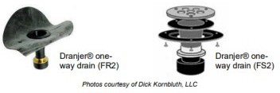
  - If the drain is connected to the ground, follow the manufacturer's instructions for installing the appropriate one-way drain. Examples below:
Figure 22. One way drain examples

Policy: The use of Priority List Audit Events as defined by the United States Department of Energy (US DOE) in WPN 22-8 are an initiative of the Minnesota Weatherization Assistance Program (MN WAP) intended to streamline the energy audit process to allow Minnesota Weatherization Service Providers to provide weatherization services more broadly to income-eligible Minnesota households.
General Guidance
- All aspects of the MN WAP Policy Manual and its appendices apply to Priority List Audit
Events, including but not limited to health and safety measures, procurement, and contracting if not otherwise stated in this document.
- The criteria and requirements for Priority List Audit Events will follow the appropriate checklists by housing type. This will be done by following and completing the most up to date (WAP Memo 114) Form A Checklist – Region 3, Form C – Combustion Safety, and Form H – Health and Safety located in WAPLink.
- The primary difference between Priority List Audit Events and Site-Specific Audit Events is the cost justification and selection of Energy Conservation Measures. Policy and Procedures in this document will include differences in data collection, file contents, measure selection, documentation requirements, and monitoring requirements.
- With respect to climate zones defined in WPN 22-8, all areas of Minnesota are Region 3 - Cold.
- All applicable Health and Safety Measures included in the Minnesota US DOE State Plan must be completed for Priority List Audit Events.
- The average cost per unit (ACPU) applies to Priority List Audit Events as defined in the MN WAP Policy Manual.
- Any measure listed as “mandatory” in WPN 22-8 may only be skipped if it is physically impossible to install, regardless of funding source used for the measure. SP is to properly document and inactive the measure in WAPLink.
  - A measure is considered physically impossible to install if it cannot be implemented within the existing physical, structural, or mechanical constraints of the building without major reconstruction, code violation, or safety compromise.
- If a dwelling meets the criteria found in WPN 22-8 for Priority List Audit Event Weatherization, the dwelling may be weatherized using the Priority List approach. If the energy auditor determines that the dwelling unit needs any measure not included on the relevant Priority List or if the home does not meet the basic requirements listed in WPN 22- 8, then a site-specific energy audit must be run in compliance with the Minnesota’s US DOE- approved energy audit procedures.
- Travel measures must be charged as an IRM and subject to the $500 cap for Site Built and Manufactured Homes and the 10% cap of ECMs for Low Rise Multifamily projects.
- Additional measures paid for with other funding sources, including EAPWX Measure Expansion and utility program measures can be installed in tandem with Priority List Audit Events.

Priority List Audit Events may only be completed for those eligible dwellings that meet the following criteria (as defined by WPN 22-8).
- Site Built Dwellings: Wood-framed single-family site-built dwelling unit that meets the following checklist:
  - Three (3) stories or less above grade.
  - Primary heating system is not:
    - a sealed-combustion natural gas furnace with an original AFUE rating of 90% or greater.
    - a heat pump manufactured after 2006.
  - Job will not exceed $500 in incidental repairs meeting the definition outlined in the MNWAP Policy 4.2.2.
- Manufactured Homes: Single-wide or double-wide manufactured homes that meet the following checklist:
  - Manufactured before 2010.
  - Has an accessible unconditioned subspace.
  - Does not have an attached conditioned addition.
  - Primary heating system is not a natural gas furnace with an original AFUE rating of 80% or greater.
  - Job will not exceed $500 in incidental repairs meeting the definition outlined in MNWAP Policy 4.2.2.
- Low-Rise Multifamily: Wood-framed Low-Rise Multifamily structures that meet the following checklist:
  - Three (3) stories or less above grade.
  - Contains five or more units per building.
  - Incidental Repair Measure (IRM) costs, as defined in MNWAP Policy 4.2.2, funded with US DOE WAP funds will not exceed 10% of the project’s total Energy Conservation Measures (ECM).

Special Multifamily Requirements Related to Common Spaces: Only items labeled as “Mandatory” may be installed in common spaces regardless of who pays the utility costs for these spaces. Common areas not physically connected to the qualified building, even if existing only for the use of the tenants of the qualified building, may not receive services paid for with WAP funding. “Optional” measures may not be installed using US DOE WAP funds in common spaces and may only be installed in dwelling units if all other applicable mandatory measures are installed as well

Appendix I: Policy Guidance additions MN WAP Policy Manual
Return to Additional information and resources

Section 1: Program management
    - Unit Averages: The Average Cost Per Unit (ACPU) for units completed using a Priority List Audit Event is the same as that for Audit Events.
    - Production Planning: Service Providers should incorporate anticipated US DOE ACPU for Priority List Audit Events into planned US DOE units based on cost of priority list measures relative to site specific audit events.

Section 2: Eligibility and service requirements
2.2 Priority for Providing Weatherization Services: Whether a dwelling can be weatherized as a Priority List Audit Event has no bearing on the prioritization of weatherization services. MN WAP Policy 2.2 must be implemented as written in the MN WAP Policy Manual. The ability to weatherize a home as a Priority List Audit Event is not a priority category as defined under MN WAP Policy 2.2.

Section 3: Dwelling eligibility
3.3.2 Multifamily Rental Requirements: The ability to use a Priority List Audit Event in a multifamily project will depend on whether the dwelling or dwelling units meet the criteria outlined above for either a Site Built or Low-Rise Multifamily building. In most cases rented townhomes with complete separation between the building units’ thermal barriers, air pressure boundaries, mechanical systems, and with individually metered units may be weatherized according to the Site Built Priority List.
3.8 Deferrals: The inability to weatherize a home using a Priority List Audit Event cannot be used as a justification for deferring a dwelling. Dwellings that cannot be weatherized using a Priority List Audit Event must be evaluated for a Site-Specific Audit Event.

Section 4: Audit event
  - Definition:
POLICY: MN WAP uses priority lists as defined in WPN 22-8 to generate energy conservation measures for Priority List Audit Events.
    - Energy Conservation Measure: ECMs are to be evaluated based on the definitions and procedures found in WPN 22-8 for Priority List Audit Events.
    - Incidental Repair Measures: Incidental repair measures are limited to $500 for site built and manufactured homes and to 10% of the projects total Energy Conservation Measures for multifamily dwellings for Priority List Audit Events.
    - Health & Safety Measures: Health and Safety Measures must be installed as they would be for site specific homes for Priority List Audit Events.
    - : General Heat Waste Measure (GHW): General Heat Waste Measures are allowed and are to be implemented per WPN 22-8, which is different than for Site-Built Audit Event checklists as defined in MN WAP Policy 4.2.3.4.
  - Household File Content: Unless otherwise noted in this document household file contents are the same for Priority List Audit Events as for Site Specific Audit Events including all required forms and eligibility documentation.
    - WAPLink Data:
      - WAPLink engine form data entry is not required.
      - All relevant data inputs needed to accurately assess the house per the criteria found the WPN 22-8 Priority Lists and the priority list data collection forms.
  - Energy Audit: Where not specifically noted in this document Energy Audit Procedures are the same for Priority List Audit Events as for Site Specific Audit Events.
4.4.1.4 WAPLink Data Entry: The Audit form in WAPLink is not required to be completed for Priority List Audit Events. An Audit form may be utilized to generate heat load calculations if needed.
4.4.2 Measure Consideration: Unless otherwise noted in this document, measure specific requirements are the same for Priority List Audit Events as for Site Specific Audit Events.
- Air Leakage Reduction: All single family and manufactured home dwellings weatherized as Priority List Audit Events have a minimum target of one CFM per finished square foot. However, this is a minimum and should not be a limiting factor as aggressive and achievable air sealing should still be pursued in all homes. Blower door testing is still optional for Low- Rise Multifamily Priority List Audit Events. Review Mandatory Air Sealing on Form A – Region 3 for all dwellings.
- Wall Insulation: Minnesota Weatherization Service Providers can choose whether to pay for wall insulation as gross wall square footage or as net wall square footage if it matches their existing procurement method. Service Providers paying contractors for net wall square footage must calculate net wall square footage of any walls to be insulated to accurately price wall insulation.
4.4.3 Work Orders:
- Priority list audit event work orders are generated automatically by WAPLink.
- Differences for Priority List Audit Events
  - Audit Events will be downloaded from FACSPro and when Priority List is selected, the file will include dwelling and client information.
  - WA Measure Types as Priority List – Priority List Mandatory (PLM) and Priority List Optional (PLO)
  - WAPLink reports will be adapted to track and differentiate between Priority List Audit Events and Site-Specific Audit Events.
  - Measures installed in the dwelling that use any portion of US DOE WAP funding must meet US DOE WAP rules. When applying the Priority List, any measure that is included in the dwelling that is ranked higher than the last measure with US DOE funds, the measure must meet the minimum installation requirements outlined in the appropriate priority list.
4.6 Quality Control Inspection: Where not specifically noted in this document the Quality Control Inspection (QCI) procedures are the same for Priority List Audit Events as for Site Specific Audit Events. The QCI procedure must include an assessment of whether the use of PL was appropriate.

Appendix J: Expire Alert quick reference table
Return to Additional information and resources
Return to Vendor management
Table 3. Expire Alert quick reference table
Document | Expire Alert (# days)
Contractor Documents | null
Contract between SP and Contractor | 60
Verification of Receipt of SWS | 60
Contractor License/Bond | 30
Insurance Certificate (Property damage, bodily injury, liability) | 30
Workers Compensation | 30
Debarment Check | 60
EPA Lead Firm Certification | 90
Covid-19 Preparedness Plan | N/A
Employee Documents | null
Employee Criminal Background Check | 60
EPA Lead-Certified Renovator | 90
Lead-Safe Work training | 90
Asbestos Training | 90

Appendix K: Checklists
Return to Download and complete required checklists
Return to Additional information and resources

Dwelling Eligibility for Priority List Checklists
Single Family: Attachment 1: DOE-Sponsored Priority List for Single-Family Site-Built Homes
Manufactured Home: Attachment 2: DOE-Sponsored Priority List for Manufactured Homes
Low-Rise Multifamily: Attachment 3: DOE-Sponsored Priority List for Low-Rise Multifamily Projects

Audit Checklists
Single Family: Form A – Single Family Site-Built Priority List Checklist - Region 3
Manufactured Home: Form A – Manufactured Home Priority List Checklist - Region 3
Low-Rise Multifamily: Form A – Low-Rise Multifamily Priority List Checklist - Region

Form C Checklist – Combustion Safety
Single Family: Form C – Single Family Site-Built Combustion Safety Checklist
Manufactured Home: Form C – Manufactured Home Combustion Safety Checklist
Low-Rise Multifamily: Form C – LRMF Combustion Safety Checklist

Form H Checklist – Health and Safety
Single Family: Form H – Single Family Site-Built Home Health & Safety Checklist

Manufactured Home: Form H – Manufactured Home Health & Safety Checklist
Low-Rise Multifamily: Form H – LRMF Dwelling Unit Health & Safety Checklist

By selecting No, this allows you to have your current Setting Group enabled while you edit your new Setting Group. Once you are ready to archive your old Setting Group, you can simply follow the steps again and select Archive Only. To prevent users from using a Setting Group too soon, it may be helpful to name the file something that informs the user that the file is not ready (i.e. Draft or Do Not Use) and once the Setting Group is complete, you can simply select the name and change the name on the main WA Setting Group page.
For example, an “Other” cost for an attic insulation measure in NEAT has units of “Each Attic,” implying that this dollar cost will be added to the cost of insulating each individual attic segment, not to the total cost for insulating all the attics in an entire dwelling. Only in the case of a home having a single attic segment qualifying for insulation would the entry have the likely intended purpose of a setup cost for equipment necessary to install the insulation.
MHEA does not have the option to describe multiple attic segments for the mobile home, so doesn’t suffer from this problem. The “Other” cost column in NEAT is more appropriately used for measures such as window treatments where you have an option to cost the measure per window (“Each”) or per square foot of window area.
Based on the ORNL engine design, WAPLink follows specific rules for floor insulation. If a floor is sheathed, the system will ignore the option to install batt insulation. If a floor is unsheathed, the system will ignore the option to dense pack and will only allow batt insulation. This behavior is determined by the ORNL engine, not by WAPLink, and no changes to this logic are planned. This is not temporary guidance; the User Guide will be updated to reflect this intended workflow.

