
This template is intended to be easy to customize and update.

Yellow highlighted areas and text with XX can be updated or deleted. Remove information that is in [brackets].
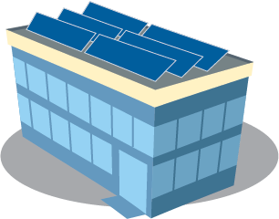
Customize and revise as you’d like. Please include this sentence: [Your government name] is one of more than 80 local governments across the state awarded a grant from the Minnesota Department of Commerce Solar on Public Buildings Program (https://tinyurl.com/SolarOnPublicBuildingsMN) to install solar power.

Xx has been awarded a grant from Minnesota’s Solar on Public Buildings program

XX is adding solar to help power our building and to benefit our community now and into the future. XX is one of more than 80 local governments across the state that are on track to receive grants from the Minnesota Department of Commerce Solar on Public Buildings Program (https://tinyurl.com/SolarOnPublicBuildingsMN) to install solar power.
[add quote from local council/board member or administrator – suggested: ]
“We are proud to be among the local governments in Minnesota’s Solar on Public Buildings Program to install solar panels,” said name/title. “Solar power will help reduce our building’s energy costs, so we have more money to invest in our community.”
The Solar on Public Buildings grant for $xxxx will cover xx% of costs for xx to install solar panels on the rooftop/ grounds at location, such as southeast corner or near the west entrance, or other location. The solar installation is expected to be completed and delivering power to our building by xx date.
Benefits of the Solar on Public Buildings Program
Solar on Public Buildings is designed to provide incentives for installation of solar energy systems on Minnesota local government buildings. The program offers benefits to communities across Minnesota:
- Adding solar reduces energy costs.
- Our local economy benefits from investments made in expanding our energy infrastructure, and from adding clean energy jobs, like solar installations.
- Solar power helps reduce electricity-based greenhouse gas emissions.
- Solar power adds “homegrown” renewable sources of energy to our building and the state’s electrical grid, since Minnesota currently imports 100% of its fossil fuels.
For more Solar on Public Buildings Program info: https://tinyurl.com/SolarOnPublicBuildingsMN.
For more information about xx’s solar installation, contact xx contact info.

