
MN Solar on Public Buildings program
Sample proclamation for local gov consideration
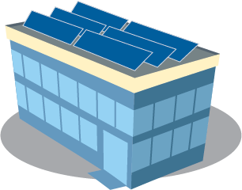
WHEREAS; _____ [local government] was founded in ___ [year] to respond to the needs of this community to educate our youth and provide area employers with life-long learners and future workers with capacity for specialized training; and
WHEREAS; _____ [local goverment name] has been awarded a grant by the Minnesota Department of Commerce, Division of Energy Resources, Solar on Public Buildings program, making our local government renewable energy pioneers in the state of Minnesota; and
WHEREAS; the MN Solar on Public Buildings program was established by the state legislature in 2023 to stimulate the installation of solar energy systems on Minnesota public buildings; and
WHEREAS; MN Solar on Public Buildings program benefits include:
- Buildings can reduce energy costs by adding solar power.
- Solar projects provide clean energy and often provide local jobs.
- Solar energy has an important role in reducing greenhouse gas emissions. Solar power produces no emissions during generation itself; and
WHEREAS; Renewable technologies provided 31 percent of Minnesota’s power generation in 2022. Over the last decade, renewable generation has risen 75 percent and accounts for 81 percent of all new power-generating capacity built during that time; and
WHEREAS; Clean and renewable energy jobs are increasing in the state. More than 57,000 Minnesotans work in clean energy [IF IN GR MN: with nearly 40% of these jobs residing in Greater MN]; and
WHEREAS; Today, ____ [local government name] will bring into service a new solar installation, consisting of __ [#] solar panels that will produce an estimated __ [#] kilowatt hours of electricity per year and save local citizens an estimated $______ [projected annual savings] annually; and
NOW, THEREFORE, I/WE, _______ [council/board chair/members], on behalf of _____ [local government name] do hereby proclaim ____ [date] as SOLAR ENERGY DAY.
[Insert your seal and signatures here.]

