This template press release is intended to be easy for you to customize and update.

Yellow highlighted areas and text with XX are for you to update or delete.

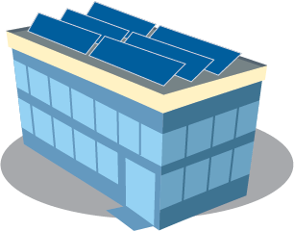Remove information that is in [brackets].

You are welcome to customize and revise as you’d like. But please include this sentence: XX [your government’s name] is one of 18 local governments across the state that are on track to receive grants from the Minnesota Department of Commerce Solar on Public Buildings Program (<https://tinyurl.com/SolarOnPublicBuildingsMN>) to install solar power.

**Xx is getting SOLAR POWER**

XX is adding solar to help power our building and benefit our community now and into the future. XX is one of 18 local governments across the state to receive grants from the Minnesota Department of Commerce Solar on Public Buildings Program (<https://tinyurl.com/SolarOnPublicBuildingsMN>) to install solar power.

The Solar on Public Buildings grant for $xxxx will cover xx% of costs for xx to install solar panels on the rooftop/ grounds at location, such as southeast corner or near the west entrance, or other location. The solar installation is expected to be completed and delivering power to our building by xx date.

**Benefits of the Solar on Public Buildings Program**

* Adding solar reduces energy costs.
* Our local economy benefits from investments made in expanding our energy infrastructure, and from adding clean energy jobs, like solar installations.
* Solar power helps reduce electricity-based greenhouse gas emissions.
* Solar power adds “homegrown” renewable sources of energy to our building and the state’s electrical grid, since Minnesota currently imports 100% of its fossil fuels.

For more Solar on Public Buildings Program info: <https://tinyurl.com/SolarOnPublicBuildingsMN>.

For more information about xx solar installation, contact xx contact info.