Practical guidance for energy recovery ventilation in Minnesota commercial buildings

Energy recovery ventilation (ERV) systems exchange heat and/or moisture between outgoing exhaust air the incoming outdoor (ventilation) air. When operating according to design, it is possible for ERVs to use 10 to 100 times less energy than conventional heating and cooling systems, resulting in up to 80% energy savings on ventilation loads. Over the last 20 years these systems have become more common in Minnesota. However, studies on as-operated ERVs are few and real world observations suggest that performance of ERVs may not live up to expectations.

The Center for Energy and Environment received a CARD grant to investigate the expectations and the operating performance of ERV units in Minnesota commercial and institutional buildings. The project team used available data to characterize ERVs and then monitored the performance of representative ERV systems, identified and rectified problems that diminish ERV performance, and documented the energy use and costs associated with under-performing ERVs.

The research team analyzed data on 402 ERVs from 134 different buildings to understand basic system demographics. The analysis showed that the majority of buildings that have energy recovery units also have multiple air handling systems, multiple energy recovery systems, and several ERVs of the same type. However, only a fraction of ventilation air is typically served by energy recovery, particularly in institutional buildings. The data suggest that the most common scenario for air-to-air exhaust energy recovery in Minnesota is total enthalpy wheels in institutional buildings, most likely K-12 schools. The importance of large ERVs to statewide savings is striking—the top 25% of units are responsible for conditioning over 13 times the amount of ventilation air as the bottom quarter of units.

Figure 1. A CEE researcher observes the performance of one the ERV systems in the study.
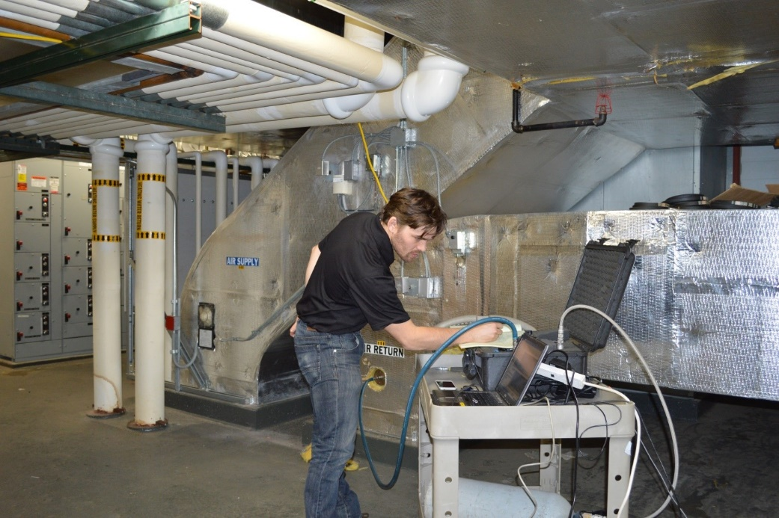

After analyzing available data, primary characteristics of the systems (such as recovery unit type, unit size and problems uncovered during screening or preliminary interviews) along with secondary considerations (such as manufacturer, age, space use, building owner) were used to select nine representative systems for detailed monitoring (Figure 1).

With respect to energy savings and outside air temperature, the team observed that at a bare minimum, an ERV should be activated between 0ᵒF and 45ᵒF in order to realize between 60% and 80% of potential savings, and it should be activated above 80ᵒF to achieve peak cooling load reduction. In Minnesota, very little energy recovery takes place between 45ºF and 65ºF.

Through this field work, the project team also documented 75 different issues among the nine ERVs in the study. While the types of issues and their impact varied widely, they can be sorted into 11 different categories, as shown in Figure 2.

Figure 2: Breakdown of 75 issues encountered
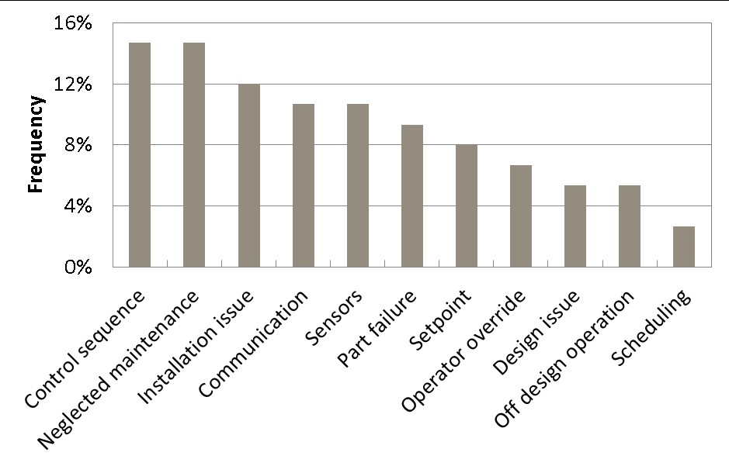

About one-third of the issues (24) were deemed to have significant energy impacts. Of those, 21 reduced energy recovery during the heating season and 16 increased the ventilation load during cooling season. Six issues relating to overrides, part failures, and installation prohibited energy recovery entirely. Several issues had very minor impacts and these included the adjustment of frost control sequences and the adoption of more aggressive frost control set points. Similar to frost control, economizer issues resulted in a lower energy impact than anticipated. The energy and cost penalties of the encountered issues are summarized in Table 1.

Table 1: Summary of energy and cost penalties of encountered issues
 | Heating Penalty | Heating Cost Penalty | Cooling Penalty | Cooling Cost Penalty
 | therms/yr | $/yr | kWh/yr | $/yr
Min | 16 | 13 | 52 | 6
Max | 4,721 | 3,857 | 5,213 | 584
Average | 1,388 | 1,134 | 1,498 | 168
Median | 698 | 571 | 813 | 91
Sum | 27,756 | 22,676 | 23,963 | 2,684

While ERVs are in fact capable of achieving impressive savings, the study showed that steps must be taken to ensure that units are installed and operated according to specification to reach performance expectations. Performance expectations should consider that practical implementation choices and performance under mild conditions will diminish savings with respect to design estimates.

A general lack of understanding around ERV performance has led to bad experiences with ERVs and their associated systems, leading to negative perceptions and diminished expectations. However, these experiences and perceptions generally have little to do with the energy efficiency performance, but more so around the typical processes involved with implementing the technology.

Mistakes relating to part failures, operator overrides, and installation account for 75% of the lost energy recovery. These mistakes persist due to unfamiliarity among operations staff and controls technicians as well as the absence of system feedback from poorly functioning ERVs. Fortunately, these mistakes can be easily corrected by commissioning new units to ensure that they function properly from the start. Problems with existing ERV systems can be easily identified by staff that are trained to understand ERVs and assess their operation.

CIP recommendations that came out of the study are:
- Commission new systems. This project demonstrated a strong need for commissioning new energy recovery systems. The persistence of dysfunctional ERVs as part of normal operations indicates a need for system installations to be validated immediately. Fifty percent of the found savings discovered would have been identified during a robust initial commissioning process.
- Improve existing systems. The majority of energy penalties that were found as a part of this project can be discovered and avoided if ERVs are touched by staff that are able to identify when an ERV should be running and assess whether an ERV is running. ERV problems often go unnoticed because there are usually no obvious operational implications. Validating an ERV system does not necessarily require a full recommissioning effort. Given that 60% to 80% of energy recovery occurs between 0ᵒF and 45ᵒF, a simple procedure to verify that an ERV is operational in this temperature range is an easy way to validate a majority of savings. Beyond basic operational validation, a dedicated recommissioning effort may be needed to achieve additional savings opportunities.
- Target recommendations. Design engineers, mechanical and controls contractors, commissioning agents, and owners all need slightly different information and resources in order to ensure ERV performance in actual operation.

Detailed results are available in the full report, “Energy Recovery in Minnesota Commercial and Institutional Buildings: Expectations and Performance.” In addition, CEE developed a “Practical Guide to Energy Recovery Ventilation Operations” to give operator/owners details of how common ERVs work, as well as “A Quick Guide to Validate Air-to-Air Exhaust Energy Recovery” that emphasizes the validation of energy recovery performance and the identification of ineffective operation. CEE will also conduct a webinar the provides an overview of the results of this project on June 22 (see registration information in the CARDS Project Webinar section of this newsletter). If you have questions on this project, contact project manager Mark Garofano or CARD program administrator Mary Sue Lobenstein.

