Check with your Workers’ Compensation Coordinator to determine if your agency participates in the First-Fill Program.

MN Department of Admin

Claimant Name: ________________________________________________________

Date of Injury: __________________________ SSN: __________________________

Notice to Injured Worker and Pharmacy

This temporary First Fill card is only valid if used within 30 days of the reported date of injury. Temporary eligibility through this program allows for a one time fill of prescription medications. For assistance processing claims please contact the CorVel Pharmacy Department at **(800) 563-8438.**

Injured Worker Instructions

On your first Pharmacy visit, please give this notice to any pharmacy listed on this insert to expedite the processing of your approved Workers’ Compensation prescriptions, based on the parameters established by **MN Dept of Admin.**  With the CorVel pharmacy program, you do not need to complete any paperwork or claim forms. Simply present this CorVel First Fill Prescription Form to the pharmacy. You should not incur any costs or co-pays at the pharmacy and you will be allowed up to a 14 day supply of medications.

Pharmacy Instructions

For assistance processing claims please contact the CorVel Pharmacy Department at **(800) 563-8438.** Please use the BIN, PCN, and RxGroup number below to process an online/electronic claim to CorVel:

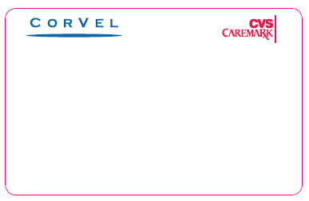



**BIN: 004336**

**PCN: ADV**

**RxGroup: RXFFWC162**

**Member ID: See below to generate ID**

**To Generate Member ID:** The Injured Worker’s 9 digit Social Security Number plus 8 digit Date of Injury will be used as their 17 digit **Member Identification number** when processing their First Fill Prescription: **XXXXXXXXXMMDDYYYY**

Below is a sample listing of some of the over 72,000 Participating Pharmacies in the CorVel Network. Please call **(800)563-8438** for a participating pharmacy near you.

|  |  |  |  |
| --- | --- | --- | --- |
| Costco Pharmacy | H-E-B Pharmacies | Meijer Pharmacy | Smith’s Food & Drug Centers |
| CVS | Hy-Vee Pharmacy | Publix Pharmacy | Target Pharmacy |
| Dominick’s Finer Foods | Ingles Pharmacy | Raley’s Drug Center | Von’s Pharmacy |
| Drug Mart | Kroger Pharmacy | Rite Aid Pharmacy | Wal-Mart Pharmacy |
| Fred’s Pharmacy | Longs Drug Store | Safeway Pharmacy | Walgreens Pharmacy |
| Giant Eagle Pharmacy | Marc’s Pharmacy | Sav-On Drug Store | Wegman Pharmacy |