

Optimized Operation of Indoor Public Pool Facilities
Minnesota’s estimated 2,200 indoor public pools are high-energy users with substantial optimization opportunities. However, Conservation Improvement Program (CIP) initiatives in the state have generally underserved this segment of the commercial building market. An estimated 580 large public pools are located in schools and fitness centers that may be served by recommissioning programs, but the recommissioning of these facilities is very expensive and seldom adequately addresses the indoor pool area, due to the specialized nature of the facilities and inconsistencies of their tie-ins with central building automation systems. Additionally, thorough recommissioning is rarely undertaken for hospitality and multifamily buildings that house an estimated 1,400 smaller indoor public pools.
In response to the challenges, the Center for Energy and Environment (CEE) undertook this CARD project to jump-start efforts to address the need for cost-effective operational improvements in existing indoor public pool facilities. The primary objectives were to provide a better understanding of the energy-savings potential associated with improved operations and to develop technical guides for utility program providers and operators.
CEE completed on-site surveys of 30 buildings with a total of 36 pools and 13 spas, including detailed follow-ups with six of these buildings. The survey and follow-up sites were chosen to represent common variations in pools, buildings, and equipment types, as well as opportunities for energy efficient operations improvements. These follow-up efforts included recommissioning-level investigations, implementation of specific operational improvements, and long-term field monitoring to validate savings estimates.

Existing facilities and conditions
Figure 1 shows CEE’s estimates of the statewide count of indoor public pools, organized by facility and pool category. The 2,000 square-foot breakpoint used to define small and large pools is based on input from pool industry professionals, accounting for differences in the distribution between buildings and the types of mechanical equipment used. Most of the small pools were actually less than 1,000 square feet, making the average large pool about six times larger than the average small pool.

Figure 1. Statewide estimates of indoor public pool counts by building and pool type *
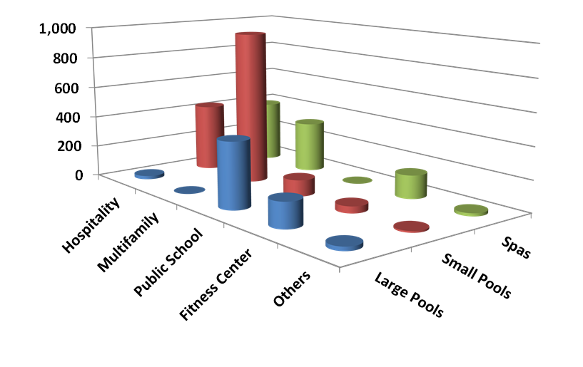
*The categorization of pools between small and large is based on a 2,000 ft2 breakpoint.
CEE found a wide variety of equipment and operating conditions in Minnesota indoor public pool facilities, as well as a few noteworthy trends. Pool water-side systems are dominated by constant speed pumping and the use of boilers with secondary heat exchangers to heat the water. This constant speed pumping tends to provide much more than the code required water flow rate in small pools, while larger pools sometimes use inefficient valve throttling to prevent excessively high flow rates (Figure 2). Nearly half of the facilities use only fresh outdoor air to dehumidify the pool room, while the use of a dehumidifier with a compressor was more common in hospitality buildings and buildings with large pools.
Figure 2. Throttle valves on pool pumps and sand filters
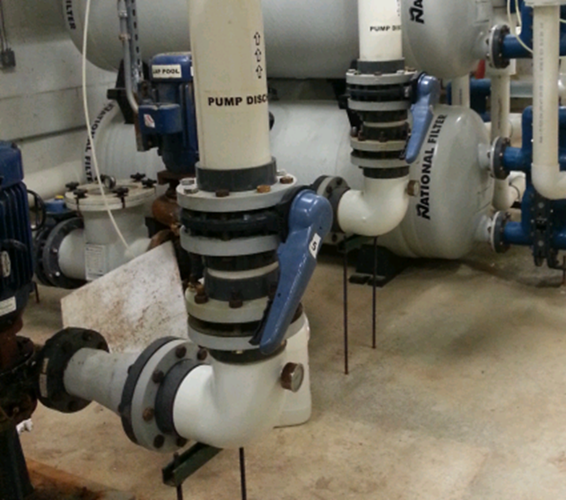
Problems with the control of the pool room’s heating, fresh air ventilation, and dehumidification are very common. CEE also found that the use of commonly promoted efficiency features, such as a pool cover or reclaiming heat from the dehumidifier for pool water heating, are often abandoned after a short period of time.

Cost-effective opportunities
Table 1 conveys statewide savings opportunities available in Minnesota indoor public pool facilities by category of measure and fuel. HVAC recommissioning-related activities show the largest potential for savings of both gas and electricity. No-cost control adjustments and liquid pool covers provide significant secondary opportunities for gas savings, whereas variable speed pool pumping provides about one-third of electric savings potential. It’s also important to note that the one-third of pool facilities that have large pools represent about two-thirds of the overall savings potential. Although liquid pool cover savings potential is fairly consistent across the population of small pools, CEE found that the applicability, nature, and potential savings for HVAC control changes and variable speed pool pumping varies significantly from site to site.
Table 1. Summary of cost-effective statewide savings potential
 | # of Applicable Buildings |  | CCF/ Building |  | kWh/  Building | MCF Statewide | MWh Statewide
No-Cost Changes* | 907 | 853* |  | 3,878* |  | 77,394* | 3,517*
HVAC Recommissioning/Audits | 2,029 | 2,545 |  | 8,788 |  | 516,302 | 17,832
Liquid Pool Cover | 1,394 | 221 |  | 1,453 |  | 30,755 | 2,026
Variable Speed Pool Pumping | 907 | 0 |  | 9,789 |  | 0 | 8,879
Total | 2,029 | 2,696 |  | 14,163 |  | 547,057 | 28,736
* Values for no-cost changes were not added to the totals because the savings associated with this measure is mutually exclusive with the recommissioning audits (within the same building).

CIP program recommendations
The findings of this study led to the following recommendations for CIP program activities:
- Recommissioning Using CEE’s New Guide: Use the Recommissioning Guide for Indoor Public Pool Facilities in Minnesota, developed as part of this project, to direct recommissioning efforts.
- Simple Rebate for Pump VSD: Offer a simple prescriptive (or similar) rebate option for variable speed pool pumping.
- Develop Rebates for Liquid Pool Covers with Further Verification: Consider offering pilot or custom rebates for liquid pool covers, with measurement and verification of the first few participants, before undertaking wide promotion of this technology.

More detailed results will be available in a forthcoming final report to be posted soon on the CARD Research Projects webpage. For more information, contact project manager and CARD program administrator Mary Sue Lobenstein.

