

GreenStep Cities workshop highlights the value of benchmarking wastewater treatment plants
On Dec. 6, GreenStep Cities (GSC) in collaboration with the Minnesota Department of Commerce, hosted a workshop highlighting how benchmarking helps wastewater treatment plants (WWTPs) begin to identify significant energy and cost-saving opportunities at Minnesota WWTPs. A main takeaway from the workshop was that no matter whether a WWTP receives a high or low benchmarking score, plants can leverage their score to benefit their facility. It is not unusual for a typical plant in Minnesota to identify $13,000 in annual energy cost savings, and B3 Benchmarking, funded by Commerce and the Minnesota Department of Administration, is a powerful and simple tool that WWTPs can use to generate a variety of metrics to benchmark their facilities.
The workshop also included informative presentations by the Minnesota Technical Assistance Program (MnTAP), The Weidt Group, the City of St. Cloud, and the City of New Prague.
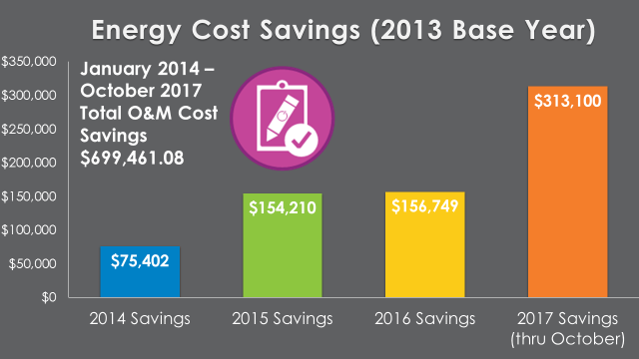
Tracy Hodel, St. Cloud’s Assistant Public Utilities Director, highlighted the impressive results that St. Cloud has achieved using B3 Benchmarking to benchmark its WWTP and track the impact of installing efficient lighting, HVAC, pneumatic system upgrades, blower optimization, biofuel recovery, and solar panels. As illustrated in Figure 1, between 2014 and 2017, these combined energy efficiency and renewable energy measures resulted in a total operations and maintenance cost savings of close to $700,000 for St. Cloud’s WWTP.
Figure 7. St. Cloud WWTP’s Energy Cost Savings (2014-2017). Source: Tracy Hodel, St. Cloud’s Assistant Public Utilities Director.
All of the workshop’s presentation slides and the full webinar recording can be accessed on the GSC website. For more information and to get started benchmarking your WWTP, please visit the B3 Benchmarking website.
This work is supported through a U.S. Department of Energy grant that Commerce, the Minnesota Pollution Control Agency, and MnTAP received to capture energy efficiency opportunities in the wastewater sector by providing tools and technical assistance to small and mid-sized facilities across the state.
WWTPs operate in approximately 600 communities in Minnesota. Energy can account for 25-40% of the operating budgets of wastewater utilities. Effective water and wastewater infrastructure is critical for continued economic development and job growth in all regions of Minnesota. Optimizing the operations and energy use of wastewater facilities can help save money that can then be used to meet other critical community needs.

