

A Field Assessment of Cold-Climate Air Source Heat Pumps

High-efficiency technologies such as air source heat pumps (ASHPs) have significant potential to improve space heating efficiency and reduce energy costs for houses in cold climates. ASHP technology has been available for many years, but until recently, technological limitations caused concern about efficiency and reliability during the coldest months of the year in climate zones 6 and 7. Recent generations of ASHP have improved with the addition of an inverter-driven compressor and updates to the refrigerant, making the systems better suited for cold-climate heating. In particular, the inverter-driven compressor allows the compressor speed to modulate and increase capacity during periods of colder outdoor air temperatures.

The increase in efficiency and operating capacities of cold-climate air source heat pumps (ccASHP) provides an opportunity for energy efficient space heating for Minnesota homes, in particular homes without access to natural gas heating. However, a field study was necessary to evaluate this new technology and understand how the system would perform in actual installations. The Center for Energy and Environment (CEE) conducted this assessment with a CARD grant and additional support from Great River Energy and the Electric Power Research Institute (EPRI).

ccASHP technology

Figure 1. Whole home ducted cold-climate air source heat pump
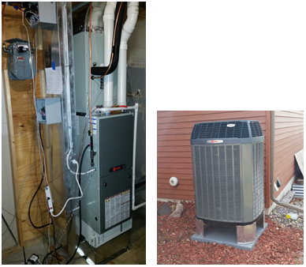

Figure 2. Ductless cold-climate air source heat pump
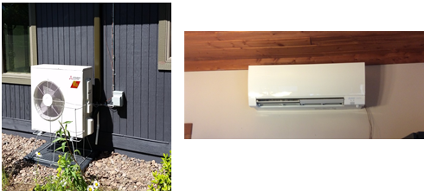

Cold-climate air source heat pumps are available as both central-ducted systems (Figure 1) and ductless systems (Figure 2). Both system types are available with single and multi-zone indoor units. While this project focused on single-zone systems, multi-zone systems are expected to perform similarly.

Central-ducted systems are designed and installed to meet the full load of the home by distributing heat through forced air ductwork. Ductless systems deliver heat to a specific area of a home through a single interior head with no ductwork. In cold-climate applications, air source heat pumps typically require a backup system. Backup systems take over the heating load at an outdoor air temperature when a heat pump capacity is no longer sufficient, or when a heat pump can no longer operate. The exact temperature when this happens is based on the house load and system size but is about 10⁰F. Ducted systems typically use a propane furnace as a backup. Ductless systems often rely on electric resistance baseboards for backup heating. The integration between the heat pump and the backup systems are important design and installation considerations that can drastically impact the performance of a system.

Methodology
CEE developed a field test methodology to characterize ccASHP and understand their potential in Conservation Improvement Programs (CIP). The methodology focused on several key phases:

- First, Minnesota characterization data was used to develop site selection criterion to best represent the Minnesota market for ASHPs.
- Once the sites were identified, equipment was selected from a range of manufacturer and installation types to look at the full range of available technology.
- Detailed monitoring equipment was then installed with the ASHP system to characterize system performance in the real world.
- Finally, data was collected and analyzed to characterize ccASHP equipment performance and to compare it to the performance of baseline systems. The analysis included energy consumption, operating costs, impact of the cold-climate on system performance and occupant comfort, and a characterization of system efficiency over the range of Minnesota temperatures.

Results
Cold-climate air source heat pumps have three types of heating operation: heat pump heating (ashp.htg.on), backup heating (lp.htg.on), and defrost mode. These three modes are illustrated in Figure 3, which shows the operation of the ducted ccASHP in one of the monitored sites. The plot shows the coefficient of performance (COP) or the ratio of energy delivered to the home to energy consumed in electricity or propane.

Figure 3. Heating performance of the ducted ccASHP at Site 01

Heating events where only the heat pump was used typically had the highest COPs, around 1.3 at the lower temperature change point (10⁰F) and increasing to about 3.5 in the shoulder heating seasons (around 50⁰F to 60⁰F). While the outdoor air temperature has the largest impact on the COP, as the figure shows, heating cycles at the same outside air temperature did have a range of COPs. Secondary factors which affected on-cycle COP include the rates of operation of components in both the indoor and outdoor units.

The second type of heating operation was the backup furnace mode. These events occurred at outdoor temperatures below the point where the ASHP was expected to meet the full load of the home (10 ⁰F for how these systems were sized).

The final mode of operation was defrost. When the ccASHP is operational and outdoor conditions are below freezing, there is a risk that frost can form on the outdoor coil. To prevent this, ccASHP systems run in defrost mode by reversing the system and transferring a small amount of indoor heat back to the outside. There is a lot of variation in the defrost performance, because defrost can turn on mid-heating cycle. There are also times in an event when only the defrost mode is running, and almost no heat is provided to the home. This results in a COP near 0, because almost all of the heat goes to the outdoor unit to keep it from frosting. Some events have higher COPs because the heat pump has been on for a long time, and the defrost mode is only active for a small fraction of the event run time.

The high-resolution data was compiled to determine the annual system performance. The findings from this research show opportunities for residents and utilities to reduce total site energy by 35% to 50%. These savings may be attributed to climate, ASHP type, and the system the heat pump replaced, but in all cases, ccASHPs saved homeowners and renters significant amounts of energy and money (Figure 4).

Figure 4. Propane and electricity use for the ccASHP and baseline heating systems at each site
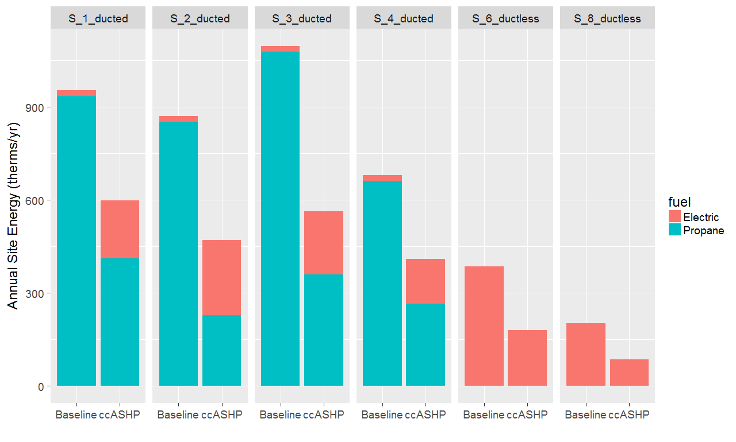

Detailed data collection at each site allowed system performance curves to be developed. The performance data allowed for estimates of ccASHP savings across a range of baseline heating systems and installation locations. Table 1 summarizes those results.

Table 1. Summary of savings for MN homes
Air Source Heat Pump | Baseline | Location | Site Energy Reduction | Cost Reduction | Propane Reduction
Ducted | Condensing LP Furnace | Metro | 41% | 30% | 63%
Ducted | 82% LP Furnace | Metro | 49% | 40% | 67%
Ductless | Elect. Resistance | Metro | 56% | 56% | N/A
Ducted | Condensing LP Furnace | Northern MN | 36% | 26% | 55%
Ducted | 82% LP Furnace | Northern MN | 44% | 36% | 61%
Ductless | Elect. Resistance | Northern MN | 53% | 53% | N/A

Overall, CEE research found that ccASHP performed to their rated specifications for both system capacity and efficiency (coefficient of performance or heating seasonal performance factor). With proper sizing, installation, and integration with backup heating systems, ccASHPs are an attractive heating system replacement for homes with propane or electric heating.

Many electric utilities and co-ops in Minnesota have existing ASHP rebate programs that can be modified to include the benefits of heating with ccASHPs. One method would be to provide a tiered rebate structure. For example, a low rebate could be provided for ASHP systems installed only for cooling, a middle level rebate for systems designed for cooling and shoulder season heating, and the highest level rebate for systems designed for cooling and heating through the winter. The project also recommends that programs for ASHP consider installation requirements to ensure the desired heating performance is met.

More detailed results are available in the full report, which is forthcoming, and in a webinar that was presented in October of 2017. For more information, contact project manager Mark Garofano or CARD program administrator Mary Sue Lobenstein.

